EL NIÑO/SOUTHERN OSCILLATION (ENSO) DIAGNOSTIC DISCUSSION

issued by

CLIMATE PREDICTION CENTER/NCEP/NWS
and the International Research Institute for Climate and Society
9 February 2017

ENSO Alert System Status: Final La Niña Advisory

Synopsis: ENSO-neutral conditions have returned and are favored to continue through at least the Northern Hemisphere spring 2017.
La Niña conditions are no longer present, with slightly below-average sea surface temperatures (SSTs) observed across the central equatorial Pacific and above-average SSTs increasing in the eastern Pacific (Fig. 1). The latest weekly Niño index values were -0.3°C in the westernmost Niño-4 and Niño-3.4 regions, and +1.5°C in the easternmost Niño-1+2 region (Fig. 2). The upper-ocean heat content anomaly increased during January and was slightly positive when averaged across the eastern Pacific (Fig. 3), a reflection of above-average temperatures at depth (Fig. 4). Atmospheric convection remained suppressed over the central tropical Pacific and enhanced over Indonesia (Fig. 5). The low-level easterly winds were slightly enhanced over the western tropical Pacific, and upper-level westerly winds were near average. Overall, the ocean and atmosphere system is consistent with ENSO-neutral conditions.

Most models predict the continuation of ENSO-neutral (3-month average Niño-3.4 index between -0.5°C and 0.5°C) through the Northern Hemisphere summer (Fig. 6). However, a few dynamical model forecasts, including the NCEP CFSv2, anticipate an onset of El Niño as soon as the Northern Hemisphere spring (March-May 2017). Because of typically high uncertainty in forecasts made at this time of the year for the upcoming spring and summer, and the lingering La Niña-like tropical convection patterns, the forecaster consensus favors ENSO-neutral during the spring with a ~60% chance. Thereafter, there are increasing odds for El Niño toward the second half of 2017 (~50% chance in September-November). In summary, ENSO-neutral conditions have returned and are favored to continue through at least the Northern Hemisphere spring 2017 (click CPC/IRI consensus forecast for the chance of each outcome for each 3-month period).

This discussion is a consolidated effort of the National Oceanic and Atmospheric Administration (NOAA), NOAA’s National Weather Service, and their funded institutions. Oceanic and atmospheric conditions are updated weekly on the Climate Prediction Center web site (El Niño/La Niña Current Conditions and Expert Discussions). Forecasts are also updated monthly in the Forecast Forum of CPC's Climate Diagnostics Bulletin. Additional perspectives and analysis are also available in an ENSO blog. The next ENSO Diagnostics Discussion is scheduled for 9 March 2017. To receive an e-mail notification when the monthly ENSO Diagnostic Discussions are released, please send an e-mail message to: ncep.list.enso-update@noaa.gov.

Climate Prediction Center
National Centers for Environmental Prediction
NOAA/National Weather Service
College Park, MD 20740

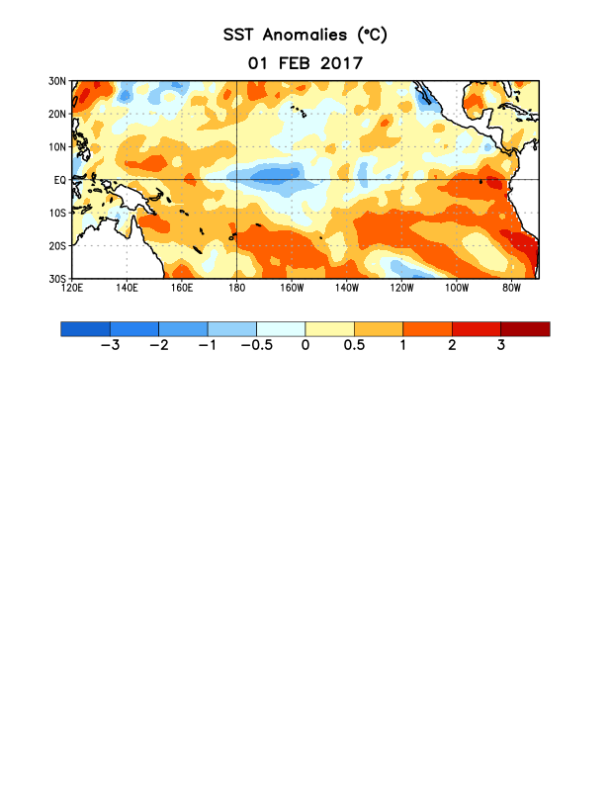
Figure 1. Average sea surface temperature (SST) anomalies (°C) for the week centered on 1 February 2017. Anomalies are computed with respect to the 1981-2010 base period weekly means.

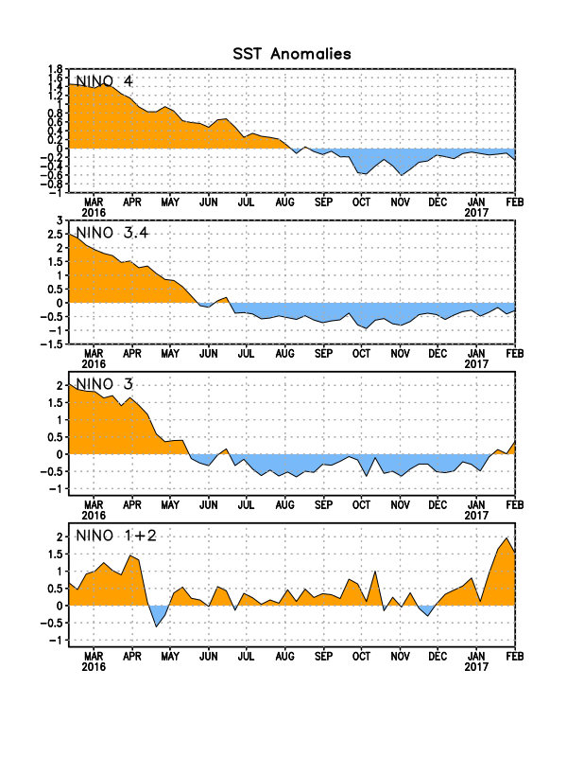
Figure 2. Time series of area-averaged sea surface temperature (SST) anomalies (°C) in the Niño regions [Niño-1+2 (0°-10°S, 90°W-80°W), Niño 3 (5°N-5°S, 150°W-90°W), Niño-3.4 (5°N-5°S, 170°W-120°W), Niño-4 (5ºN-5ºS , 150ºW-160ºE]. SST anomalies are departures from the 1981-2010 base period weekly means.
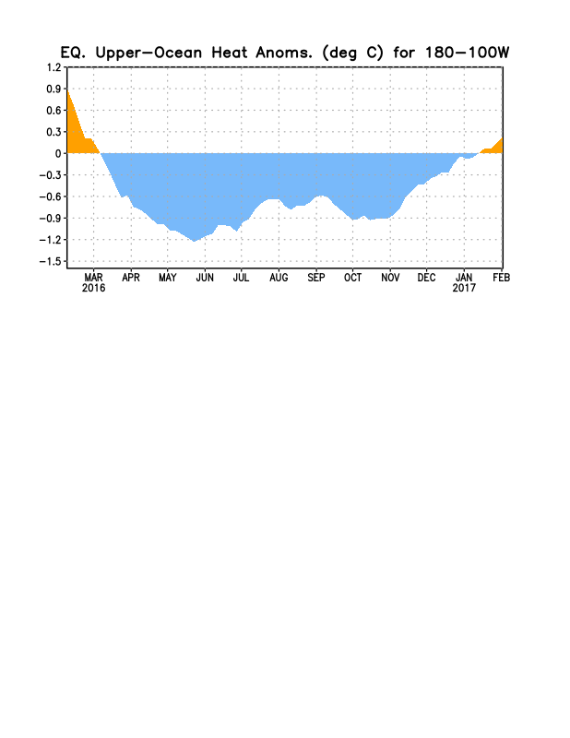
Figure 3. Area-averaged upper-ocean heat content anomaly (°C) in the equatorial Pacific (5°N-5°S, 180º-100ºW). The heat content anomaly is computed as the departure from the 1981-2010 base period pentad means.

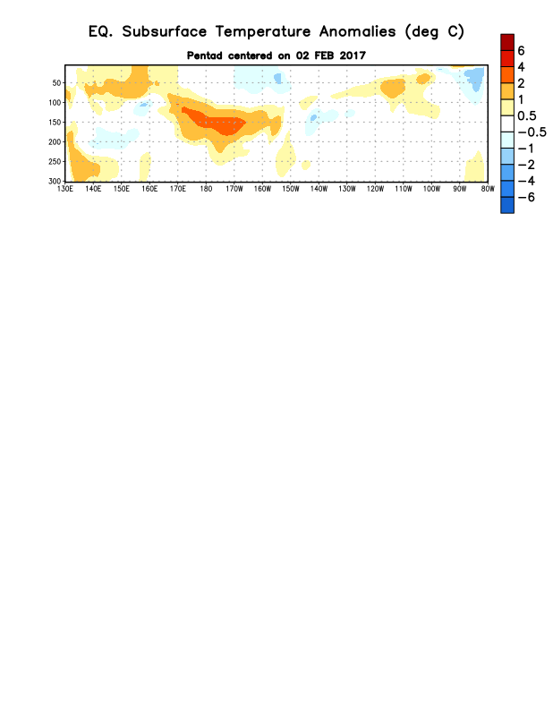
Figure 4. Depth-longitude section of equatorial Pacific upper-ocean (0-300m) temperature anomalies (°C) centered on the pentad of 2 February 2017. The anomalies are averaged between 5°N-5°S. Anomalies are departures from the 1981-2010 base period pentad means.

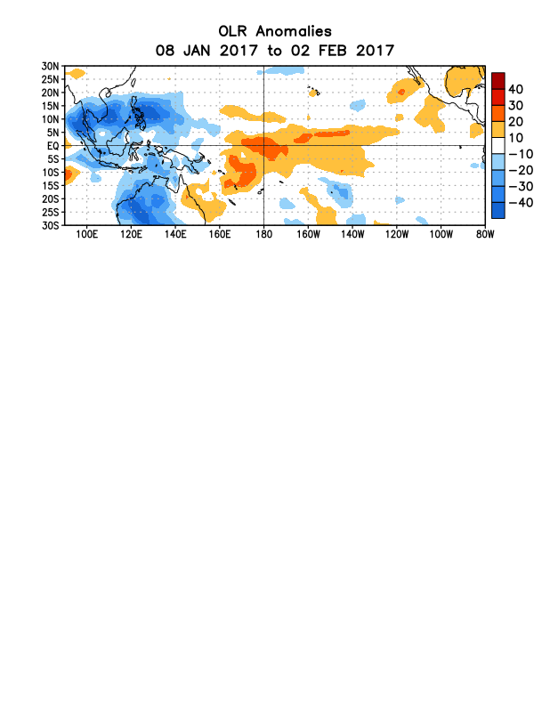
Figure 5. Average outgoing longwave radiation (OLR) anomalies (W/m²) for the period 8 January – 2 February 2017. OLR anomalies are computed as departures from the 1981-2010 base period pentad means.

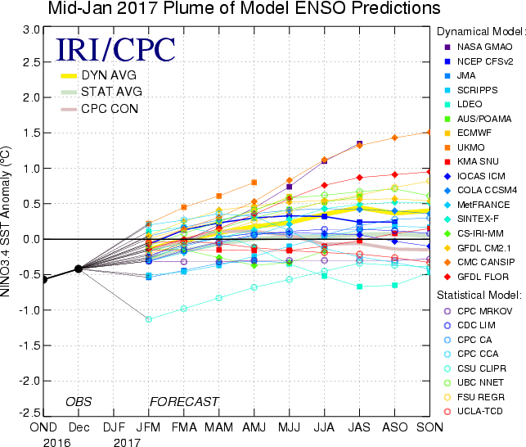

Figure 6. Forecasts of sea surface temperature (SST) anomalies for the Niño 3.4 region (5°N-5°S, 120°W-170°W). Figure updated 18 January 2017.

