EL NIÑO/SOUTHERN OSCILLATION (ENSO) DIAGNOSTIC DISCUSSION

issued by

CLIMATE PREDICTION CENTER/NCEP/NWS
and the International Research Institute for Climate and Society
8 February 2018

ENSO Alert System Status: La Niña Advisory

Synopsis: A transition from La Niña to ENSO-neutral is most likely during the Northern Hemisphere spring (~55% chance of ENSO-neutral during the March-May season).
During January 2018, La Niña was evident in the pattern of below-average sea surface temperatures (SSTs) across the central and eastern equatorial Pacific Ocean (Fig. 1). The latest weekly index values were close to -1.0°C in the Niño-1+2, Niño-3, and Niño-3.4 regions, while the western-most Niño-4 region was -0.5°C (Fig. 2). While negative anomalies were maintained near the surface, the sub-surface temperatures in the eastern Pacific Ocean returned to near average during the last month (Fig. 3). This was due to the eastward propagation of above-average temperatures in association with a downwelling equatorial oceanic Kelvin wave, which undercut the below-average temperatures near the surface (Fig. 4). The atmospheric conditions over the tropical Pacific Ocean also reflected La Niña, with suppressed convection near and east of the International Date Line and enhanced convection around Indonesia (Fig. 5). Also, the low-level trade winds remained stronger than average over the western and central Pacific, while upper-level winds were anomalously westerly. Overall, the ocean and atmosphere system remained consistent with La Niña.
Most models in the IRI/CPC plume predict La Niña will decay and return to ENSO-Neutral during the Northern Hemisphere spring 2018 (Fig. 6). The forecast consensus also favors a transition during the spring with a continuation of ENSO-neutral conditions thereafter. In summary, a transition from La Niña to ENSO-neutral is most likely during the Northern Hemisphere spring (~55% chance of ENSO-neutral during the March-May season) (click CPC/IRI consensus forecast for the chance of each outcome for each 3-month period).
La Niña is anticipated to continue affecting temperature and precipitation across the United States during the next few months (the 3-month seasonal temperature and precipitation outlooks will be updated on Thursday February 15th). The outlooks generally favor above-average temperatures and below-median precipitation across the southern tier of the United States, and below-average temperatures and above-median precipitation across the northern tier of the United States.
This discussion is a consolidated effort of the National Oceanic and Atmospheric Administration (NOAA), NOAA’s National Weather Service, and their funded institutions. Oceanic and atmospheric conditions are updated weekly on the Climate Prediction Center web site (El Niño/La Niña Current Conditions and Expert Discussions). Forecasts are also updated monthly in the Forecast Forum of CPC's Climate Diagnostics Bulletin. Additional perspectives and analysis are also available in an ENSO blog. The next ENSO Diagnostics Discussion is scheduled for 8 March 2018. To receive an e-mail notification when the monthly ENSO Diagnostic Discussions are released, please send an e-mail message to: ncep.list.enso-update@noaa.gov.

Climate Prediction Center
National Centers for Environmental Prediction
NOAA/National Weather Service
College Park, MD 20740

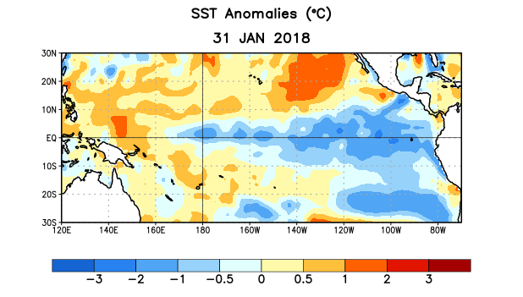
Figure 1. Average sea surface temperature (SST) anomalies (°C) for the week centered on 31 January 2018. Anomalies are computed with respect to the 1981-2010 base period weekly means.

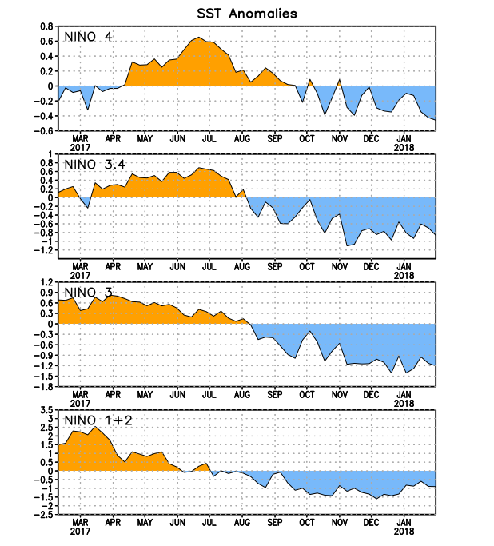
Figure 2. Time series of area-averaged sea surface temperature (SST) anomalies (°C) in the Niño regions [Niño-1+2 (0°-10°S, 90°W-80°W), Niño-3 (5°N-5°S, 150°W-90°W), Niño-3.4 (5°N-5°S, 170°W-120°W), Niño-4 (5ºN-5ºS , 150ºW-160ºE]. SST anomalies are departures from the 1981-2010 base period weekly means.
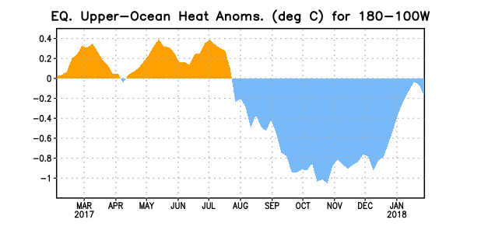
Figure 3. Area-averaged upper-ocean heat content anomaly (°C) in the equatorial Pacific (5°N-5°S, 180º-100ºW). The heat content anomaly is computed as the departure from the 1981-2010 base period pentad means.

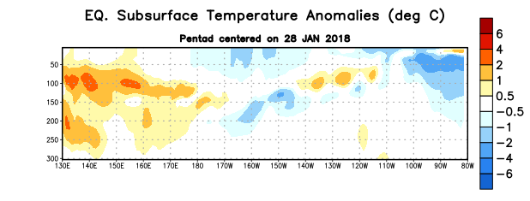
Figure 4. Depth-longitude section of equatorial Pacific upper-ocean (0-300m) temperature anomalies (°C) centered on the pentad of 28 January 2018. Anomalies are departures from the 1981-2010 base period pentad means.

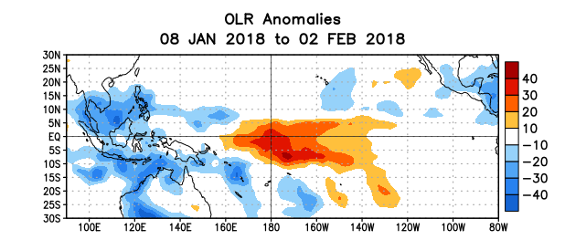
Figure 5. Average outgoing longwave radiation (OLR) anomalies (W/m²) for the period 8 January – 2 February 2018. OLR anomalies are computed as departures from the 1981-2010 base period pentad means.

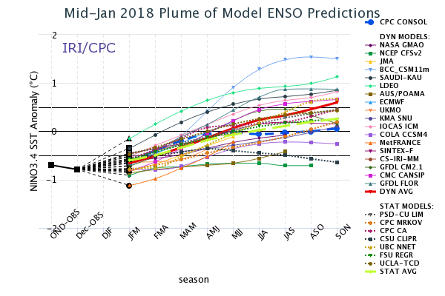

Figure 6. Forecasts of sea surface temperature (SST) anomalies for the Niño 3.4 region (5°N-5°S, 120°W-170°W). Figure updated 18 January 2018.

