EL NIÑO/SOUTHERN OSCILLATION (ENSO) DIAGNOSTIC DISCUSSION

issued by

CLIMATE PREDICTION CENTER/NCEP/NWS

and the International Research Institute for Climate and Society

14 February 2019

ENSO Alert System Status: El Niño Advisory

Synopsis: Weak El Niño conditions are present and are expected to continue through the Northern Hemisphere spring 2019 (~55% chance).

El Niño conditions formed during January 2019, based on the presence of above-average sea surface temperatures (SSTs) across most of the equatorial Pacific Ocean (Fig. 1) and corresponding changes in the overlying atmospheric circulation. The weekly Niño indices remained above average during the month, although decreasing in the Niño-3 and Niño-3.4 regions (Fig. 2). However, the Niño-4 region remained elevated, with a value of +0.8°C in early February. Positive subsurface temperature anomalies (averaged across 180°-100°W) increased in the last couple weeks (Fig. 3), in association with a downwelling Kelvin wave that contributed to above-average temperatures in the central Pacific (Fig. 4). Compared to last month, the region of enhanced equatorial convection expanded near the Date Line, while anomalies remained weak over Indonesia (Fig. 5). Low-level wind anomalies became westerly across the western Pacific Ocean, while upper-level wind anomalies were mostly westerly over the eastern Pacific. The equatorial Southern Oscillation index was negative (-0.6 standard deviations). Overall, these features are consistent with borderline, weak El Niño conditions.
The majority of models in the IRI/CPC plume predict a Niño 3.4 index of +0.5°C or greater through at least the Northern Hemisphere spring 2019 (Fig. 6). Given the recent downwelling Kelvin wave and the forecast of westerly wind anomalies, most forecasters expect SST anomalies in the east-central Pacific to increase slightly in the upcoming month or so. Because forecasts through the spring tend to be more uncertain and/or less accurate, the predicted chance that El Niño will persist beyond the spring is 50% or less. In summary, weak El Niño conditions are present and are expected to continue through the Northern Hemisphere spring 2019 (~55% chance; click CPC/IRI consensus forecast for the chance of each outcome for each 3-month period).
Due to the expected weak strength, widespread or significant global impacts are not anticipated. However, the impacts often associated with El Niño may occur in some locations during the next few months (the 3-month seasonal outlook will be updated on Thursday February 21st).
This discussion is a consolidated effort of the National Oceanic and Atmospheric Administration (NOAA), NOAA’s National Weather Service, and their funded institutions. Oceanic and atmospheric conditions are updated weekly on the Climate Prediction Center web site (El Niño/La Niña Current Conditions and Expert Discussions). Forecasts are also updated monthly in the Forecast Forum of CPC's Climate Diagnostics Bulletin. Additional perspectives and analysis are also available in an ENSO blog. The next ENSO Diagnostics Discussion is scheduled for 14 March 2019. To receive an e-mail notification when the monthly ENSO Diagnostic Discussions are released, please send an e-mail message to: ncep.list.enso-update@noaa.gov.

Climate Prediction Center
National Centers for Environmental Prediction
NOAA/National Weather Service
College Park, MD 20740

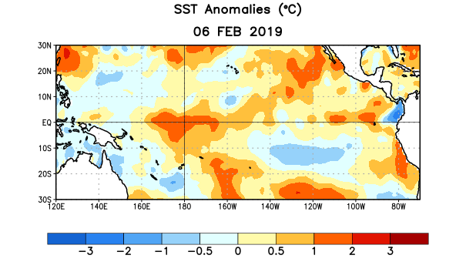
Figure 1. Average sea surface temperature (SST) anomalies (°C) for the week centered on 6 February 2019. Anomalies are computed with respect to the 1981-2010 base period weekly means.

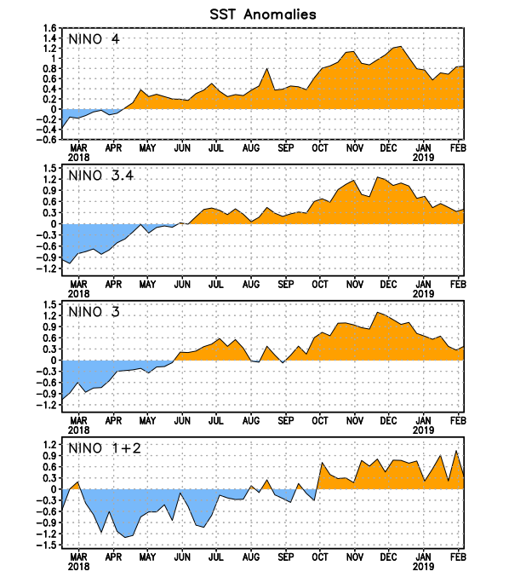
Figure 2. Time series of area-averaged sea surface temperature (SST) anomalies (°C) in the Niño regions [Niño-1+2 (0°-10°S, 90°W-80°W), Niño-3 (5°N-5°S, 150°W-90°W), Niño-3.4 (5°N-5°S, 170°W-120°W), Niño-4 (5ºN-5ºS , 150ºW-160ºE)]. SST anomalies are departures from the 1981-2010 base period weekly means.
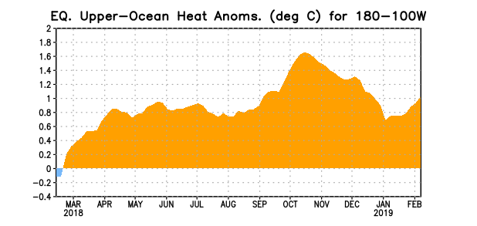
Figure 3. Area-averaged upper-ocean heat content anomaly (°C) in the equatorial Pacific (5°N-5°S, 180º-100ºW). The heat content anomaly is computed as the departure from the 1981-2010 base period pentad means.

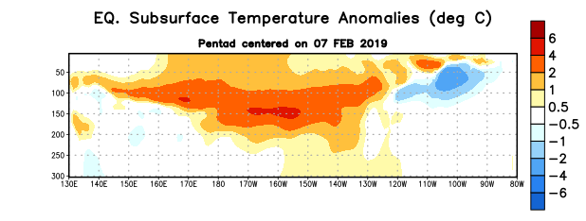
Figure 4. Depth-longitude section of equatorial Pacific upper-ocean (0-300m) temperature anomalies (°C) centered on the pentad of 7 February 2019. Anomalies are departures from the 1981-2010 base period pentad means.

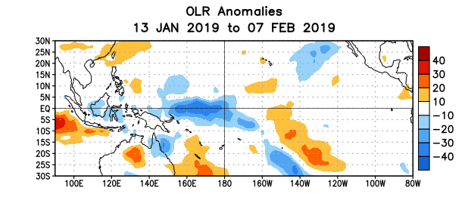
Figure 5. Average outgoing longwave radiation (OLR) anomalies (W/m²) for the period 13 January – 7 February 2019. OLR anomalies are computed as departures from the 1981-2010 base period pentad means.

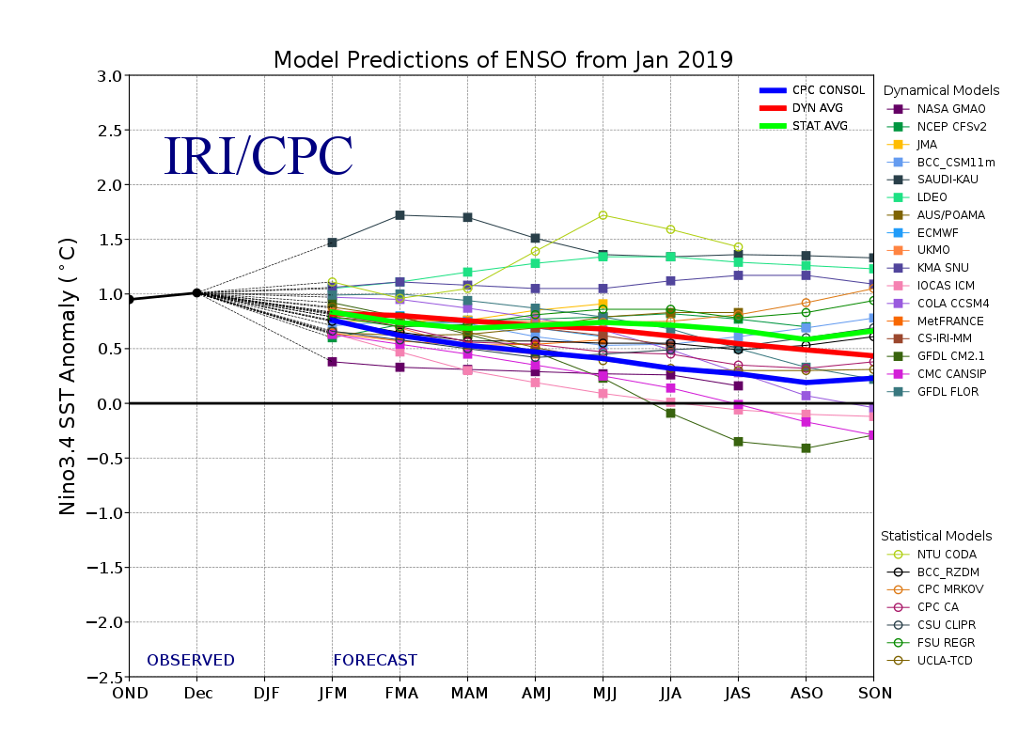
Figure 6. Forecasts of sea surface temperature (SST) anomalies for the Niño 3.4 region (5°N-5°S, 120°W-170°W). Figure updated 19 January 2019.

