EL NIÑO/SOUTHERN OSCILLATION (ENSO) DIAGNOSTIC DISCUSSION

issued by

CLIMATE PREDICTION CENTER/NCEP/NWS

and the International Research Institute for Climate and Society

13 February 2020

ENSO Alert System Status: Not Active

Synopsis: ENSO-neutral is favored through Northern Hemisphere spring 2020 (~60% chance), continuing through summer 2020 (~50% chance).

During January 2020, near- to above-average sea surface temperatures (SSTs) were evident across most of the equatorial Pacific Ocean (Fig. 1). The latest weekly Niño-3.4 and Niño-3 indices were near average (+0.2°C to 0.0°C), while the Niño-4 and Niño-1+2 indices were warmer at +1.2°C and +0.8°C, respectively (Fig. 2). After decreasing in early to mid January, positive equatorial subsurface temperature anomalies (averaged across 180°-100°W) slightly increased during the latter part of the month (Fig. 3). Temperatures remained above average across most of the subsurface ocean, reaching ~150m depth in the central Pacific (Fig. 4). During the month, westerly wind anomalies persisted over the western equatorial Pacific Ocean, while upper-level winds were mostly westerly over the east-central and eastern equatorial Pacific. Tropical convection remained suppressed over Indonesia and was enhanced around the Date Line (Fig. 5). The traditional and equatorial Southern Oscillation indices were near zero. Overall, the combined oceanic and atmospheric system remained consistent with ENSO-neutral.
The majority of models in the IRI/CPC plume (Fig. 6) continue to mostly favor ENSO-neutral (Niño-3.4 index between -0.5°C and +0.5°C) through the Northern Hemisphere summer. The forecaster consensus predicts the Niño-3.4 index will be at or slightly above +0.5°C for the January – March 2020 season, but then slightly favors ENSO-neutral for the February – April 2020 season. While it is expected that oceanic temperatures will remain elevated in the near term, particularly in the western and central equatorial Pacific Ocean, most models predict a gradual decrease in Niño-3.4 SST anomalies into the spring and summer. In summary, ENSO-neutral is favored through Northern Hemisphere spring 2020 (~60% chance), continuing through summer 2020 (~50% chance; click CPC/IRI consensus forecast for the chance of each outcome for each 3-month period).
This discussion is a consolidated effort of the National Oceanic and Atmospheric Administration (NOAA), NOAA’s National Weather Service, and their funded institutions. Oceanic and atmospheric conditions are updated weekly on the Climate Prediction Center web site (El Niño/La Niña Current Conditions and Expert Discussions). Forecasts are also updated monthly in the Forecast Forum of CPC's Climate Diagnostics Bulletin. Additional perspectives and analysis are also available in an ENSO blog. The next ENSO Diagnostics Discussion is scheduled for 12 March 2020. To receive an e-mail notification when the monthly ENSO Diagnostic Discussions are released, please send an e-mail message to: ncep.list.enso-update@noaa.gov.

Climate Prediction Center
National Centers for Environmental Prediction
NOAA/National Weather Service
College Park, MD 20740

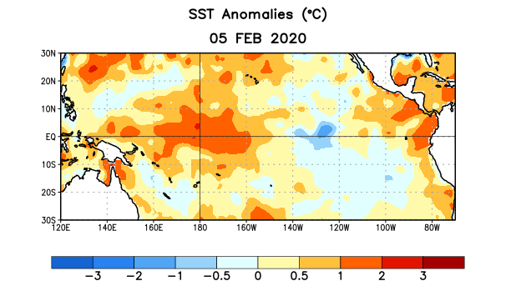
Figure 1. Average sea surface temperature (SST) anomalies (°C) for the week centered on 5 February 2020. Anomalies are computed with respect to the 1981-2010 base period weekly means.

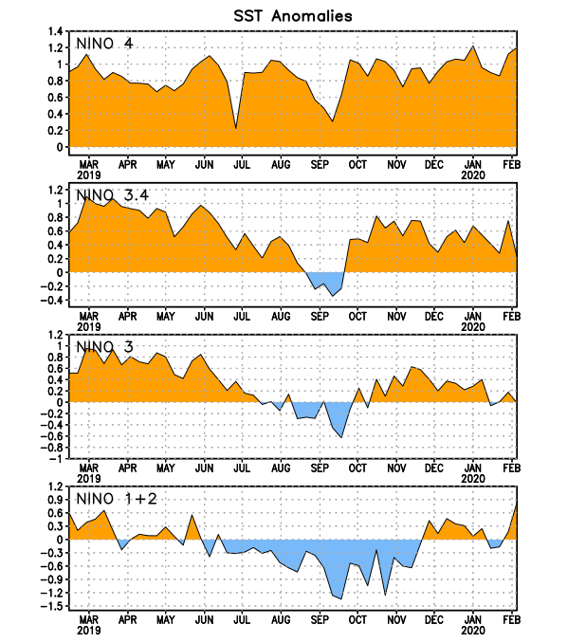
Figure 2. Time series of area-averaged sea surface temperature (SST) anomalies (°C) in the Niño regions [Niño-1+2 (0°-10°S, 90°W-80°W), Niño-3 (5°N-5°S, 150°W-90°W), Niño-3.4 (5°N-5°S, 170°W-120°W), Niño-4 (5ºN-5ºS , 150ºW-160ºE)]. SST anomalies are departures from the 1981-2010 base period weekly means.
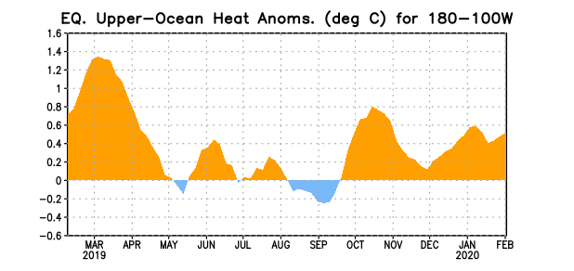
Figure 3. Area-averaged upper-ocean heat content anomaly (°C) in the equatorial Pacific (5°N-5°S, 180º-100ºW). The heat content anomaly is computed as the departure from the 1981-2010 base period pentad means.

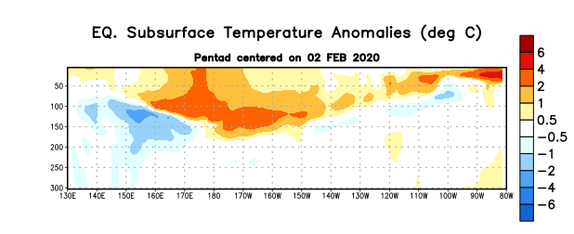
Figure 4. Depth-longitude section of equatorial Pacific upper-ocean (0-300m) temperature anomalies (°C) centered on the pentad of 2 February 2020. Anomalies are departures from the 1981-2010 base period pentad means.

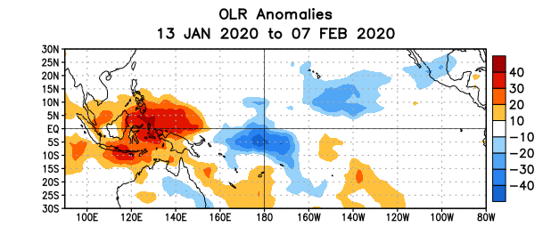
Figure 5. Average outgoing longwave radiation (OLR) anomalies (W/m²) for the period 13 January – 7 February 2020. OLR anomalies are computed as departures from the 1981-2010 base period pentad means.

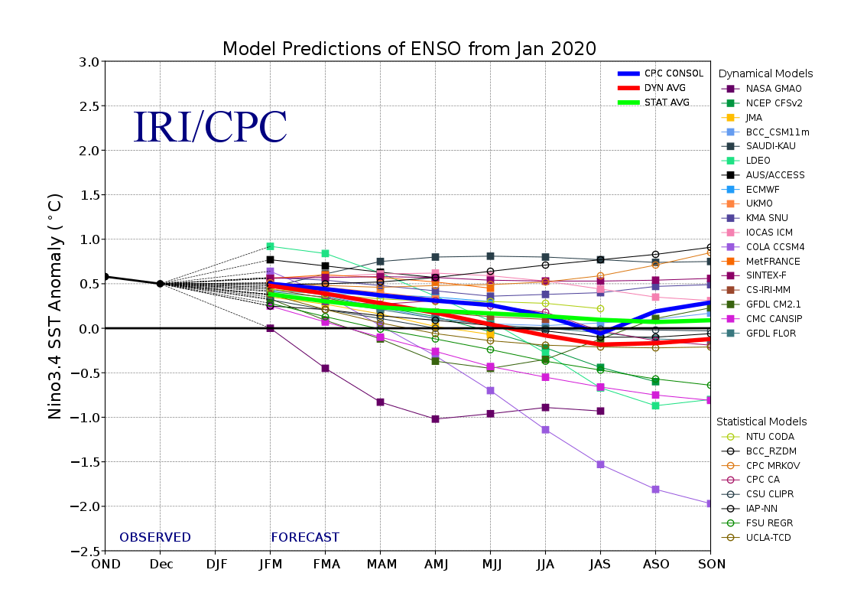
Figure 6. Forecasts of sea surface temperature (SST) anomalies for the Niño 3.4 region (5°N-5°S, 120°W-170°W). Figure updated 19 January 2020.

