EL NIÑO/SOUTHERN OSCILLATION (ENSO) DIAGNOSTIC DISCUSSION

issued by

CLIMATE PREDICTION CENTER/NCEP/NWS

and the International Research Institute for Climate and Society

11 February 2021

ENSO Alert System Status: La Niña Advisory

Synopsis: There is a ~60% chance of a transition from La Niña to ENSO-Neutral during the Northern Hemisphere spring 2021 (April-June).

La Niña persisted in January, reflected by below-average sea surface temperatures (SST) anomalies extending from the western to east-central Pacific Ocean (Fig. 1). SSTs returned to near average in the eastern Pacific Ocean by the end of the month, as indicated by the latest weekly Niño-3 and Niño-1+2 index values of -0.3ºC and -0.2ºC, respectively (Fig. 2). However, the latest weekly Niño index values in the central (Niño-4) and east-central (Niño-3.4) Pacific Ocean were -1.1ºC and -0.7ºC. The below-average SSTs were supported by negative subsurface temperature anomalies (Fig. 3), which extended from the surface to at least ~150m below the surface between 160°E and 130°W (Fig. 4). Low-level wind anomalies remained easterly from the western to east-central (~140°W) tropical Pacific, with the largest amplitude near the Date Line. Upper-level wind anomalies were westerly across most of the tropical Pacific. Tropical convection continued to be suppressed over the western and central Pacific and enhanced around the Philippines and Indonesia (Fig. 5), while both the Southern Oscillation and Equatorial Southern Oscillation remained positive. Overall, the coupled ocean-atmosphere system remains consistent with La Niña.
Most of the models in the IRI/CPC plume predict a transition to ENSO-neutral during the Northern Hemisphere spring 2021 (Fig. 6). The forecaster consensus is in agreement with this transition and then predicts a continuation of ENSO-neutral at least through the Northern Hemisphere summer. In part, due to the inherent uncertainty in predictions made at this time of year, the forecast for the fall remains split (~50%) between La Niña and the combination of the other two possibilities (El Niño and Neutral). In summary, there is a ~60% chance of a transition from La Niña to ENSO-Neutral during the Northern Hemisphere spring 2021 (April-June; click CPC/IRI consensus forecast for the chances in each 3-month period).
La Niña is anticipated to affect climate across the United States during the upcoming months. The 3-month seasonal temperature and precipitation outlooks will be updated on Thursday February 18th.
This discussion is a consolidated effort of the National Oceanic and Atmospheric Administration (NOAA), NOAA’s National Weather Service, and their funded institutions. Oceanic and atmospheric conditions are updated weekly on the Climate Prediction Center web site (El Niño/La Niña Current Conditions and Expert Discussions). Additional perspectives and analysis are also available in an ENSO blog. A probabilistic strength forecast is available here. The next ENSO Diagnostics Discussion is scheduled for 11 March 2021. To receive an e-mail notification when the monthly ENSO Diagnostic Discussions are released, please send an e-mail message to: ncep.list.enso-update@noaa.gov.

Climate Prediction Center
National Centers for Environmental Prediction
NOAA/National Weather Service
College Park, MD 20740

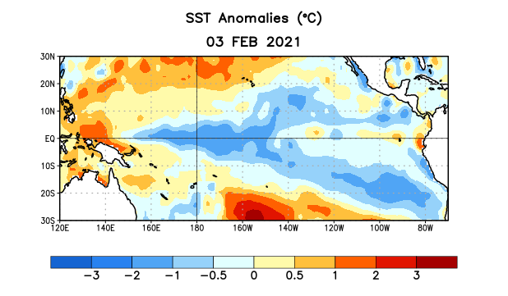
Figure 1. Average sea surface temperature (SST) anomalies (°C) for the week centered on 3 February 2021. Anomalies are computed with respect to the 1991-2020 base period weekly means.

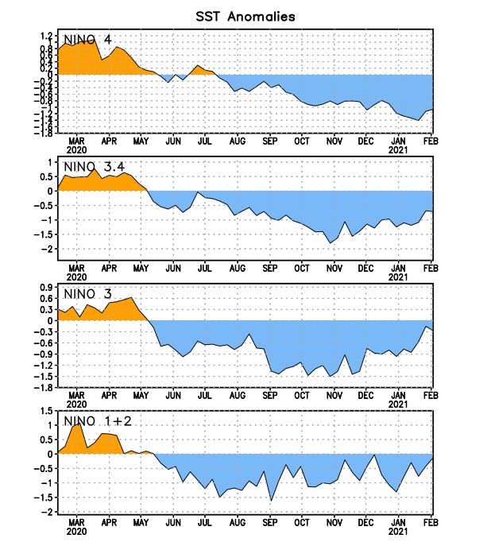
Figure 2. Time series of area-averaged sea surface temperature (SST) anomalies (°C) in the Niño regions [Niño-1+2 (0°-10°S, 90°W-80°W), Niño-3 (5°N-5°S, 150°W-90°W), Niño-3.4 (5°N-5°S, 170°W-120°W), Niño-4 (5ºN-5ºS , 150ºW-160ºE)]. SST anomalies are departures from the 1991-2020 base period weekly means.
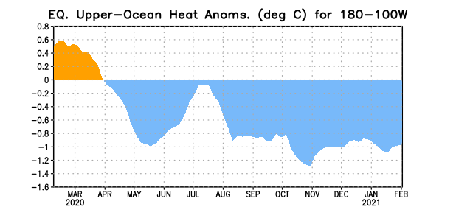
Figure 3. Area-averaged upper-ocean heat content anomaly (°C) in the equatorial Pacific (5°N-5°S, 180º-100ºW). The heat content anomaly is computed as the departure from the 1981-2010 base period pentad means.

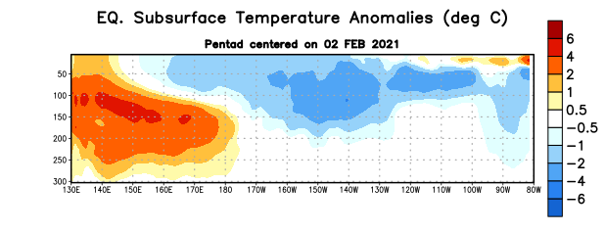
Figure 4. Depth-longitude section of equatorial Pacific upper-ocean (0-300m) temperature anomalies (°C) centered on the pentad of 2 February 2021. Anomalies are departures from the 1981-2010 base period pentad means.

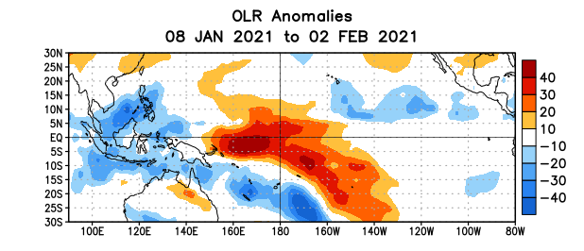
Figure 5. Average outgoing longwave radiation (OLR) anomalies (W/m²) for the period 8 January – 2 February 2021. OLR anomalies are computed as departures from the 1981-2010 base period pentad means.

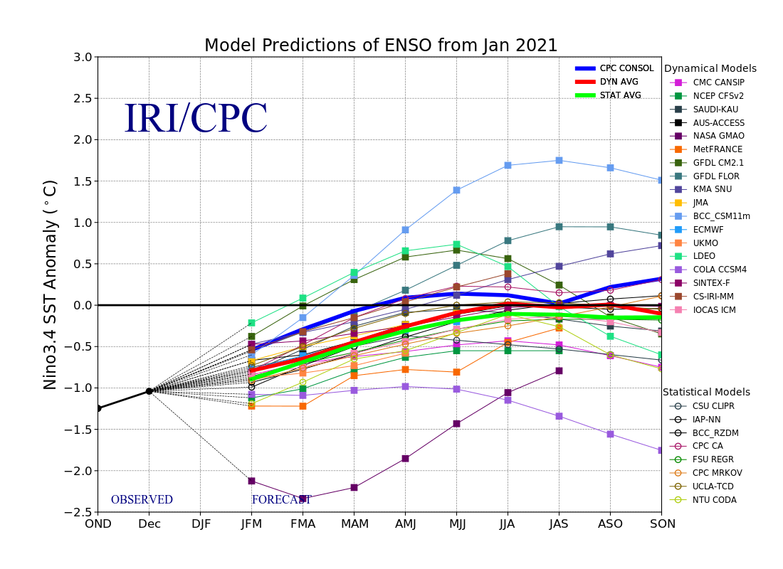
Figure 6. Forecasts of sea surface temperature (SST) anomalies for the Niño 3.4 region (5°N-5°S, 120°W-170°W). Figure updated 19 January 2021.

