EL NIÑO/SOUTHERN OSCILLATION (ENSO) DIAGNOSTIC DISCUSSION

issued by

CLIMATE PREDICTION CENTER/NCEP/NWS

and the International Research Institute for Climate and Society

10 February 2022

ENSO Alert System Status: La Niña Advisory

Synopsis: La Niña is likely to continue into the Northern Hemisphere spring (77% chance during March-May 2022) and then transition to ENSO-neutral (56% chance during May-July 2022).

Below-average sea surface temperatures (SSTs) weakened during January 2022, though anomalies stayed negative across most of the east-central and eastern equatorial Pacific Ocean (Fig. 1). Most of the weekly ENSO indices remained between -0.5ºC and -1.0ºC in the last week, except for the Niño-4 index, which was -0.2ºC (Fig. 2). In contrast, subsurface temperatures (averaged between 180º-100ºW and 0-300m depth) trended to near average during the month (Fig. 3). This large change in recent weeks reflected the eastward progression of a downwelling Kelvin wave, as indicated by the extension of above-average subsurface temperatures across much of the Pacific (Fig. 4). Below-average subsurface temperatures were confined to the eastern Pacific Ocean at the end of the month. For the monthly mean, low-level equatorial winds were near average across much of the Pacific, while upper-level westerly wind anomalies remained over the east-central Pacific Ocean. Below-average convection strengthened near and west of the Date Line, while convection was near average over Indonesia (Fig. 5). Overall, the coupled ocean-atmosphere system reflected a weakening La Niña.
The IRI/CPC plume average for the Niño-3.4 SST index continues to forecast a transition to ENSO-neutral during the Northern Hemisphere spring (Fig. 6). Because the easterly trade winds have recently been strengthening and are predicted to continue in the near term, the forecaster consensus favors those models suggesting a slower decay of La Niña through the spring. However, ENSO-neutral is still anticipated to return by the Northern Hemisphere summer, although the chance does not exceed 57% during June-August 2022, reflecting the uncertainty associated with the spring predictability barrier. In summary, La Niña is likely to continue into the Northern Hemisphere spring (77% chance during March-May 2022) and then transition to ENSO-neutral (56% chance during May-July; click CPC/IRI consensus forecast for the chances in each 3-month period).
La Niña is anticipated to affect temperature and precipitation across the United States during the upcoming months (the 3-month seasonal temperature and precipitation outlooks will be updated on Thurs. Feb. 17th).
This discussion is a consolidated effort of the National Oceanic and Atmospheric Administration (NOAA), NOAA’s National Weather Service, and their funded institutions. Oceanic and atmospheric conditions are updated weekly on the Climate Prediction Center web site (El Niño/La Niña Current Conditions and Expert Discussions). Additional perspectives and analysis are also available in an ENSO blog. A probabilistic strength forecast is available here. The next ENSO Diagnostics Discussion is scheduled for 10 March 2022. To receive an e-mail notification when the monthly ENSO Diagnostic Discussions are released, please send an e-mail message to: ncep.list.enso-update@noaa.gov.

Climate Prediction Center
National Centers for Environmental Prediction
NOAA/National Weather Service
College Park, MD 20740

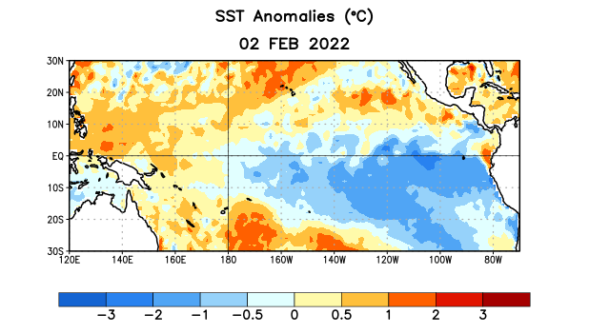
Figure 1. Average sea surface temperature (SST) anomalies (°C) for the week centered on 2 February 2022. Anomalies are computed with respect to the 1991-2020 base period weekly means.

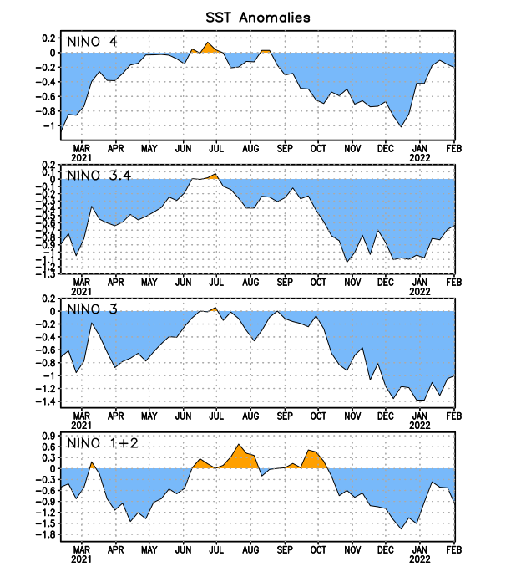
Figure 2. Time series of area-averaged sea surface temperature (SST) anomalies (°C) in the Niño regions [Niño-1+2 (0°-10°S, 90°W-80°W), Niño-3 (5°N-5°S, 150°W-90°W), Niño-3.4 (5°N-5°S, 170°W-120°W), Niño-4 (5ºN-5ºS, 150ºW-160ºE)]. SST anomalies are departures from the 1991-2020 base period weekly means.
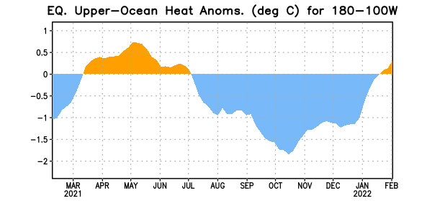
Figure 3. Area-averaged upper-ocean heat content anomaly (°C) in the equatorial Pacific (5°N-5°S, 180º-100ºW). The heat content anomaly is computed as the departure from the 1991-2020 base period pentad means.

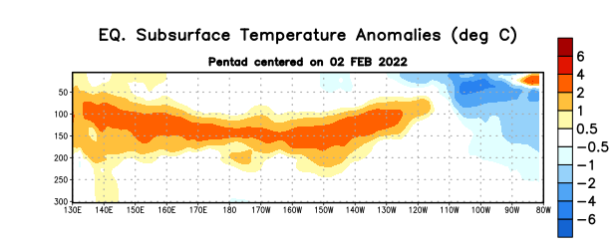

Figure 4. Depth-longitude section of equatorial Pacific upper-ocean (0-300m) temperature anomalies (°C) centered on the pentad of 2 February 2022. Anomalies are departures from the 1991-2020 base period pentad means.

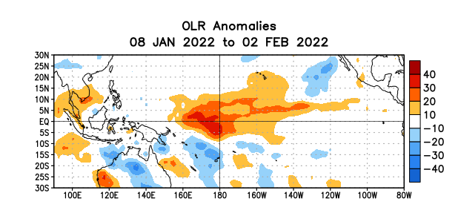

Figure 5. Average outgoing longwave radiation (OLR) anomalies (W/m²) for the period 8 January – 2 February 2022. OLR anomalies are computed as departures from the 1991-2020 base period pentad means.

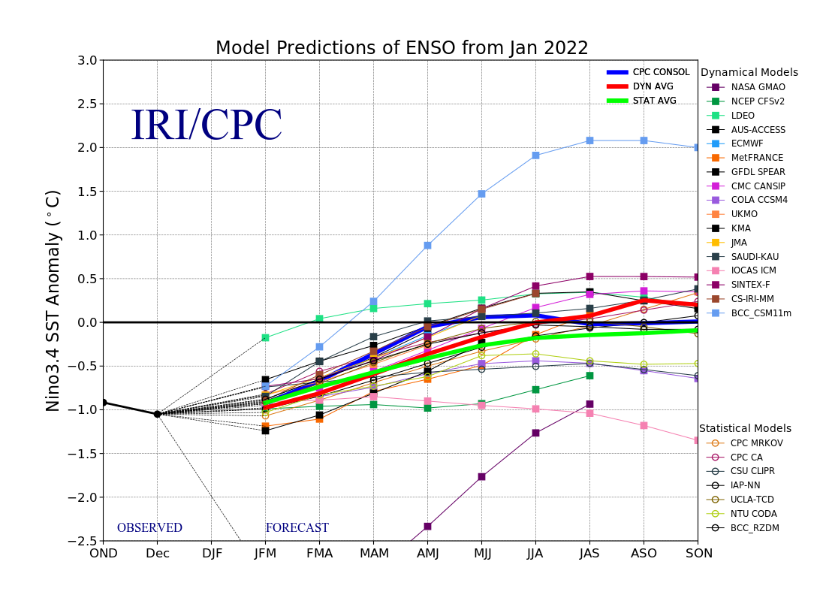
Figure 6. Forecasts of sea surface temperature (SST) anomalies for the Niño 3.4 region (5°N-5°S, 120°W-170°W). Figure updated 19 January 2022.

