EL NIÑO/SOUTHERN OSCILLATION (ENSO) DIAGNOSTIC DISCUSSION

issued by

CLIMATE PREDICTION CENTER/NCEP/NWS

9 February 2023

ENSO Alert System Status: La Niña Advisory

Synopsis: ENSO-neutral conditions are expected to begin within the next couple of months, and persist through the Northern Hemisphere spring and early summer.

Although a weak La Niña was still apparent during January, below-average sea surface temperatures (SSTs) continued to weaken further across the equatorial Pacific Ocean (Fig. 1). The latest weekly Niño index values were mostly near -0.5ºC, with the exception of Niño-1+2 which was +0.1ºC (Fig. 2). Like the surface, negative subsurface temperature anomalies continued to weaken (Fig. 3), with above-average subsurface temperatures expanding eastward at depth and near the surface of the eastern Pacific Ocean (Fig. 4). Low-level easterly wind anomalies continued, but were confined to the western and central Pacific Ocean. Upper-level westerly wind anomalies were evident over the east-central Pacific. Suppressed convection persisted over the western and central tropical Pacific, while enhanced convection was observed over western Indonesia (Fig. 5). Overall, the coupled ocean-atmosphere system continued to reflect La Niña.
The most recent IRI plume predicts a transition from La Niña to ENSO-neutral in the next couple of months (Fig. 6). The forecaster consensus is largely in agreement. ENSO-neutral is expected to prevail during the spring and early summer. There are increasing chances of El Niño at longer forecast horizons, though uncertainty remains high because of the spring prediction barrier, which typically is associated with lower forecast accuracy. In summary, ENSO-neutral conditions are expected to begin within the next couple of months, and persist through the Northern Hemisphere spring and early summer (Fig. 7).
This discussion is a consolidated effort of the National Oceanic and Atmospheric Administration (NOAA), NOAA’s National Weather Service, and their funded institutions. Oceanic and atmospheric conditions are updated weekly on the Climate Prediction Center website (El Niño/La Niña Current Conditions and Expert Discussions). Additional perspectives and analyses are also available in an ENSO blog. A probabilistic strength forecast is available here. The next ENSO Diagnostics Discussion is scheduled for 9 March 2023. To receive an e-mail notification when the monthly ENSO Diagnostic Discussions are released, please send an e-mail message to: ncep.list.enso-update@noaa.gov.

Climate Prediction Center
National Centers for Environmental Prediction
NOAA/National Weather Service
College Park, MD 20740
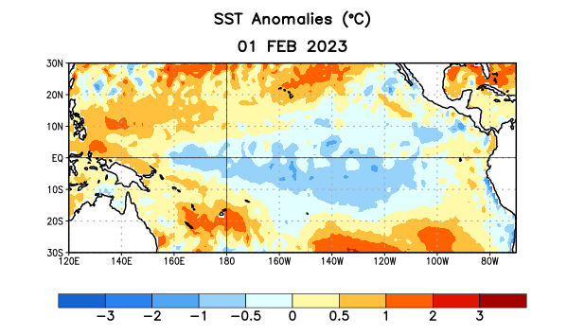
Figure 1. Average sea surface temperature (SST) anomalies (°C) for the week centered on 1 February 2023. Anomalies are computed with respect to the 1991-2020 base period weekly means.

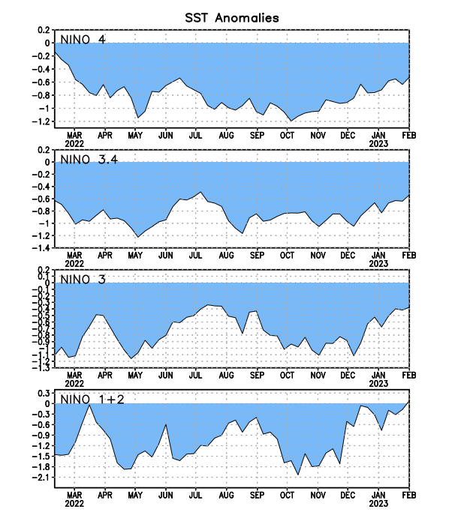
Figure 2. Time series of area-averaged sea surface temperature (SST) anomalies (°C) in the Niño regions [Niño-1+2 (0°-10°S, 90°W-80°W), Niño-3 (5°N-5°S, 150°W-90°W), Niño-3.4 (5°N-5°S, 170°W-120°W), Niño-4 (5ºN-5ºS, 150ºW-160ºE)]. SST anomalies are departures from the 1991-2020 base period weekly means.

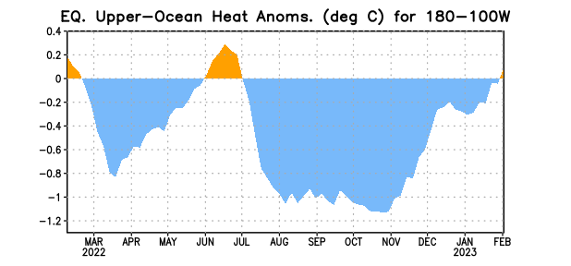

Figure 3. Area-averaged upper-ocean heat content anomaly (°C) in the equatorial Pacific (5°N-5°S, 180º-100ºW). The heat content anomaly is computed as the departure from the 1991-2020 base period pentad means.

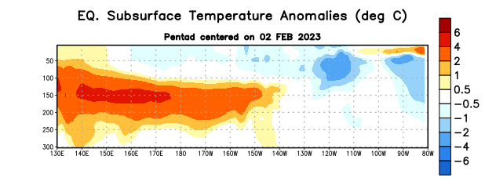
Figure 4. Depth-longitude section of equatorial Pacific upper-ocean (0-300m) temperature anomalies (°C) centered on the pentad of 2 February 2023. Anomalies are departures from the 1991-2020 base period pentad means.

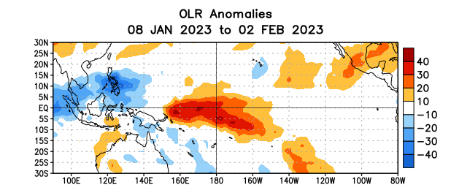

Figure 5. Average outgoing longwave radiation (OLR) anomalies (W/m²) for the period 8 January – 2 February 2023. OLR anomalies are computed as departures from the 1991-2020 base period pentad means.

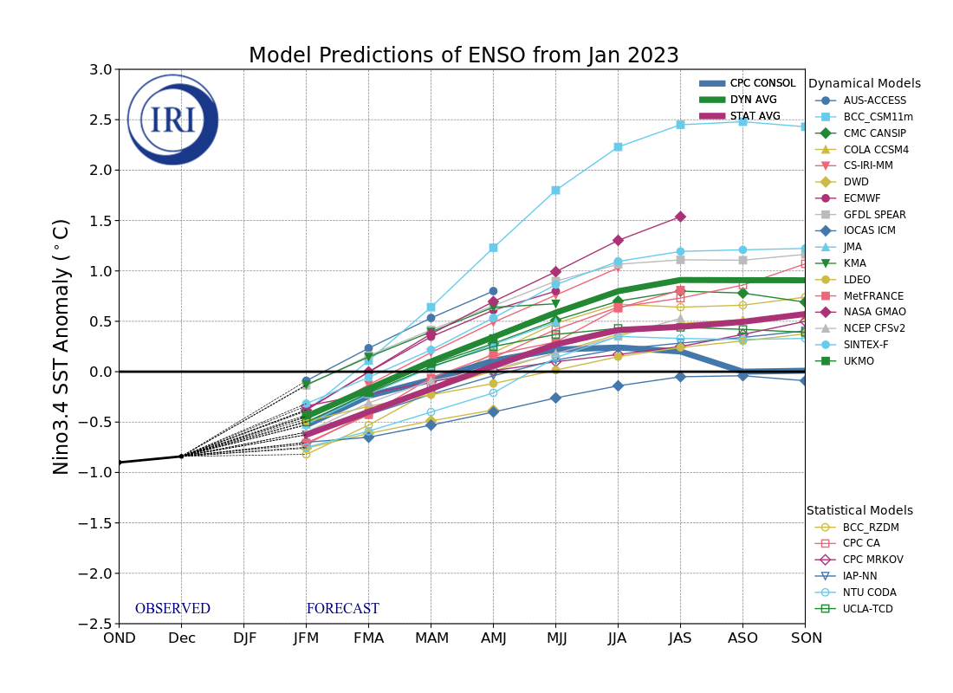
Figure 6. Forecasts of sea surface temperature (SST) anomalies for the Niño 3.4 region (5°N-5°S, 120°W-170°W). Figure updated 19 January 2023 by the International Research Institute (IRI) for Climate and Society.
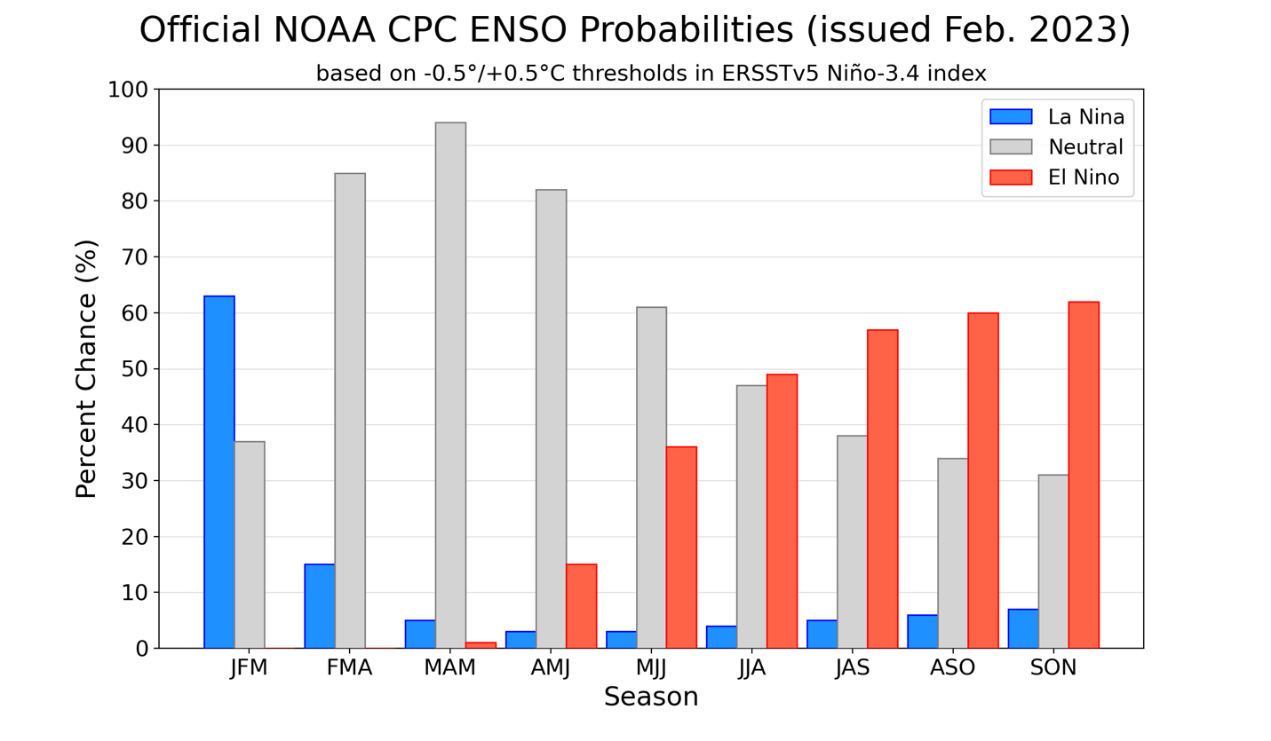
Figure 7. Official ENSO probabilities for the Niño 3.4 sea surface temperature index (5°N-5°S,
120°W-170°W). Figure updated 9 February 2023.

