EL NIÑO/SOUTHERN OSCILLATION (ENSO) DIAGNOSTIC DISCUSSION

issued by

CLIMATE PREDICTION CENTER/NCEP/NWS

8 February 2024

ENSO Alert System Status: El Niño Advisory / La Niña Watch

Synopsis: A transition from El Niño to ENSO-neutral is likely by April-June 2024 (79% chance), with increasing odds of La Niña developing in June-August 2024 (55% chance).

During January 2024, above-average sea surface temperatures (SST) continued across most of the equatorial Pacific Ocean (Fig. 1). SST anomalies weakened slightly in the eastern and east-central Pacific, as indicated by the weekly Niño index values (Fig. 2). However, changes were more pronounced below the surface of the equatorial Pacific Ocean, with area-averaged subsurface temperature anomalies returning to near zero (Fig. 3). Although above-average temperatures persisted in the upper 100 meters of the equatorial Pacific, below-average temperatures were widespread at greater depths (Fig. 4). Atmospheric anomalies across the tropical Pacific also weakened during January. Low-level winds were near average over the equatorial Pacific, while upper-level wind anomalies were easterly over the east-central Pacific. Convection remained slightly enhanced near the Date Line and was close to average around Indonesia (Fig. 5). Collectively, the coupled ocean-atmosphere system reflected a weakening El Niño.
The most recent IRI plume indicates a transition to ENSO-neutral during spring 2024, with La Niña potentially developing during summer 2024 (Fig. 6). Even though forecasts made through the spring season tend to be less reliable, there is a historical tendency for La Niña to follow strong El Niño events. The forecast team is in agreement with the latest model guidance, with some uncertainty around the timing of transitions to ENSO-neutral and, following that, La Niña. Even as the current El Niño weakens, impacts on the United States could persist through April 2024 (see CPC seasonal outlooks for probabilities of temperature and precipitation). In summary, a transition from El Niño to ENSO-neutral is likely by April-June 2024 (79% chance), with increasing odds of La Niña developing in June-August 2024 (55% chance; Fig. 7).
This discussion is a consolidated effort of the National Oceanic and Atmospheric Administration (NOAA), NOAA’s National Weather Service, and their funded institutions. Oceanic and atmospheric conditions are updated weekly on the Climate Prediction Center website (El Niño/La Niña Current Conditions and Expert Discussions). Additional perspectives and analyses are also available in an ENSO blog. A probabilistic strength forecast is available here. The next ENSO Diagnostics Discussion is scheduled for 14 March 2024. To receive an e-mail notification when the monthly ENSO Diagnostic Discussions are released, please send an e-mail message to: ncep.list.enso-update@noaa.gov.

Climate Prediction Center
National Centers for Environmental Prediction
NOAA/National Weather Service
College Park, MD 20740
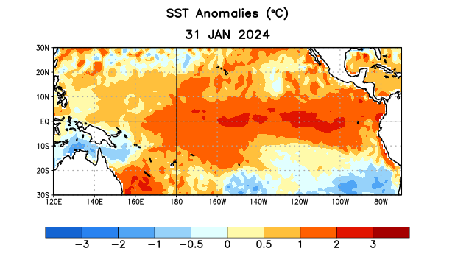
Figure 1. Average sea surface temperature (SST) anomalies (°C) for the week centered on 31 January 2024. Anomalies are computed with respect to the 1991-2020 base period weekly means.

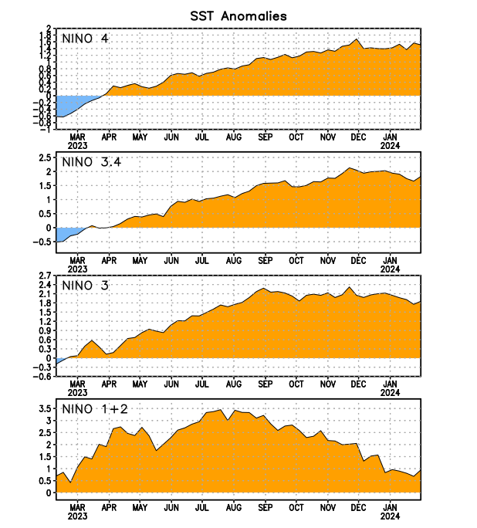
Figure 2. Time series of area-averaged sea surface temperature (SST) anomalies (°C) in the Niño regions [Niño-1+2 (0°-10°S, 90°W-80°W), Niño-3 (5°N-5°S, 150°W-90°W), Niño-3.4 (5°N-5°S, 170°W-120°W), Niño-4 (5ºN-5ºS, 150ºW-160ºE)]. SST anomalies are departures from the 1991-2020 base period weekly means.

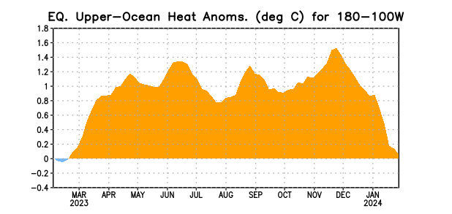

Figure 3. Area-averaged upper-ocean heat content anomaly (°C) in the equatorial Pacific (5°N-5°S, 180º-100ºW). The heat content anomaly is computed as the departure from the 1991-2020 base period pentad means.

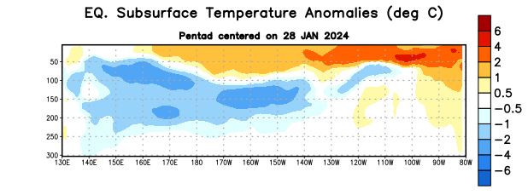
Figure 4. Depth-longitude section of equatorial Pacific upper-ocean (0-300m) temperature anomalies (°C) centered on the pentad of 28 January 2024. Anomalies are departures from the 1991-2020 base period pentad means.

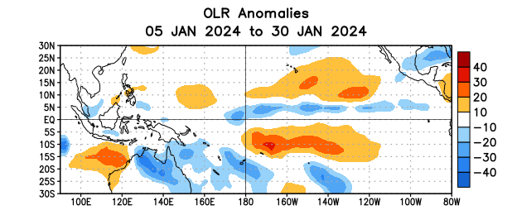

Figure 5. Average outgoing longwave radiation (OLR) anomalies (W/m²) for the period 5 – 30 January 2024. OLR anomalies are computed as departures from the 1991-2020 base period pentad means.

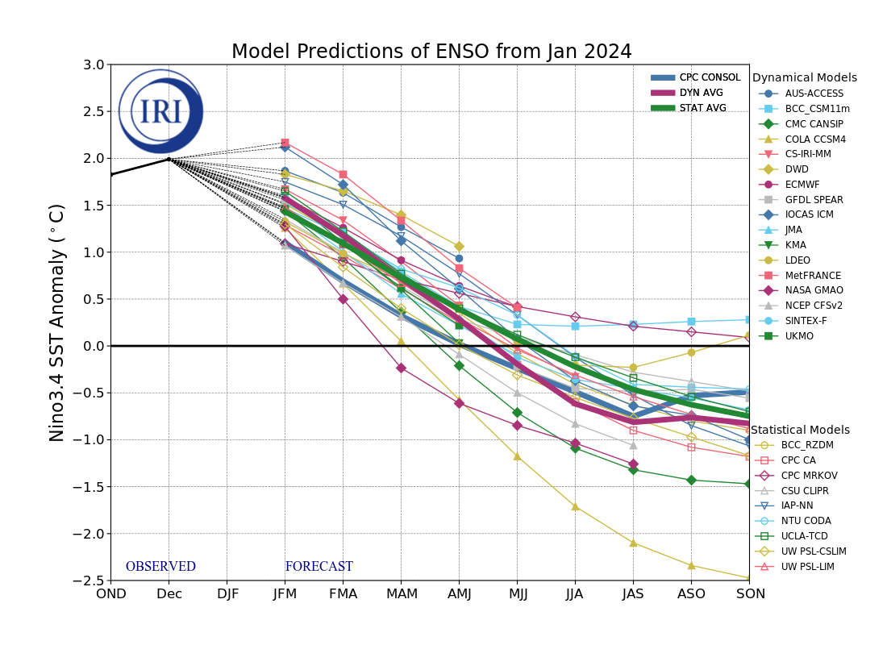
Figure 6. Forecasts of sea surface temperature (SST) anomalies for the Niño 3.4 region (5°N-5°S, 120°W-170°W). Figure updated 19 January 2024 by the International Research Institute (IRI) for Climate and Society.
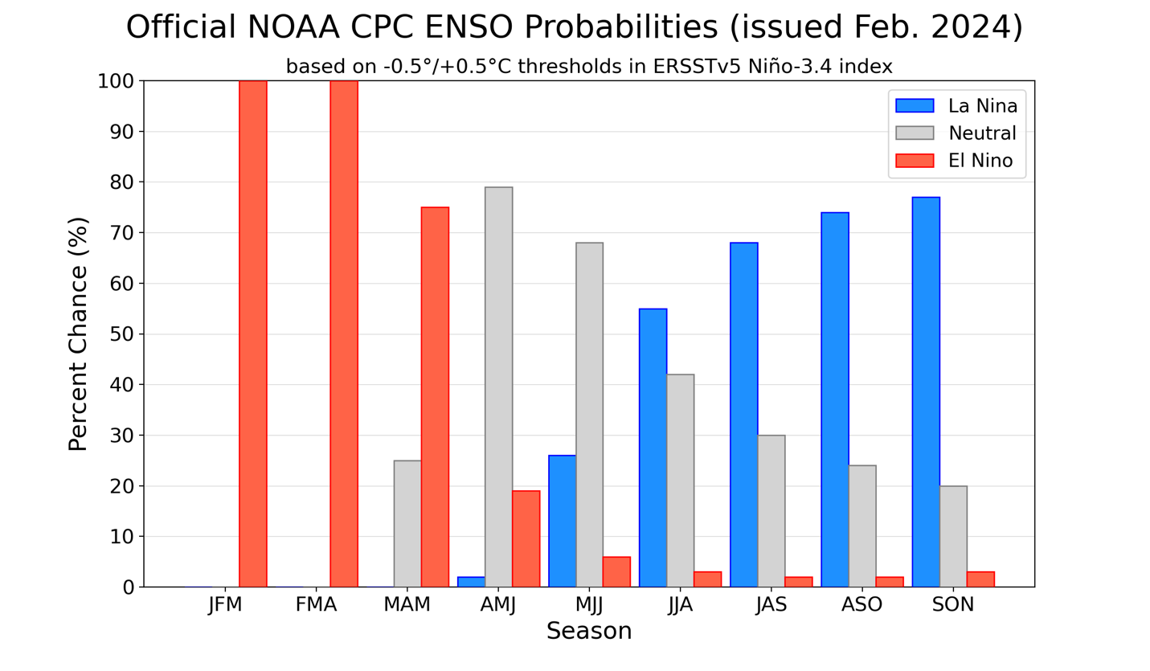
Figure 7. Official ENSO probabilities for the Niño 3.4 sea surface temperature index (5°N-5°S, 120°W-170°W). Figure updated 8 February 2024.

