EL NIÑO/SOUTHERN OSCILLATION (ENSO) DIAGNOSTIC DISCUSSION
issued by
CLIMATE PREDICTION CENTER/NCEP/NWS
8 January 2009

Synopsis: Developing La Niña conditions are likely to continue into Northern Hemisphere Spring 2009.
During December 2008, negative equatorial sea surface temperature (SST) anomalies strengthened across the central and east-central Pacific Ocean (Fig. 1). Correspondingly, the latest weekly SST index values were −0.3°C in Niño-1+2, −0.9°C in Niño 3, −1.1°C in Niño 3.4, and −0.7°C in Niño 4 (Fig. 2). The subsurface oceanic heat content anomalies (average temperatures in the upper 300m of the ocean, Fig. 3) also became increasingly negative as below-average temperatures at thermocline depth strengthened in the central and eastern Pacific (Fig. 4). Convection remained suppressed near the International Date Line, and became more persistent near Indonesia during December. Low-level easterly winds and upper-level westerly winds also strengthened across the equatorial Pacific Ocean. Collectively, these oceanic and atmospheric anomalies reflect the development of La Niña.
Nearly all of the recent forecasts for the Niño-3.4 region indicate a continuation of below-average SSTs through the first half of 2009, with at least one-half predicting La Niña conditions throughout the period (Fig. 5). While the magnitude of cooling remains uncertain, NOAA’s official La Niña threshold (3-month average of the Niño-3.4 index less than or equal to −0.5°C) is expected be met at least through January-March 2009. Therefore, based on current observations, recent trends, and model forecasts, La Niña conditions are likely to continue into the Northern Hemisphere Spring 2009.
Despite the unusually late start to this La Niña, expected impacts during January-March 2009 include above-average precipitation over Indonesia and below-average precipitation over the central and eastern equatorial Pacific. For the contiguous United States, potential impacts include above-average precipitation in the Ohio and Tennessee Valleys and below-average precipitation across the South, particularly in the southwestern and southeastern states. Other potential impacts include below-average temperatures in the Pacific Northwest and above-average temperatures across much of the southern United States.
This discussion is a consolidated effort of the National Atmospheric and Oceanic Administration (NOAA), NOAA’s National Weather Service, and their funded institutions. Oceanic and atmospheric conditions are updated weekly on the Climate Prediction Center web site (El Niño/La Niña Current Conditions and Expert Discussions). Forecasts for the evolution of El Niño/La Niña are updated monthly in the Forecast Forum section of CPC's Climate Diagnostics Bulletin. The next ENSO Diagnostics Discussion is scheduled for 5 February 2009. To receive an e-mail notification when the monthly ENSO Diagnostic Discussions are released, please send an e-mail message to: ncep.list.enso-update@noaa.gov.
Climate Prediction Center
National Centers for Environmental Prediction
NOAA/National Weather Service
Camp Springs, MD 20746-4304

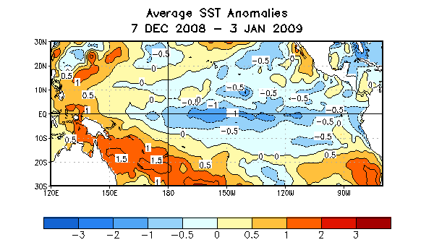

Figure 1. Average sea surface temperature (SST) anomalies (°C) for the four-week period 7 December 2008 - 3 January 2009. Anomalies are computed with respect to the 1971-2000 base period weekly means (Xue et al. 2003, J. Climate, 16, 1601-1612).

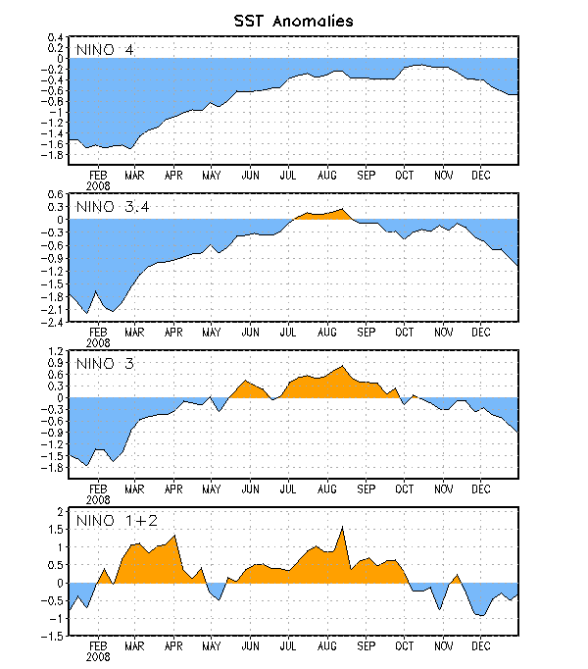
Figure 2. Time series of area-averaged sea surface temperature (SST) anomalies (°C) in the Niño regions [Niño-1+2 (0°-10°S, 90°W-80°W), Niño 3 (5°N-5°S, 150°W-90°W), Niño-3.4 (5°N-5°S, 170°W-120°W), Niño-4 (150ºW-160ºE and 5ºN-5ºS)]. SST anomalies are departures from the 1971-2000 base period weekly means (Xue et al. 2003, J. Climate, 16, 1601-1612).

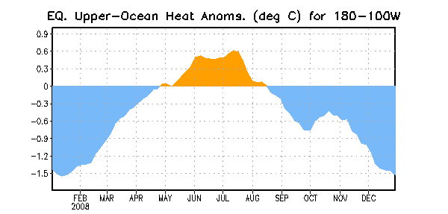
Figure 3. Area-averaged upper-ocean heat content anomalies (°C) in the equatorial Pacific (5°N-5°S, 180º-100ºW). Heat content anomalies are computed as departures from the 1982-2004 base period pentad means.

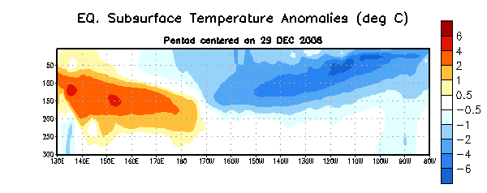
Figure 4. Depth-longitude section of equatorial Pacific upper-ocean (0-300m) temperature anomalies (°C) centered on the week of 29 December 2008. The anomalies are averaged between 5°N-5°S. Anomalies are departures from the 1982-2004 base period pentad means.

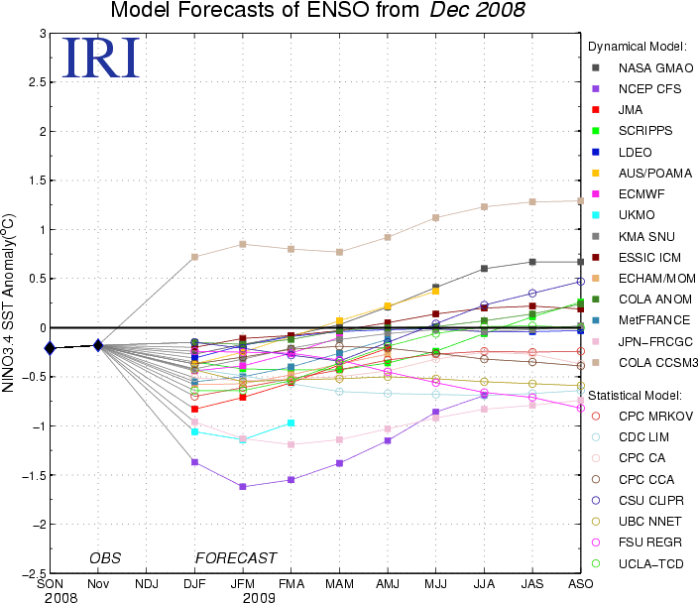

Figure 5. Forecasts of sea surface temperature (SST) anomalies for the Niño 3.4 region (5°N-5°S, 120°W-170°W). Figure courtesy of the International Research Institute (IRI) for Climate and Society. Figure updated 17 December 2008.

