EL NIÑO/SOUTHERN OSCILLATION (ENSO) DIAGNOSTIC DISCUSSION

issued by

CLIMATE PREDICTION CENTER/NCEP/NWS
7 January 2010

ENSO Alert System Status: El Niño Advisory

Synopsis: El Niño is expected to continue at least into the Northern Hemisphere spring 2010.
El Niño strengthened during December 2009, with above-average sea surface temperatures (SST) encompassing the central and eastern equatorial Pacific Ocean (Fig. 1). Weekly values of the Niño-3.4 index increased slightly with the most recent value reaching +1.8°C (Fig. 2). Consistent with this warmth, equatorial upper-ocean heat content anomalies remained positive (Fig. 3). Subsurface temperature anomalies exceeded +2°C across much of the equatorial Pacific (Fig. 4), with the largest departures seen in the eastern part of the basin at the end of the month. Equatorial low-level westerly and upper-level easterly wind anomalies were also consistent with El Niño, along with a continuation of suppressed convection over Indonesia and enhanced convection over the western and central equatorial Pacific. Collectively, these oceanic and atmospheric anomalies reflect a strong El Niño.
The models continue to disagree on the eventual peak strength of El Niño (Fig. 5). At this time, it is expected that the 3-month Niño-3.4 SST average will exceed +1.5°C during the winter (e.g. November-December-January and December-January-February). Regardless of its precise peak strength, El Niño is expected to exert a significant influence on the global weather and climate in the coming months. Most models indicate that SST anomalies in the Niño-3.4 region will begin to decrease in early 2010, and that El Niño will persist through April-May-June 2010.
Expected El Niño impacts during January-March 2010 include drier-than-average conditions over Indonesia and enhanced convection over the central tropical Pacific Ocean, which will likely expand eastward and influence portions of the eastern equatorial Pacific, as well as coastal sections of Peru and Ecuador. For the contiguous United States, potential El Niño impacts include above-average precipitation for the southern tier of the country, with below-average precipitation in the Pacific Northwest and in the Ohio and Tennessee Valleys. Below-average snowfall and above-average temperatures are most likely across the northern tier of states (excluding New England), while below-average temperatures are favored for the south-central and southeastern states.
This discussion is a consolidated effort of the National Oceanic and Atmospheric Administration (NOAA), NOAA’s National Weather Service, and their funded institutions. Oceanic and atmospheric conditions are updated weekly on the Climate Prediction Center web site (El Niño/La Niña Current Conditions and Expert Discussions). Forecasts for the evolution of El Niño/La Niña are updated monthly in the Forecast Forum section of CPC's Climate Diagnostics Bulletin. The next ENSO Diagnostics Discussion is scheduled for 4 February 2010. To receive an e-mail notification when the monthly ENSO Diagnostic Discussions are released, please send an e-mail message to: ncep.list.enso-update@noaa.gov.
Climate Prediction Center
National Centers for Environmental Prediction
NOAA/National Weather Service
Camp Springs, MD 20746-4304
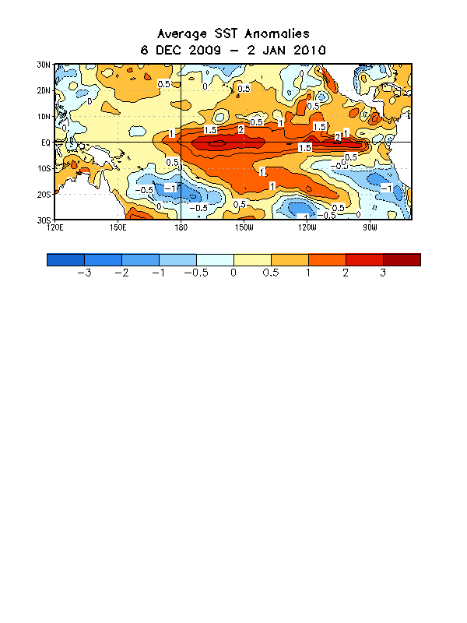
Figure 1. Average sea surface temperature (SST) anomalies (°C) for the four-week period 6 December 2009 – 2 January 2010. Anomalies are computed with respect to the 1971-2000 base period weekly means (Xue et al. 2003, J. Climate, 16, 1601-1612).

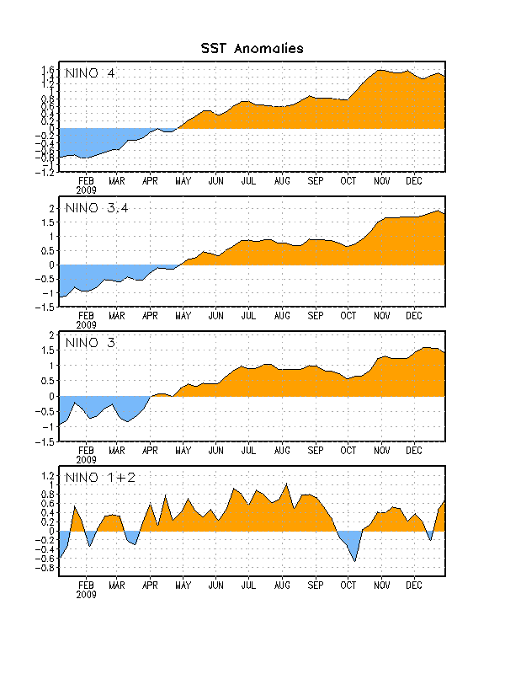
Figure 2. Time series of area-averaged sea surface temperature (SST) anomalies (°C) in the Niño regions [Niño-1+2 (0°-10°S, 90°W-80°W), Niño 3 (5°N-5°S, 150°W-90°W), Niño-3.4 (5°N-5°S, 170°W-120°W), Niño-4 (150ºW-160ºE and 5ºN-5ºS)]. SST anomalies are departures from the 1971-2000 base period weekly means (Xue et al. 2003, J. Climate, 16, 1601-1612).

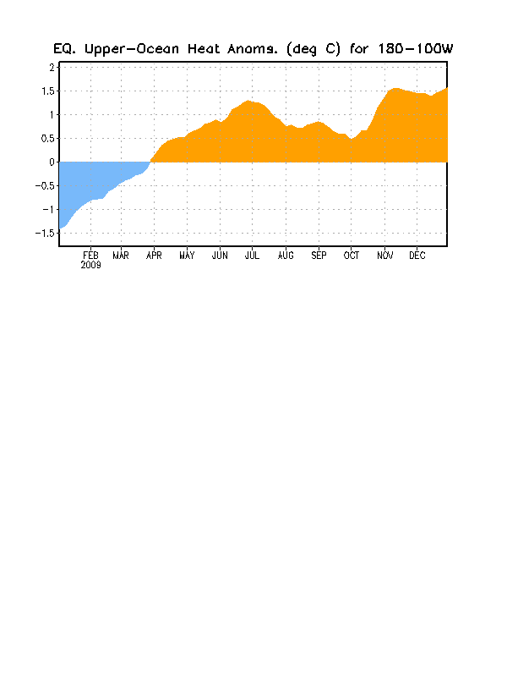
Figure 3. Area-averaged upper-ocean heat content anomalies (°C) in the equatorial Pacific (5°N-5°S, 180º-100ºW). Heat content anomalies are computed as departures from the 1982-2004 base period pentad means.

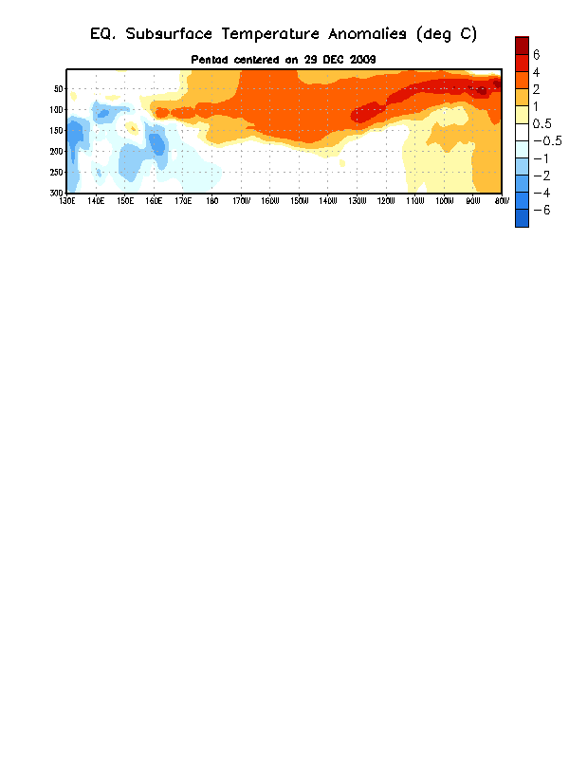
Figure 4. Depth-longitude section of equatorial Pacific upper-ocean (0-300m) temperature anomalies (°C) centered on the week of 29 December 2009. The anomalies are averaged between 5°N-5°S. Anomalies are departures from the 1982-2004 base period pentad means

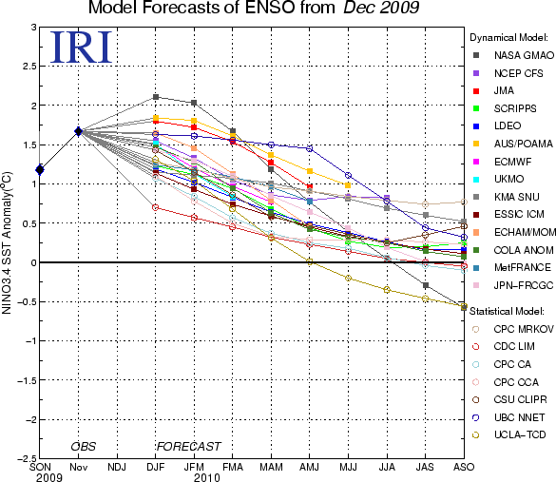

Figure 5. Forecasts of sea surface temperature (SST) anomalies for the Niño 3.4 region (5°N-5°S, 120°W-170°W). Figure courtesy of the International Research Institute (IRI) for Climate and Society. Figure updated 17 December 2009.

