EL NIÑO/SOUTHERN OSCILLATION (ENSO) DIAGNOSTIC DISCUSSION

issued by

CLIMATE PREDICTION CENTER/NCEP/NWS
6 January 2011

ENSO Alert System Status: La Niña Advisory

Synopsis: La Niña is expected to continue well into the Northern Hemisphere spring 2011.
A moderate-to-strong La Niña continued during December 2010 as reflected by well below-average sea surface temperatures (SSTs) across the equatorial Pacific Ocean (Fig. 1). All of the Niño indices were –1.5°C at the end of December, except for the easternmost Niño-1+2 region (Fig. 2). The subsurface oceanic heat content (average temperatures in the upper 300m of the ocean, Fig. 3) continued to reflect a large reservoir of below-average temperatures at depth in the central and eastern equatorial Pacific (Fig. 4). Convection remained enhanced over Indonesia and suppressed over the western and central equatorial Pacific (Fig. 5). Also, enhanced low-level easterly trade winds and anomalous upper-level westerly winds continued over the equatorial Pacific. Collectively, these oceanic and atmospheric anomalies reflect the ongoing La Niña.
The current ENSO model forecasts have not changed significantly compared to last month. La Niña is currently near its peak and is expected to persist into the Northern Hemisphere spring 2011 at a lesser intensity. Thereafter, there remains considerable uncertainty as to whether La Niña will last into the Northern Hemisphere summer (as suggested by the NCEP CFS and a few other models), or whether there will be a transition to ENSO-neutral conditions (as suggested by the CPC CON and a majority of the other models).
Likely La Niña impacts during January-March 2011 include suppressed convection over the west-central tropical Pacific Ocean, and enhanced convection over Indonesia. Impacts in the United States include an enhanced chance of above-average precipitation in the Pacific Northwest, Northern Rockies (along with a concomitant increase in snowfall), Great Lakes, and Ohio Valley. Below-average precipitation is favored across the southwestern and southeastern states. An increased chance of below-average temperatures is predicted for much of the West Coast and northern tier of states (excluding New England), and a higher possibility of above-average temperatures is forecast for much of the southern and central U.S. (see 3-month seasonal outlook released on December 16th, 2010). While seasonal temperature and precipitation patterns in the U.S. are strongly influenced by La Niña, these signals can be modified by other factors, such as the Arctic Oscillation (AO)/ North Atlantic Oscillation (NAO).
This discussion is a consolidated effort of the National Oceanic and Atmospheric Administration (NOAA), NOAA’s National Weather Service, and their funded institutions. Oceanic and atmospheric conditions are updated weekly on the Climate Prediction Center web site (El Niño/La Niña Current Conditions and Expert Discussions). Forecasts for the evolution of El Niño/La Niña are updated monthly in the Forecast Forum section of CPC's Climate Diagnostics Bulletin. The next ENSO Diagnostics Discussion is scheduled for 10 February 2011. To receive an e-mail notification when the monthly ENSO Diagnostic Discussions are released, please send an e-mail message to: ncep.list.enso-update@noaa.gov.
Climate Prediction Center
National Centers for Environmental Prediction
NOAA/National Weather Service
Camp Springs, MD 20746-4304

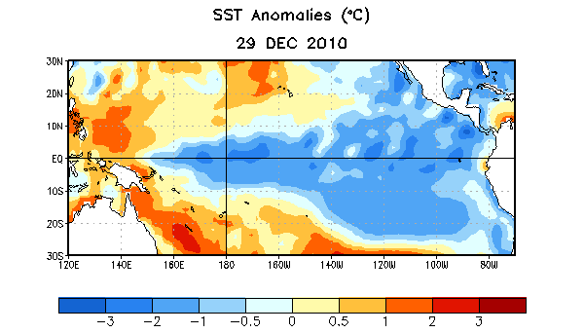
Figure 1. Average sea surface temperature (SST) anomalies (°C) for the week centered on 29 December 2010. Anomalies are computed with respect to the 1971-2000 base period weekly means (Xue et al. 2003, J. Climate, 16, 1601-1612).

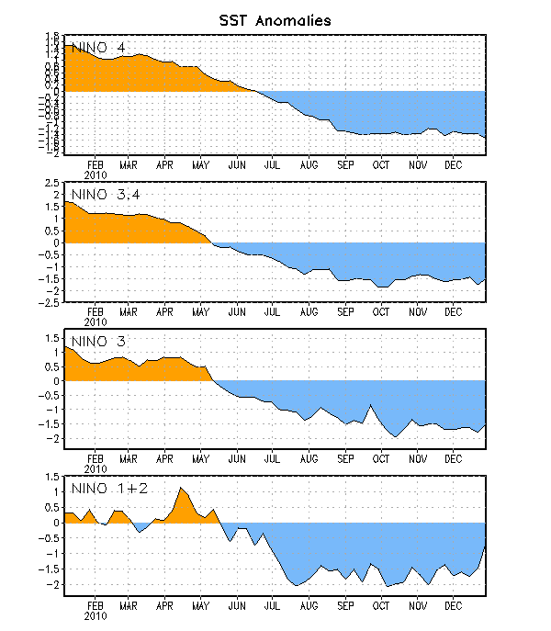
Figure 2. Time series of area-averaged sea surface temperature (SST) anomalies (°C) in the Niño regions [Niño-1+2 (0°-10°S, 90°W-80°W), Niño 3 (5°N-5°S, 150°W-90°W), Niño-3.4 (5°N-5°S, 170°W-120°W), Niño-4 (150ºW-160ºE and 5ºN-5ºS)]. SST anomalies are departures from the 1971-2000 base period weekly means (Xue et al. 2003, J. Climate, 16, 1601-1612).

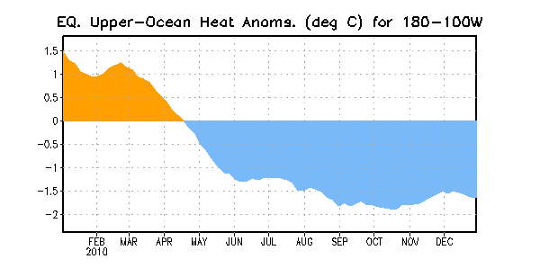
Figure 3. Area-averaged upper-ocean heat content anomalies (°C) in the equatorial Pacific (5°N-5°S, 180º-100ºW). Heat content anomalies are computed as departures from the 1982-2004 base period pentad means.

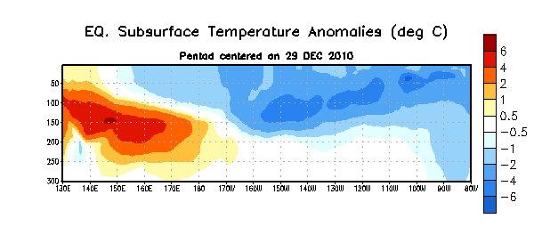
Figure 4. Depth-longitude section of equatorial Pacific upper-ocean (0-300m) temperature anomalies (°C) centered on the week of 29 December 2010. The anomalies are averaged between 5°N-5°S. Anomalies are departures from the 1982-2004 base period pentad means.

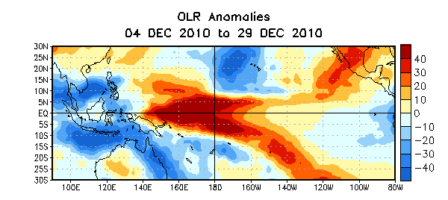

Figure 5. Average outgoing longwave radiation (OLR) anomalies (W/m²) for the four-week period 4 – 29 December 2010. OLR anomalies are computed as departures from the 1979-1995 base period pentad means.

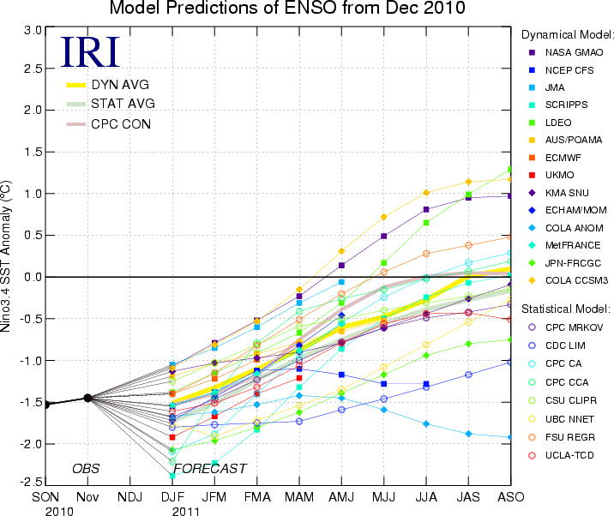
Figure 6. Forecasts of sea surface temperature (SST) anomalies for the Niño 3.4 region (5°N-5°S, 120°W-170°W). Figure courtesy of the International Research Institute (IRI) for Climate and Society. Figure updated 14 December 2010.

