EL NIÑO/SOUTHERN OSCILLATION (ENSO) DIAGNOSTIC DISCUSSION

issued by

CLIMATE PREDICTION CENTER/NCEP/NWS
and the International Research Institute for Climate and Society
10 January 2013

ENSO Alert System Status: Not Active

Synopsis: ENSO-neutral is favored through Northern Hemisphere spring 2013.
ENSO-neutral conditions continued during December 2012. Equatorial sea surface temperature (SST) anomalies were positive in the western Pacific, near zero in the central Pacific, and slightly negative in much of the eastern Pacific (Fig 1). This SST anomaly pattern is also reflected in the Niño indices (Fig. 2). The oceanic heat content (average temperature in the upper 300m of the ocean) in the equatorial Pacific became slightly below average (Fig. 3), with positive sub-surface temperature anomalies west of 165°W and stronger negative anomalies in the east-central and eastern Pacific (Fig. 4). Upper- and lower-level zonal winds were near average across the tropical Pacific, and the Southern Oscillation Index was slightly negative. Also, convection was suppressed over the central tropical Pacific and enhanced over western Indonesia (Fig. 5). Collectively, these oceanic and atmospheric features indicate ENSO-neutral conditions.
Model predictions favor near-average SST in the Niño-3.4 region from the Northern Hemisphere winter 2012-13 into summer 2013 (Fig. 6). Because predictions through the April-June season are known to be less skillful, the forecasts for the summer carry limited confidence at this time. Thus, it is considered unlikely that an El Niño or La Niña will develop during the next several months, and ENSO-neutral is favored through Northern Hemisphere spring 2013 (see CPC/IRI consensus forecast).
This discussion is a consolidated effort of the National Oceanic and Atmospheric Administration (NOAA), NOAA’s National Weather Service, and their funded institutions. Oceanic and atmospheric conditions are updated weekly on the Climate Prediction Center web site (El Niño/La Niña Current Conditions and Expert Discussions). Forecasts for the evolution of El Niño/La Niña are updated monthly in the Forecast Forum section of CPC's Climate Diagnostics Bulletin. The next ENSO Diagnostics Discussion is scheduled for 7 February 2013. To receive an e-mail notification when the monthly ENSO Diagnostic Discussions are released, please send an e-mail message to: ncep.list.enso-update@noaa.gov.
Climate Prediction Center
National Centers for Environmental Prediction
NOAA/National Weather Service
College Park, MD 20740

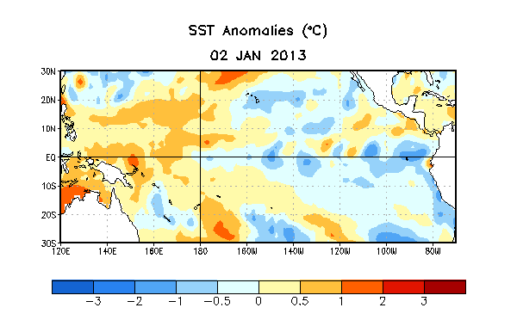
Figure 1. Average sea surface temperature (SST) anomalies (°C) for the week centered on 2 January 2013. Anomalies are computed with respect to the 1981-2010 base period weekly means.

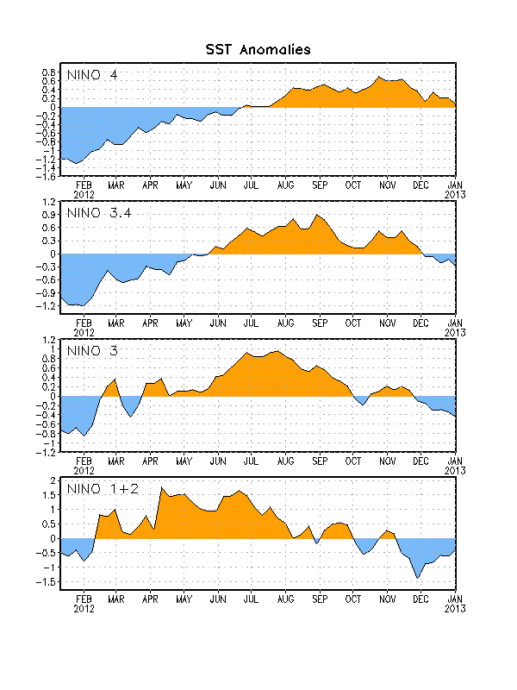
Figure 2. Time series of area-averaged sea surface temperature (SST) anomalies (°C) in the Niño regions [Niño-1+2 (0°-10°S, 90°W-80°W), Niño 3 (5°N-5°S, 150°W-90°W), Niño-3.4 (5°N-5°S, 170°W-120°W), Niño-4 (150ºW-160ºE and 5ºN-5ºS)]. SST anomalies are departures from the 1981-2010 base period weekly means.

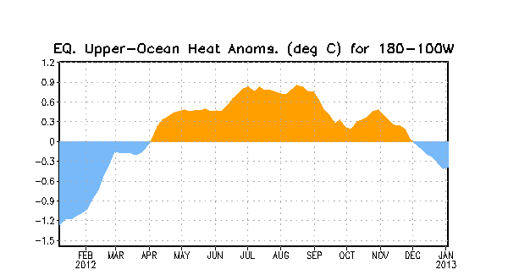
Figure 3. Area-averaged upper-ocean heat content anomaly (°C) in the equatorial Pacific (5°N-5°S, 180º-100ºW). The heat content anomaly is computed as the departure from the 1981-2010 base period pentad means.

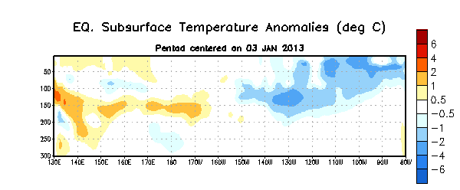
Figure 4. Depth-longitude section of equatorial Pacific upper-ocean (0-300m) temperature anomalies (°C) centered on the pentad of 3 January 2013. The anomalies are averaged between 5°N-5°S. Anomalies are departures from the 1981-2010 base period pentad means.

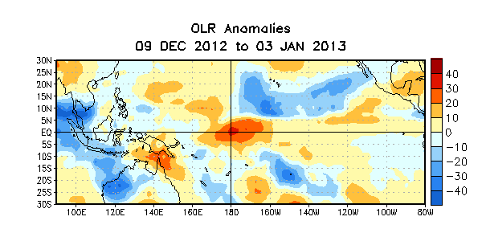

Figure 5. Average outgoing longwave radiation (OLR) anomalies (W/m²) for the four-week period 9 December 2012 – 3 January 2013. OLR anomalies are computed as departures from the 1979-1995 base period pentad means.

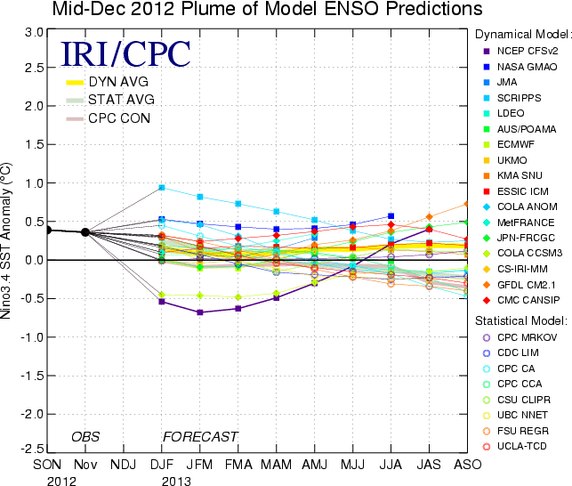
Figure 6. Forecasts of sea surface temperature (SST) anomalies for the Niño 3.4 region (5°N-5°S, 120°W-170°W). Figure courtesy of the International Research Institute (IRI) for Climate and Society. Figure updated 18 December 2012.

