EL NIÑO/SOUTHERN OSCILLATION (ENSO) DIAGNOSTIC DISCUSSION

issued by

CLIMATE PREDICTION CENTER/NCEP/NWS
and the International Research Institute for Climate and Society
9 January 2014

ENSO Alert System Status: Not Active

Synopsis: ENSO-neutral is expected to continue into the Northern Hemisphere summer 2014.
During December, ENSO-neutral persisted, as reflected by near-average sea surface temperatures (SST) across much of the equatorial Pacific Ocean (Fig. 1). The Nino indices in all of the regions were within ±0.5°C and showed only small changes during the month (Fig. 2). The oceanic heat content (average temperature in the upper 300m of the ocean) decreased but remained above average (Fig. 3), following the passing of a downwelling oceanic Kelvin wave that had raised the sub-surface temperatures in November (Fig. 4). Also in December, slightly enhanced low-level trade winds were observed in the western tropical Pacific Ocean, while enhanced upper level westerly winds prevailed in portions of the eastern half of the basin. Convection was suppressed in the central equatorial Pacific and enhanced over Indonesia (Fig. 5). Collectively, these atmospheric and oceanic conditions reflect ENSO-neutral.
The majority of models predict that ENSO-neutral (Niño-3.4 index between -0.5°C and 0.5°C) will persist into the Northern Hemisphere summer 2014 (Fig. 6). While current forecast probabilities are still greatest for ENSO-neutral during summer, there is an increasing chance for the development of El Niño. The consensus forecast is for ENSO-neutral to continue into the Northern Hemisphere summer 2014 (see CPC/IRI consensus forecast).
This discussion is a consolidated effort of the National Oceanic and Atmospheric Administration (NOAA), NOAA’s National Weather Service, and their funded institutions. Oceanic and atmospheric conditions are updated weekly on the Climate Prediction Center web site (El Niño/La Niña Current Conditions and Expert Discussions). Forecasts for the evolution of El Niño/La Niña are updated monthly in the Forecast Forum section of CPC's Climate Diagnostics Bulletin. The next ENSO Diagnostics Discussion is scheduled for 6 February 2014. To receive an e-mail notification when the monthly ENSO Diagnostic Discussions are released, please send an e-mail message to: ncep.list.enso-update@noaa.gov.
Climate Prediction Center
National Centers for Environmental Prediction
NOAA/National Weather Service
College Park, MD 20740

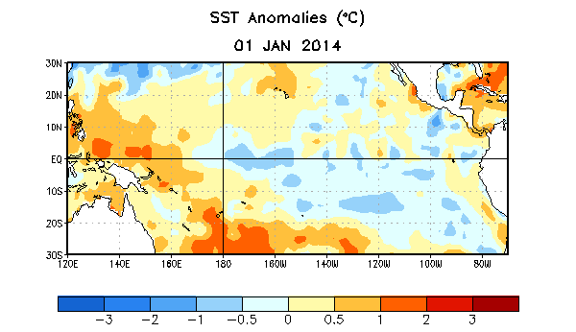
Figure 1. Average sea surface temperature (SST) anomalies (°C) for the week centered on 1 January 2014. Anomalies are computed with respect to the 1981-2010 base period weekly means.

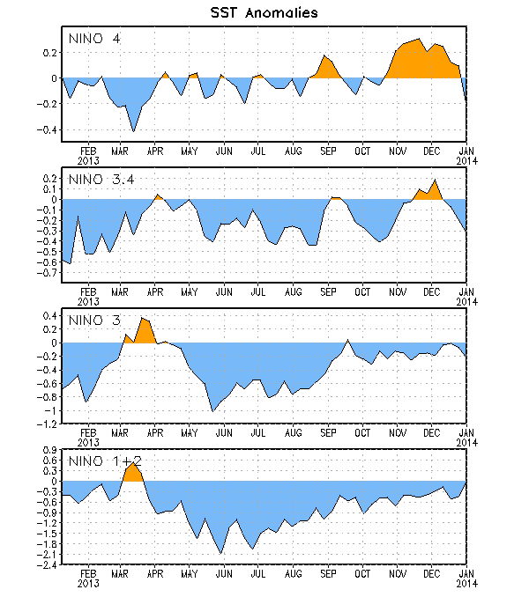
Figure 2. Time series of area-averaged sea surface temperature (SST) anomalies (°C) in the Niño regions [Niño-1+2 (0°-10°S, 90°W-80°W), Niño 3 (5°N-5°S, 150°W-90°W), Niño-3.4 (5°N-5°S, 170°W-120°W), Niño-4 (5ºN-5ºS , 150ºW-160ºE]. SST anomalies are departures from the 1981-2010 base period weekly means.

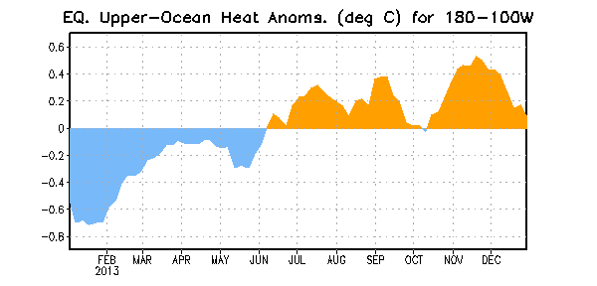
Figure 3. Area-averaged upper-ocean heat content anomaly (°C) in the equatorial Pacific (5°N-5°S, 180º-100ºW). The heat content anomaly is computed as the departure from the 1981-2010 base period pentad means.

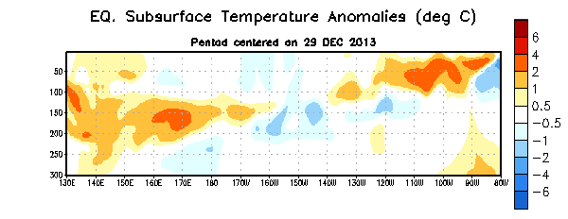
Figure 4. Depth-longitude section of equatorial Pacific upper-ocean (0-300m) temperature anomalies (°C) centered on the pentad of 29 December 2013. The anomalies are averaged between 5°N-5°S. Anomalies are departures from the 1981-2010 base period pentad means.

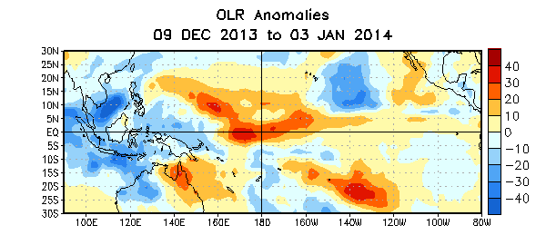
Figure 5. Average outgoing longwave radiation (OLR) anomalies (W/m²) for the period 9 December 2013 – 3 January 2014. OLR anomalies are computed as departures from the 1979-1995 base period pentad means.

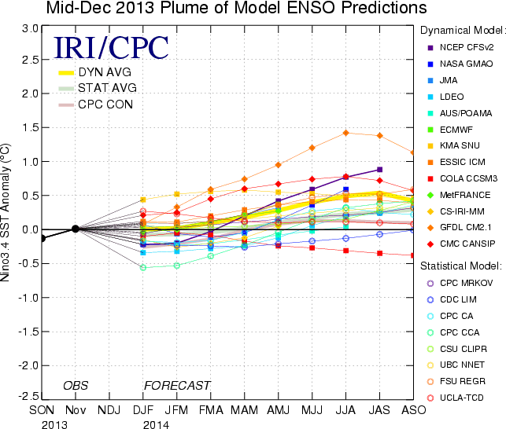
Figure 6. Forecasts of sea surface temperature (SST) anomalies for the Niño 3.4 region (5°N-5°S, 120°W-170°W). Figure updated 17 December 2013.

