EL NIÑO/SOUTHERN OSCILLATION (ENSO) DIAGNOSTIC DISCUSSION

issued by

CLIMATE PREDICTION CENTER/NCEP/NWS
and the International Research Institute for Climate and Society
8 January 2015

ENSO Alert System Status: El Niño Watch

Synopsis: There is an approximately 50-60% chance of El Niño conditions during the next two months, with ENSO-neutral favored thereafter.
During December 2014, positive sea surface temperature (SST) anomalies decreased across the central and east-central equatorial Pacific (Fig. 1). At the end of the month, the weekly Niño indices ranged from +0.8°C in the Niño-4 region, to +0.5°C in the Niño-3.4 region, to 0.0°C in the Niño-1+2 region (Fig. 2). The positive subsurface heat content anomalies (averaged between 180º-100ºW) also decreased during December (Fig. 3) in response to an upwelling equatorial oceanic Kelvin wave (Fig. 4). Although the surface and sub-surface temperature anomalies were consistent with El Niño, the overall atmospheric circulation continued to show only limited coupling with the anomalously warm water. The equatorial low-level winds were largely near average during the month, while upper-level easterly anomalies continued in the central and eastern tropical Pacific. The Southern Oscillation Index (SOI) remained slightly negative, but the Equatorial SOI remained near zero. Also, rainfall remained below-average near the Date Line and was above-average over Indonesia (Fig. 5). Overall, the combined atmospheric and oceanic state remains ENSO-neutral.
Similar to last month, most models predict the SST anomalies to remain at weak El Niño levels (3-month values of the Niño-3.4 index between 0.5°C and 0.9°C) during December-February 2014-15, and lasting into the Northern Hemisphere spring 2015 (Fig. 6). If El Niño were to emerge, the forecaster consensus favors a weak event that ends in early Northern Hemisphere spring. In summary, there is an approximately 50-60% chance of El Niño conditions during the next two months, with ENSO-neutral favored thereafter (click CPC/IRI consensus forecast for the chance of each outcome).
This discussion is a consolidated effort of the National Oceanic and Atmospheric Administration (NOAA), NOAA’s National Weather Service, and their funded institutions. Oceanic and atmospheric conditions are updated weekly on the Climate Prediction Center web site (El Niño/La Niña Current Conditions and Expert Discussions). Forecasts are also updated monthly in the Forecast Forum of CPC's Climate Diagnostics Bulletin. Additional perspectives and analysis are also available in an ENSO blog. The next ENSO Diagnostics Discussion is scheduled for 5 February 2015. To receive an e-mail notification when the monthly ENSO Diagnostic Discussions are released, please send an e-mail message to: ncep.list.enso-update@noaa.gov.

Climate Prediction Center
National Centers for Environmental Prediction
NOAA/National Weather Service
College Park, MD 20740

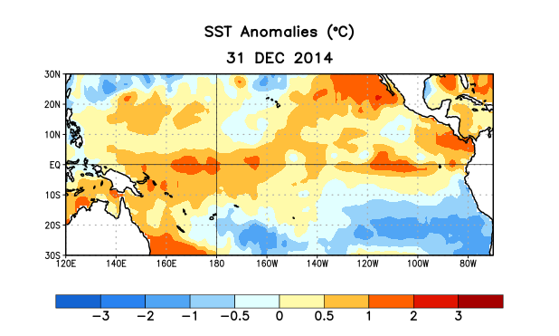
Figure 1. Average sea surface temperature (SST) anomalies (°C) for the week centered on 31 December 2014. Anomalies are computed with respect to the 1981-2010 base period weekly means.

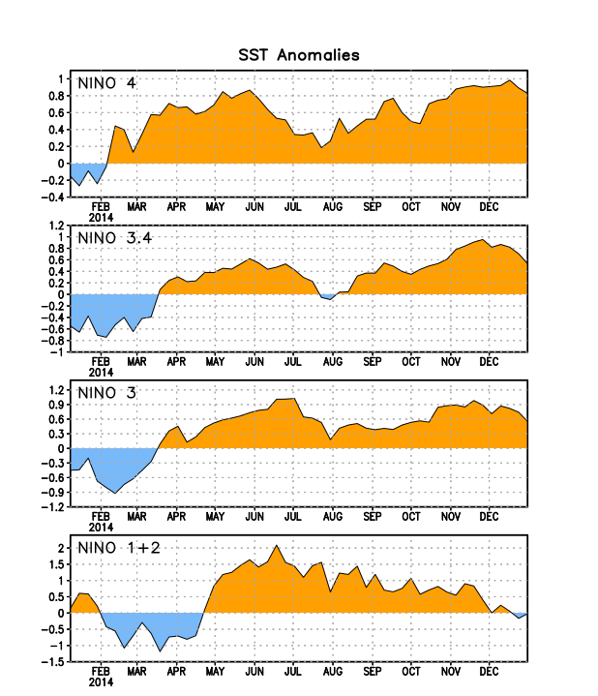
Figure 2. Time series of area-averaged sea surface temperature (SST) anomalies (°C) in the Niño regions [Niño-1+2 (0°-10°S, 90°W-80°W), Niño 3 (5°N-5°S, 150°W-90°W), Niño-3.4 (5°N-5°S, 170°W-120°W), Niño-4 (5ºN-5ºS , 150ºW-160ºE]. SST anomalies are departures from the 1981-2010 base period weekly means.
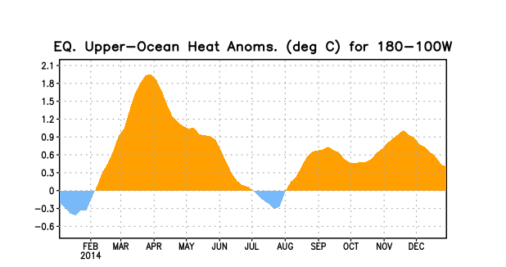
Figure 3. Area-averaged upper-ocean heat content anomaly (°C) in the equatorial Pacific (5°N-5°S, 180º-100ºW). The heat content anomaly is computed as the departure from the 1981-2010 base period pentad means.

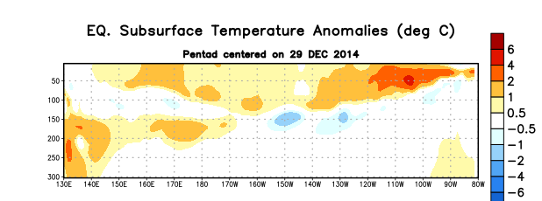
Figure 4. Depth-longitude section of equatorial Pacific upper-ocean (0-300m) temperature anomalies (°C)
centered on the pentad of 29 December 2014. The anomalies are averaged between 5°N-5°S. Anomalies are departures from the 1981-2010 base period pentad means.

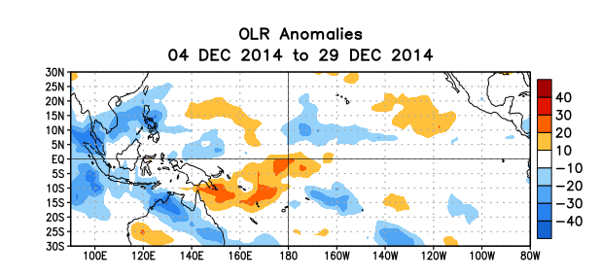
Figure 5. Average outgoing longwave radiation (OLR) anomalies (W/m²) for the period 4 – 29 December 2014. OLR anomalies are computed as departures from the 1979-1995 base period pentad means.

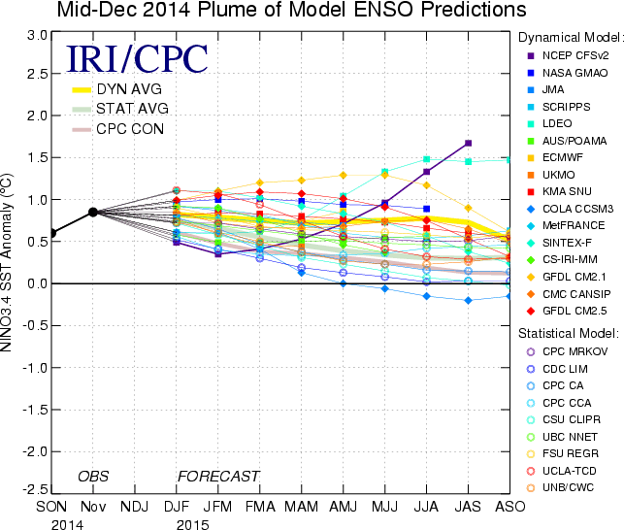

Figure 6. Forecasts of sea surface temperature (SST) anomalies for the Niño 3.4 region (5°N-5°S, 120°W-170°W). Figure updated 16 December 2014.

