EL NIÑO/SOUTHERN OSCILLATION (ENSO) DIAGNOSTIC DISCUSSION

issued by

CLIMATE PREDICTION CENTER/NCEP/NWS
and the International Research Institute for Climate and Society
12 January 2017

ENSO Alert System Status: La Niña Advisory

Synopsis: A transition to ENSO-neutral is expected to occur by February 2017, with ENSO-neutral then continuing through the first half of 2017.
La Niña continued during December, with negative sea surface temperature (SST) anomalies continuing across the central and eastern equatorial Pacific (Fig. 1). The weekly Niño index values fluctuated during the last month, with the Niño-3 and Niño-3.4 regions hovering near and slightly warmer than -0.5°C (Fig. 2). The upper-ocean heat content anomaly was near zero when averaged across the eastern Pacific (Fig. 3), though near-to-below average subsurface temperatures were evident closer to the surface (Fig. 4). Atmospheric convection remained suppressed over the central tropical Pacific and enhanced over Indonesia (Fig. 5). The low-level easterly winds were slightly enhanced over the western Pacific, and upper-level westerly anomalies were observed across the eastern Pacific. Overall, the ocean and atmosphere system remained consistent with a weak La Niña.

The multi-model averages favor an imminent transition to ENSO-neutral (3-month average Niño-3.4 index between -0.5°C and 0.5°C), with ENSO-neutral lasting through August-October (ASO) 2017 (Fig. 6). Along with the model forecasts, the decay of the subsurface temperature anomalies and marginally cool conditions at and near the ocean surface portends the return of ENSO-neutral over the next month. In summary, a transition to ENSO-neutral is expected to occur by February 2017, with ENSO-neutral then continuing through the first half of 2017 (click CPC/IRI consensus forecast for the chance of each outcome for each 3-month period).

Even as the tropical Pacific Ocean returns to ENSO-neutral conditions, the atmospheric impacts from La Niña could persist during the upcoming months (NOAA’s 3-month seasonal outlook will be updated on Thursday January 19th). The current seasonal outlook for JFM 2017 favors above-average temperatures and below-median precipitation across much of the southern tier of the U.S., and below-average temperatures and above-median precipitation in portions of the northern tier of the U.S.

This discussion is a consolidated effort of the National Oceanic and Atmospheric Administration (NOAA), NOAA’s National Weather Service, and their funded institutions. Oceanic and atmospheric conditions are updated weekly on the Climate Prediction Center web site (El Niño/La Niña Current Conditions and Expert Discussions). Forecasts are also updated monthly in the Forecast Forum of CPC's Climate Diagnostics Bulletin. Additional perspectives and analysis are also available in an ENSO blog. The next ENSO Diagnostics Discussion is scheduled for 9 February 2017. To receive an e-mail notification when the monthly ENSO Diagnostic Discussions are released, please send an e-mail message to: ncep.list.enso-update@noaa.gov.

Climate Prediction Center
National Centers for Environmental Prediction
NOAA/National Weather Service
College Park, MD 20740

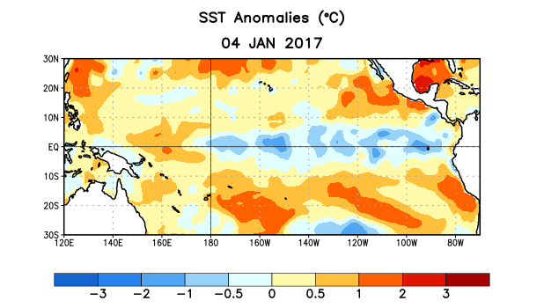
Figure 1. Average sea surface temperature (SST) anomalies (°C) for the week centered on 4 January 2017. Anomalies are computed with respect to the 1981-2010 base period weekly means.

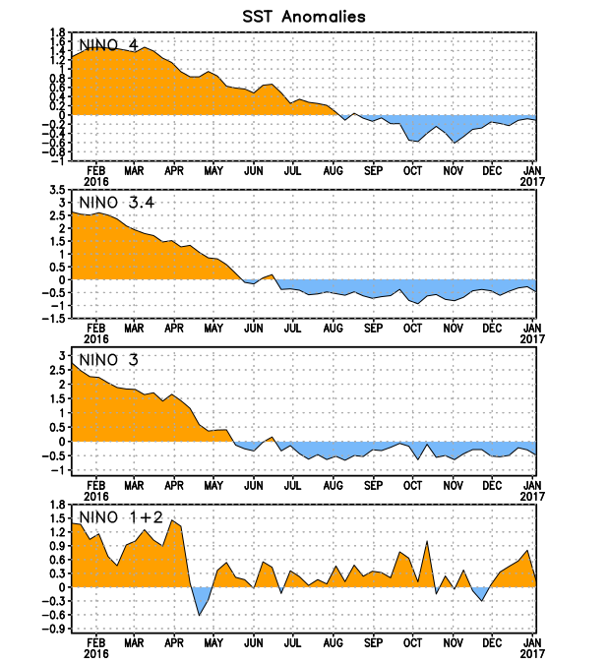
Figure 2. Time series of area-averaged sea surface temperature (SST) anomalies (°C) in the Niño regions [Niño-1+2 (0°-10°S, 90°W-80°W), Niño 3 (5°N-5°S, 150°W-90°W), Niño-3.4 (5°N-5°S, 170°W-120°W), Niño-4 (5ºN-5ºS , 150ºW-160ºE]. SST anomalies are departures from the 1981-2010 base period weekly means.
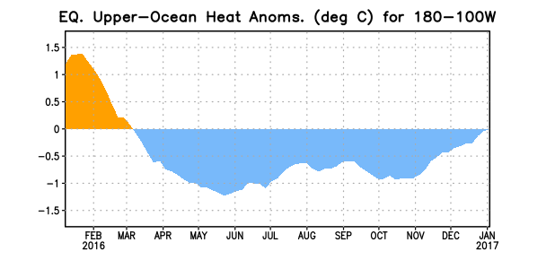
Figure 3. Area-averaged upper-ocean heat content anomaly (°C) in the equatorial Pacific (5°N-5°S, 180º-100ºW). The heat content anomaly is computed as the departure from the 1981-2010 base period pentad means.

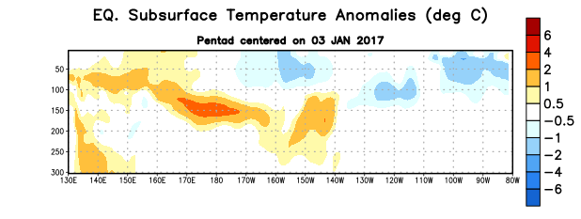
Figure 4. Depth-longitude section of equatorial Pacific upper-ocean (0-300m) temperature anomalies (°C) centered on the pentad of 3 January 2017. The anomalies are averaged between 5°N-5°S. Anomalies are departures from the 1981-2010 base period pentad means.

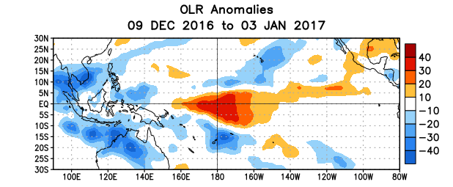
Figure 5. Average outgoing longwave radiation (OLR) anomalies (W/m²) for the period 9 December 2016 – 3 January 2017. OLR anomalies are computed as departures from the 1981-2010 base period pentad means.

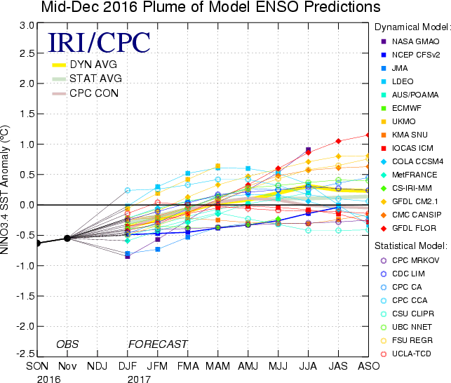

Figure 6. Forecasts of sea surface temperature (SST) anomalies for the Niño 3.4 region (5°N-5°S, 120°W-170°W). Figure updated 13 December 2016.

