EL NIÑO/SOUTHERN OSCILLATION (ENSO) DIAGNOSTIC DISCUSSION

issued by

CLIMATE PREDICTION CENTER/NCEP/NWS
and the International Research Institute for Climate and Society
11 January 2018

ENSO Alert System Status: La Niña Advisory

Synopsis: La Niña is likely (~85-95%) through Northern Hemisphere winter, with a transition to ENSO-neutral expected during the spring.
La Niña continued during the past month, as indicated by the pattern of below-average sea surface temperatures (SSTs) across the central and eastern equatorial Pacific Ocean (Fig. 1). The latest weekly Niño-3.4 index value was -0.8°C, and the Niño-3 and Niño-1+2 indices were at or below -1.0°C during much of the month (Fig. 2). Negative sub-surface temperature anomalies in the central and east-central equatorial Pacific weakened at the end of the month (Fig. 3) as anomalously warm waters in the western Pacific at depths greater than 100 m propagated eastward to approximately 140°W (Fig. 4). The atmospheric conditions over the tropical Pacific Ocean also reflected La Niña, with suppressed convection near and east of the International Date Line and enhanced convection to the north of Indonesia (Fig. 5). Also, the low-level trade winds continued to be stronger than average over the western and central Pacific. Overall, the ocean and atmosphere system remained consistent with La Niña.
Nearly all models in the IRI/CPC plume predict La Niña will persist through the Northern Hemisphere winter 2017-18 (Fig. 6). Based on the latest observations and forecast guidance, forecasters believe this weak-to-moderate La Niña (3-month Niño-3.4 values between -0.5°C and -1.5°C) is currently peaking and will eventually weaken into the spring. In summary, La Niña is likely (~85-95%) through Northern Hemisphere winter, with a transition to ENSO-neutral expected during the spring (click CPC/IRI consensus forecast for the chance of each outcome for each 3-month period).
La Niña is anticipated to affect temperature and precipitation across the United States during the upcoming months (the 3-month seasonal temperature and precipitation outlooks will be updated on Thursday January 18th). The outlooks generally favor above-average temperatures and below-median precipitation across the southern tier of the United States, and below-average temperatures and above-median precipitation across the northern tier of the United States.
This discussion is a consolidated effort of the National Oceanic and Atmospheric Administration (NOAA), NOAA’s National Weather Service, and their funded institutions. Oceanic and atmospheric conditions are updated weekly on the Climate Prediction Center web site (El Niño/La Niña Current Conditions and Expert Discussions). Forecasts are also updated monthly in the Forecast Forum of CPC's Climate Diagnostics Bulletin. Additional perspectives and analysis are also available in an ENSO blog. The next ENSO Diagnostics Discussion is scheduled for 8 February 2018. To receive an e-mail notification when the monthly ENSO Diagnostic Discussions are released, please send an e-mail message to: ncep.list.enso-update@noaa.gov.

Climate Prediction Center
National Centers for Environmental Prediction
NOAA/National Weather Service
College Park, MD 20740

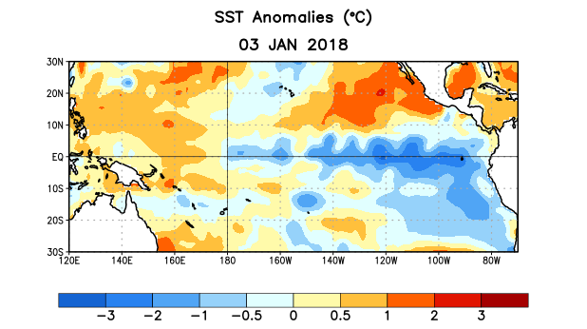
Figure 1. Average sea surface temperature (SST) anomalies (°C) for the week centered on 3 January 2018. Anomalies are computed with respect to the 1981-2010 base period weekly means.

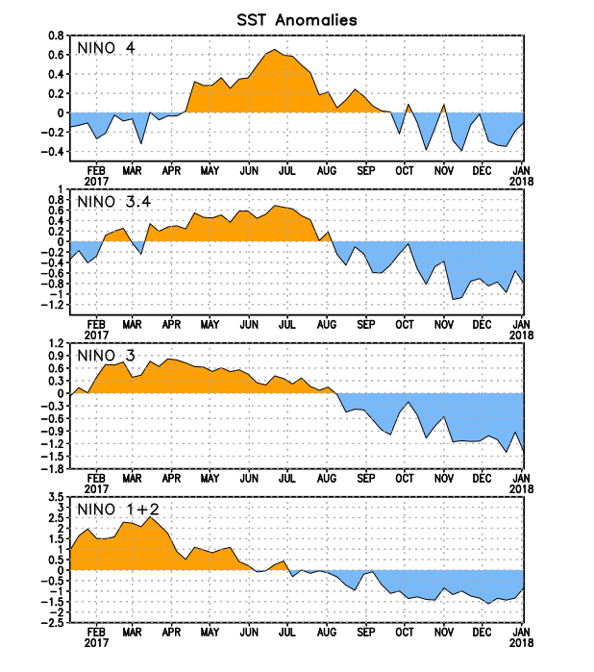
Figure 2. Time series of area-averaged sea surface temperature (SST) anomalies (°C) in the Niño regions [Niño-1+2 (0°-10°S, 90°W-80°W), Niño-3 (5°N-5°S, 150°W-90°W), Niño-3.4 (5°N-5°S, 170°W-120°W), Niño-4 (5ºN-5ºS , 150ºW-160ºE]. SST anomalies are departures from the 1981-2010 base period weekly means.
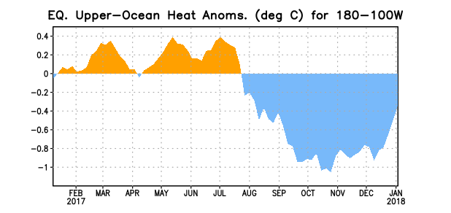
Figure 3. Area-averaged upper-ocean heat content anomaly (°C) in the equatorial Pacific (5°N-5°S, 180º-100ºW). The heat content anomaly is computed as the departure from the 1981-2010 base period pentad means.

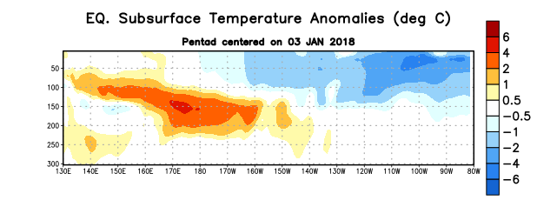
Figure 4. Depth-longitude section of equatorial Pacific upper-ocean (0-300m) temperature anomalies (°C) centered on the pentad of 3 January 2018. Anomalies are departures from the 1981-2010 base period pentad means.

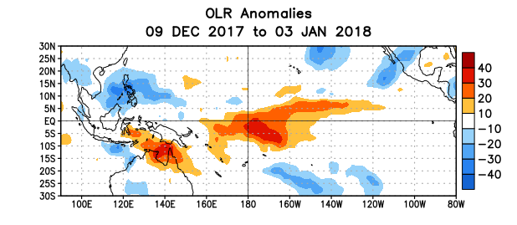
Figure 5. Average outgoing longwave radiation (OLR) anomalies (W/m²) for the period 9 December 2017 – 3 January 2018. OLR anomalies are computed as departures from the 1981-2010 base period pentad means.

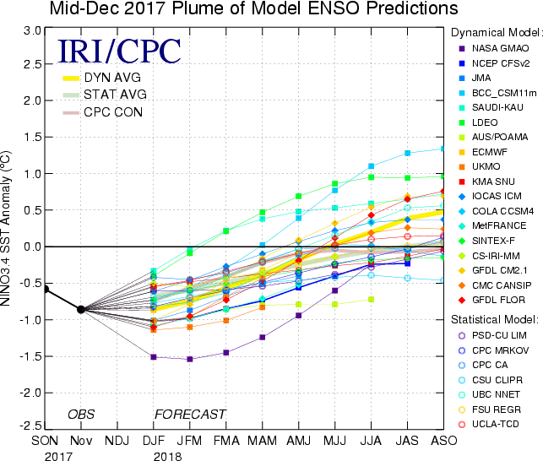

Figure 6. Forecasts of sea surface temperature (SST) anomalies for the Niño 3.4 region (5°N-5°S, 120°W-170°W). Figure updated 18 December 2017.

