EL NIÑO/SOUTHERN OSCILLATION (ENSO) DIAGNOSTIC DISCUSSION

issued by

CLIMATE PREDICTION CENTER/NCEP/NWS

and the International Research Institute for Climate and Society

10 January 2019

ENSO Alert System Status: El Niño Watch

Synopsis: El Niño is expected to form and continue through the Northern Hemisphere spring 2019 (~65% chance).

ENSO-neutral continued during December 2018, despite widespread above-average sea surface temperatures (SSTs) across the equatorial Pacific Ocean (Fig. 1). In the last couple of weeks, all four Niño indices decreased, with the latest weekly values at +0.2°C in the Niño-1+2 region and near +0.7°C in the other regions (Fig. 2). Positive subsurface temperature anomalies (averaged across 180°-100°W) also weakened (Fig. 3), but above-average temperatures continued at depth across most of the equatorial Pacific Ocean (Fig. 4). The atmospheric anomalies largely reflected intra-seasonal variability related to the Madden-Julian Oscillation, and have not yet shown a clear coupling to the above-average ocean temperatures. Equatorial convection was generally enhanced west of the Date Line and suppressed east of the Date Line, while anomalies were weak or near average over Indonesia (Fig. 5). Low-level winds were near average, while upper-level wind anomalies were westerly over the eastern Pacific. The traditional Southern Oscillation index was positive, while the equatorial Southern Oscillation index was slightly negative. Despite the above-average ocean temperatures across the equatorial Pacific Ocean, the overall coupled ocean-atmosphere system continued to reflect ENSO-neutral.
The majority of models in the IRI/CPC plume predict a Niño3.4 index of +0.5°C or greater to continue through at least the Northern Hemisphere spring 2019 (Fig. 6). Regardless of the above-average SSTs, the atmospheric circulation over the tropical Pacific has not yet shown clear evidence of coupling to the ocean. The late winter and early spring tend to be the most favorable months for coupling, so forecasters still believe weak El Niño conditions will emerge shortly. However, given the timing and that a weak event is favored, significant global impacts are not anticipated during the remainder of winter, even if conditions were to form. In summary, El Niño is expected to form and continue through the Northern Hemisphere spring 2019 (~65% chance; click CPC/IRI consensus forecast for the chance of each outcome for each 3-month period).
This discussion is a consolidated effort of the National Oceanic and Atmospheric Administration (NOAA), NOAA’s National Weather Service, and their funded institutions. Oceanic and atmospheric conditions are updated weekly on the Climate Prediction Center web site (El Niño/La Niña Current Conditions and Expert Discussions). Forecasts are also updated monthly in the Forecast Forum of CPC's Climate Diagnostics Bulletin. Additional perspectives and analysis are also available in an ENSO blog. The next ENSO Diagnostics Discussion is scheduled for 14 February 2019. To receive an e-mail notification when the monthly ENSO Diagnostic Discussions are released, please send an e-mail message to: ncep.list.enso-update@noaa.gov.

Climate Prediction Center
National Centers for Environmental Prediction
NOAA/National Weather Service
College Park, MD 20740

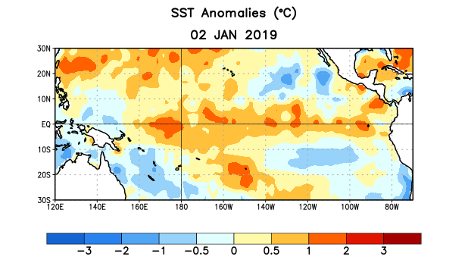
Figure 1. Average sea surface temperature (SST) anomalies (°C) for the week centered on 2 January 2019. Anomalies are computed with respect to the 1981-2010 base period weekly means.

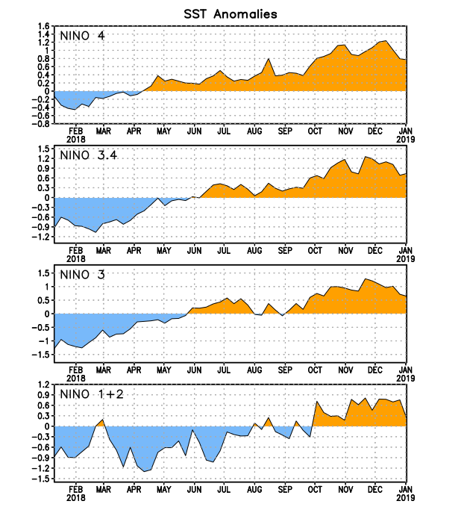
Figure 2. Time series of area-averaged sea surface temperature (SST) anomalies (°C) in the Niño regions [Niño-1+2 (0°-10°S, 90°W-80°W), Niño-3 (5°N-5°S, 150°W-90°W), Niño-3.4 (5°N-5°S, 170°W-120°W), Niño-4 (5ºN-5ºS , 150ºW-160ºE)]. SST anomalies are departures from the 1981-2010 base period weekly means.
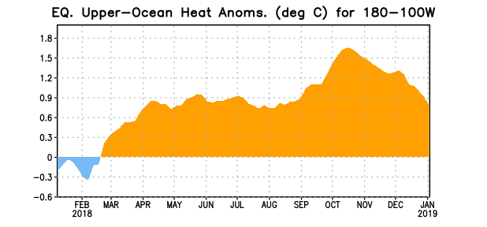
Figure 3. Area-averaged upper-ocean heat content anomaly (°C) in the equatorial Pacific (5°N-5°S, 180º-100ºW). The heat content anomaly is computed as the departure from the 1981-2010 base period pentad means.

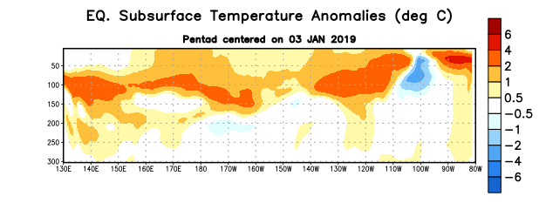
Figure 4. Depth-longitude section of equatorial Pacific upper-ocean (0-300m) temperature anomalies (°C) centered on the pentad of 3 January 2019. Anomalies are departures from the 1981-2010 base period pentad means.

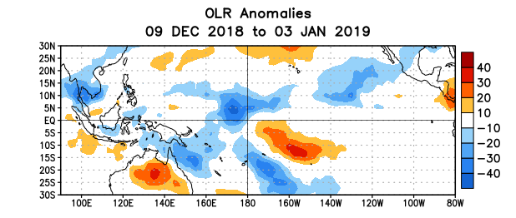
Figure 5. Average outgoing longwave radiation (OLR) anomalies (W/m²) for the period 9 December 2018 – 3 January 2019. OLR anomalies are computed as departures from the 1981-2010 base period pentad means.

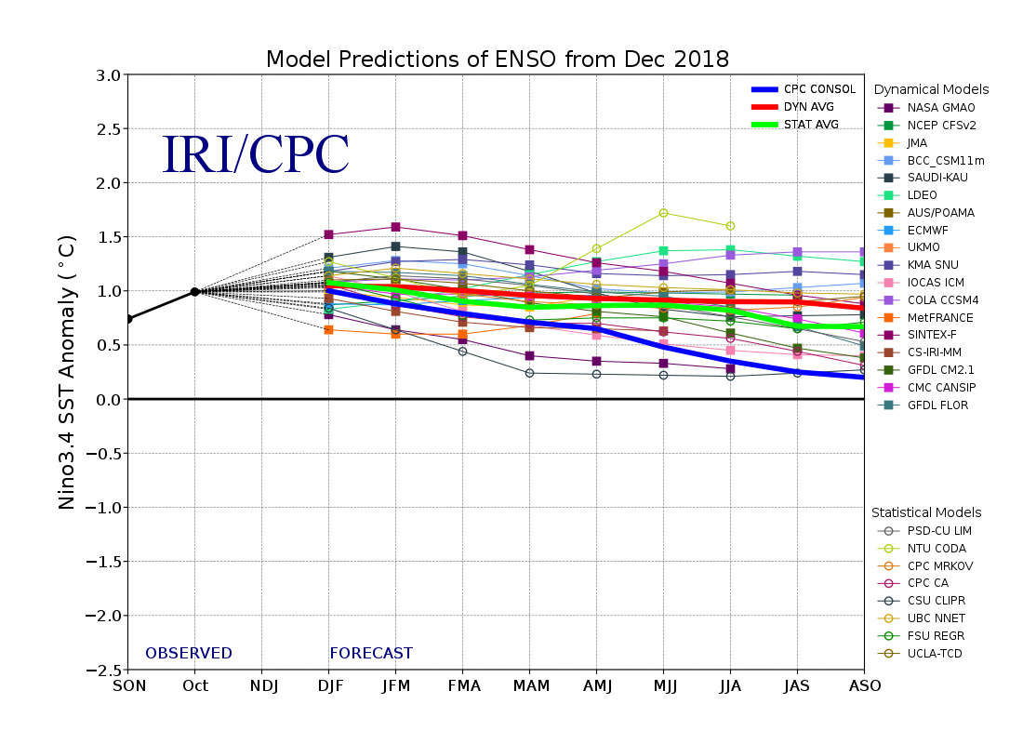
Figure 6. Forecasts of sea surface temperature (SST) anomalies for the Niño 3.4 region (5°N-5°S, 120°W-170°W). Figure updated 19 December 2018.

