EL NIÑO/SOUTHERN OSCILLATION (ENSO) DIAGNOSTIC DISCUSSION

issued by

CLIMATE PREDICTION CENTER/NCEP/NWS

and the International Research Institute for Climate and Society

9 January 2020

ENSO Alert System Status: Not Active

Synopsis: ENSO-neutral is favored through Northern Hemisphere spring 2020 (~60% chance), continuing through summer 2020 (~50% chance).

During December 2019, near-to-above-average sea surface temperatures (SSTs) were evident over the equatorial Pacific Ocean (Fig. 1). Most SST indices increased in the past week, with the eastern Niño-1+2 and Niño-3 regions remaining near average (+0.1°C to +0.3°C), while the Niño-4 and Niño-3.4 regions were warmer at +1.2°C and +0.7°C, respectively (Fig. 2). The recent increase in SST anomalies was partially driven by a combination of low-level westerly wind anomalies and the growth in positive equatorial subsurface temperature anomalies (averaged across 180°-100°W; Fig. 3). The latter indicates a downwelling Kelvin wave, which was evident in the above-average temperatures in the central and east-central Pacific Ocean (Fig. 4). Over the month, westerly wind anomalies persisted over small regions of the western and eastern equatorial Pacific Ocean, while upper-level winds were near average over most of the equator. Tropical convection remained suppressed over Indonesia and east of the Date Line, and was enhanced to the west of the Date Line (Fig. 5). The overall oceanic and atmospheric system was consistent with ENSO-neutral, though recent observations reflected a trend toward warmer conditions that will be monitored.
The majority of models in the IRI/CPC plume (Fig. 6) continue to mostly favor ENSO-neutral (Niño-3.4 index between -0.5°C and +0.5°C) through the Northern Hemisphere summer. For the December 2019-February 2020 season, the Niño-3.4 index is predicted to be near +0.5°C, which is consistent with the latest observations. The forecasters also favor above-average ocean temperatures to continue in the next month or two, but, in alignment with most model guidance, do not foresee a continuation over several consecutive seasons or shifts in the atmospheric circulation that would indicate El Niño. In summary, ENSO-neutral is favored through Northern Hemisphere spring 2020 (~60% chance), continuing through summer 2020 (~50% chance; click CPC/IRI consensus forecast for the chance of each outcome for each 3-month period).
This discussion is a consolidated effort of the National Oceanic and Atmospheric Administration (NOAA), NOAA’s National Weather Service, and their funded institutions. Oceanic and atmospheric conditions are updated weekly on the Climate Prediction Center web site (El Niño/La Niña Current Conditions and Expert Discussions). Forecasts are also updated monthly in the Forecast Forum of CPC's Climate Diagnostics Bulletin. Additional perspectives and analysis are also available in an ENSO blog. The next ENSO Diagnostics Discussion is scheduled for 13 February 2020. To receive an e-mail notification when the monthly ENSO Diagnostic Discussions are released, please send an e-mail message to: ncep.list.enso-update@noaa.gov.

Climate Prediction Center
National Centers for Environmental Prediction
NOAA/National Weather Service
College Park, MD 20740

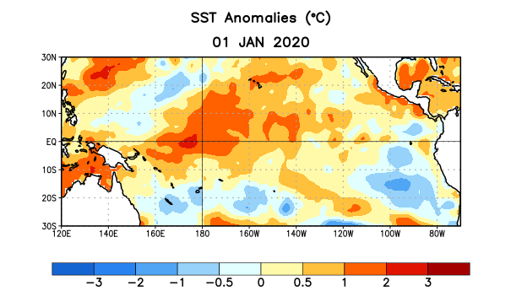
Figure 1. Average sea surface temperature (SST) anomalies (°C) for the week centered on 1 January 2020. Anomalies are computed with respect to the 1981-2010 base period weekly means.

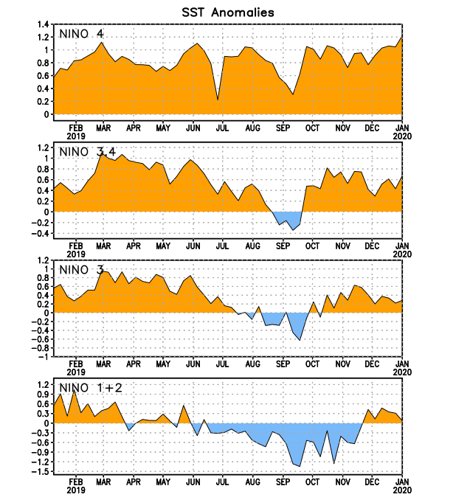
Figure 2. Time series of area-averaged sea surface temperature (SST) anomalies (°C) in the Niño regions [Niño-1+2 (0°-10°S, 90°W-80°W), Niño-3 (5°N-5°S, 150°W-90°W), Niño-3.4 (5°N-5°S, 170°W-120°W), Niño-4 (5ºN-5ºS , 150ºW-160ºE)]. SST anomalies are departures from the 1981-2010 base period weekly means.
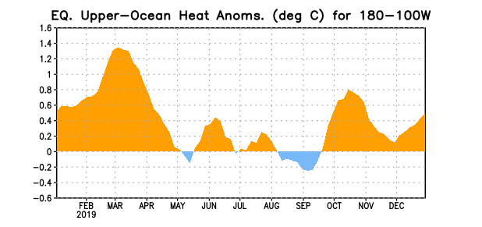
Figure 3. Area-averaged upper-ocean heat content anomaly (°C) in the equatorial Pacific (5°N-5°S, 180º-100ºW). The heat content anomaly is computed as the departure from the 1981-2010 base period pentad means.

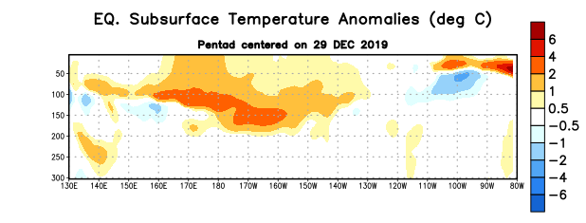
Figure 4. Depth-longitude section of equatorial Pacific upper-ocean (0-300m) temperature anomalies (°C) centered on the pentad of 29 December 2019. Anomalies are departures from the 1981-2010 base period pentad means.

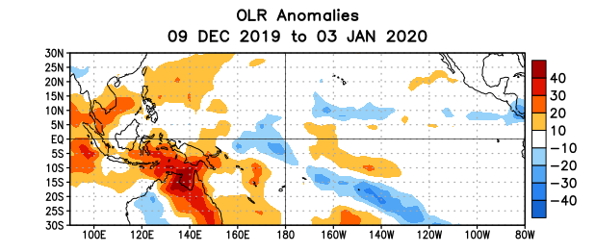
Figure 5. Average outgoing longwave radiation (OLR) anomalies (W/m²) for the period 9 December 2019 – 3 January 2020. OLR anomalies are computed as departures from the 1981-2010 base period pentad means.

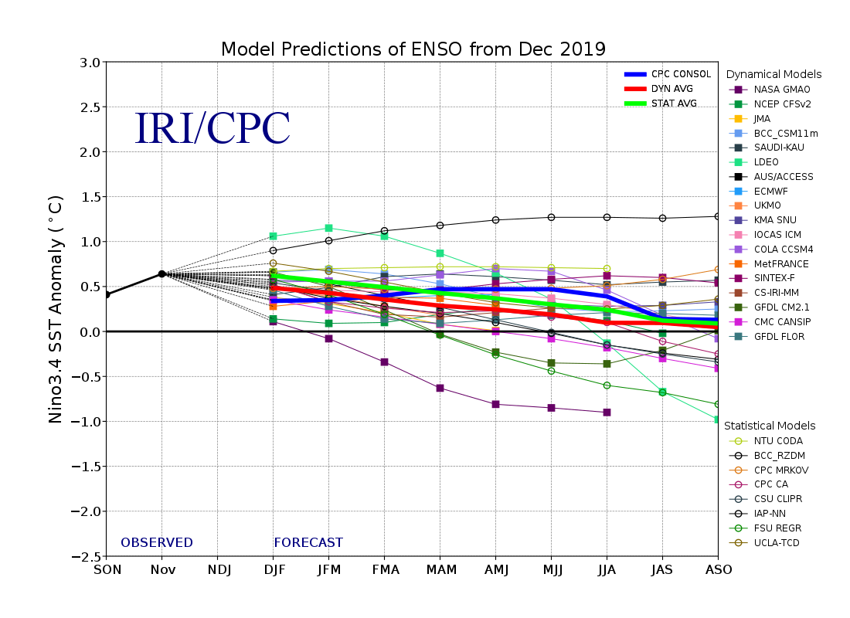
Figure 6. Forecasts of sea surface temperature (SST) anomalies for the Niño 3.4 region (5°N-5°S, 120°W-170°W). Figure updated 19 December 2019.

