EL NIÑO/SOUTHERN OSCILLATION (ENSO) DIAGNOSTIC DISCUSSION

issued by

CLIMATE PREDICTION CENTER/NCEP/NWS

and the International Research Institute for Climate and Society

14 January 2021

ENSO Alert System Status: La Niña Advisory

Synopsis: La Niña is expected to continue through the Northern Hemisphere winter 2020-21 (~95% chance during January-March), with a potential transition to ENSO-neutral during the spring 2021 (55% chance during April-June).

Below-average sea surface temperatures (SSTs) extend from the western to the eastern Pacific Ocean, and reflect the continuation of La Niña (Fig. 1). Most of the Niño indices were relatively steady throughout the month (the latest weekly Niño-3.4 index value was -1.1ºC), with negative values strengthening to -1.2ºC in the westernmost Niño-4 region (Fig. 2). The subsurface temperature anomalies on the equator (averaged from 180°-100°W) remained negative (Fig. 3), but weakened slightly in the eastern equatorial Pacific Ocean (Fig. 4). The atmospheric circulation associated with La Niña strengthened over the tropical Pacific Ocean during the month. Low-level wind anomalies were easterly over the western to east-central tropical Pacific and upper-level wind anomalies were westerly across most of the tropical Pacific. Tropical convection was suppressed over the western and central Pacific and enhanced around the Philippines and parts of Indonesia (Fig. 5). Both the Southern Oscillation and Equatorial Southern Oscillation strengthened during December. Overall, the coupled ocean-atmosphere system is consistent with the ongoing La Niña.
A majority of the models in the IRI/CPC plume predict La Niña to continue through the Northern Hemisphere spring (Fig. 6). The forecaster consensus is in line with the models and suggests a transition to ENSO-neutral in the late spring 2021. However, the forecast uncertainty increases throughout the summer and fall, which is reflected by the lower probabilities (less than ~50%) for La Niña and ENSO-neutral. These low forecast probabilities beyond the spring are consistent with the spring predictability barrier, when model forecasts are historically less accurate than during other times of the year. In summary, La Niña is expected to continue through the Northern Hemisphere winter 2020-21 (~95% chance for January-March), with a potential transition to ENSO-neutral during the spring 2021 (55% chance during April-June; click CPC/IRI consensus forecast for the chances in each 3-month period).
La Niña is anticipated to affect climate across the United States during the upcoming months. The 3-month seasonal temperature and precipitation outlooks will be updated on Thursday January 21st.
This discussion is a consolidated effort of the National Oceanic and Atmospheric Administration (NOAA), NOAA’s National Weather Service, and their funded institutions. Oceanic and atmospheric conditions are updated weekly on the Climate Prediction Center web site (El Niño/La Niña Current Conditions and Expert Discussions). Additional perspectives and analysis are also available in an ENSO blog. A probabilistic strength forecast is available here. The next ENSO Diagnostics Discussion is scheduled for 11 February 2021. To receive an e-mail notification when the monthly ENSO Diagnostic Discussions are released, please send an e-mail message to: ncep.list.enso-update@noaa.gov.

Climate Prediction Center
National Centers for Environmental Prediction
NOAA/National Weather Service
College Park, MD 20740

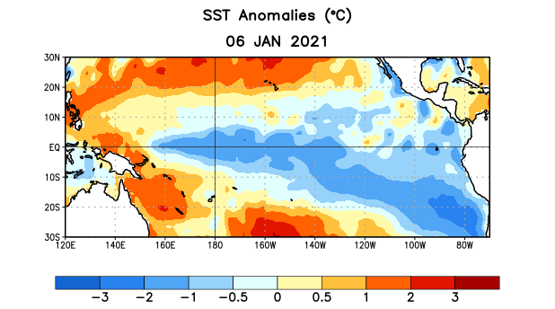
Figure 1. Average sea surface temperature (SST) anomalies (°C) for the week centered on 6 January 2021. Anomalies are computed with respect to the 1981-2010 base period weekly means.

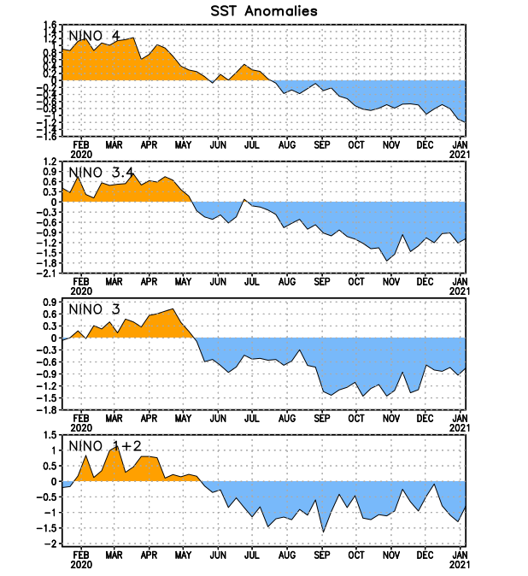
Figure 2. Time series of area-averaged sea surface temperature (SST) anomalies (°C) in the Niño regions [Niño-1+2 (0°-10°S, 90°W-80°W), Niño-3 (5°N-5°S, 150°W-90°W), Niño-3.4 (5°N-5°S, 170°W-120°W), Niño-4 (5ºN-5ºS , 150ºW-160ºE)]. SST anomalies are departures from the 1981-2010 base period weekly means.
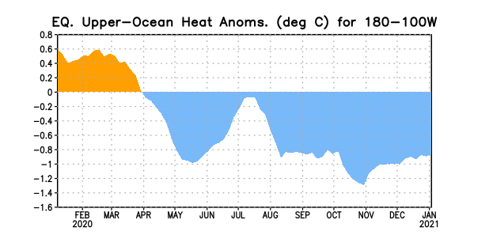
Figure 3. Area-averaged upper-ocean heat content anomaly (°C) in the equatorial Pacific (5°N-5°S, 180º-100ºW). The heat content anomaly is computed as the departure from the 1981-2010 base period pentad means.

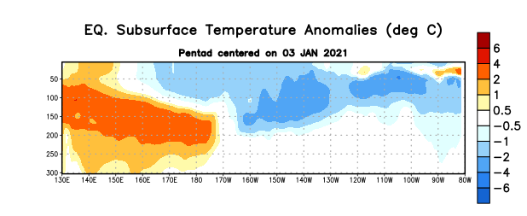
Figure 4. Depth-longitude section of equatorial Pacific upper-ocean (0-300m) temperature anomalies (°C) centered on the pentad of 3 January 2021. Anomalies are departures from the 1981-2010 base period pentad means.

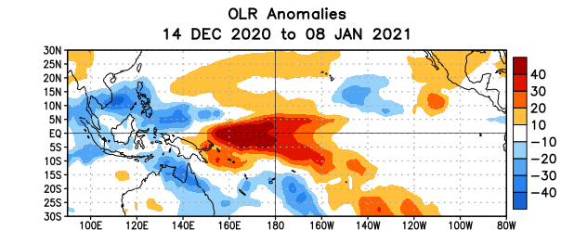
Figure 5. Average outgoing longwave radiation (OLR) anomalies (W/m²) for the period 14 December 2020 – 8 January 2021. OLR anomalies are computed as departures from the 1981-2010 base period pentad means.

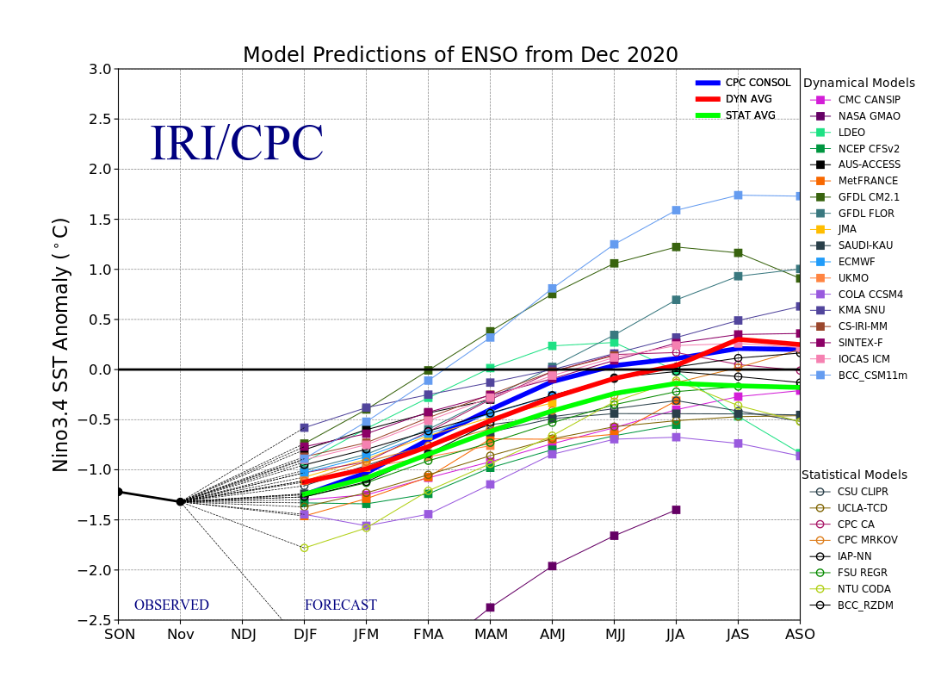
Figure 6. Forecasts of sea surface temperature (SST) anomalies for the Niño 3.4 region (5°N-5°S, 120°W-170°W). Figure updated 19 December 2020.

