EL NIÑO/SOUTHERN OSCILLATION (ENSO) DIAGNOSTIC DISCUSSION

issued by

CLIMATE PREDICTION CENTER/NCEP/NWS

and the International Research Institute for Climate and Society

13 January 2022

ENSO Alert System Status: La Niña Advisory

Synopsis: La Niña is likely to continue into the Northern Hemisphere spring (67% chance during March-May 2022) and then transition to ENSO-neutral (51% chance during April-June 2022).

In December 2021, below-average sea surface temperatures (SSTs) across the central and eastern equatorial Pacific Ocean were consistent with a mature La Niña (Fig. 1). With the exception of the westernmost Niño-4 region, which warmed to -0.4ºC at the end of the December, the other Niño indices were between -0.9ºC and -1.4ºC during the last week (Fig. 2). Below-average subsurface temperatures weakened east of the Date Line (Fig. 3), reflecting the slow eastward movement of positive temperature anomalies, at depth, from the western into the central Pacific Ocean (Fig. 4). However, below-average subsurface temperatures still dominated the eastern Pacific from ~200m to the surface. Low-level easterly wind anomalies and upper-level westerly wind anomalies prevailed over the east-central and eastern Pacific Ocean. Enhanced convection persisted near Indonesia and the western Pacific, while suppressed convection remained over the Date Line (Fig. 5). Overall, the coupled ocean-atmosphere system reflected a mature La Niña.
The IRI/CPC plume average for the Niño-3.4 SST index continues to forecast a transition to ENSO-neutral during the Northern Hemisphere spring (Fig. 6). The forecaster consensus this month favors the continuation of La Niña through March-May 2022, with a transition to ENSO-neutral occurring in April-June 2022 (51% chance). ENSO-neutral is then expected to persist through the Northern Hemisphere summer, though chances do not exceed 57% (for May-July 2022), which is consistent with the generally lower confidence forecasts made through the spring. In summary, La Niña is likely to continue into the Northern Hemisphere spring (67% chance during March-May 2022) and then transition to ENSO-neutral (51% chance during April-June; click CPC/IRI consensus forecast for the chances in each 3-month period).
La Niña is anticipated to affect temperature and precipitation across the United States during the upcoming months (the 3-month seasonal temperature and precipitation outlooks will be updated on Thurs. Jan. 20th).
This discussion is a consolidated effort of the National Oceanic and Atmospheric Administration (NOAA), NOAA’s National Weather Service, and their funded institutions. Oceanic and atmospheric conditions are updated weekly on the Climate Prediction Center web site (El Niño/La Niña Current Conditions and Expert Discussions). Additional perspectives and analysis are also available in an ENSO blog. A probabilistic strength forecast is available here. The next ENSO Diagnostics Discussion is scheduled for 10 February 2022. To receive an e-mail notification when the monthly ENSO Diagnostic Discussions are released, please send an e-mail message to: ncep.list.enso-update@noaa.gov.

Climate Prediction Center
National Centers for Environmental Prediction
NOAA/National Weather Service
College Park, MD 20740

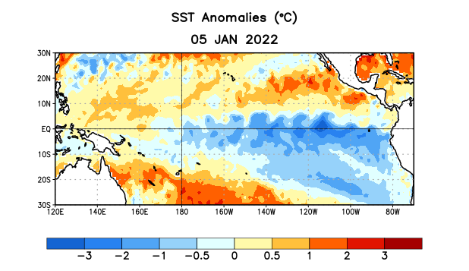
Figure 1. Average sea surface temperature (SST) anomalies (°C) for the week centered on 5 January 2022. Anomalies are computed with respect to the 1991-2020 base period weekly means.

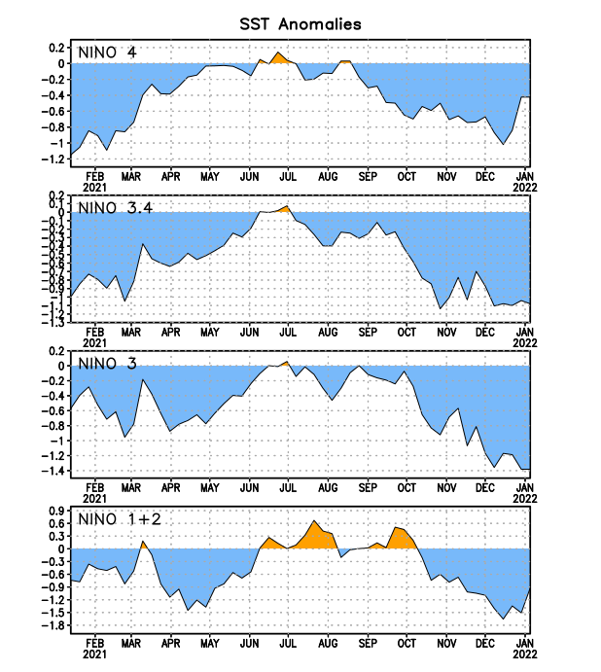
Figure 2. Time series of area-averaged sea surface temperature (SST) anomalies (°C) in the Niño regions [Niño-1+2 (0°-10°S, 90°W-80°W), Niño-3 (5°N-5°S, 150°W-90°W), Niño-3.4 (5°N-5°S, 170°W-120°W), Niño-4 (5ºN-5ºS, 150ºW-160ºE)]. SST anomalies are departures from the 1991-2020 base period weekly means.
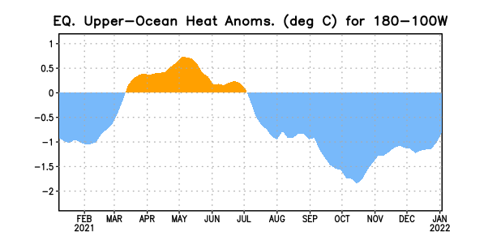
Figure 3. Area-averaged upper-ocean heat content anomaly (°C) in the equatorial Pacific (5°N-5°S, 180º-100ºW). The heat content anomaly is computed as the departure from the 1991-2020 base period pentad means.

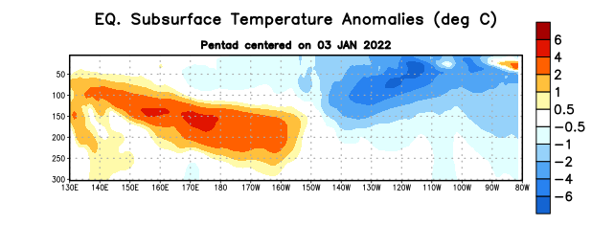

Figure 4. Depth-longitude section of equatorial Pacific upper-ocean (0-300m) temperature anomalies (°C) centered on the pentad of 3 January 2022. Anomalies are departures from the 1991-2020 base period pentad means.

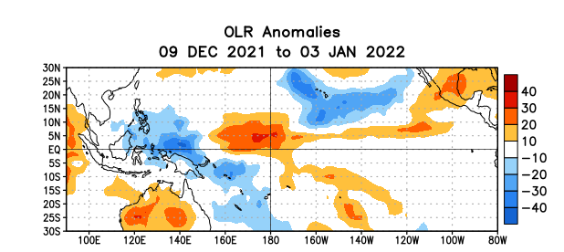

Figure 5. Average outgoing longwave radiation (OLR) anomalies (W/m²) for the period 9 December 2021 – 3 January 2022. OLR anomalies are computed as departures from the 1991-2020 base period pentad means.

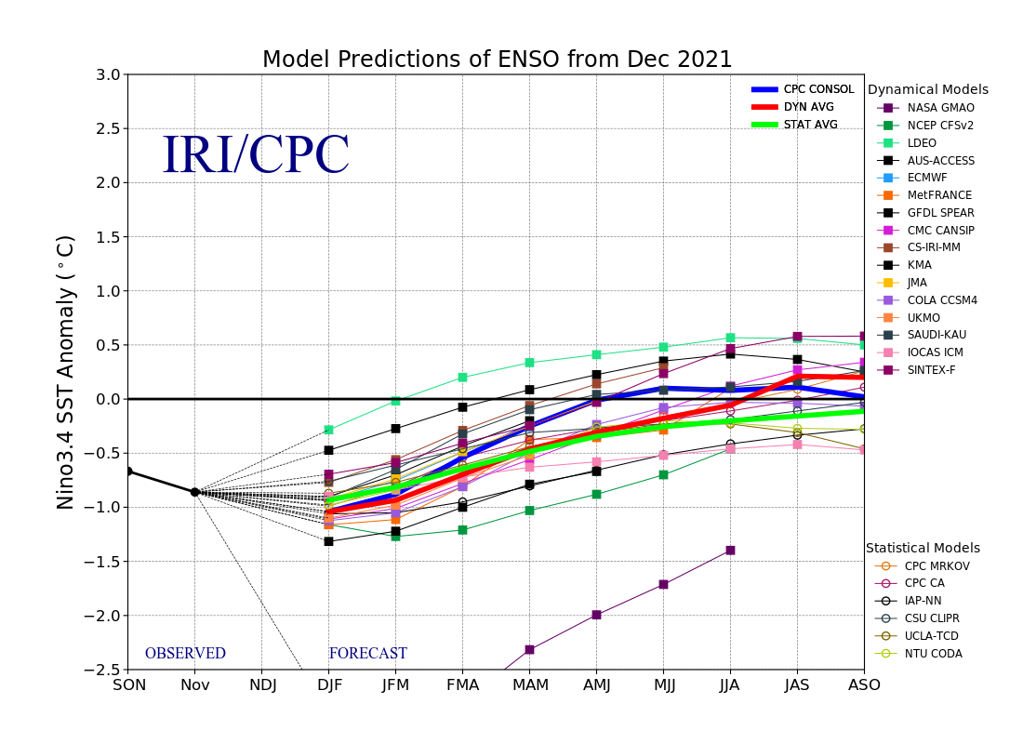
Figure 6. Forecasts of sea surface temperature (SST) anomalies for the Niño 3.4 region (5°N-5°S, 120°W-170°W). Figure updated 20 December 2021.

