EL NIÑO/SOUTHERN OSCILLATION (ENSO) DIAGNOSTIC DISCUSSION

issued by

CLIMATE PREDICTION CENTER/NCEP/NWS

12 January 2023

ENSO Alert System Status: La Niña Advisory

Synopsis: A transition from La Niña to ENSO-neutral is anticipated during the February-April 2023 season. By Northern Hemisphere spring (March-May 2023), the chance for ENSO-neutral is 82%.

During December, below-average sea surface temperatures (SSTs) weakened over the equatorial Pacific Ocean (Fig. 1). All of the latest weekly Niño index values were between -0.7ºC and -0.8ºC (Fig. 2). The subsurface temperature anomalies also weakened substantially (Fig. 3), but below-average subsurface temperatures persisted near the surface and at depth in the eastern equatorial Pacific Ocean (Fig. 4). However, the atmospheric circulation anomalies over the tropical Pacific Ocean did not notably weaken. Low-level easterly wind and upper-level westerly wind anomalies remained across most of the equatorial Pacific. Suppressed convection persisted over the western and central tropical Pacific, while enhanced convection was observed around Indonesia (Fig. 5). Overall, the coupled ocean-atmosphere system continued to reflect La Niña.
The most recent IRI plume predicts that La Niña will transition to ENSO-neutral during the Northern Hemisphere winter 2022-23 (Fig. 6). Interestingly, the dynamical models indicate a faster transition (January-March) than the statistical models (February-April). At this time, the forecaster consensus favors the statistical models, with a transition to ENSO-neutral in the February-April 2023 season. The sustained atmospheric circulation anomalies and the weakening downwelling oceanic Kelvin wave do not support an imminent transition. However, lower accuracy during times of transition, and when predictions go through the spring, means that uncertainty remains high. In summary, a transition from La Niña to ENSO-neutral is anticipated during the February-April 2023 season. By Northern Hemisphere spring (March-May 2023), the chance for ENSO-neutral is 82% (Fig. 7).
This discussion is a consolidated effort of the National Oceanic and Atmospheric Administration (NOAA), NOAA’s National Weather Service, and their funded institutions. Oceanic and atmospheric conditions are updated weekly on the Climate Prediction Center website (El Niño/La Niña Current Conditions and Expert Discussions). Additional perspectives and analyses are also available in an ENSO blog. A probabilistic strength forecast is available here. The next ENSO Diagnostics Discussion is scheduled for 9 February 2023. To receive an e-mail notification when the monthly ENSO Diagnostic Discussions are released, please send an e-mail message to: ncep.list.enso-update@noaa.gov.

Climate Prediction Center
National Centers for Environmental Prediction
NOAA/National Weather Service
College Park, MD 20740
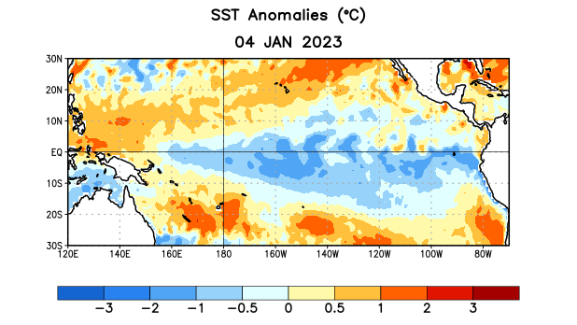
Figure 1. Average sea surface temperature (SST) anomalies (°C) for the week centered on 4 January 2023. Anomalies are computed with respect to the 1991-2020 base period weekly means.

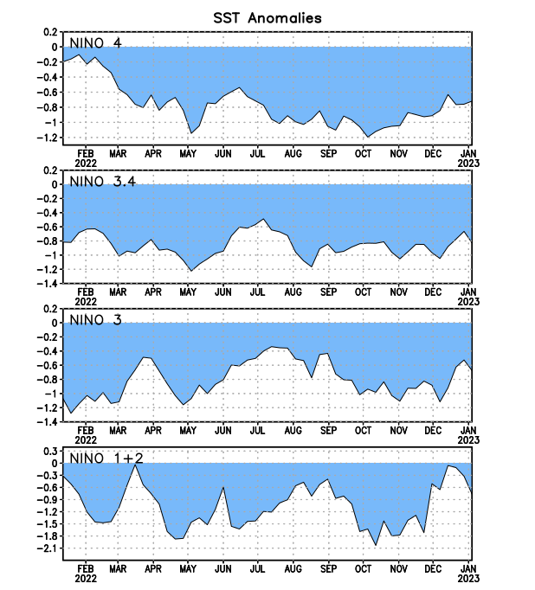
Figure 2. Time series of area-averaged sea surface temperature (SST) anomalies (°C) in the Niño regions [Niño-1+2 (0°-10°S, 90°W-80°W), Niño-3 (5°N-5°S, 150°W-90°W), Niño-3.4 (5°N-5°S, 170°W-120°W), Niño-4 (5ºN-5ºS, 150ºW-160ºE)]. SST anomalies are departures from the 1991-2020 base period weekly means.

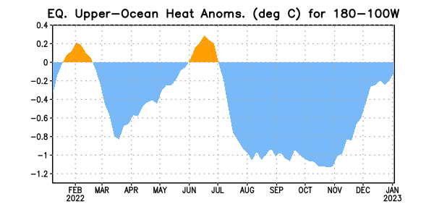

Figure 3. Area-averaged upper-ocean heat content anomaly (°C) in the equatorial Pacific (5°N-5°S, 180º-100ºW). The heat content anomaly is computed as the departure from the 1991-2020 base period pentad means.

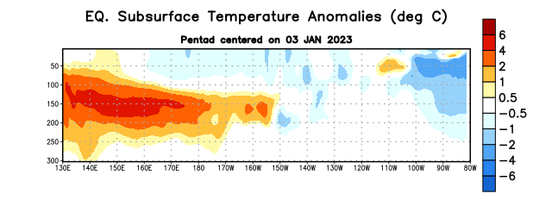
Figure 4. Depth-longitude section of equatorial Pacific upper-ocean (0-300m) temperature anomalies (°C) centered on the pentad of 3 January 2023. Anomalies are departures from the 1991-2020 base period pentad means.

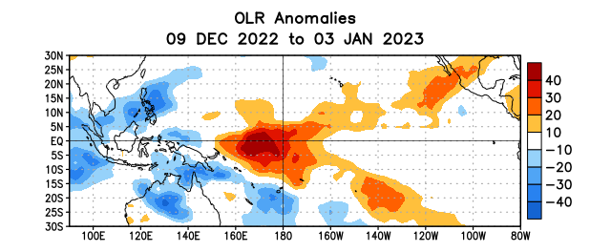

Figure 5. Average outgoing longwave radiation (OLR) anomalies (W/m²) for the period 9 December 2022 – 3 January 2023. OLR anomalies are computed as departures from the 1991-2020 base period pentad means.

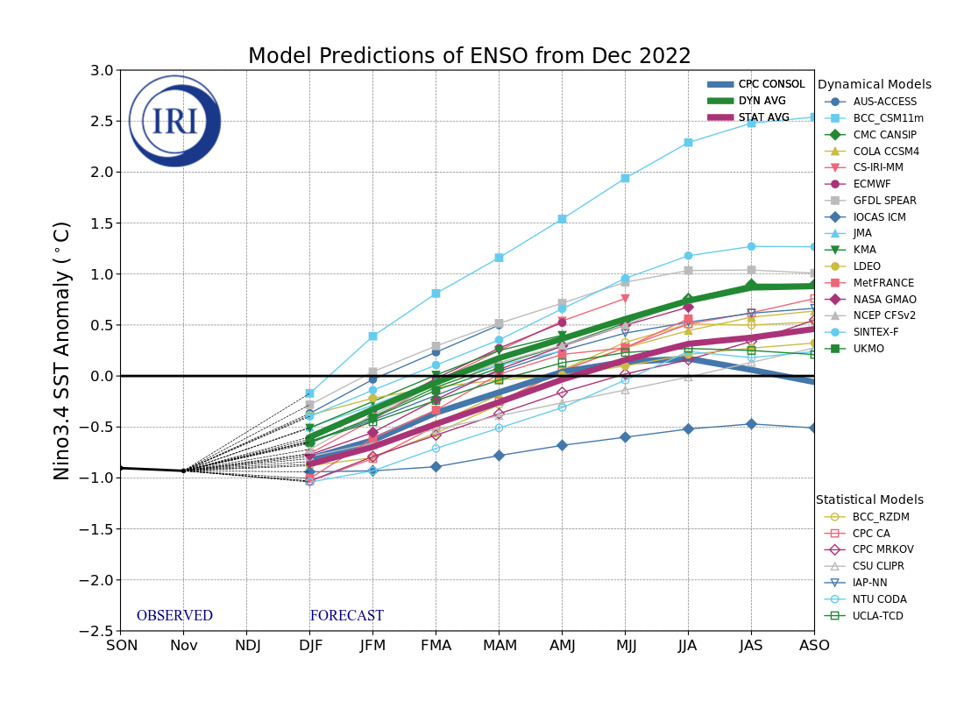
Figure 6. Forecasts of sea surface temperature (SST) anomalies for the Niño 3.4 region (5°N-5°S, 120°W-170°W). Figure updated 19 December 2022 by the International Research Institute (IRI) for Climate and Society.
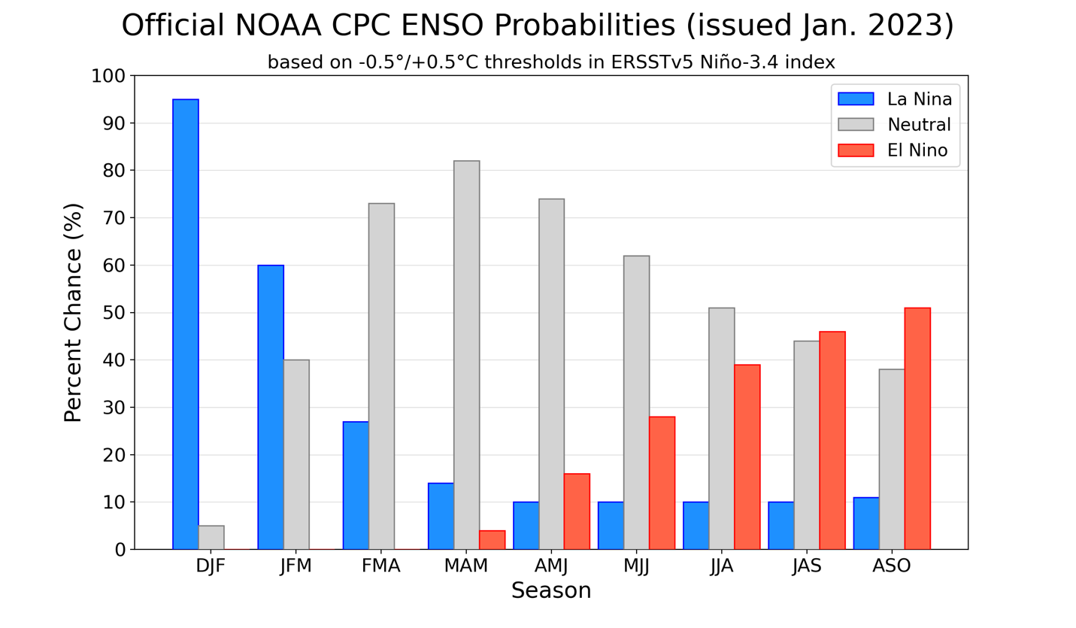
Figure 7. Official ENSO probabilities for the Niño 3.4 sea surface temperature index (5°N-5°S,
120°W-170°W). Figure updated 12 January 2023.

