EL NIÑO/SOUTHERN OSCILLATION (ENSO) DIAGNOSTIC DISCUSSION

issued by

CLIMATE PREDICTION CENTER/NCEP/NWS

11 January 2024

ENSO Alert System Status: El Niño Advisory

Synopsis: El Niño is expected to continue for the next several seasons, with ENSO-neutral favored during April-June 2024 (73% chance).

Above-average sea surface temperatures (SST) persisted across the equatorial Pacific Ocean, with the largest anomalies observed in the central and east-central Pacific (Fig. 1). The latest weekly Niño index values remained at +1.4ºC in Niño-4, +1.9ºC in Niño-3.4, and +2.0ºC in Niño-3, while Niño-1+2 weakened to +1.0ºC (Fig. 2). Area-averaged positive subsurface temperature anomalies decreased in December (Fig. 3), reflecting the strengthening and eastward expansion of below-average subsurface temperatures in the western Pacific (Fig. 4). Over the east-central Pacific Ocean, low-level wind anomalies were westerly, while upper-level wind anomalies were easterly. Convection/rainfall remained enhanced at the Date Line and was suppressed around Indonesia (Fig. 5). The equatorial and station-based SOI were negative. Collectively, the coupled ocean-atmosphere system reflected a strong and mature El Niño.
The most recent IRI plume indicates El Niño will gradually weaken and then transition to ENSO-neutral during spring 2024 (Fig. 6). Some state-of the-art dynamical climate models suggest a transition to ENSO-neutral as soon as March-May 2024. The forecast team, however, delays this timing and strongly favors a transition to ENSO-neutral in April-June 2024. There are also increasing odds of La Niña in the seasons following a shift to ENSO-neutral. It is typical for El Niño to peak in December/early January, but despite weakening, its impacts on the United States could last through April (see CPC seasonal outlooks for probabilities of temperature and precipitation). In summary, El Niño is expected to continue for the next several seasons, with ENSO-neutral favored during April-June 2024 (73% chance; Fig. 7).
This discussion is a consolidated effort of the National Oceanic and Atmospheric Administration (NOAA), NOAA’s National Weather Service, and their funded institutions. Oceanic and atmospheric conditions are updated weekly on the Climate Prediction Center website (El Niño/La Niña Current Conditions and Expert Discussions). Additional perspectives and analyses are also available in an ENSO blog. A probabilistic strength forecast is available here. The next ENSO Diagnostics Discussion is scheduled for 8 February 2024. To receive an e-mail notification when the monthly ENSO Diagnostic Discussions are released, please send an e-mail message to: ncep.list.enso-update@noaa.gov.

Climate Prediction Center
National Centers for Environmental Prediction
NOAA/National Weather Service
College Park, MD 20740
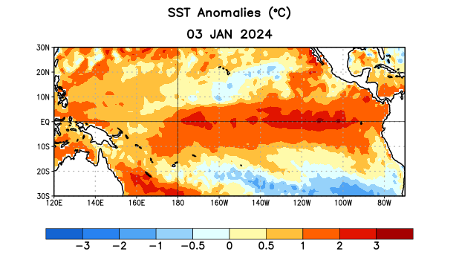
Figure 1. Average sea surface temperature (SST) anomalies (°C) for the week centered on 3 January 2024. Anomalies are computed with respect to the 1991-2020 base period weekly means.

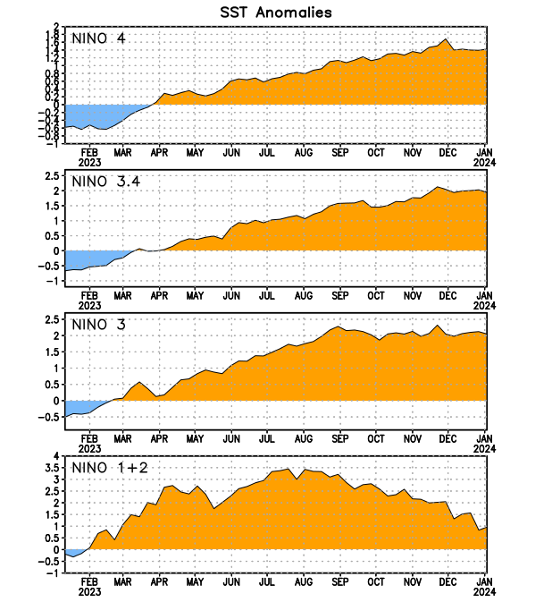
Figure 2. Time series of area-averaged sea surface temperature (SST) anomalies (°C) in the Niño regions [Niño-1+2 (0°-10°S, 90°W-80°W), Niño-3 (5°N-5°S, 150°W-90°W), Niño-3.4 (5°N-5°S, 170°W-120°W), Niño-4 (5ºN-5ºS, 150ºW-160ºE)]. SST anomalies are departures from the 1991-2020 base period weekly means.

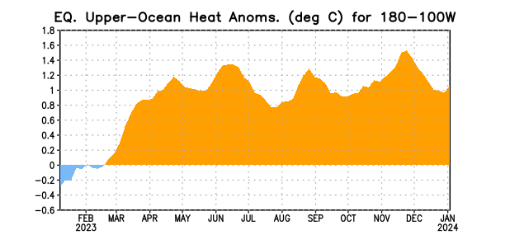

Figure 3. Area-averaged upper-ocean heat content anomaly (°C) in the equatorial Pacific (5°N-5°S, 180º-100ºW). The heat content anomaly is computed as the departure from the 1991-2020 base period pentad means.

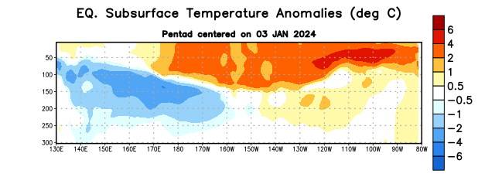
Figure 4. Depth-longitude section of equatorial Pacific upper-ocean (0-300m) temperature anomalies (°C) centered on the pentad of 3 January 2024. Anomalies are departures from the 1991-2020 base period pentad means.

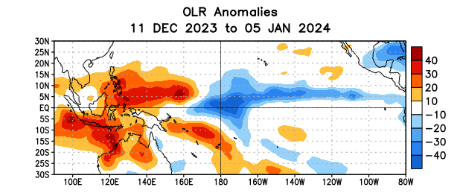

Figure 5. Average outgoing longwave radiation (OLR) anomalies (W/m²) for the period 11 December 2023 – 5 January 2024. OLR anomalies are computed as departures from the 1991-2020 base period pentad means.

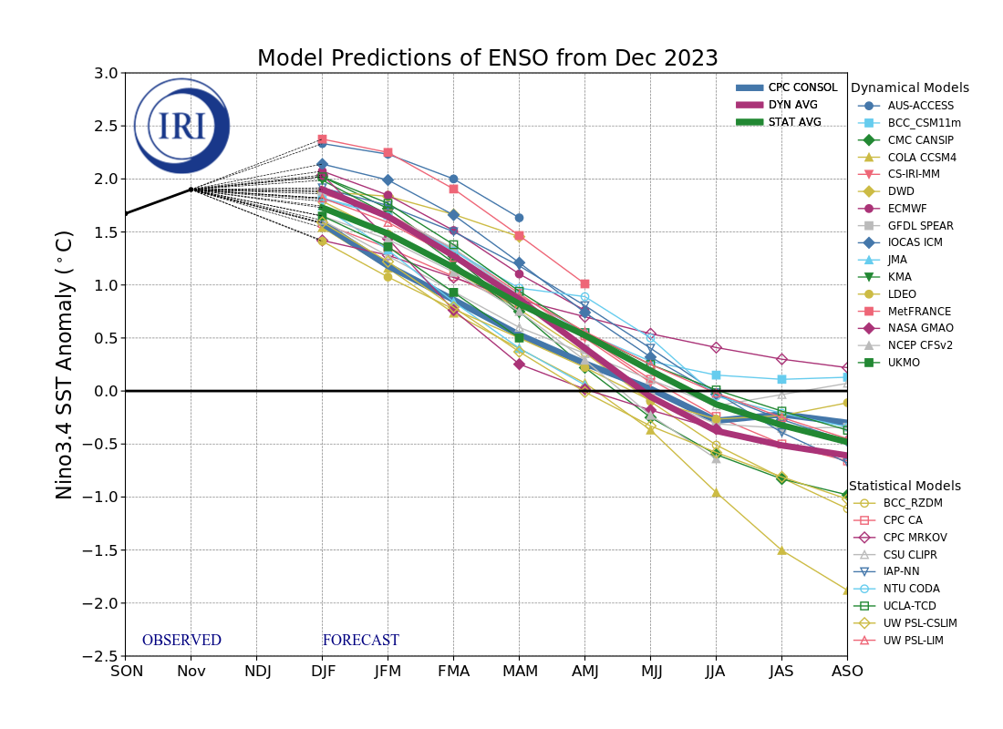
Figure 6. Forecasts of sea surface temperature (SST) anomalies for the Niño 3.4 region (5°N-5°S, 120°W-170°W). Figure updated 19 December 2023 by the International Research Institute (IRI) for Climate and Society.
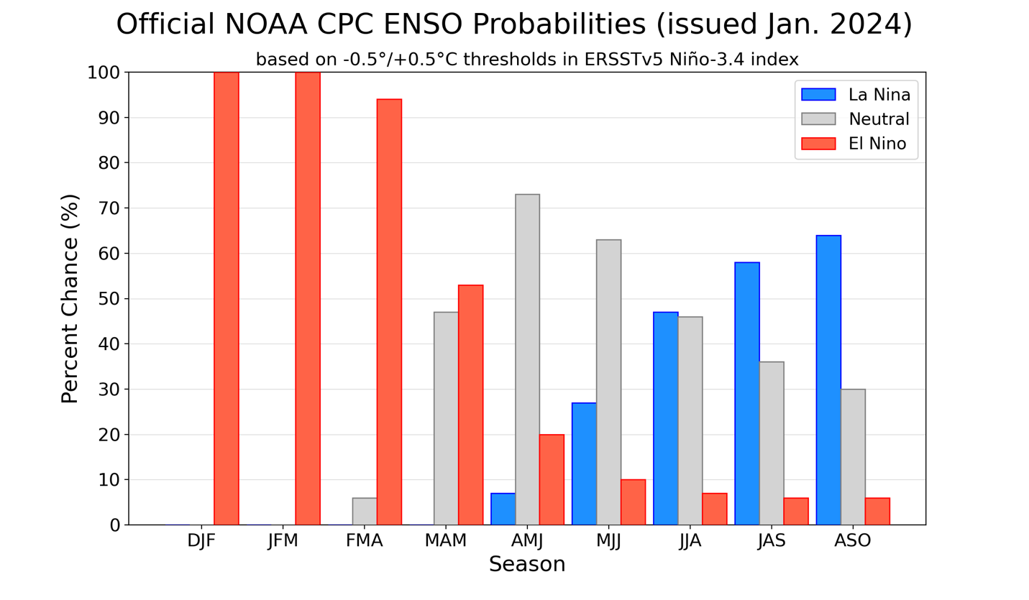
Figure 7. Official ENSO probabilities for the Niño 3.4 sea surface temperature index (5°N-5°S, 120°W-170°W). Figure updated 11 January 2024.

