EL NIÑO/SOUTHERN OSCILLATION (ENSO) DIAGNOSTIC DISCUSSION
issued by
CLIMATE PREDICTION CENTER/NCEP/NWS
12 July 2007

Synopsis: ENSO-neutral conditions are expected to continue during the next 2 months, with ENSO-neutral or La Niña conditions equally likely thereafter.
ENSO-neutral conditions continued in the tropical Pacific during June 2007, with average to below-average sea surface temperatures (SSTs) extending from the date line to the west coast of South America (Fig. 1). The latest weekly SST departures are negative in the Niño 1+2 (−1.1ºC), Niño 3 (−0.6 ºC), and Niño 3.4 (−0.3 ºC) regions, while remaining near zero in the Niño 4 (+0.1ºC) region (Fig. 2).
The evolution toward La Niña conditions slowed during June 2007. The upper-ocean heat content (average temperatures in the upper 300 m of the ocean) in the central and east-central equatorial Pacific remained below-average, but departures were less negative (Fig. 3), consistent with the increased temperatures at thermocline depth (Fig 4). The low-level easterly winds remained stronger than average in the west-central equatorial Pacific, with suppressed convection across the equatorial Pacific and a weak area of enhanced convection over parts of Indonesia and northern Australia. Collectively, these oceanic and atmospheric patterns are consistent with ENSO-neutral conditions.
Nearly all of the model forecasts predict below-average SSTs in the Niño 3.4 region (5°N-5°S, 120-170°W) during the remainder of the year (Fig 5). A majority of the statistical models indicate a continuation of ENSO-neutral conditions through the summer months, with several statistical models forecasting weak La Niña conditions during the fall or winter. In contrast, most dynamical models, including the NCEP Climate Forecast System (CFS), continue to predict a transition to La Niña within the next three months. However, several of the dynamical models have recently been predicting a stronger and more rapid cooling than has actually occurred. Given the large spread in ENSO forecasts, along with the slower than expected decrease in observed SSTs over the past few months, it is reasonable to expect either a slower evolution toward La Niña conditions or the continuation of ENSO-neutral conditions.
This discussion is a consolidated effort of the National Atmospheric and Oceanic Administration (NOAA), NOAA’s National Weather Service, and their funded institutions. Oceanic and atmospheric conditions are updated weekly on the Climate Prediction Center web site (El Niño/La Niña Current Conditions and Expert Discussions). Forecasts for the evolution of El Niño/La Niña are updated monthly in the Forecast Forum section of CPC's Climate Diagnostics Bulletin. The next ENSO Diagnostics Discussion is scheduled for 9 August 2007. To receive an e-mail notification when the monthly ENSO Diagnostic Discussions are released, please send an e-mail message to: ncep.list.enso-update@noaa.gov.
Climate Prediction Center
National Centers for Environmental Prediction
NOAA/National Weather Service
Camp Springs, MD 20746-4304
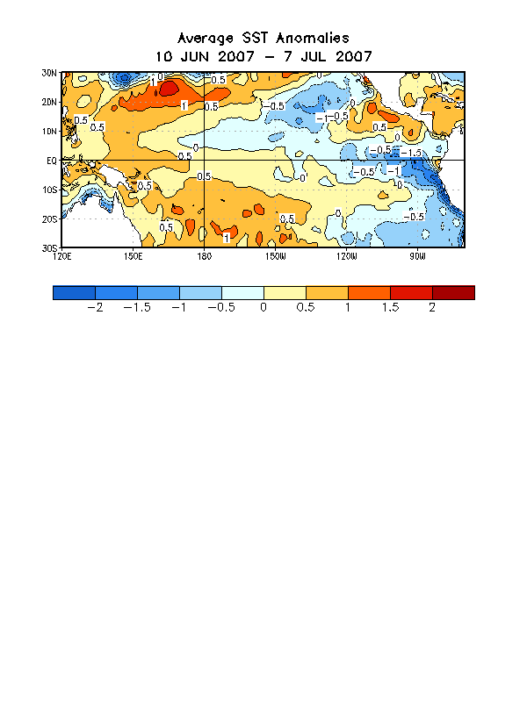
Figure 1. Sea surface temperature (SST) anomalies (°C) during the four-week period 10 June-7 July 2007. SST anomalies are computed with respect to the 1971-2000 base period weekly means (Xue et al. 2003, J. Climate, 16, 1601-1612).

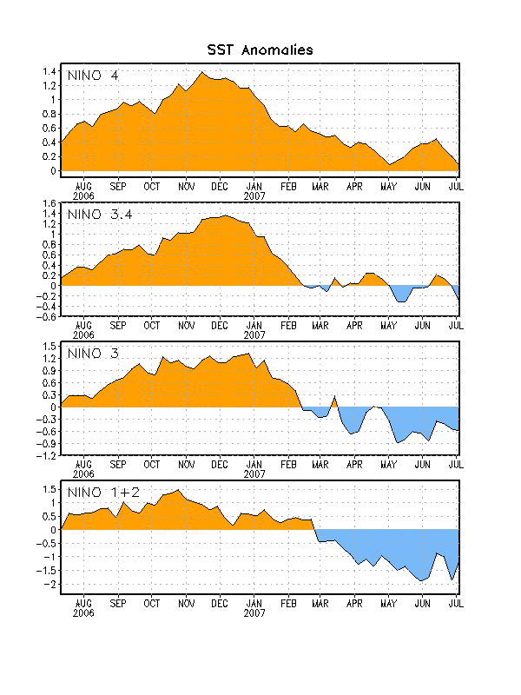Figure 2. Time series of area-averaged sea surface temperature (SST) anomalies (°C) in the Niño regions [Niño-1+2 (0°-10°S, 90°-80°W), Niño 3 (5°N-5°S, 150°W-90°W), Niño-3.4 (5°N-5°S, 170°W-120°W), Niño-4 (150ºW-160ºE and 5ºN-5ºS)]. SST anomalies are departures are from the 1971-2000 base period means (Xue et al. 2003, J. Climate, 16, 1601-1612).

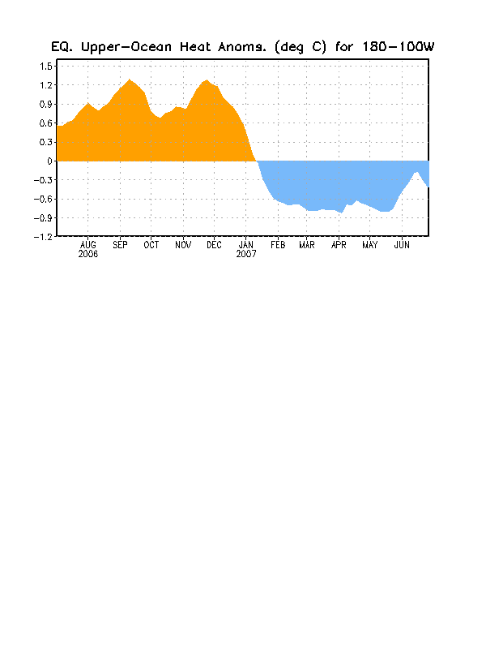

Figure 3. Area-averaged upper-ocean heat content anomalies in the equatorial Pacific (5°N-5°S, 180º-100ºW). Heat content anomalies are computed as departures from the 1982-2004 base period means.

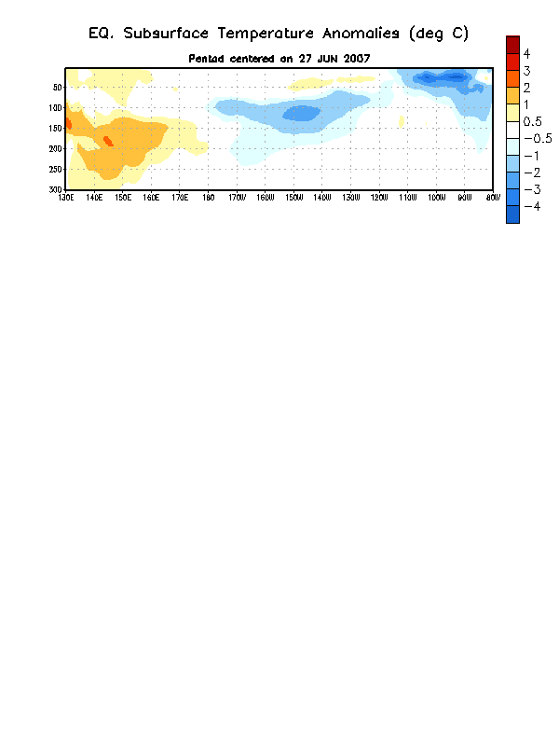

Figure 4. Depth-longitude section of upper-ocean (0-300m) temperature anomalies for the equatorial Pacific averaged between 5°N-5°S. Temperature anomalies are departures from the 1982-2004 base period means.

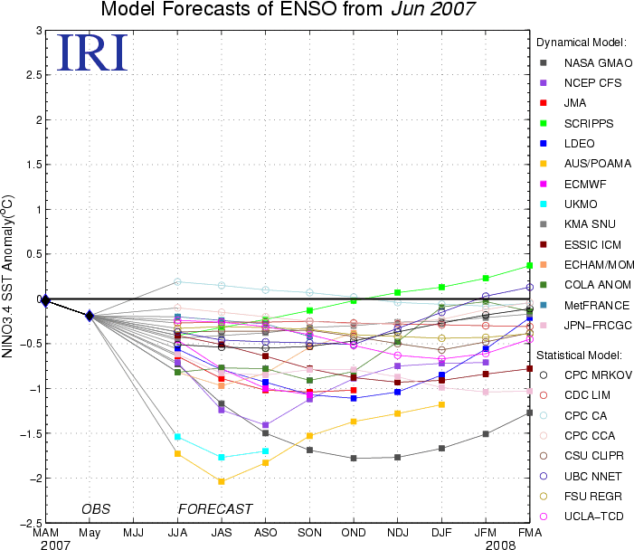
Figure 5. Forecasts of sea surface temperature (SST) anomalies for the Niño 3.4 region (5°N-5°S, 120°W-170°W). Figure courtesy of the International Research Institute (IRI) for Climate and Society.

