EL NIÑO/SOUTHERN OSCILLATION (ENSO) DIAGNOSTIC DISCUSSION

issued by

CLIMATE PREDICTION CENTER/NCEP/NWS
8 July 2010

ENSO Alert System Status: La Niña Watch

Synopsis: La Niña conditions are likely to develop during July – August 2010.
During June 2010, sea surface temperature (SST) anomalies continued to decrease across the equatorial Pacific Ocean, with negative anomalies expanding across the central and eastern Pacific (Fig. 1). While the rate of decrease slowed during June, all of the Niño indices were cooler compared to the previous month (Fig. 2). The subsurface heat content (average temperatures in the upper 300m of the ocean, Fig. 3) also remained below-average during the month. Subsurface temperature anomalies became increasingly negative in the east-central equatorial Pacific and extended to the surface across the eastern half of the basin (Fig. 4). Also during June, enhanced convection persisted over Indonesia, while the area of suppressed convection strengthened and expanded westward over the western and central equatorial Pacific (Fig. 5). Enhanced low-level easterly trade winds and anomalous upper-level westerly winds prevailed over the western and central equatorial Pacific. Collectively, these oceanic and atmospheric anomalies reflect developing La Niña conditions.
The majority of models now predict La Niña conditions (SST anomalies less than or equal to -0.5°C in the Niño-3.4 region) to develop during June-August and to continue through early 2011 (Fig. 6). Confidence in this outcome is reinforced by the recent performance of the NCEP Climate Forecast System (CFS) (Fig. 7), the large reservoir of colder-than-average subsurface water (Fig. 3), and signs of coupling with the atmospheric circulation. Therefore, La Niña conditions are likely to develop during July-August 2010.
This discussion is a consolidated effort of the National Oceanic and Atmospheric Administration (NOAA), NOAA’s National Weather Service, and their funded institutions. Oceanic and atmospheric conditions are updated weekly on the Climate Prediction Center web site (El Niño/La Niña Current Conditions and Expert Discussions). Forecasts for the evolution of El Niño/La Niña are updated monthly in the Forecast Forum section of CPC's Climate Diagnostics Bulletin. The next ENSO Diagnostics Discussion is scheduled for 5 August 2010. To receive an e-mail notification when the monthly ENSO Diagnostic Discussions are released, please send an e-mail message to: ncep.list.enso-update@noaa.gov.
Climate Prediction Center
National Centers for Environmental Prediction
NOAA/National Weather Service
Camp Springs, MD 20746-4304
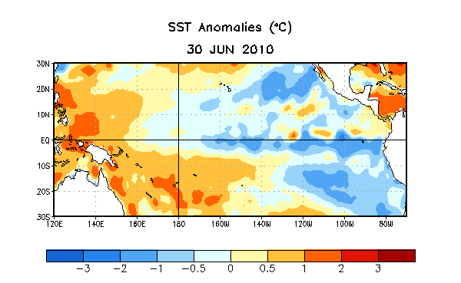
Figure 1. Average sea surface temperature (SST) anomalies (°C) for the week centered on 30 June 2010. Anomalies are computed with respect to the 1971-2000 base period weekly means (Xue et al. 2003, J. Climate, 16, 1601-1612).

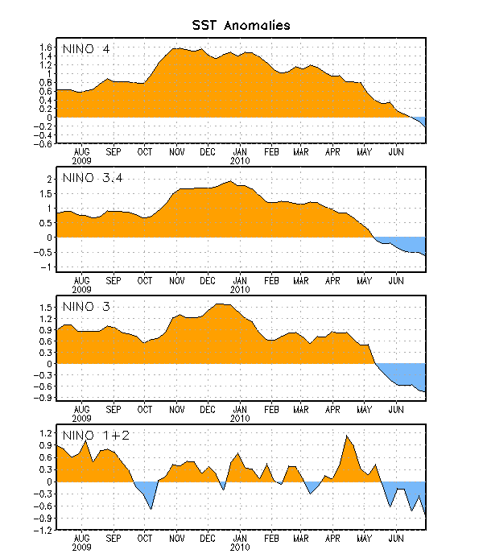
Figure 2. Time series of area-averaged sea surface temperature (SST) anomalies (°C) in the Niño regions [Niño-1+2 (0°-10°S, 90°W-80°W), Niño 3 (5°N-5°S, 150°W-90°W), Niño-3.4 (5°N-5°S, 170°W-120°W), Niño-4 (150ºW-160ºE and 5ºN-5ºS)]. SST anomalies are departures from the 1971-2000 base period weekly means (Xue et al. 2003, J. Climate, 16, 1601-1612).

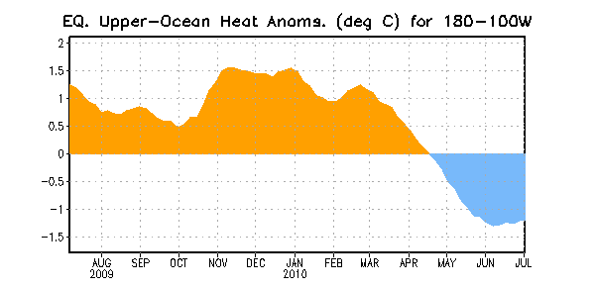
Figure 3. Area-averaged upper-ocean heat content anomalies (°C) in the equatorial Pacific (5°N-5°S, 180º-100ºW). Heat content anomalies are computed as departures from the 1982-2004 base period pentad means.

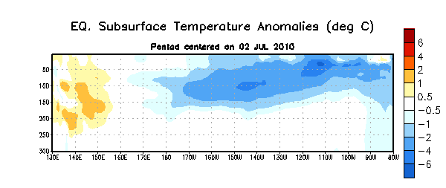
Figure 4. Depth-longitude section of equatorial Pacific upper-ocean (0-300m) temperature anomalies (°C) centered on the week of 2 July 2010. The anomalies are averaged between 5°N-5°S. Anomalies are departures from the 1982-2004 base period pentad means.

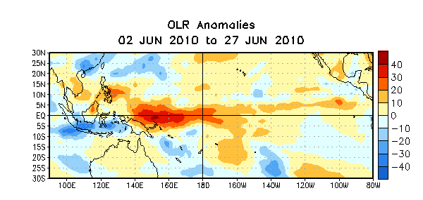
Figure 5. Average outgoing longwave radiation (OLR) anomalies (W/m²) for the four-week period 2 – 27 June 2010. OLR anomalies are computed as departures from the 1979-1995 base period pentad means.

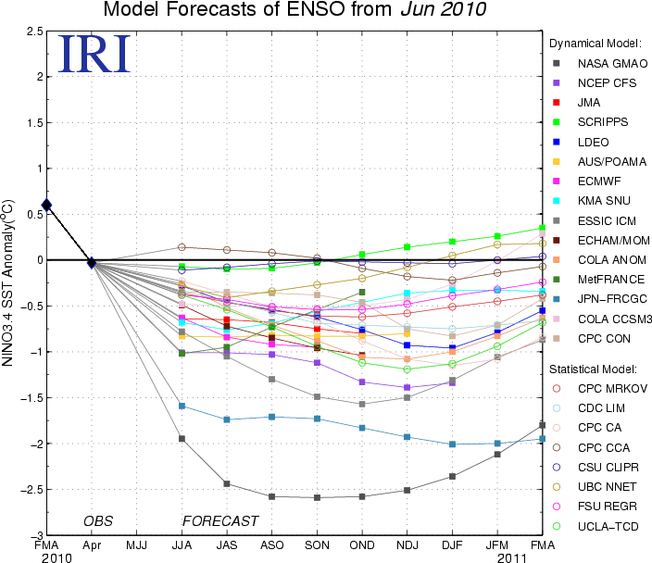
Figure 6. Forecasts of sea surface temperature (SST) anomalies for the Niño 3.4 region (5°N-5°S, 120°W-170°W). Figure courtesy of the International Research Institute (IRI) for Climate and Society. Figure updated 15 June 2010.

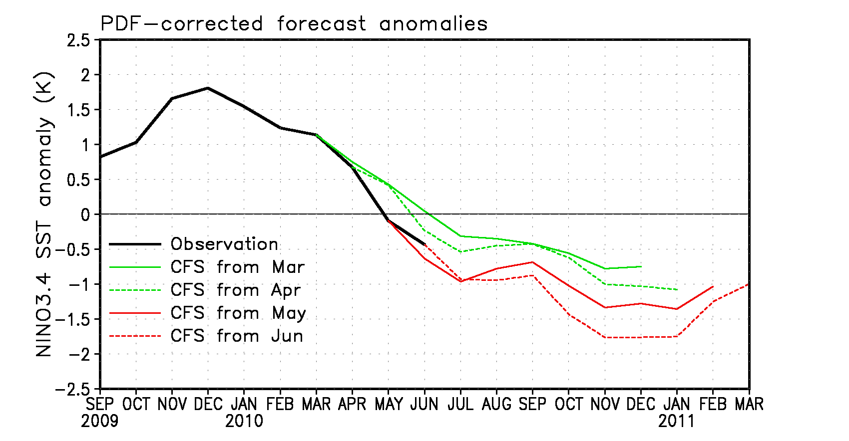
Figure 7. Forecasts of sea surface temperature (SST) anomalies for the Niño 3.4 region (5°N-5°S, 120°W-170°W) from the NCEP Climate Forecast System (CFS). The observation from OI.v2 SST is shown by the black line and colored lines show the CFS model runs initialized from four different months (March – June 2010). Forecast anomalies are corrected with a PDF (probability density function) based on 1981-2006 retrospective forecasts. The PDF correction reduces amplitude of the forecast anomalies. Figure updated 30 June 2010.

