EL NIÑO/SOUTHERN OSCILLATION (ENSO) DIAGNOSTIC DISCUSSION

issued by

CLIMATE PREDICTION CENTER/NCEP/NWS
7 July 2011

ENSO Alert System Status: Not Active (NA)

Synopsis: ENSO-neutral conditions are expected to continue into the Northern Hemisphere fall 2011.
During June 2011, ENSO-neutral conditions continued as reflected by the overall pattern of small sea surface temperature (SST) anomalies across the equatorial Pacific Ocean (Fig. 1). All of the latest weekly Niño index values were near average (Fig. 2), ranging between 0.0°C (Niño-4) and 0.4°C (Niño-1+2). The subsurface oceanic heat content anomaly (average temperature anomalies in the upper 300m of the ocean, Fig. 3) remained elevated, but weakened slightly throughout the month, in accordance with the declining strength of above-average temperatures at depth (Fig. 4). While weak, the atmospheric circulation anomalies remained consistent with certain aspects of La Niña. In particular, convection continued to be enhanced over eastern Indonesia and suppressed over the central equatorial Pacific, mainly south of the equator (Fig. 5). Also, anomalous low-level easterly and upper-level westerly winds persisted over the central Pacific. Collectively, these tropical Pacific anomalies indicate ENSO-neutral conditions, but the atmospheric circulation continues to be characteristic of La Niña.
Forecasts from a majority of the ENSO models, indicate ENSO-neutral will continue into the Northern Hemisphere fall 2011 (three-month average in the Nino-3.4 index between –0.5°C and +0.5°C; Fig. 6). However, over the last couple of weeks, forecasts created by the NCEP Climate Forecast System (CFS) have begun to indicate the re-emergence of La Niña during Northern Hemisphere fall 2011 (Fig. 7). Combined with the recent weakening of the positive subsurface ocean anomalies and the lingering La Niña state of the atmosphere, the possibility of a return to La Niña during the Northern Hemisphere fall 2011 has increased over the past month. However, ENSO-neutral remains most likely into the Northern Hemisphere fall 2011, with most models and all multi-model forecasts (shown by the thick lines) predicting ENSO-neutral to continue through early 2012.
This discussion is a consolidated effort of the National Oceanic and Atmospheric Administration (NOAA), NOAA’s National Weather Service, and their funded institutions. Oceanic and atmospheric conditions are updated weekly on the Climate Prediction Center web site (El Niño/La Niña Current Conditions and Expert Discussions). Forecasts for the evolution of El Niño/La Niña are updated monthly in the Forecast Forum section of CPC's Climate Diagnostics Bulletin. The next ENSO Diagnostics Discussion is scheduled for 4 August 2011. To receive an e-mail notification when the monthly ENSO Diagnostic Discussions are released, please send an e-mail message to: ncep.list.enso-update@noaa.gov.
Climate Prediction Center
National Centers for Environmental Prediction
NOAA/National Weather Service
Camp Springs, MD 20746-4304

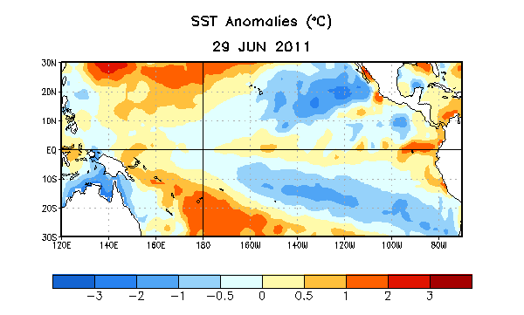
Figure 1. Average sea surface temperature (SST) anomalies (°C) for the week centered on 29 June 2011. Anomalies are computed with respect to the 1971-2000 base period weekly means (Xue et al. 2003, J. Climate, 16, 1601-1612).

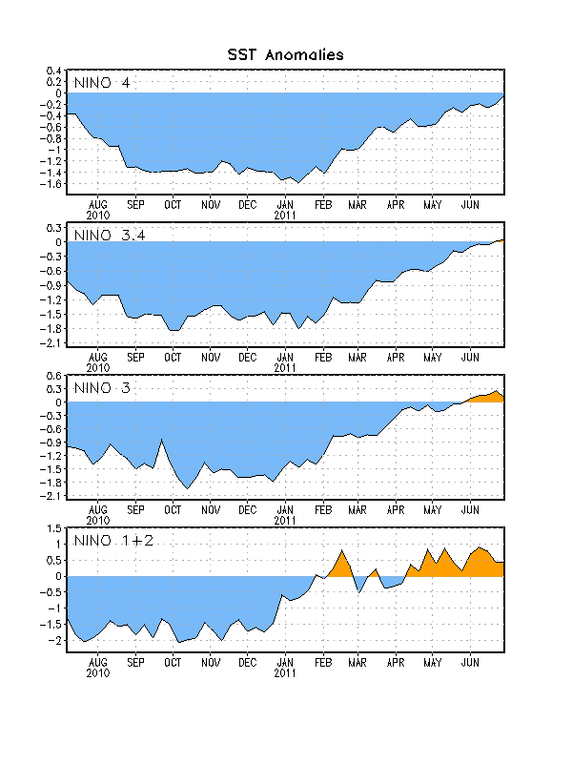
Figure 2. Time series of area-averaged sea surface temperature (SST) anomalies (°C) in the Niño regions [Niño-1+2 (0°-10°S, 90°W-80°W), Niño 3 (5°N-5°S, 150°W-90°W), Niño-3.4 (5°N-5°S, 170°W-120°W), Niño-4 (150ºW-160ºE and 5ºN-5ºS)]. SST anomalies are departures from the 1971-2000 base period weekly means (Xue et al. 2003, J. Climate, 16, 1601-1612).

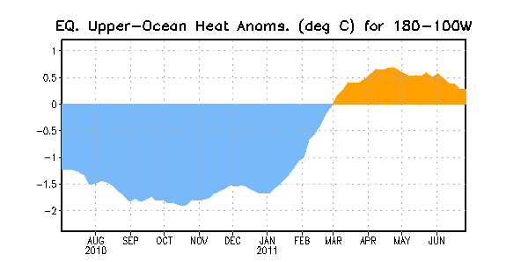
Figure 3. Area-averaged upper-ocean heat content anomalies (°C) in the equatorial Pacific (5°N-5°S, 180º-100ºW). Heat content anomalies are computed as departures from the 1982-2004 base period pentad means.

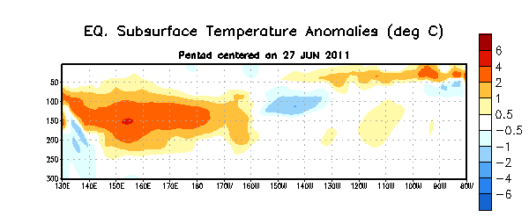
Figure 4. Depth-longitude section of equatorial Pacific upper-ocean (0-300m) temperature anomalies (°C) centered on the week of 27 June 2011. The anomalies are averaged between 5°N-5°S. Anomalies are departures from the 1982-2004 base period pentad means.

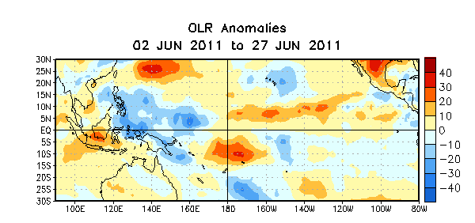

Figure 5. Average outgoing longwave radiation (OLR) anomalies (W/m²) for the four-week period 2 – 27 June 2011. OLR anomalies are computed as departures from the 1979-1995 base period pentad means.

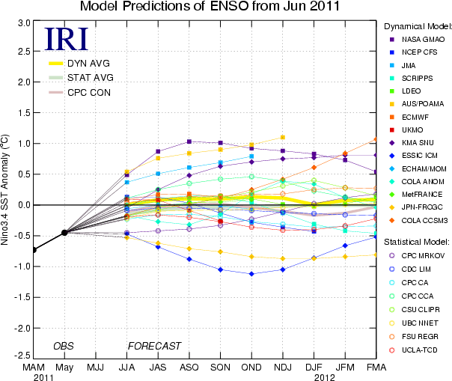
Figure 6. Forecasts of sea surface temperature (SST) anomalies for the Niño 3.4 region (5°N-5°S, 120°W-170°W). Figure courtesy of the International Research Institute (IRI) for Climate and Society. Figure updated 14 June 2011.

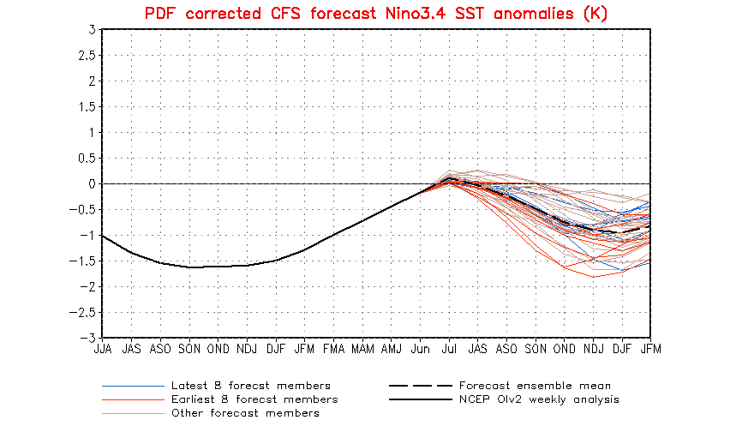
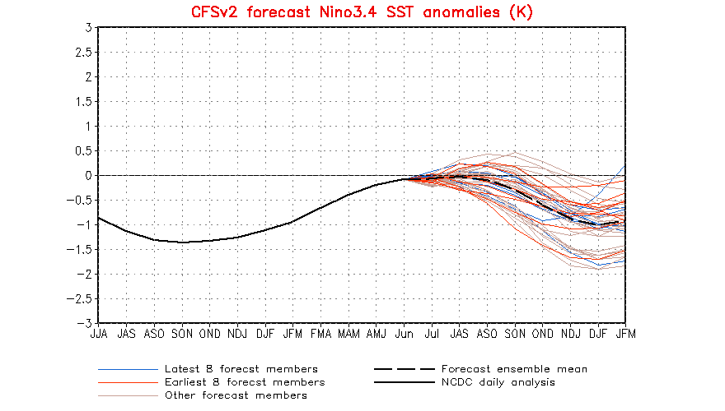
Figure 7. Forecasts of sea surface temperature (SST) anomalies for the Niño 3.4 region (5°N-5°S, 120°W-170°W) from version 1 of the NCEP Climate Forecast System (top panel) and version 2 of the CFS (bottom panel). Figure updated 6 July 2011.

