EL NIÑO/SOUTHERN OSCILLATION (ENSO) DIAGNOSTIC DISCUSSION

issued by

CLIMATE PREDICTION CENTER/NCEP/NWS
and the International Research Institute for Climate and Society
5 July 2012

ENSO Alert System Status: El Niño Watch

Synopsis: Chances increase for El Niño beginning in July-September 2012.
During June 2012, ENSO-neutral continued as reflected in both the oceanic and atmospheric anomalies. However, positive equatorial Pacific sea surface temperature (SST) anomalies have grown, exceeding +0.5°C across the eastern Pacific Ocean by the end of June (Fig. 1). SST anomalies increase moving from the westernmost Niño 4 region to the Niño 1+2 region adjacent to South America, which remained near +1.5°C during the month (Fig. 2). The oceanic heat content anomalies (average temperature in the upper 300m of the ocean) increased during June (Fig. 3), as above-average sub-surface temperatures became more entrenched in the equatorial Pacific (Fig. 4). This warming was consistent with a weakening of the low-level trade winds across the east-central equatorial Pacific, along with a weakening of the persistent pattern of enhanced convection near Papua New Guinea (Fig. 5). The observations are consistent with ENSO-neutral, but reflect a likely progression towards El Niño.
There continues to be a substantial disparity between the statistical and dynamical model SST forecasts for the Niño-3.4 region (Fig. 6). The dynamical models, including the NCEP Climate Forecast System (CFS), largely favor the development of El Niño by July-September 2012, while the majority of statistical models predict ENSO-neutral through the rest of 2012. The forecaster consensus largely favors the dynamical model outcome because those models tend to exhibit greater skill emerging from the Northern Hemisphere “spring barrier” (a period of relatively low confidence ENSO forecasts) and also due to the strengthening of observed signals indicating an evolution towards El Niño. Overall, the forecaster consensus reflects increased chances for El Niño beginning in July-September 2012 (see CPC/IRI consensus forecast).
This discussion is a consolidated effort of the National Oceanic and Atmospheric Administration (NOAA), NOAA’s National Weather Service, and their funded institutions. Oceanic and atmospheric conditions are updated weekly on the Climate Prediction Center web site (El Niño/La Niña Current Conditions and Expert Discussions). Forecasts for the evolution of El Niño/La Niña are updated monthly in the Forecast Forum section of CPC's Climate Diagnostics Bulletin. The next ENSO Diagnostics Discussion is scheduled for 9 August 2012. To receive an e-mail notification when the monthly ENSO Diagnostic Discussions are released, please send an e-mail message to: ncep.list.enso-update@noaa.gov.
Climate Prediction Center
National Centers for Environmental Prediction
NOAA/National Weather Service
Camp Springs, MD 20746-4304

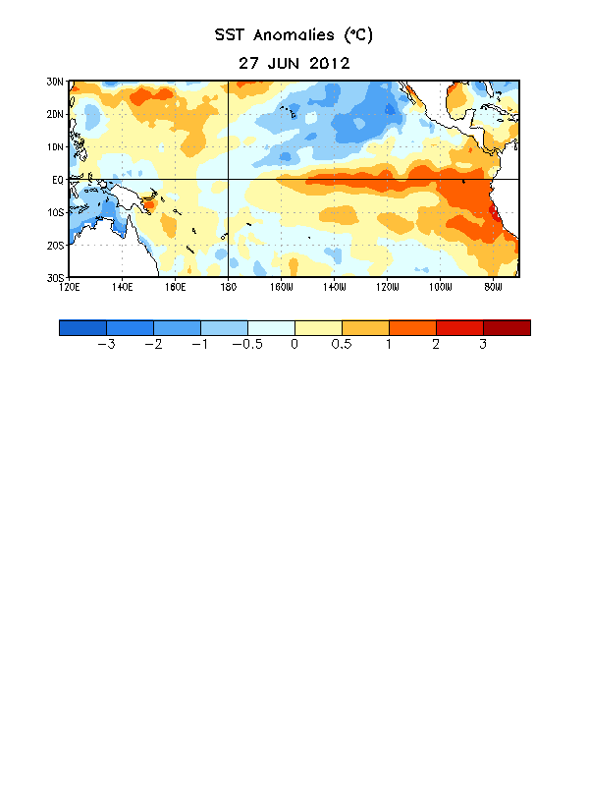
Figure 1. Average sea surface temperature (SST) anomalies (°C) for the week centered on 27 June 2012. Anomalies are computed with respect to the 1981-2010 base period weekly means.
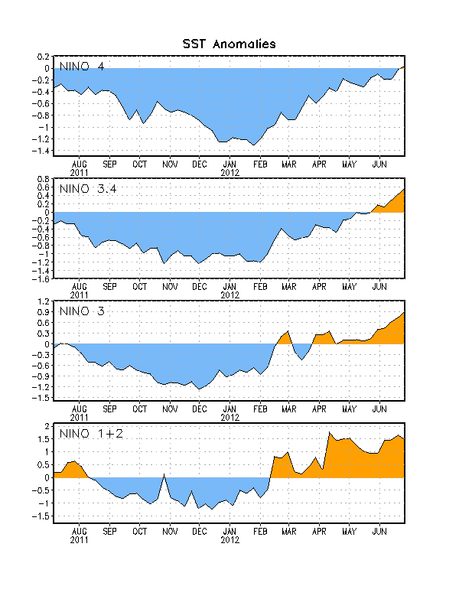
Figure 2. Time series of area-averaged sea surface temperature (SST) anomalies (°C) in the Niño regions [Niño-1+2 (0°-10°S, 90°W-80°W), Niño 3 (5°N-5°S, 150°W-90°W), Niño-3.4 (5°N-5°S, 170°W-120°W), Niño-4 (150ºW-160ºE and 5ºN-5ºS)]. SST anomalies are departures from the 1981-2010 base period weekly means.

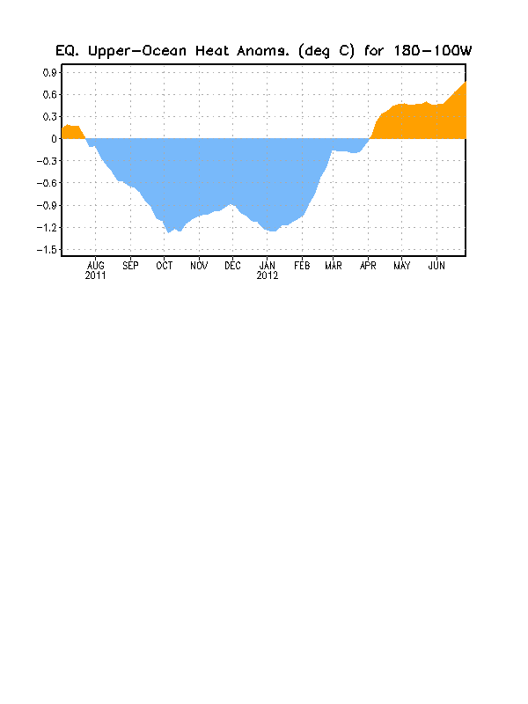
Figure 3. Area-averaged upper-ocean heat content anomaly (°C) in the equatorial Pacific (5°N-5°S, 180º-100ºW). The heat content anomaly is computed as the departure from the 1982-2010 base period pentad means.

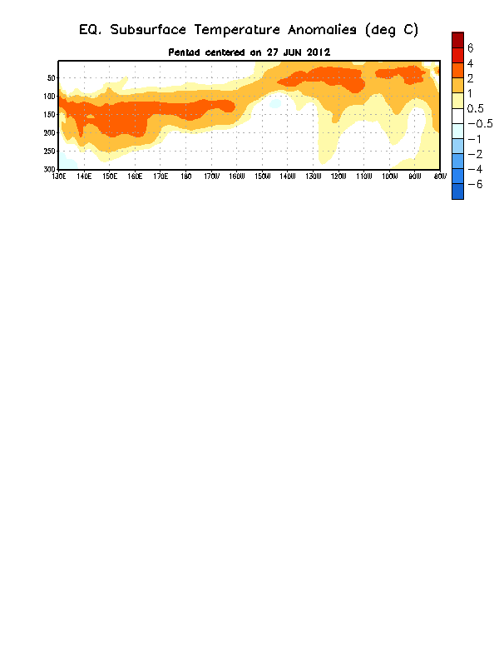
Figure 4. Depth-longitude section of equatorial Pacific upper-ocean (0-300m) temperature anomalies (°C) centered on the pentad of 27 June 2012. The anomalies are averaged between 5°N-5°S. Anomalies are departures from the 1982-2010 base period pentad means.

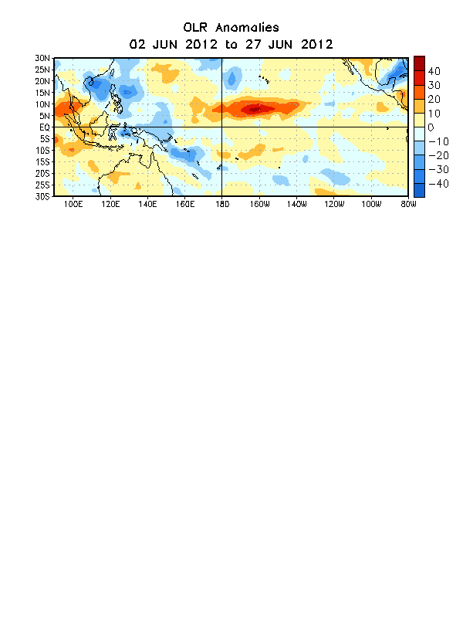

Figure 5. Average outgoing longwave radiation (OLR) anomalies (W/m²) for the four-week period 2 – 27 June 2012. OLR anomalies are computed as departures from the 1979-1995 base period pentad means.

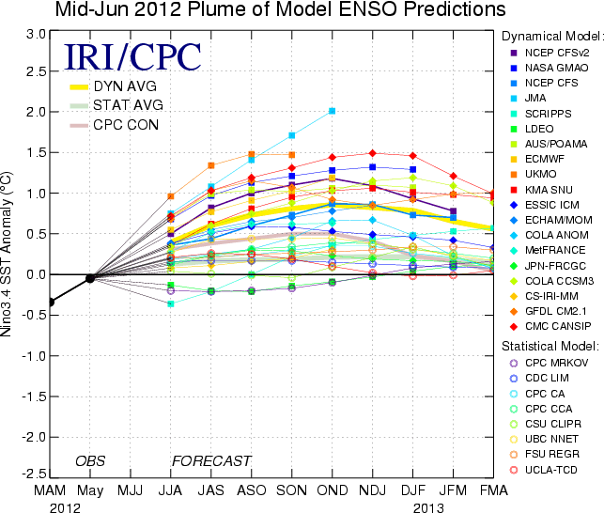
Figure 6. Forecasts of sea surface temperature (SST) anomalies for the Niño 3.4 region (5°N-5°S, 120°W-170°W). Figure courtesy of the International Research Institute (IRI) for Climate and Society. Figure updated 15 June 2012.

