EL NIÑO/SOUTHERN OSCILLATION (ENSO) DIAGNOSTIC DISCUSSION

issued by

CLIMATE PREDICTION CENTER/NCEP/NWS
and the International Research Institute for Climate and Society
5 July 2013

ENSO Alert System Status: Not Active

Synopsis: ENSO-neutral is favored into the Northern Hemisphere fall 2013.
During June 2013, below-average sea surface temperatures (SST) prevailed in the eastern Pacific, while near-average SSTs persisted across the rest of the equatorial Pacific (Fig. 1). This ENSO-neutral pattern was also reflected in the Niño indices, which were warmer than -0.5°C in Niño-4 and Niño-3.4 and cooler than -0.5°C in Niño-3 and Niño-1+2 during the month (Fig. 2). Meanwhile, the oceanic heat content (average temperature in the upper 300m of the ocean) anomalies increased during June (Fig. 3), due to the emergence of above-average subsurface temperatures in the eastern half of the Pacific (Fig. 4). Across the equatorial Pacific, the low-level winds remained near average, while weak upper-level westerly anomalies persisted in the central Pacific. Convection remained enhanced over Indonesia and weakly suppressed near the International Date Line (Fig. 5). Collectively, these atmospheric and oceanic conditions were consistent with ENSO-neutral.
Most model forecasts continue to indicate ENSO-neutral (Niño-3.4 index between -0.5°C and 0.5°C) into the Northern Hemisphere winter 2013-14. The statistical model forecasts remain cooler in the Niño-3.4 region relative to the dynamical models forecasts (Fig. 6). The forecast consensus favors ENSO-neutral (near 60% or greater) into the Northern Hemisphere fall 2013 (see CPC/IRI consensus forecast).
This discussion is a consolidated effort of the National Oceanic and Atmospheric Administration (NOAA), NOAA’s National Weather Service, and their funded institutions. Oceanic and atmospheric conditions are updated weekly on the Climate Prediction Center web site (El Niño/La Niña Current Conditions and Expert Discussions). Forecasts for the evolution of El Niño/La Niña are updated monthly in the Forecast Forum section of CPC's Climate Diagnostics Bulletin. The next ENSO Diagnostics Discussion is scheduled for 8 August 2013. To receive an e-mail notification when the monthly ENSO Diagnostic Discussions are released, please send an e-mail message to: ncep.list.enso-update@noaa.gov.
Climate Prediction Center
National Centers for Environmental Prediction
NOAA/National Weather Service
College Park, MD 20740

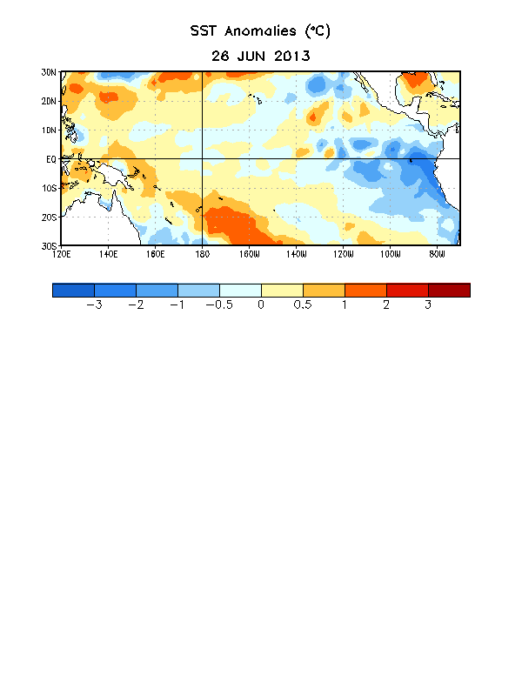
Figure 1. Average sea surface temperature (SST) anomalies (°C) for the week centered on 26 June 2013. Anomalies are computed with respect to the 1981-2010 base period weekly means.

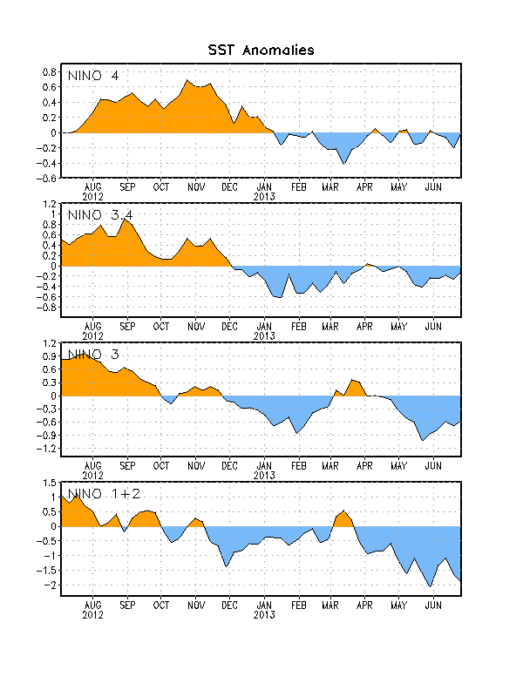
Figure 2. Time series of area-averaged sea surface temperature (SST) anomalies (°C) in the Niño regions [Niño-1+2 (0°-10°S, 90°W-80°W), Niño 3 (5°N-5°S, 150°W-90°W), Niño-3.4 (5°N-5°S, 170°W-120°W), Niño-4 (150ºW-160ºE and 5ºN-5ºS)]. SST anomalies are departures from the 1981-2010 base period weekly means.

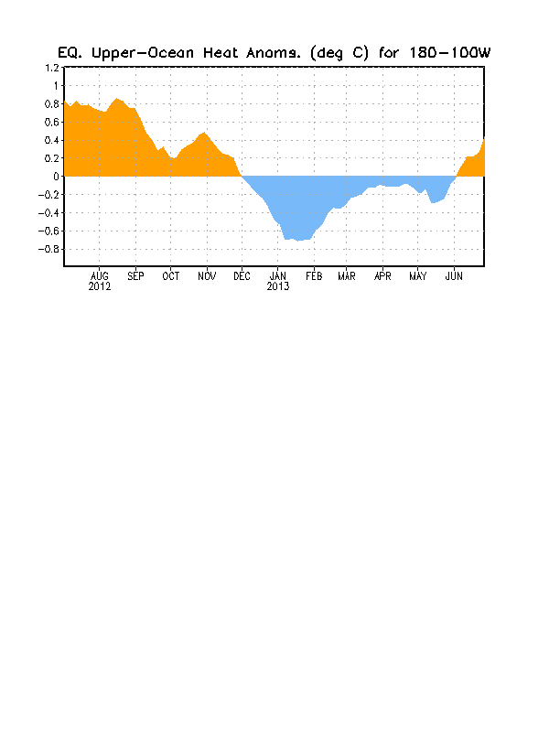
Figure 3. Area-averaged upper-ocean heat content anomaly (°C) in the equatorial Pacific (5°N-5°S, 180º-100ºW). The heat content anomaly is computed as the departure from the 1981-2010 base period pentad means.

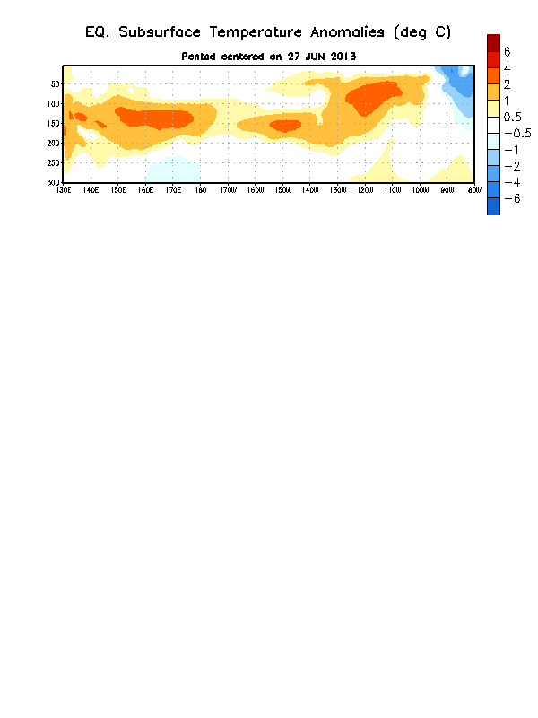

Figure 4. Depth-longitude section of equatorial Pacific upper-ocean (0-300m) temperature anomalies (°C) centered on the pentad of 27 June 2013. The anomalies are averaged between 5°N-5°S. Anomalies are departures from the 1981-2010 base period pentad means.

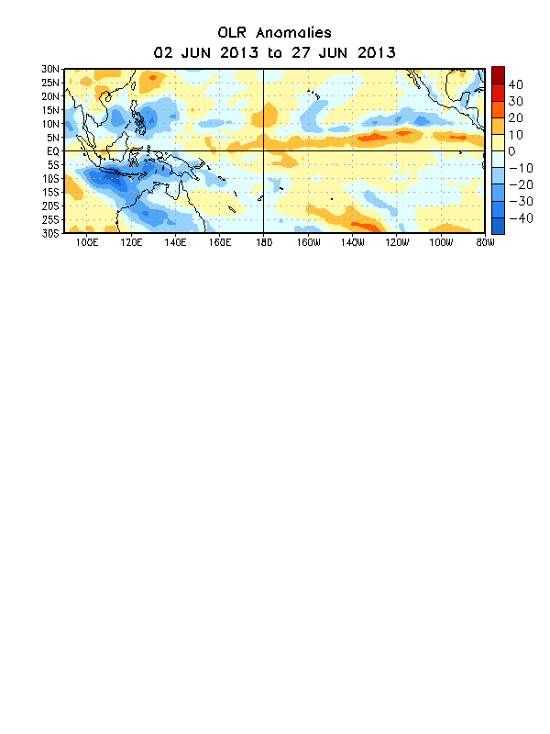

Figure 5. Average outgoing longwave radiation (OLR) anomalies (W/m²) for the four-week period 2 – 27 June 2013. OLR anomalies are computed as departures from the 1979-1995 base period pentad means.

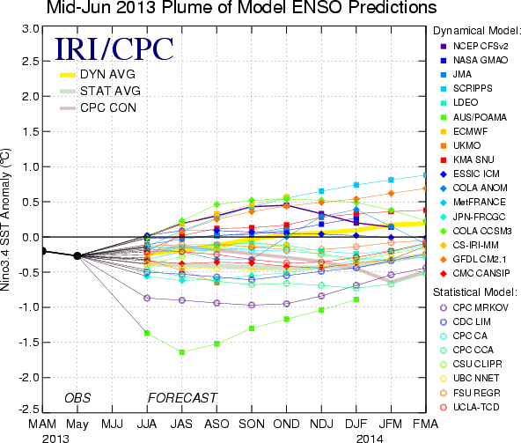
Figure 6. Forecasts of sea surface temperature (SST) anomalies for the Niño 3.4 region (5°N-5°S, 120°W-170°W). Figure courtesy of the International Research Institute (IRI) for Climate and Society. Figure updated 18 June 2013.

