EL NIÑO/SOUTHERN OSCILLATION (ENSO) DIAGNOSTIC DISCUSSION

issued by

CLIMATE PREDICTION CENTER/NCEP/NWS
and the International Research Institute for Climate and Society
13 July 2017

ENSO Alert System Status: Not Active

Synopsis: ENSO-neutral is favored (~50 to 55% chance) into the Northern Hemisphere winter 2017-18.
During June, ENSO-neutral continued, although equatorial sea surface temperatures (SSTs) remained above average in the central and east-central Pacific Ocean (Fig. 1). The latest weekly Niño index values were near +0.5°C in the Niño-4 and Niño-3.4 regions, and closer to zero in the Niño-3 and Niño-1+2 regions (Fig. 2). The upper-ocean heat content anomaly was above average during June (Fig. 3), reflecting above-average sub-surface temperatures across the central and eastern Pacific (Fig. 4). In the atmosphere, tropical convection was suppressed over the west-central tropical Pacific and enhanced over the Maritime Continent (Fig. 5). The lower-level and upper-level winds were near average over most of the tropical Pacific, and the Southern Oscillation Index (SOI) and Equatorial SOI were slightly negative to near-zero. Overall, the ocean and atmosphere system remains consistent with ENSO-neutral.

Some models predict the onset of El Niño (3-month average Niño-3.4 index at or greater than 0.5°C) during the Northern Hemisphere summer (Fig. 6). However, more than half of the models favor ENSO-neutral through the remainder of 2017. These predictions, along with the near-average atmospheric conditions over the Pacific, lead forecasters to favor ENSO-neutral into the winter (~50 to 55% chance). However, chances for El Niño remain elevated (~35-45%) relative to the long-term average. In summary, ENSO-neutral is favored (~50 to 55% chance) into the Northern Hemisphere winter 2017-18 (click CPC/IRI consensus forecast for the chance of each outcome for each 3-month period).

This discussion is a consolidated effort of the National Oceanic and Atmospheric Administration (NOAA), NOAA’s National Weather Service, and their funded institutions. Oceanic and atmospheric conditions are updated weekly on the Climate Prediction Center web site (El Niño/La Niña Current Conditions and Expert Discussions). Forecasts are also updated monthly in the Forecast Forum of CPC's Climate Diagnostics Bulletin. Additional perspectives and analysis are also available in an ENSO blog. The next ENSO Diagnostics Discussion is scheduled for 10 August 2017. To receive an e-mail notification when the monthly ENSO Diagnostic Discussions are released, please send an e-mail message to: ncep.list.enso-update@noaa.gov.

Climate Prediction Center
National Centers for Environmental Prediction
NOAA/National Weather Service
College Park, MD 20740

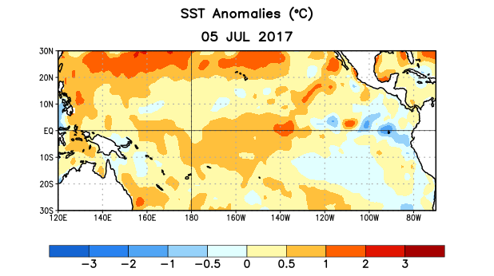
Figure 1. Average sea surface temperature (SST) anomalies (°C) for the week centered on 5 July 2017. Anomalies are computed with respect to the 1981-2010 base period weekly means.

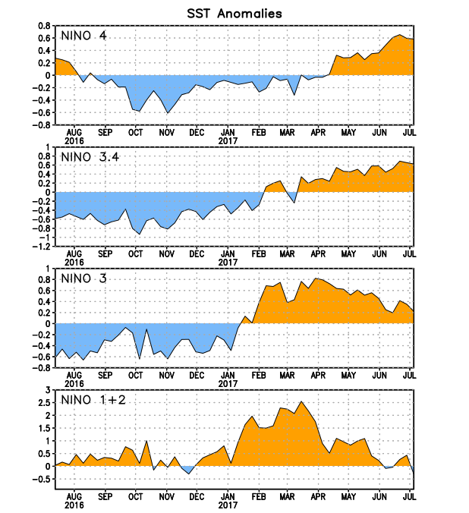
Figure 2. Time series of area-averaged sea surface temperature (SST) anomalies (°C) in the Niño regions [Niño-1+2 (0°-10°S, 90°W-80°W), Niño-3 (5°N-5°S, 150°W-90°W), Niño-3.4 (5°N-5°S, 170°W-120°W), Niño-4 (5ºN-5ºS , 150ºW-160ºE]. SST anomalies are departures from the 1981-2010 base period weekly means.
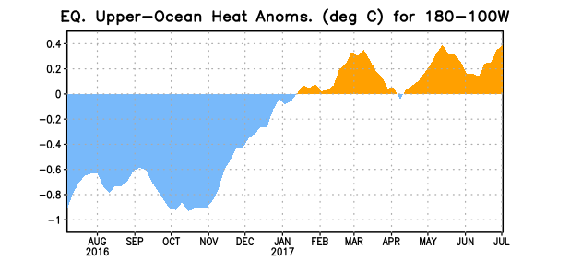
Figure 3. Area-averaged upper-ocean heat content anomaly (°C) in the equatorial Pacific (5°N-5°S, 180º-100ºW). The heat content anomaly is computed as the departure from the 1981-2010 base period pentad means.

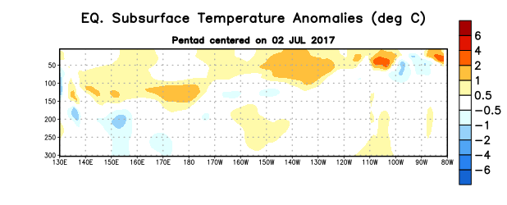
Figure 4. Depth-longitude section of equatorial Pacific upper-ocean (0-300m) temperature anomalies (°C) centered on the pentad of 2 July 2017. The anomalies are averaged between 5°N-5°S. Anomalies are departures from the 1981-2010 base period pentad means.

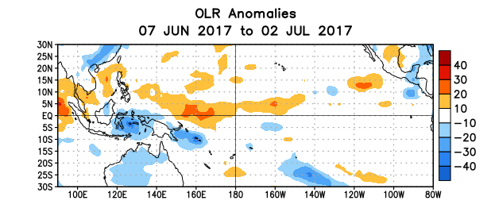
Figure 5. Average outgoing longwave radiation (OLR) anomalies (W/m²) for the period 7 June – 2 July 2017. OLR anomalies are computed as departures from the 1981-2010 base period pentad means.

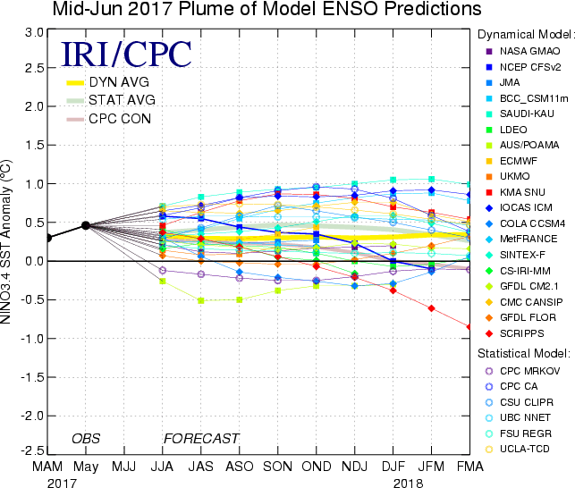

Figure 6. Forecasts of sea surface temperature (SST) anomalies for the Niño 3.4 region (5°N-5°S, 120°W-170°W). Figure updated 15 June 2017.

