EL NIÑO/SOUTHERN OSCILLATION (ENSO) DIAGNOSTIC DISCUSSION

issued by

CLIMATE PREDICTION CENTER/NCEP/NWS

and the International Research Institute for Climate and Society

11 July 2019

ENSO Alert System Status: El Niño Advisory

Synopsis: A transition from El Niño to ENSO-neutral is expected in the next month or two, with ENSO-neutral most likely to continue through Northern Hemisphere fall and winter.

During June, El Niño was reflected in the continued presence of above average sea surface temperatures (SSTs) across the central equatorial Pacific Ocean (Fig. 1). However, SST anomalies across most of the eastern Pacific decreased during the month. The latest weekly ENSO indices were +0.9°C in Niño-4 and +0.6°C in Niño-3.4, with smaller departures in the Niño-3 and Niño-1+2 regions (Fig. 2). Upper-ocean subsurface temperatures (averaged across 180°-100°W) were above average at the beginning of June, but returned to near average by end of the month (Fig. 3), as anomalously cool waters expanded at depth (Fig. 4). Weakly suppressed tropical convection continued over Indonesia, while weakly enhanced convection persisted near the Date Line (Fig. 5). Low-level wind anomalies were near average over the tropical Pacific Ocean, and upper-level wind anomalies were westerly over the far eastern Pacific. The traditional and equatorial Southern Oscillation Indices were slightly negative. Overall, oceanic and atmospheric conditions were consistent with a weakening El Niño.
The latest plume of North American Multi-model Ensemble forecasts of the Niño-3.4 index (Fig. 6) shows a rapid transition toward ENSO-neutral by the late Northern Hemisphere summer, remaining neutral through fall and winter. Due to this model guidance and recent observations, the forecast consensus also favors a transition to ENSO-neutral during the next few months. In summary, a transition from El Niño to ENSO-neutral is expected in the next month or two, with ENSO-neutral most likely to continue through Northern Hemisphere fall and winter (click CPC/IRI consensus forecast for the chance of each outcome for each 3-month period).
This discussion is a consolidated effort of the National Oceanic and Atmospheric Administration (NOAA), NOAA’s National Weather Service, and their funded institutions. Oceanic and atmospheric conditions are updated weekly on the Climate Prediction Center web site (El Niño/La Niña Current Conditions and Expert Discussions). Forecasts are also updated monthly in the Forecast Forum of CPC's Climate Diagnostics Bulletin. Additional perspectives and analysis are also available in an ENSO blog. The next ENSO Diagnostics Discussion is scheduled for 8 August 2019. To receive an e-mail notification when the monthly ENSO Diagnostic Discussions are released, please send an e-mail message to: ncep.list.enso-update@noaa.gov.

Climate Prediction Center
National Centers for Environmental Prediction
NOAA/National Weather Service
College Park, MD 20740

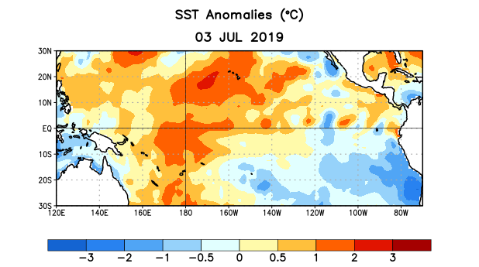
Figure 1. Average sea surface temperature (SST) anomalies (°C) for the week centered on 3 July 2019. Anomalies are computed with respect to the 1981-2010 base period weekly means.

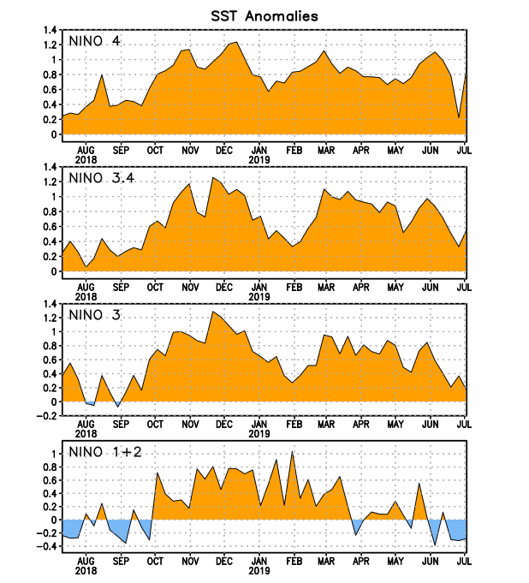
Figure 2. Time series of area-averaged sea surface temperature (SST) anomalies (°C) in the Niño regions [Niño-1+2 (0°-10°S, 90°W-80°W), Niño-3 (5°N-5°S, 150°W-90°W), Niño-3.4 (5°N-5°S, 170°W-120°W), Niño-4 (5ºN-5ºS , 150ºW-160ºE)]. SST anomalies are departures from the 1981-2010 base period weekly means.
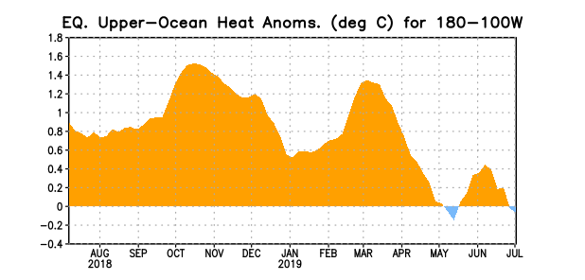
Figure 3. Area-averaged upper-ocean heat content anomaly (°C) in the equatorial Pacific (5°N-5°S, 180º-100ºW). The heat content anomaly is computed as the departure from the 1981-2010 base period pentad means.

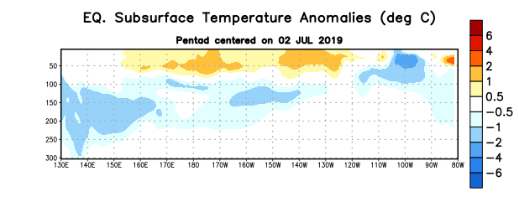
Figure 4. Depth-longitude section of equatorial Pacific upper-ocean (0-300m) temperature anomalies (°C) centered on the pentad of 2 July 2019. Anomalies are departures from the 1981-2010 base period pentad means.

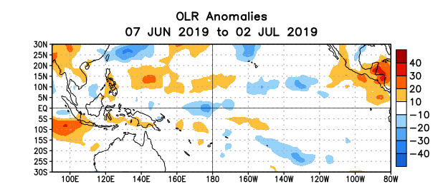
Figure 5. Average outgoing longwave radiation (OLR) anomalies (W/m²) for the period 7 June – 2 July 2019. OLR anomalies are computed as departures from the 1981-2010 base period pentad means.

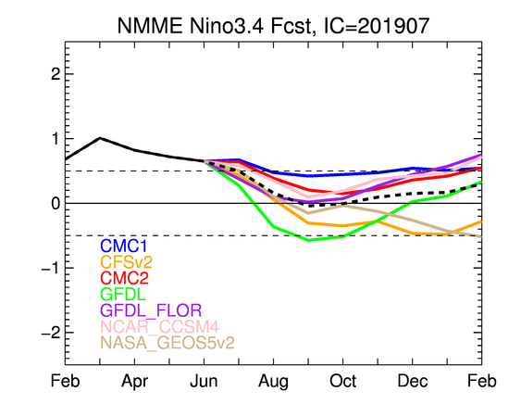
Figure 6. Forecasts of sea surface temperature (SST) anomalies for the Niño 3.4 region (5°N-5°S, 120°W-170°W) from the North American Multi-model Ensemble (NMME). Figure updated 8 July 2019.

