EL NIÑO/SOUTHERN OSCILLATION (ENSO) DIAGNOSTIC DISCUSSION

issued by

CLIMATE PREDICTION CENTER/NCEP/NWS

and the International Research Institute for Climate and Society

9 July 2020

ENSO Alert System Status: La Niña Watch

Synopsis: ENSO-neutral is favored to continue through the summer, with a 50-55% chance of La Niña development during Northern Hemisphere fall 2020 and continuing through winter 2020-21 (~50% chance).

During June 2020, sea surface temperatures (SST) were near average in the east-central equatorial Pacific and below average in the eastern Pacific (Fig. 1). The Niño-4 and Niño-3.4 indices were near zero during the latest week, while the Niño-3 and Niño-1+2 indices were negative (Fig. 2). Negative equatorial subsurface temperature anomalies (averaged across 180°-100°W) weakened from May through June (Fig. 3). However, below-average subsurface temperatures continued in the eastern equatorial Pacific (Fig. 4). Also during the month, low-level wind anomalies were easterly across the east-central Pacific, while upper-level wind anomalies were westerly over parts of the far western and eastern Pacific. Tropical convection was suppressed over the western and central Pacific, and near average over Indonesia (Fig. 5). Overall, the combined oceanic and atmospheric system is consistent with ENSO-neutral.
The models in the IRI/CPC plume (Fig. 6) are roughly split between La Niña and ENSO-neutral (Niño-3.4 index between -0.5°C and +0.5°C) during the fall and winter. Based largely on dynamical model guidance, the forecaster consensus slightly favors La Niña development during the August-October season, and then lasting through the remainder of 2020. In summary, ENSO-neutral is favored to continue through the summer, with a 50-55% chance of La Niña development during Northern Hemisphere fall 2020 and continuing through winter 2020-21 (~50% chance; click CPC/IRI consensus forecast for the chance of each outcome for each 3-month period).
This discussion is a consolidated effort of the National Oceanic and Atmospheric Administration (NOAA), NOAA’s National Weather Service, and their funded institutions. Oceanic and atmospheric conditions are updated weekly on the Climate Prediction Center web site (El Niño/La Niña Current Conditions and Expert Discussions). Forecasts are also updated monthly in the Forecast Forum of CPC's Climate Diagnostics Bulletin. Additional perspectives and analysis are also available in an ENSO blog. The next ENSO Diagnostics Discussion is scheduled for 13 August 2020. To receive an e-mail notification when the monthly ENSO Diagnostic Discussions are released, please send an e-mail message to: ncep.list.enso-update@noaa.gov.

Climate Prediction Center
National Centers for Environmental Prediction
NOAA/National Weather Service
College Park, MD 20740

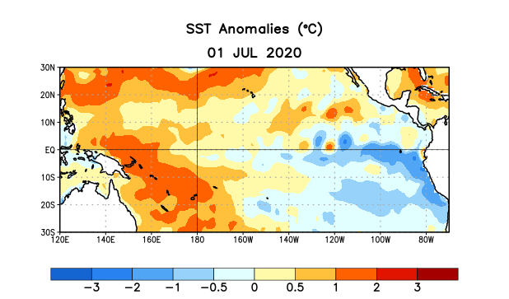
Figure 1. Average sea surface temperature (SST) anomalies (°C) for the week centered on 1 July 2020. Anomalies are computed with respect to the 1981-2010 base period weekly means.

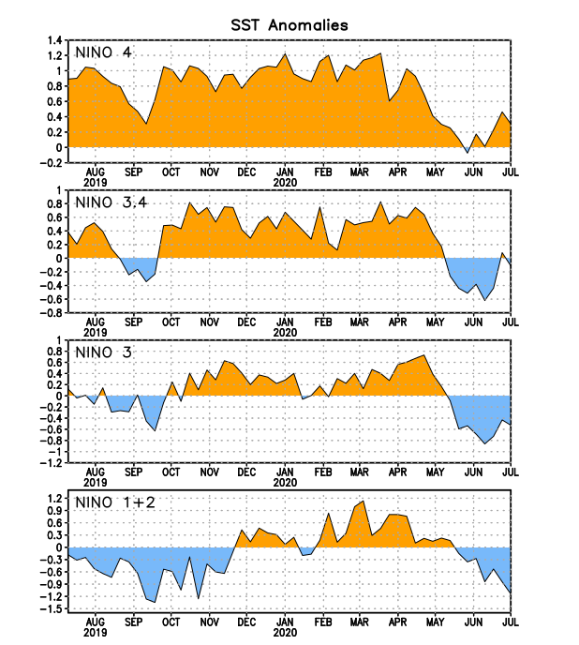
Figure 2. Time series of area-averaged sea surface temperature (SST) anomalies (°C) in the Niño regions [Niño-1+2 (0°-10°S, 90°W-80°W), Niño-3 (5°N-5°S, 150°W-90°W), Niño-3.4 (5°N-5°S, 170°W-120°W), Niño-4 (5ºN-5ºS , 150ºW-160ºE)]. SST anomalies are departures from the 1981-2010 base period weekly means.
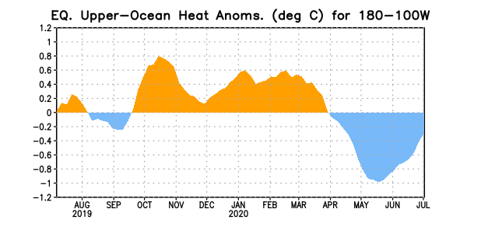
Figure 3. Area-averaged upper-ocean heat content anomaly (°C) in the equatorial Pacific (5°N-5°S, 180º-100ºW). The heat content anomaly is computed as the departure from the 1981-2010 base period pentad means.

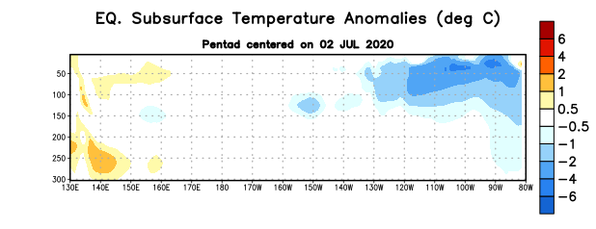
Figure 4. Depth-longitude section of equatorial Pacific upper-ocean (0-300m) temperature anomalies (°C) centered on the pentad of 2 July 2020. Anomalies are departures from the 1981-2010 base period pentad means.

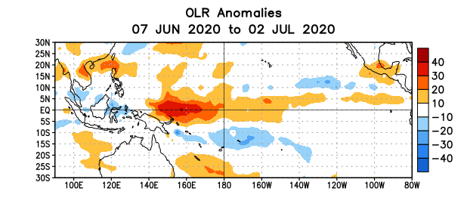
Figure 5. Average outgoing longwave radiation (OLR) anomalies (W/m²) for the period 7 June – 2 July 2020. OLR anomalies are computed as departures from the 1981-2010 base period pentad means.

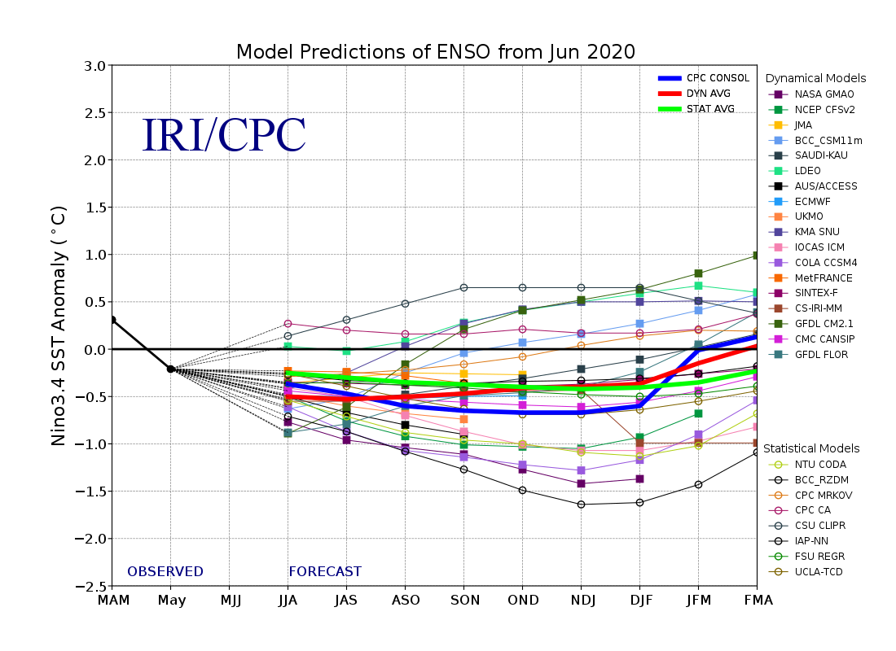
Figure 6. Forecasts of sea surface temperature (SST) anomalies for the Niño 3.4 region (5°N-5°S, 120°W-170°W). Figure updated 19 June 2020.

