EL NIÑO/SOUTHERN OSCILLATION (ENSO) DIAGNOSTIC DISCUSSION

issued by

CLIMATE PREDICTION CENTER/NCEP/NWS

and the International Research Institute for Climate and Society

8 July 2021

ENSO Alert System Status: La Niña Watch

Synopsis: ENSO-neutral is favored through the Northern Hemisphere summer and into the fall (51% chance for the August-October season), with La Niña potentially emerging during the September-November season and lasting through the 2021-22 winter (66% chance during November-January).

Near-average sea surface temperatures, consistent with ENSO-neutral conditions, were observed across most of the equatorial Pacific Ocean during June (Fig. 1). In the last week, most Niño indices were near zero except for the Niño-1+2 index, which was +0.3ºC (Fig. 2). Subsurface temperature anomalies were slightly positive (averaged from 180-100ºW) and remained steady during the month (Fig. 3). However, in parts of the eastern Pacific, below-average subsurface temperature anomalies returned near the thermocline (Fig. 4). For the month, the low-level and upper-level winds were near average across most of the equatorial Pacific Ocean. Tropical convection was suppressed near the Date Line, while remaining mostly near average elsewhere (Fig. 5). Overall, the ocean and atmosphere system reflected ENSO-neutral conditions.
A majority of the models in the IRI/CPC plume predict ENSO-neutral to continue through the fall and winter 2021-22 (Fig. 6). However, the latest forecast model runs from the NCEP CFSv2, many of the models from the North American Multi-Model Ensemble, and some models from our international partners indicate the onset of La Niña during the Northern Hemisphere fall, continuing into winter 2021-22. The forecaster consensus favors these model ensembles, while also noting the historical tendency for a second winter of La Niña to follow the first. In summary, ENSO-neutral is favored through the Northern Hemisphere summer and into the fall (51% chance for the August-October season), with La Niña potentially emerging during the September-November season and lasting through the 2021-22 winter (66% chance during November-January; click CPC/IRI consensus forecast for the chances in each 3-month period).
This discussion is a consolidated effort of the National Oceanic and Atmospheric Administration (NOAA), NOAA’s National Weather Service, and their funded institutions. Oceanic and atmospheric conditions are updated weekly on the Climate Prediction Center web site (El Niño/La Niña Current Conditions and Expert Discussions). Additional perspectives and analysis are also available in an ENSO blog. A probabilistic strength forecast is available here. The next ENSO Diagnostics Discussion is scheduled for 12 August 2021. To receive an e-mail notification when the monthly ENSO Diagnostic Discussions are released, please send an e-mail message to: ncep.list.enso-update@noaa.gov.

Climate Prediction Center
National Centers for Environmental Prediction
NOAA/National Weather Service
College Park, MD 20740

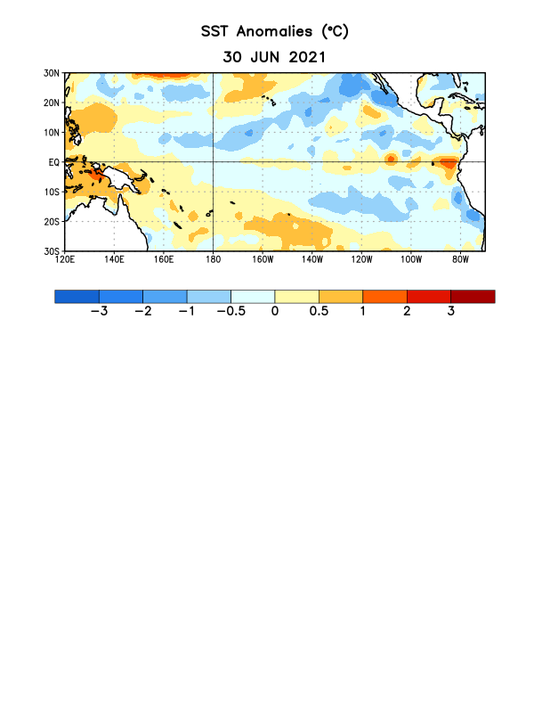
Figure 1. Average sea surface temperature (SST) anomalies (°C) for the week centered on 30 June 2021. Anomalies are computed with respect to the 1991-2020 base period weekly means.

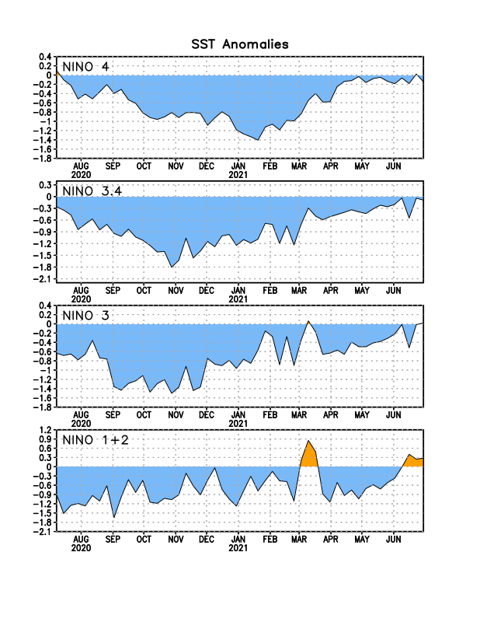
Figure 2. Time series of area-averaged sea surface temperature (SST) anomalies (°C) in the Niño regions [Niño-1+2 (0°-10°S, 90°W-80°W), Niño-3 (5°N-5°S, 150°W-90°W), Niño-3.4 (5°N-5°S, 170°W-120°W), Niño-4 (5ºN-5ºS, 150ºW-160ºE)]. SST anomalies are departures from the 1991-2020 base period weekly means.
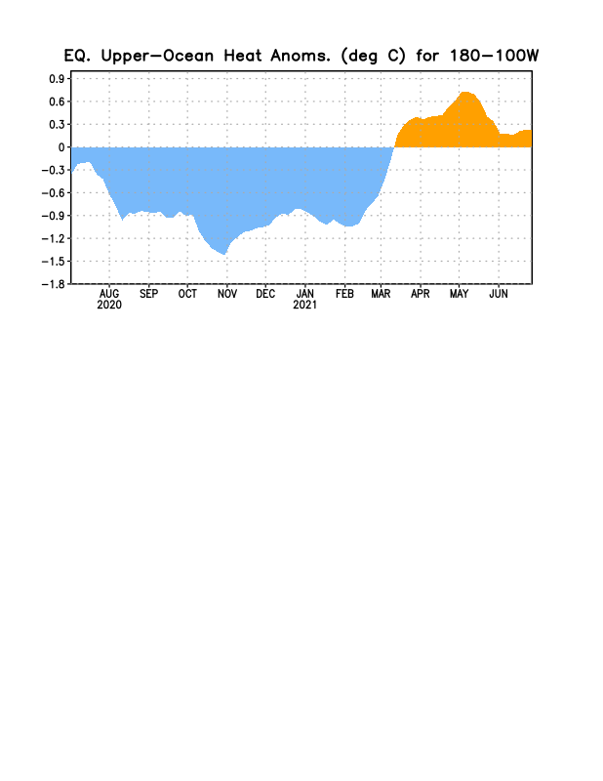
Figure 3. Area-averaged upper-ocean heat content anomaly (°C) in the equatorial Pacific (5°N-5°S, 180º-100ºW). The heat content anomaly is computed as the departure from the 1991-2020 base period pentad means.

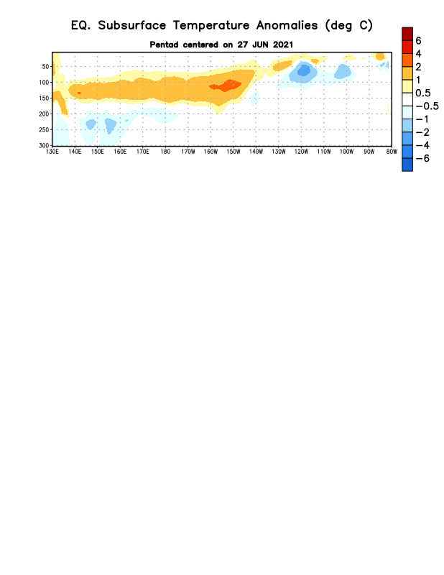

Figure 4. Depth-longitude section of equatorial Pacific upper-ocean (0-300m) temperature anomalies (°C) centered on the pentad of 27 June 2021. Anomalies are departures from the 1991-2020 base period pentad means.

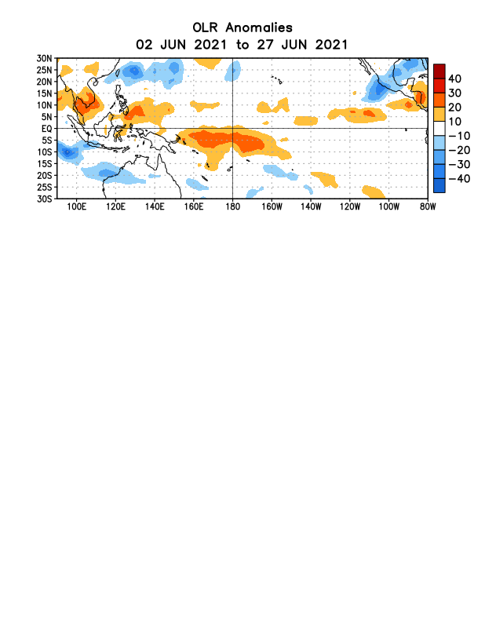
Figure 5. Average outgoing longwave radiation (OLR) anomalies (W/m²) for the period 2 – 27 June 2021. OLR anomalies are computed as departures from the 1991-2020 base period pentad means.

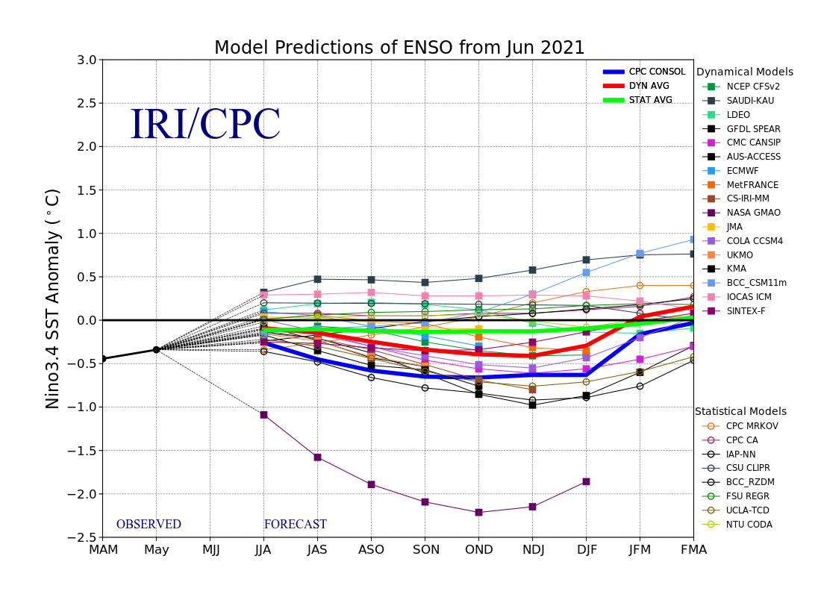
Figure 6. Forecasts of sea surface temperature (SST) anomalies for the Niño 3.4 region (5°N-5°S, 120°W-170°W). Figure updated 19 June 2021.

