EL NIÑO/SOUTHERN OSCILLATION (ENSO) DIAGNOSTIC DISCUSSION
issued by
CLIMATE PREDICTION CENTER/NCEP/NWS
7 June 2007

Synopsis: A transition from ENSO-neutral to La Niña conditions is possible within the next 1-3 months.
ENSO-neutral conditions continued in the tropical Pacific during May 2007, with average to below-average sea surface temperatures (SSTs) extending from the date line to the west coast of South America (Fig. 1). The latest weekly SST departures are negative in the Niño 1+2 (-1.9ºC) and Niño 3 (-0.6 ºC) regions, and remain near zero in the Niño 3.4 (0.0 ºC) and Niño 4 (+0.4 ºC) regions (Fig. 2).
The upper-ocean heat content (average temperatures in the upper 300 m of the ocean) remained below average across the central and east-central equatorial Pacific (Fig. 3), with temperatures at thermocline depth ranging from 1°-4°C below average (Fig. 4). Consistent with the surface and sub-surface ocean temperature patterns, stronger than-average low-level easterly winds continued over the central equatorial Pacific. Also, convection was generally enhanced over the western equatorial Pacific and suppressed east of the date line. Collectively, these atmospheric and oceanic conditions continue to indicate that La Niña conditions could develop over the next 1-3 months.
Nearly all of the model forecasts predict below-average SSTs in the Niño 3.4 region (5°N-5°S, 120-170°W) during the remainder of the year. Most statistical models show ENSO-neutral conditions persisting through August 2007, while most dynamical models indicate La Niña will develop within the next three months (Fig. 5). Some forecast models, especially the NCEP Climate Forecast System (CFS), continue to predict a rapid transition to La Niña by July 2007. However, for the past few months the CFS forecasts have been predicting a stronger and more rapid cooling than has actually occurred. Historically, the next few months are a favorable period for the development of La Niña.
This discussion is a consolidated effort of the National Atmospheric and Oceanic Administration (NOAA), NOAA’s National Weather Service, and their funded institutions. Oceanic and atmospheric conditions are updated weekly on the Climate Prediction Center web site (El Niño/La Niña Current Conditions and Expert Discussions). Forecasts for the evolution of El Niño/La Niña are updated monthly in the Forecast Forum section of CPC's Climate Diagnostics Bulletin. The next ENSO Diagnostics Discussion is scheduled for 12 July 2007. To receive an e-mail notification when the monthly ENSO Diagnostic Discussions are released, please send an e-mail message to: ncep.list.enso-update@noaa.gov.
Climate Prediction Center
National Centers for Environmental Prediction
NOAA/National Weather Service
Camp Springs, MD 20746-4304

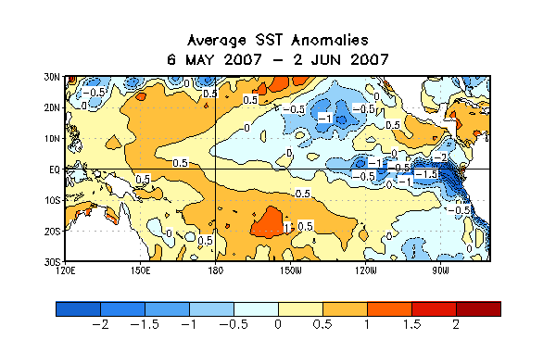
Figure 1. Sea surface temperature (SST) anomalies (°C) during the four-week period 6 May-2 June 2007. SST anomalies are computed with respect to the 1971-2000 base period weekly means (Xue et al. 2003, J. Climate, 16, 1601-1612).

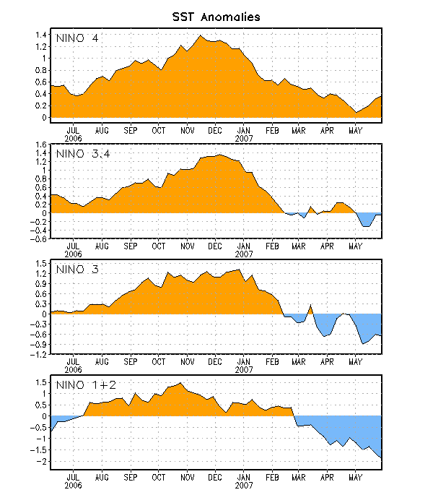
Figure 2. Time series of area-averaged sea surface temperature (SST) anomalies (°C) in the Niño regions [Niño-1+2 (0°-10°S, 90°-80°W), Niño 3 (5°N-5°S, 150°W-90°W), Niño-3.4 (5°N-5°S, 170°W-120°W), Niño-4 (150ºW-160ºE and 5ºN-5ºS)]. SST anomalies are departures are from the 1971-2000 base period means (Xue et al. 2003, J. Climate, 16, 1601-1612).

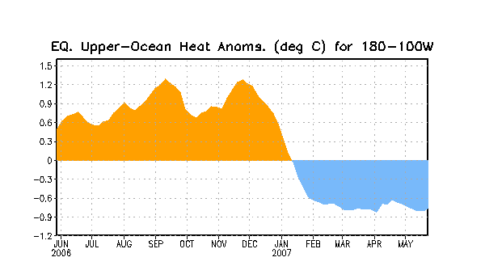
Figure 3. Area-averaged upper-ocean heat content anomalies in the equatorial Pacific (5°N-5°S, 180º-100ºW). Heat content anomalies are computed as departures from the 1982-2004 base period means.

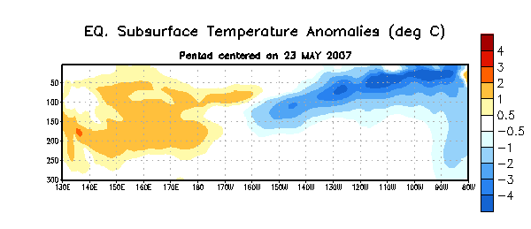
Figure 4. Depth-longitude section of upper-ocean (0-300m) temperature anomalies for the equatorial Pacific averaged between 5°N-5°S. Temperature anomalies are departures from the 1982-2004 base period means.

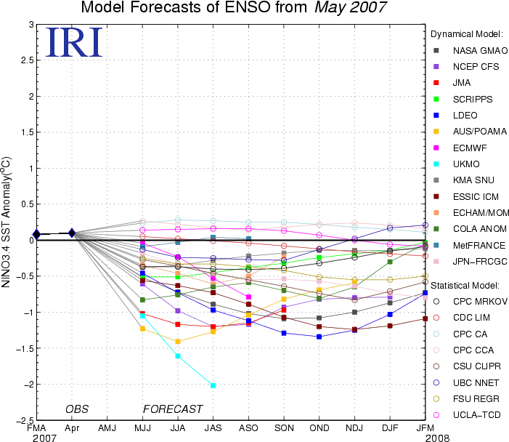
Figure 5. Forecasts of sea surface temperature (SST) anomalies for the Niño 3.4 region (5°N-5°S, 120°W-170°W). Figure courtesy of the International Research Institute (IRI) for Climate and Society.

