EL NIÑO/SOUTHERN OSCILLATION (ENSO) DIAGNOSTIC DISCUSSION
issued by
CLIMATE PREDICTION CENTER/NCEP/NWS
5 June 2008

Synopsis: A transition from La Niña to ENSO-neutral conditions is expected during June- July 2008.
La Niña continued to weaken during May 2008, reflected mainly by changes in sea surface temperatures (SSTs) across the equatorial Pacific Ocean. Negative SST anomalies in the central and east-central equatorial Pacific weakened, while the region of positive SST anomalies increased in the eastern Pacific (Fig. 1). The latest weekly SSTs in the westernmost Niño-4 and Niño-3.4 regions are near 0.5°C below-average, and were close to 0.5°C above-average in the easternmost Niño-3 and Niño 1+2 regions by the end of the month (Fig. 2).
Positive oceanic heat content anomalies (average temperatures in the upper 300m of the ocean; Fig. 3) reflected the continuation of above-average temperatures at thermocline depth in the west-central and eastern equatorial Pacific (Fig. 4). However, a shallow layer of negative anomalies (between the surface and 100m in the central Pacific) continue to be sufficiently cool to maintain the below-average SSTs, which support the atmospheric anomalies associated with La Niña. Enhanced low-level easterly winds and upper-level westerly winds continued across the central equatorial Pacific, while convection remained suppressed throughout the central equatorial Pacific and enhanced over the far western Pacific. Collectively, these atmospheric and oceanic conditions continue to indicate an ongoing, but gradually weakening, La Niña.
A majority of the recent dynamical and statistical SST forecasts for the Niño 3.4 region indicate a transition to ENSO-neutral conditions during June - August 2008 (Fig. 5). During the second half of the year, the majority of models reflect ENSO-neutral conditions (−0.5 to 0.5 in the Niño-3.4 region). However, there is considerable uncertainty during this period as some models suggest the possible development of El Niño while others show a re-development of La Niña. Based on current atmospheric and oceanic conditions and recent trends, a transition from La Niña to ENSO-neutral conditions is expected during June- July 2008.
This discussion is a consolidated effort of the National Atmospheric and Oceanic Administration (NOAA), NOAA’s National Weather Service, and their funded institutions. Oceanic and atmospheric conditions are updated weekly on the Climate Prediction Center web site (El Niño/La Niña Current Conditions and Expert Discussions). Forecasts for the evolution of El Niño/La Niña are updated monthly in the Forecast Forum section of CPC's Climate Diagnostics Bulletin. The next ENSO Diagnostics Discussion is scheduled for 10 July 2008. To receive an e-mail notification when the monthly ENSO Diagnostic Discussions are released, please send an e-mail message to: ncep.list.enso-update@noaa.gov.
Climate Prediction Center
National Centers for Environmental Prediction
NOAA/National Weather Service
Camp Springs, MD 20746-4304

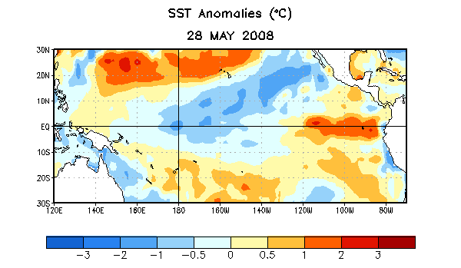
Figure 1. Weekly sea surface temperature (SST) anomalies (°C) centered on 28 May 2008. Anomalies are computed with respect to the 1971-2000 base period weekly means (Xue et al. 2003, J. Climate, 16, 1601-1612).

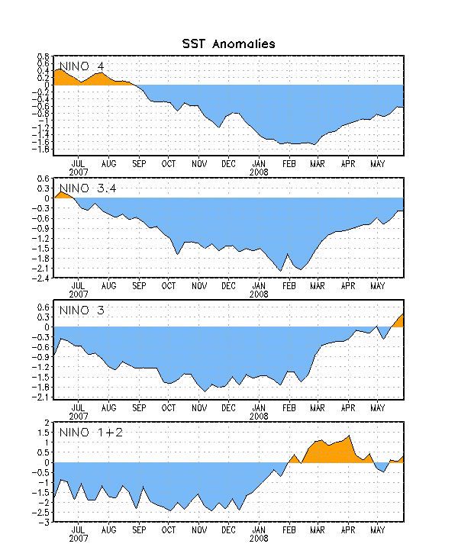

Figure 2. Time series of area-averaged sea surface temperature (SST) anomalies (°C) in the Niño regions [Niño-1+2 (0°-10°S, 90°-80°W), Niño 3 (5°N-5°S, 150°W-90°W), Niño-3.4 (5°N-5°S, 170°W-120°W), Niño-4 (150ºW-160ºE and 5ºN-5ºS)]. SST anomalies are departures are from the 1971-2000 base period weekly means (Xue et al. 2003, J. Climate, 16, 1601-1612).

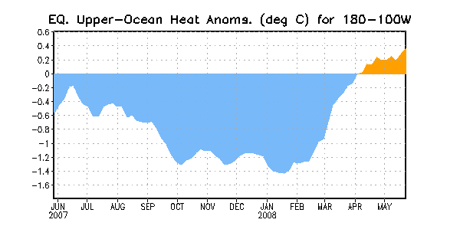
Figure 3. Area-averaged upper-ocean heat content anomalies (°C) in the equatorial Pacific (5°N-5°S, 180º-100ºW). Heat content anomalies are computed as departures from the 1982-2004 base period weekly means.

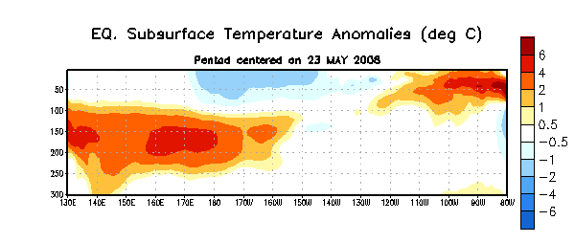

Figure 4. Depth-longitude section of equatorial Pacific upper-ocean (0-300m) temperature anomalies (°C) centered on the week of 23 May 2008. The anomalies are averaged between 5°N-5°S. Anomalies are departures from the 1982-2004 base period weekly means.

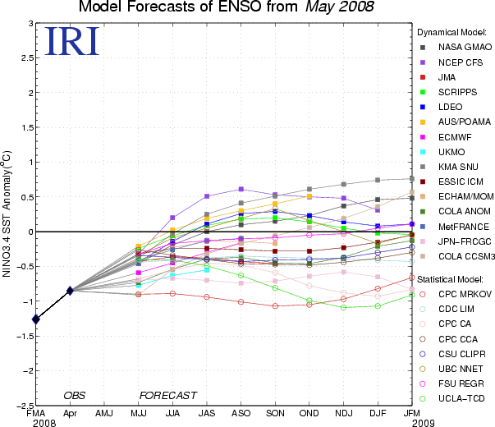

Figure 5. Forecasts of sea surface temperature (SST) anomalies for the Niño 3.4 region (5°N-5°S, 120°W-170°W). Figure courtesy of the International Research Institute (IRI) for Climate and Society. Figure updated 19 May 2008.

