EL NIÑO/SOUTHERN OSCILLATION (ENSO) DIAGNOSTIC DISCUSSION
issued by
CLIMATE PREDICTION CENTER/NCEP/NWS
4 June 2009

ENSO Alert System Status: El Niño Watch

Synopsis: Conditions are favorable for a transition from ENSO-neutral to El Niño conditions during June − August 2009.
ENSO-neutral conditions persisted across the equatorial Pacific Ocean during May 2009. However, sea surface temperatures (SST) increased for the fifth consecutive month, with above-average temperatures extending across the equatorial Pacific Ocean by the end of May (Fig. 1). Accordingly, the latest weekly SST indices ranged between +0.4° to +0.5°C in all four Niño regions (Fig. 2). Subsurface oceanic heat content anomalies (average temperatures in the upper 300m of the ocean, Fig. 3) also continued to increase in response to a large area of above-average temperatures (+2° to +4°C) near thermocline depth (Fig. 4). These surface and subsurface oceanic anomalies typically precede the development of El Niño.
From early 2007 through April 2009, enhanced low-level easterly winds persisted near the Date Line, interrupted only briefly by Madden- Julian Oscillation (MJO) activity. However, during May 2009, both the lower-level equatorial winds were near-average in that region despite the absence of the MJO. Also, suppressed convection expanded westward along the equator from the Date Line to Indonesia. The recent oceanic and atmospheric anomalies are consistent with ENSO-neutral conditions, but also reflect the evolution towards a potential El Niño.
There continues to be considerable spread in the model forecasts for the Niño-3.4 region (Fig. 5). All statistical models predict ENSO-neutral conditions will continue for the remainder of 2009. However, most dynamical models, including the NCEP Climate Forecast System, predict the onset of El Niño during June − August 2009. Current observations, recent trends, and the dynamical model forecasts indicate that conditions are favorable for a transition from ENSO-neutral to El Niño conditions during June − August 2009.
This discussion is a consolidated effort of the National Oceanic and Atmospheric Administration (NOAA), NOAA’s National Weather Service, and their funded institutions. Oceanic and atmospheric conditions are updated weekly on the Climate Prediction Center web site (El Niño/La Niña Current Conditions and Expert Discussions). Forecasts for the evolution of El Niño/La Niña are updated monthly in the Forecast Forum section of CPC's Climate Diagnostics Bulletin. The next ENSO Diagnostics Discussion is scheduled for 9 July 2009. To receive an e-mail notification when the monthly ENSO Diagnostic Discussions are released, please send an e-mail message to: ncep.list.enso-update@noaa.gov.
Climate Prediction Center
National Centers for Environmental Prediction
NOAA/National Weather Service
Camp Springs, MD 20746-4304

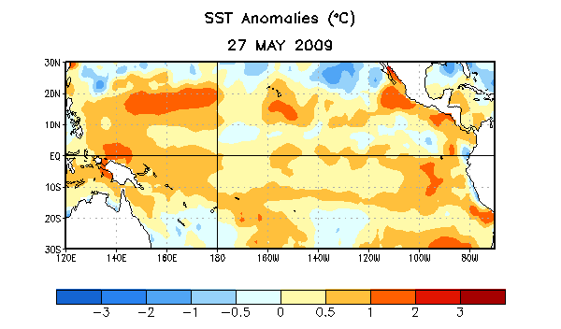

Figure 1. Average weekly sea surface temperature (SST) anomalies (°C) centered on 27 May 2009. Anomalies are computed with respect to the 1971-2000 base period weekly means (Xue et al. 2003, J. Climate, 16, 1601-1612).

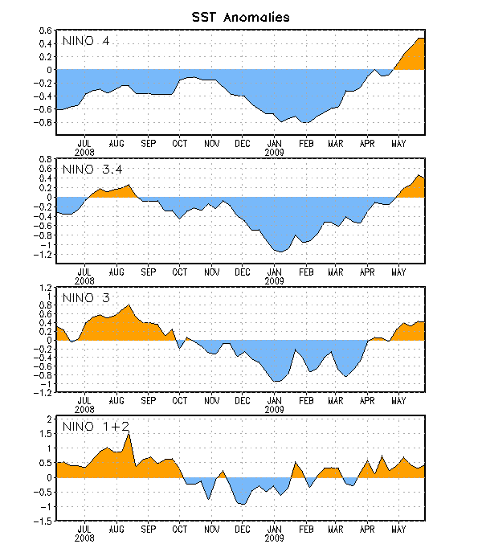
Figure 2. Time series of area-averaged sea surface temperature (SST) anomalies (°C) in the Niño regions [Niño-1+2 (0°-10°S, 90°W-80°W), Niño 3 (5°N-5°S, 150°W-90°W), Niño-3.4 (5°N-5°S, 170°W-120°W), Niño-4 (150ºW-160ºE and 5ºN-5ºS)]. SST anomalies are departures from the 1971-2000 base period weekly means (Xue et al. 2003, J. Climate, 16, 1601-1612).

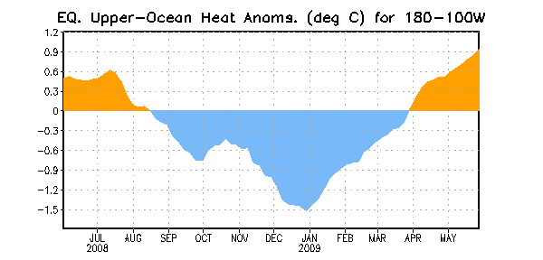
Figure 3. Area-averaged upper-ocean heat content anomalies (°C) in the equatorial Pacific (5°N-5°S, 180º-100ºW). Heat content anomalies are computed as departures from the 1982-2004 base period pentad means.

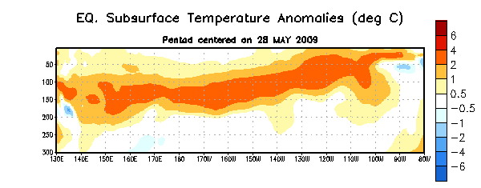
Figure 4. Depth-longitude section of equatorial Pacific upper-ocean (0-300m) temperature anomalies (°C) centered on the week of 28 May 2009. The anomalies are averaged between 5°N-5°S. Anomalies are departures from the 1982-2004 base period pentad means.

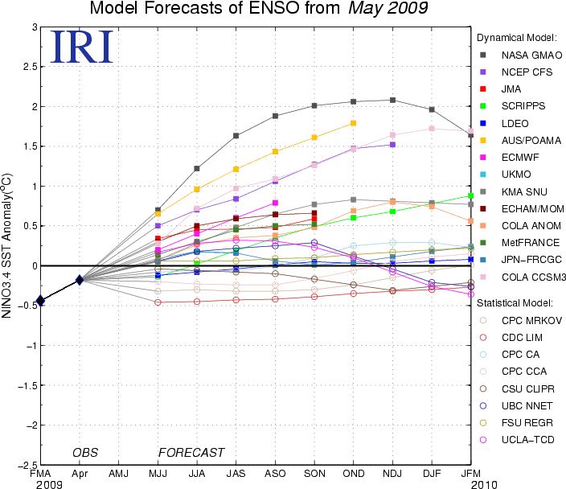

Figure 5. Forecasts of sea surface temperature (SST) anomalies for the Niño 3.4 region (5°N-5°S, 120°W-170°W). Figure courtesy of the International Research Institute (IRI) for Climate and Society. Figure updated 19 May 2009.

