EL NIÑO/SOUTHERN OSCILLATION (ENSO) DIAGNOSTIC DISCUSSION

issued by

CLIMATE PREDICTION CENTER/NCEP/NWS
9 June 2011

ENSO Alert System Status: Final La Niña Advisory

Synopsis: ENSO-neutral conditions have developed and are expected to continue at least through the Northern Hemisphere summer 2011.
A transition from La Niña to ENSO-neutral conditions occurred during May 2011 as indicated by generally small sea surface temperature (SST) anomalies across the equatorial Pacific Ocean east of the Date Line (Fig. 1). The latest weekly Nino index values (Fig. 2) showed near-average SSTs in the central and east-central equatorial Pacific (Niño-4 index of –0.2°C and Niño 3.4 index of –0.1°C), and above-average SSTs in the eastern equatorial Pacific (Niño-1+2 index of +0.7°C). The subsurface oceanic heat content anomalies (average temperatures in the upper 300m of the ocean, Fig. 3) remained elevated, but relatively constant during the month, reflecting a large area of above-average temperatures at depth (Fig. 4). Consistent with other transitions to ENSO-neutral conditions, the atmospheric circulation anomalies continued to show some features consistent with La Niña, albeit at weaker strength. Convection was enhanced over eastern Indonesia and suppressed over the central equatorial Pacific (Fig. 5). Also, anomalous low-level easterly and upper-level westerly winds weakened but persisted over the central Pacific. Collectively, these oceanic and atmospheric anomalies reflect a transition to ENSO-neutral conditions, but with lingering La Niña-like atmospheric impacts, particularly in the global Tropics.
Current observed trends, along with forecasts from a majority of the ENSO models, indicate ENSO-neutral will continue through the Northern Hemisphere summer 2011 (three-month average in the Nino-3.4 index between –0.5°C and +0.5°C; Fig. 6). Thereafter, most models and all multi-model forecasts (shown by the thick lines) predict ENSO-neutral to continue through the remainder of 2011. However, the status of ENSO beyond the Northern Hemisphere summer remains more uncertain due to lower model forecast skill at longer lead times, particularly during this time of year.
This discussion is a consolidated effort of the National Oceanic and Atmospheric Administration (NOAA), NOAA’s National Weather Service, and their funded institutions. Oceanic and atmospheric conditions are updated weekly on the Climate Prediction Center web site (El Niño/La Niña Current Conditions and Expert Discussions). Forecasts for the evolution of El Niño/La Niña are updated monthly in the Forecast Forum section of CPC's Climate Diagnostics Bulletin. The next ENSO Diagnostics Discussion is scheduled for 7 July 2011. To receive an e-mail notification when the monthly ENSO Diagnostic Discussions are released, please send an e-mail message to: ncep.list.enso-update@noaa.gov.
Climate Prediction Center
National Centers for Environmental Prediction
NOAA/National Weather Service
Camp Springs, MD 20746-4304

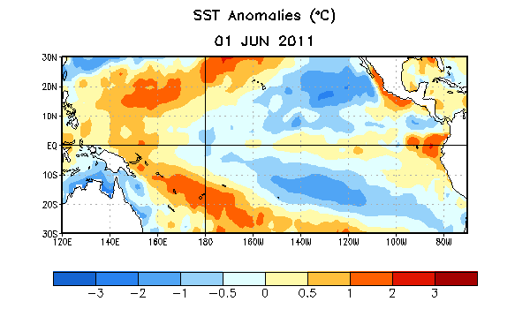
Figure 1. Average sea surface temperature (SST) anomalies (°C) for the week centered on 1 June 2011. Anomalies are computed with respect to the 1971-2000 base period weekly means (Xue et al. 2003, J. Climate, 16, 1601-1612).

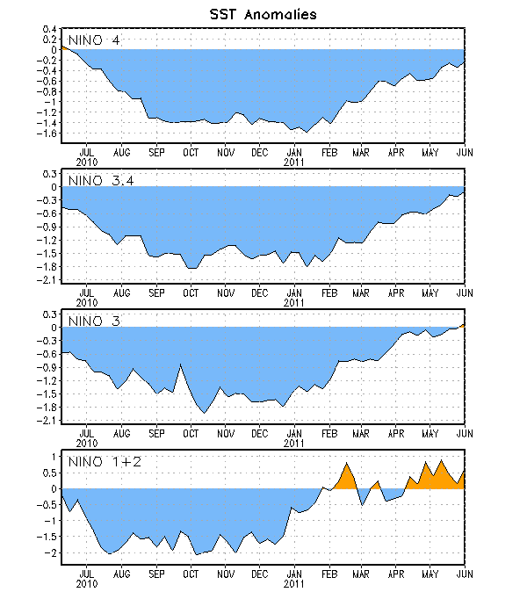
Figure 2. Time series of area-averaged sea surface temperature (SST) anomalies (°C) in the Niño regions [Niño-1+2 (0°-10°S, 90°W-80°W), Niño 3 (5°N-5°S, 150°W-90°W), Niño-3.4 (5°N-5°S, 170°W-120°W), Niño-4 (150ºW-160ºE and 5ºN-5ºS)]. SST anomalies are departures from the 1971-2000 base period weekly means (Xue et al. 2003, J. Climate, 16, 1601-1612).

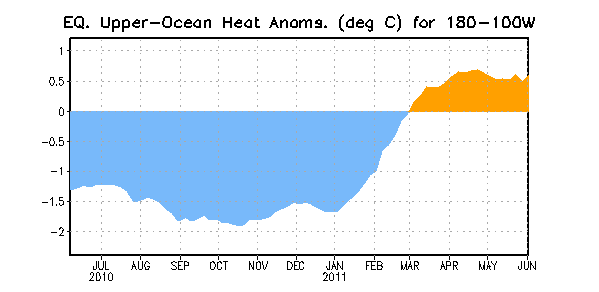
Figure 3. Area-averaged upper-ocean heat content anomalies (°C) in the equatorial Pacific (5°N-5°S, 180º-100ºW). Heat content anomalies are computed as departures from the 1982-2004 base period pentad means.

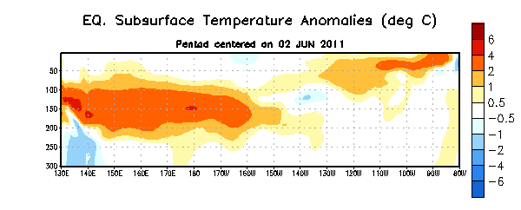
Figure 4. Depth-longitude section of equatorial Pacific upper-ocean (0-300m) temperature anomalies (°C) centered on the week of 2 June 2011. The anomalies are averaged between 5°N-5°S. Anomalies are departures from the 1982-2004 base period pentad means.

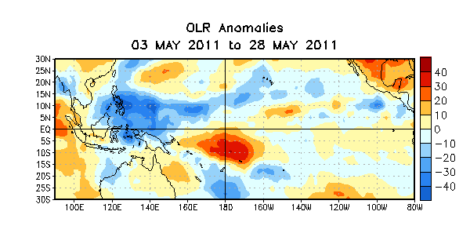

Figure 5. Average outgoing longwave radiation (OLR) anomalies (W/m²) for the four-week period 3 – 28 May 2011. OLR anomalies are computed as departures from the 1979-1995 base period pentad means.

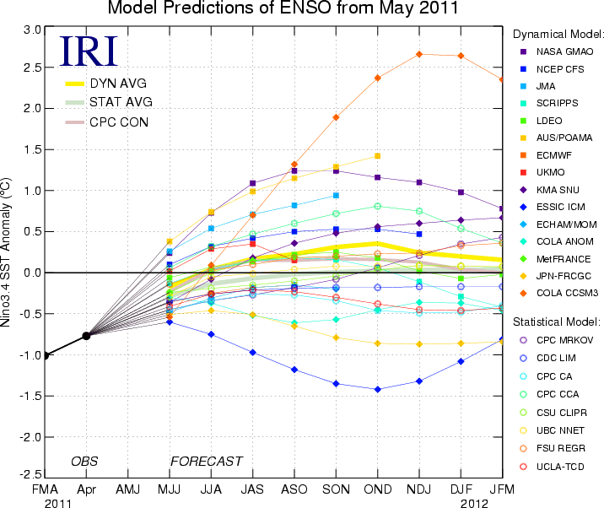
Figure 6. Forecasts of sea surface temperature (SST) anomalies for the Niño 3.4 region (5°N-5°S, 120°W-170°W). Figure courtesy of the International Research Institute (IRI) for Climate and Society. Figure updated 17 May 2011.

