EL NIÑO/SOUTHERN OSCILLATION (ENSO) DIAGNOSTIC DISCUSSION

issued by

CLIMATE PREDICTION CENTER/NCEP/NWS
and the International Research Institute for Climate and Society
6 June 2013

ENSO Alert System Status: Not Active

Synopsis: ENSO-neutral is favored through the Northern Hemisphere summer 2013.
During May 2013, ENSO-neutral continued, as reflected by the persistence of near-average sea surface temperatures (SSTs) across much of the equatorial Pacific Ocean (Fig. 1). However, below average SSTs in the eastern Pacific strengthened, with the weekly index values in the easternmost Niño-3 and Niño-1+2 regions near or less than -1.0°C by the end of month (Fig. 2). The weekly Niño-3.4 and Niño-4 regions remained greater than -0.5°C through May. The oceanic heat content (average temperature in the upper 300m of the ocean) was near average, but decreased slightly (Fig. 3) due to the emergence of below-average sub-surface temperatures in the eastern Pacific (Fig. 4). Across the Pacific, equatorial winds remained near average, except for weak low-level easterly anomalies in the western Pacific and weak upper-level westerly anomalies in the western and central Pacific. Tropical convection remained enhanced over Indonesia and suppressed over the central Pacific (Fig. 5). Despite a tendency toward cooler conditions, the overall state of the tropical Pacific was consistent with ENSO-neutral.
The majority of the model forecasts favor the continuation of ENSO-neutral, with most models predicting Niño-3.4 index values below zero (Fig. 6). A smaller number of models (mainly statistical) predict weak La Niña conditions (Niño-3.4 less than -0.5°C) as soon as the Northern Hemisphere summer. As a result, the forecast consensus indicates larger chances for La Niña relative to El Niño, but there still remains close to a 60% or greater chance of ENSO-neutral through the Northern Hemisphere summer 2013 (see CPC/IRI consensus forecast).
This discussion is a consolidated effort of the National Oceanic and Atmospheric Administration (NOAA), NOAA’s National Weather Service, and their funded institutions. Oceanic and atmospheric conditions are updated weekly on the Climate Prediction Center web site (El Niño/La Niña Current Conditions and Expert Discussions). Forecasts for the evolution of El Niño/La Niña are updated monthly in the Forecast Forum section of CPC's Climate Diagnostics Bulletin. The next ENSO Diagnostics Discussion is scheduled for 5 July 2013. To receive an e-mail notification when the monthly ENSO Diagnostic Discussions are released, please send an e-mail message to: ncep.list.enso-update@noaa.gov.
Climate Prediction Center
National Centers for Environmental Prediction
NOAA/National Weather Service
College Park, MD 20740

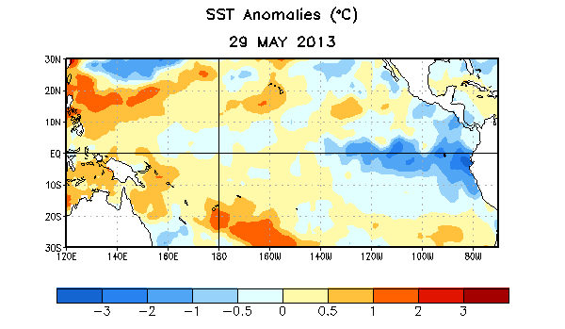
Figure 1. Average sea surface temperature (SST) anomalies (°C) for the week centered on 29 May 2013. Anomalies are computed with respect to the 1981-2010 base period weekly means.

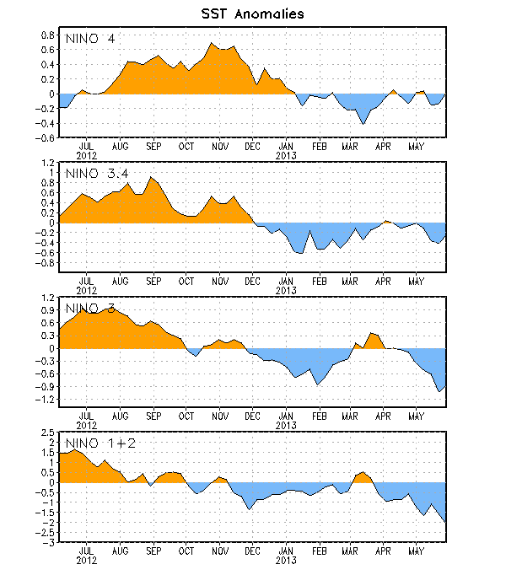
Figure 2. Time series of area-averaged sea surface temperature (SST) anomalies (°C) in the Niño regions [Niño-1+2 (0°-10°S, 90°W-80°W), Niño 3 (5°N-5°S, 150°W-90°W), Niño-3.4 (5°N-5°S, 170°W-120°W), Niño-4 (150ºW-160ºE and 5ºN-5ºS)]. SST anomalies are departures from the 1981-2010 base period weekly means.

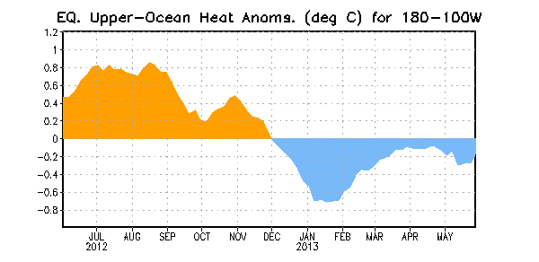
Figure 3. Area-averaged upper-ocean heat content anomaly (°C) in the equatorial Pacific (5°N-5°S, 180º-100ºW). The heat content anomaly is computed as the departure from the 1981-2010 base period pentad means.

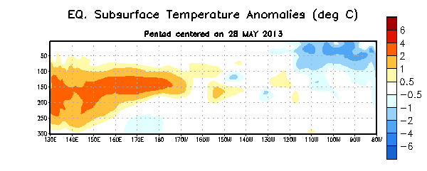
Figure 4. Depth-longitude section of equatorial Pacific upper-ocean (0-300m) temperature anomalies (°C) centered on the pentad of 28 May 2013. The anomalies are averaged between 5°N-5°S. Anomalies are departures from the 1981-2010 base period pentad means.

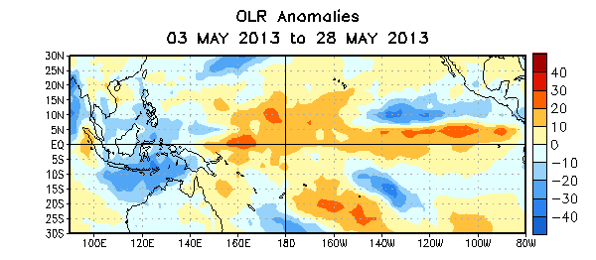

Figure 5. Average outgoing longwave radiation (OLR) anomalies (W/m²) for the four-week period 3 – 28 May 2013. OLR anomalies are computed as departures from the 1979-1995 base period pentad means.

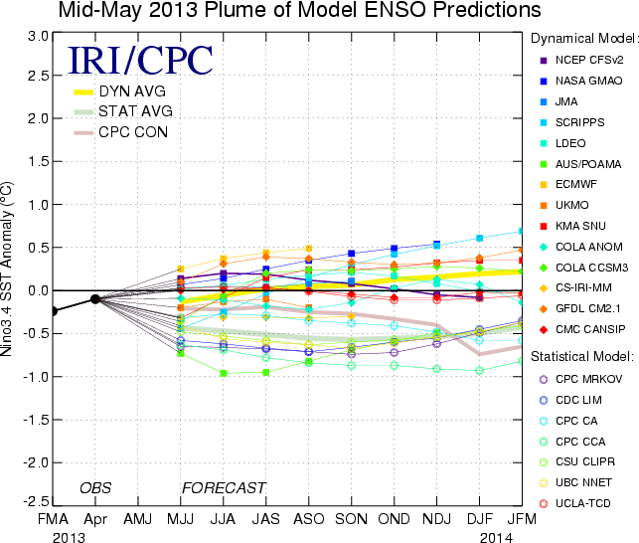
Figure 6. Forecasts of sea surface temperature (SST) anomalies for the Niño 3.4 region (5°N-5°S, 120°W-170°W). Figure courtesy of the International Research Institute (IRI) for Climate and Society. Figure updated 14 May 2013.

