EL NIÑO/SOUTHERN OSCILLATION (ENSO) DIAGNOSTIC DISCUSSION

issued by

CLIMATE PREDICTION CENTER/NCEP/NWS
and the International Research Institute for Climate and Society
5 June 2014

ENSO Alert System Status: El Niño Watch

Synopsis: The chance of El Niño is 70% during the Northern Hemisphere summer and reaches 80% during the fall and winter.
Above-average sea surface temperatures (SST) expanded over the equatorial Pacific Ocean during May 2014 (Fig. 1), though the collective atmospheric and oceanic state continued to reflect ENSO-neutral. All of the Niño indices increased during the month, with the latest weekly values between 0.6°C and 1.6°C (Fig. 2). In contrast, subsurface temperature anomalies decreased over the last two months (Fig. 3), but still reflect a large pool of above-average temperatures at depth (Fig. 4). The low-level winds over the tropical Pacific remain near average, except for westerly anomalies over the eastern Pacific. At upper-levels, anomalous easterly winds have predominated over most of the equatorial Pacific. Unlike the previous month, convection was near average across most of the tropics (Fig. 5). The lack of a clear atmospheric response to the positive SSTs indicates ENSO-neutral, though the tropical Pacific continues to evolve toward El Niño.
Over the last month, the chance of El Niño and its ultimate strength weakened slightly in the models (Fig. 6). Regardless, the forecasters remain just as confident that El Niño is likely to emerge. If El Niño forms, the forecasters and most dynamical models, such as NCEP CFSv2, slightly favor a moderate-strength event during the Northern Hemisphere fall or winter (3-month values of the Niño-3.4 index between 1.0°C and 1.4°C). However, significant uncertainty accompanies this prediction, which remains inclusive of a weaker or stronger event due to the spread of the models and their skill at these lead times. Overall, the chance of El Niño is 70% during the Northern Hemisphere summer and reaches 80% during the fall and winter (click CPC/IRI consensus forecast for the chance of each outcome).
This discussion is a consolidated effort of the National Oceanic and Atmospheric Administration (NOAA), NOAA’s National Weather Service, and their funded institutions. Oceanic and atmospheric conditions are updated weekly on the Climate Prediction Center web site (El Niño/La Niña Current Conditions and Expert Discussions). Forecasts are also updated monthly in the Forecast Forum of CPC's Climate Diagnostics Bulletin. Additional perspectives and analysis are also available in an ENSO blog. The next ENSO Diagnostics Discussion is scheduled for 10 July 2014. To receive an e-mail notification when the monthly ENSO Diagnostic Discussions are released, please send an e-mail message to: ncep.list.enso-update@noaa.gov.

Climate Prediction Center
National Centers for Environmental Prediction
NOAA/National Weather Service
College Park, MD 20740

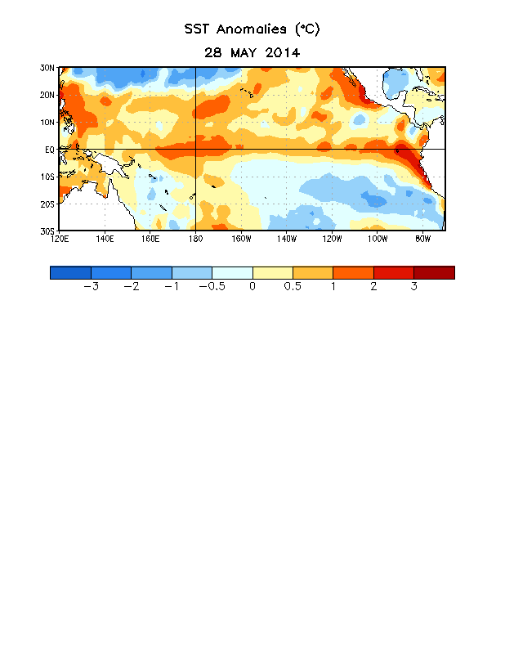
Figure 1. Average sea surface temperature (SST) anomalies (°C) for the week centered on 28 May 2014. Anomalies are computed with respect to the 1981-2010 base period weekly means.

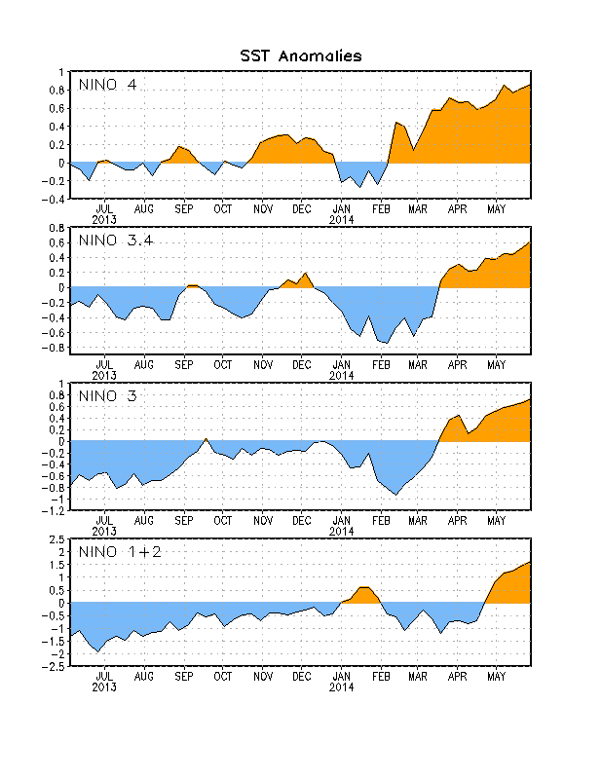
Figure 2. Time series of area-averaged sea surface temperature (SST) anomalies (°C) in the Niño regions [Niño-1+2 (0°-10°S, 90°W-80°W), Niño 3 (5°N-5°S, 150°W-90°W), Niño-3.4 (5°N-5°S, 170°W-120°W), Niño-4 (5ºN-5ºS , 150ºW-160ºE]. SST anomalies are departures from the 1981-2010 base period weekly means.

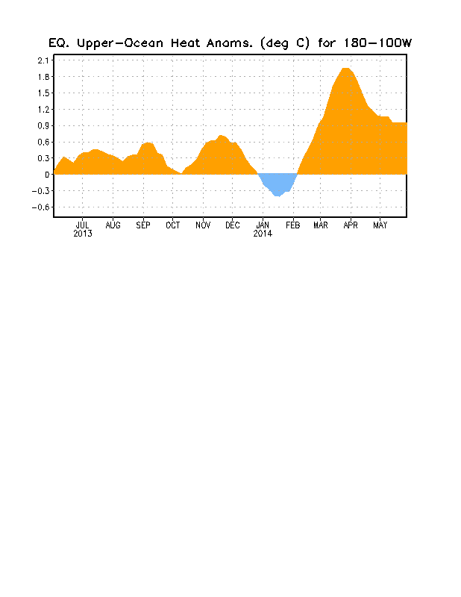
Figure 3. Area-averaged upper-ocean heat content anomaly (°C) in the equatorial Pacific (5°N-5°S, 180º-100ºW). The heat content anomaly is computed as the departure from the 1981-2010 base period pentad means.

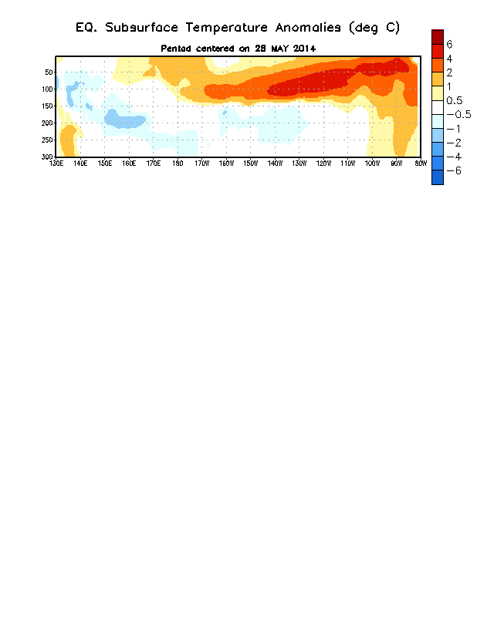
Figure 4. Depth-longitude section of equatorial Pacific upper-ocean (0-300m) temperature anomalies (°C)
centered on the pentad of 28 May 2014. The anomalies are averaged between 5°N-5°S. Anomalies are departures from the 1981-2010 base period pentad means.

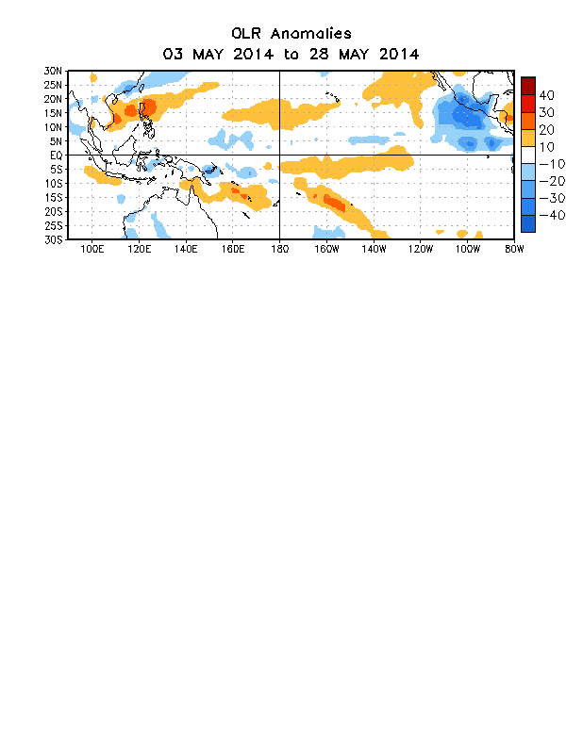

Figure 5. Average outgoing longwave radiation (OLR) anomalies (W/m²) for the period 3 – 28
May 2014. OLR anomalies are computed as departures from the 1979-1995 base period pentad means.

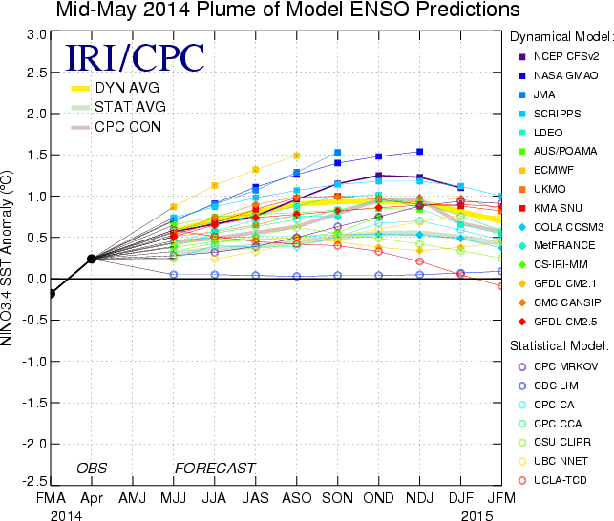

Figure 6. Forecasts of sea surface temperature (SST) anomalies for the Niño 3.4 region (5°N-5°S, 120°W-170°W). Figure updated 13 May 2014.

