EL NIÑO/SOUTHERN OSCILLATION (ENSO) DIAGNOSTIC DISCUSSION

issued by

CLIMATE PREDICTION CENTER/NCEP/NWS
and the International Research Institute for Climate and Society
9 June 2016

ENSO Alert System Status: Final El Niño Advisory / La Niña Watch

Synopsis: ENSO-neutral conditions are present and La Niña is favored to develop during the Northern Hemisphere summer 2016, with about a 75% chance of La Niña during the fall and winter 2016-17.
El Niño dissipated and ENSO-neutral conditions returned during over the past month, as indicated by the expansion of near-to-below average surface temperatures (SST) across the eastern equatorial Pacific Ocean (Fig. 1). Other than the westernmost Niño-4 region, the Niño indices were near zero by the end of May (Fig. 2). Below-average subsurface temperatures continued (Fig. 3) and extended to the surface across the eastern equatorial Pacific (Fig. 4). For the first time in 2016, atmospheric anomalies over the tropical Pacific Ocean were also consistent with ENSO-neutral conditions. The traditional and equatorial Southern Oscillation indices were near zero, while the upper and lower-level winds were both near average across most of the tropical Pacific. Convection was also near-average over the central tropical Pacific and over most of Indonesia (Fig. 5). Collectively, these atmospheric and oceanic anomalies reflect a transition from El Niño to ENSO-neutral conditions.
Many models favor La Niña (3-month average Niño-3.4 index less than or equal to -0.5°C) by the Northern Hemisphere fall (Fig. 6). However, most dynamical models indicate La Niña onset as soon as the Northern Hemisphere summer, which is slightly favored by the forecaster consensus. In contrast, many statistical models favor a later onset time, with about half indicating the persistence of ENSO-neutral conditions through the winter. At this time, the forecasters are leaning toward a weak or borderline moderate La Niña if an event were to form. Overall, ENSO-neutral conditions are present and La Niña is favored to develop during the Northern Hemisphere summer 2016, with about a 75% chance of La Niña during the fall and winter 2016-17 (click CPC/IRI consensus forecast for the chance of each outcome for each 3-month period).
This discussion is a consolidated effort of the National Oceanic and Atmospheric Administration (NOAA), NOAA’s National Weather Service, and their funded institutions. Oceanic and atmospheric conditions are updated weekly on the Climate Prediction Center web site (El Niño/La Niña Current Conditions and Expert Discussions). Forecasts are also updated monthly in the Forecast Forum of CPC's Climate Diagnostics Bulletin. Additional perspectives and analysis are also available in an ENSO blog. The next ENSO Diagnostics Discussion is scheduled for 14 July 2016. To receive an e-mail notification when the monthly ENSO Diagnostic Discussions are released, please send an e-mail message to: ncep.list.enso-update@noaa.gov.

Climate Prediction Center
National Centers for Environmental Prediction
NOAA/National Weather Service
College Park, MD 20740

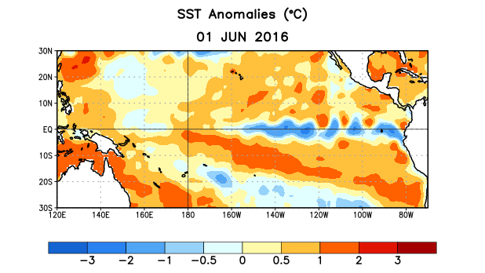
Figure 1. Average sea surface temperature (SST) anomalies (°C) for the week centered on 1 June 2016. Anomalies are computed with respect to the 1981-2010 base period weekly means.

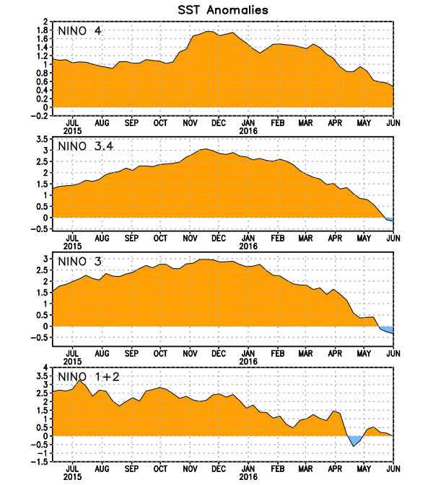
Figure 2. Time series of area-averaged sea surface temperature (SST) anomalies (°C) in the Niño regions [Niño-1+2 (0°-10°S, 90°W-80°W), Niño 3 (5°N-5°S, 150°W-90°W), Niño-3.4 (5°N-5°S, 170°W-120°W), Niño-4 (5ºN-5ºS , 150ºW-160ºE]. SST anomalies are departures from the 1981-2010 base period weekly means.
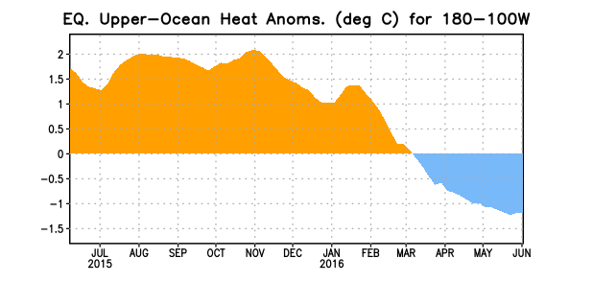
Figure 3. Area-averaged upper-ocean heat content anomaly (°C) in the equatorial Pacific (5°N-5°S, 180º-100ºW). The heat content anomaly is computed as the departure from the 1981-2010 base period pentad means.

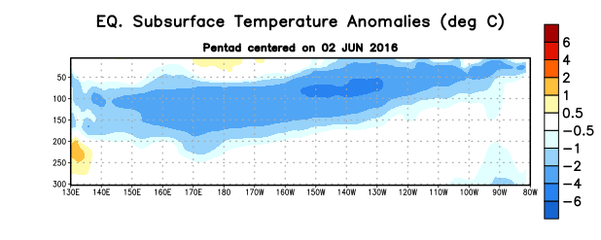
Figure 4. Depth-longitude section of equatorial Pacific upper-ocean (0-300m) temperature anomalies (°C)
centered on the pentad of 2 June 2016. The anomalies are averaged between 5°N-5°S. Anomalies are departures from the 1981-2010 base period pentad means.

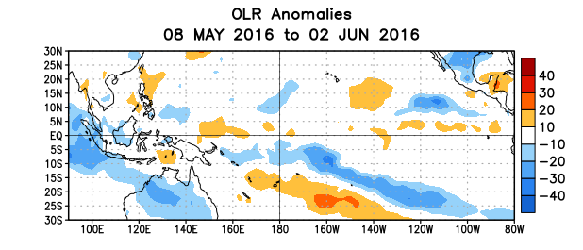
Figure 5. Average outgoing longwave radiation (OLR) anomalies (W/m²) for the period 8 May – 2 June 2016. OLR anomalies are computed as departures from the 1981-2010 base period pentad means.

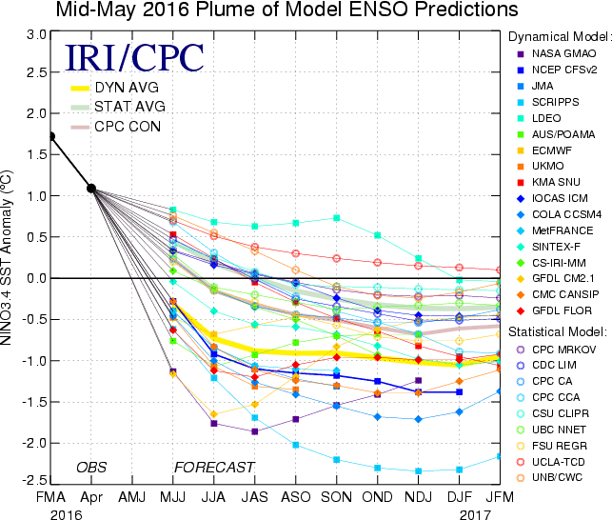
Figure 6. Forecasts of sea surface temperature (SST) anomalies for the Niño 3.4 region (5°N-5°S, 120°W-170°W). Figure updated 17 May 2016.

