EL NIÑO/SOUTHERN OSCILLATION (ENSO) DIAGNOSTIC DISCUSSION

issued by

CLIMATE PREDICTION CENTER/NCEP/NWS
and the International Research Institute for Climate and Society
8 June 2017

ENSO Alert System Status: Not Active

Synopsis: ENSO-neutral is favored (50 to ~55% chance) through the Northern Hemisphere fall 2017.
During May, ENSO-neutral continued, though sea surface temperatures (SSTs) were above average in the east-central Pacific Ocean (Fig. 1). The latest weekly Niño index values were near +0.5°C in most of the Niño regions, except for the easternmost Niño-1+2, which was at +0.2°C (Fig. 2). The upper-ocean heat content anomaly increased during May (Fig. 3), reflecting the expansion of above-average sub-surface temperatures across the central and eastern Pacific (Fig. 4) in association with a downwelling oceanic Kelvin wave. While ocean temperatures were elevated, the atmosphere was close to average. Atmospheric convection anomalies were weak over the central tropical Pacific and Maritime Continent (Fig. 5), while the lower-level and upper-level winds were near average over most of the tropical Pacific. Both the Southern Oscillation Index (SOI) and Equatorial SOI were also near zero. Overall, the ocean and atmosphere system remains consistent with ENSO-neutral.

Many models predict the onset of El Niño (3-month average Niño-3.4 index at or greater than 0.5°C) during the Northern Hemisphere summer (Fig. 6). However, the NCEP CFSv2 and most of the models from the latest runs of the North American Multi-Model Ensemble (NMME) are now favoring the continuation of ENSO-neutral. These predictions, combined with the near-average atmospheric conditions over the Pacific, have resulted in slightly more confidence for the persistence of ENSO-neutral (50 to ~55% chance). However, chances for El Niño remain elevated (35-50%) relative to the long-term average into the fall. In summary, ENSO-neutral is favored (50 to ~55% chance) through the Northern Hemisphere fall 2017 (click CPC/IRI consensus forecast for the chance of each outcome for each 3-month period).

This discussion is a consolidated effort of the National Oceanic and Atmospheric Administration (NOAA), NOAA’s National Weather Service, and their funded institutions. Oceanic and atmospheric conditions are updated weekly on the Climate Prediction Center web site (El Niño/La Niña Current Conditions and Expert Discussions). Forecasts are also updated monthly in the Forecast Forum of CPC's Climate Diagnostics Bulletin. Additional perspectives and analysis are also available in an ENSO blog. The next ENSO Diagnostics Discussion is scheduled for 13 July 2017. To receive an e-mail notification when the monthly ENSO Diagnostic Discussions are released, please send an e-mail message to: ncep.list.enso-update@noaa.gov.

Climate Prediction Center
National Centers for Environmental Prediction
NOAA/National Weather Service
College Park, MD 20740

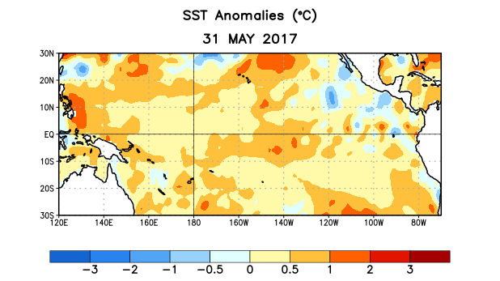
Figure 1. Average sea surface temperature (SST) anomalies (°C) for the week centered on 31 May 2017. Anomalies are computed with respect to the 1981-2010 base period weekly means.

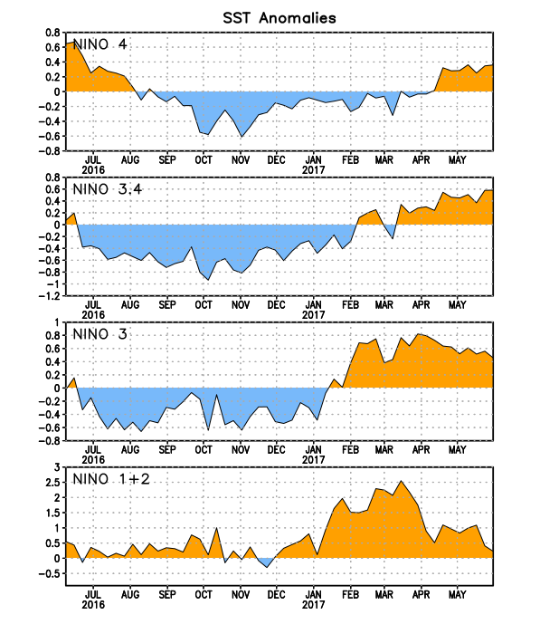
Figure 2. Time series of area-averaged sea surface temperature (SST) anomalies (°C) in the Niño regions [Niño-1+2 (0°-10°S, 90°W-80°W), Niño 3 (5°N-5°S, 150°W-90°W), Niño-3.4 (5°N-5°S, 170°W-120°W), Niño-4 (5ºN-5ºS , 150ºW-160ºE]. SST anomalies are departures from the 1981-2010 base period weekly means.
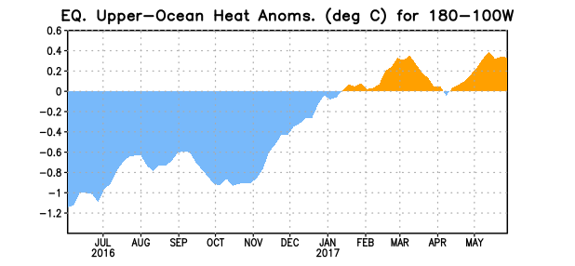
Figure 3. Area-averaged upper-ocean heat content anomaly (°C) in the equatorial Pacific (5°N-5°S, 180º-100ºW). The heat content anomaly is computed as the departure from the 1981-2010 base period pentad means.

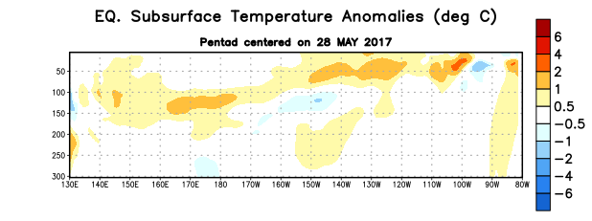
Figure 4. Depth-longitude section of equatorial Pacific upper-ocean (0-300m) temperature anomalies (°C) centered on the pentad of 28 May 2017. The anomalies are averaged between 5°N-5°S. Anomalies are departures from the 1981-2010 base period pentad means.

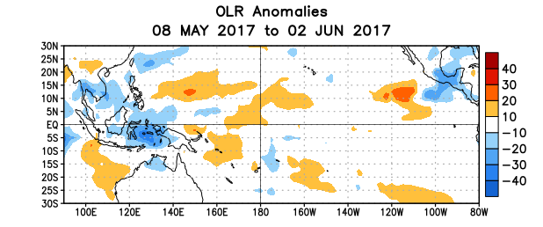
Figure 5. Average outgoing longwave radiation (OLR) anomalies (W/m²) for the period 8 May – 2 June 2017. OLR anomalies are computed as departures from the 1981-2010 base period pentad means.

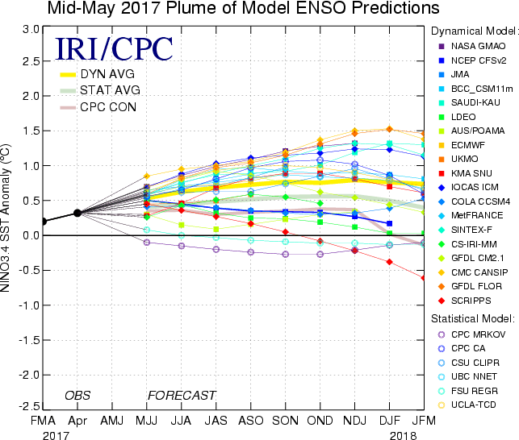

Figure 6. Forecasts of sea surface temperature (SST) anomalies for the Niño 3.4 region (5°N-5°S, 120°W-170°W). Figure updated 18 May 2017.

