EL NIÑO/SOUTHERN OSCILLATION (ENSO) DIAGNOSTIC DISCUSSION

issued by

CLIMATE PREDICTION CENTER/NCEP/NWS

and the International Research Institute for Climate and Society

14 June 2018

ENSO Alert System Status: El Niño Watch

Synopsis: ENSO-neutral is favored through Northern Hemisphere summer 2018, with the chance for El Niño increasing to 50% during fall, and ~65% during winter 2018-19.

ENSO-neutral continued during May, as indicated by mostly average sea surface temperatures (SSTs) across the central and eastern equatorial Pacific (Fig. 1). The latest weekly Niño indices were between +0.2°C and 0.0°C, except for the Niño-1+2 index, which remained negative (-0.5°C; Fig. 2). Positive subsurface temperature anomalies (averaged across 180°-100°W) increased over the past month (Fig. 3), as another downwelling equatorial oceanic Kelvin wave reinforced the already above-average subsurface temperatures (Fig. 4). Convection remained suppressed near the Date Line and was slightly enhanced over Indonesia (Fig. 5). Low-level and upper-level winds were near average across the equatorial Pacific Ocean. Overall, oceanic and atmospheric conditions reflected ENSO-neutral.
The majority of models in the IRI/CPC plume predict ENSO-neutral to continue through the Northern Hemisphere summer 2018, with El Niño most likely thereafter (Fig. 6). The forecaster consensus favors the onset of El Niño during the Northern Hemisphere fall, which would then continue through winter. These forecasts are supported by the ongoing build-up of heat within the tropical Pacific Ocean. In summary, ENSO-neutral is favored through Northern Hemisphere summer 2018, with the chance for El Niño increasing to 50% during fall, and ~65% during winter 2018-19 (click CPC/IRI consensus forecast for the chance of each outcome for each 3-month period).
This discussion is a consolidated effort of the National Oceanic and Atmospheric Administration (NOAA), NOAA’s National Weather Service, and their funded institutions. Oceanic and atmospheric conditions are updated weekly on the Climate Prediction Center web site (El Niño/La Niña Current Conditions and Expert Discussions). Forecasts are also updated monthly in the Forecast Forum of CPC's Climate Diagnostics Bulletin. Additional perspectives and analysis are also available in an ENSO blog. The next ENSO Diagnostics Discussion is scheduled for 12 July 2018. To receive an e-mail notification when the monthly ENSO Diagnostic Discussions are released, please send an e-mail message to: ncep.list.enso-update@noaa.gov.

Climate Prediction Center
National Centers for Environmental Prediction
NOAA/National Weather Service
College Park, MD 20740

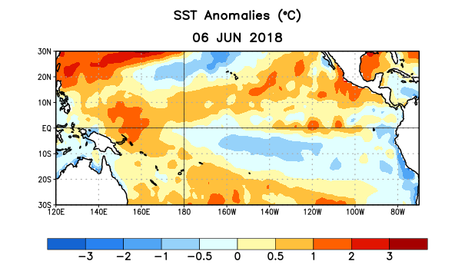
Figure 1. Average sea surface temperature (SST) anomalies (°C) for the week centered on 6 June 2018. Anomalies are computed with respect to the 1981-2010 base period weekly means.

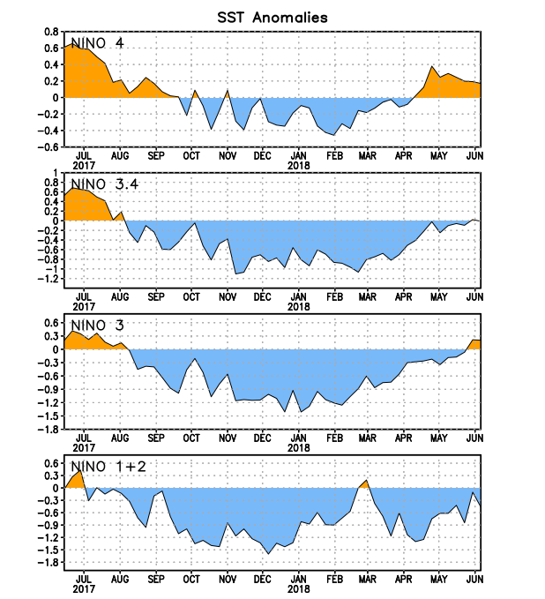
Figure 2. Time series of area-averaged sea surface temperature (SST) anomalies (°C) in the Niño regions [Niño-1+2 (0°-10°S, 90°W-80°W), Niño-3 (5°N-5°S, 150°W-90°W), Niño-3.4 (5°N-5°S, 170°W-120°W), Niño-4 (5ºN-5ºS , 150ºW-160ºE)]. SST anomalies are departures from the 1981-2010 base period weekly means.
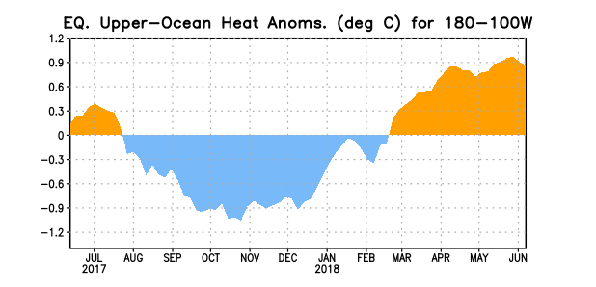
Figure 3. Area-averaged upper-ocean heat content anomaly (°C) in the equatorial Pacific (5°N-5°S, 180º-100ºW). The heat content anomaly is computed as the departure from the 1981-2010 base period pentad means.

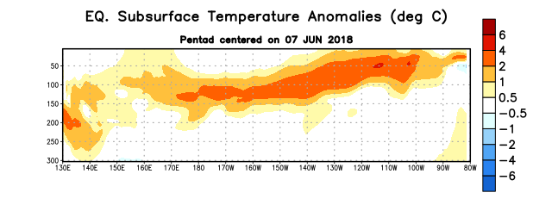
Figure 4. Depth-longitude section of equatorial Pacific upper-ocean (0-300m) temperature anomalies (°C) centered on the pentad of 7 June 2018. Anomalies are departures from the 1981-2010 base period pentad means.

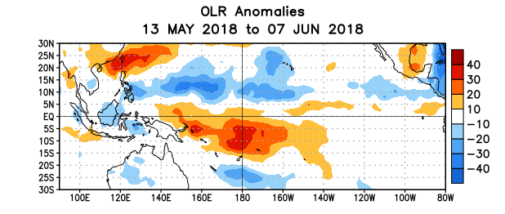
Figure 5. Average outgoing longwave radiation (OLR) anomalies (W/m²) for the period 13 May – 7 June 2018. OLR anomalies are computed as departures from the 1981-2010 base period pentad means.

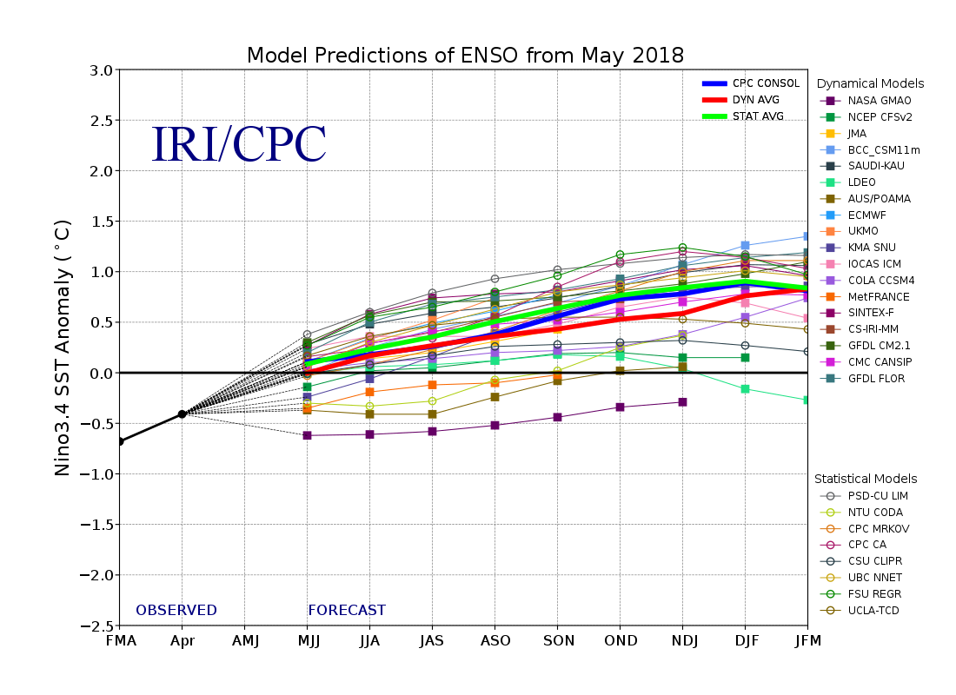
Figure 6. Forecasts of sea surface temperature (SST) anomalies for the Niño 3.4 region (5°N-5°S, 120°W-170°W). Figure updated 18 May 2018.

