EL NIÑO/SOUTHERN OSCILLATION (ENSO) DIAGNOSTIC DISCUSSION

issued by

CLIMATE PREDICTION CENTER/NCEP/NWS

and the International Research Institute for Climate and Society

13 June 2019

ENSO Alert System Status: El Niño Advisory

Synopsis: El Niño is predicted to persist through the Northern Hemisphere summer 2019 (66% chance), with lower odds of continuing through the fall and winter (50-55% chance).

During May, El Niño was reflected in the continued presence of above-average sea surface temperatures (SSTs) across most of the equatorial Pacific Ocean (Fig. 1). The latest weekly ENSO indices indicate the largest positive SST anomalies were within the central Pacific (+1.1°C in Niño-4 and +0.9°C in Niño-3.4) with smaller departures in the Niño-3 and Niño-1+2 regions (Fig. 2). Upper-ocean subsurface temperatures (averaged across 180°-100°W) were nearly average at the start of May, but positive anomalies increased toward the end of the month in association with a downwelling Kelvin wave (Fig. 3). Thus, anomalies remained positive at depth in the central equatorial Pacific Ocean, with negative anomalies evident in the eastern Pacific (Fig. 4). Suppressed tropical convection continued over Indonesia, while weak, enhanced convection persisted near the Date Line (Fig. 5). Low-level wind anomalies were westerly over the western tropical Pacific Ocean, and upper-level wind anomalies were easterly over the western and east-central Pacific. Overall, oceanic and atmospheric conditions were consistent with El Niño.
The combined averages in the IRI/CPC plume predict El Niño to continue into Northern Hemisphere winter 2019-20, but individual models span ENSO-neutral to El Niño outcomes (generally +0.0°C to +1.0°C; Fig. 6). The forecast consensus reflects this uncertainty, with slightly lower chances for El Niño compared to the previous month. Ongoing subseasonal variability within the tropical Pacific contributes to an overall murky picture, but the current downwelling oceanic Kelvin wave should fuel the persistence of El Niño at least in the short-term. In summary, El Niño is predicted to persist through the Northern Hemisphere summer 2019 (66% chance), with lower odds of continuing through the fall and winter (50-55% chance; click CPC/IRI consensus forecast for the chance of each outcome for each 3-month period).
This discussion is a consolidated effort of the National Oceanic and Atmospheric Administration (NOAA), NOAA’s National Weather Service, and their funded institutions. Oceanic and atmospheric conditions are updated weekly on the Climate Prediction Center web site (El Niño/La Niña Current Conditions and Expert Discussions). Forecasts are also updated monthly in the Forecast Forum of CPC's Climate Diagnostics Bulletin. Additional perspectives and analysis are also available in an ENSO blog. The next ENSO Diagnostics Discussion is scheduled for 11 July 2019. To receive an e-mail notification when the monthly ENSO Diagnostic Discussions are released, please send an e-mail message to: ncep.list.enso-update@noaa.gov.

Climate Prediction Center
National Centers for Environmental Prediction
NOAA/National Weather Service
College Park, MD 20740

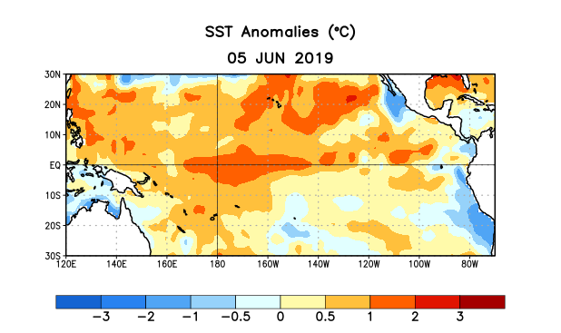
Figure 1. Average sea surface temperature (SST) anomalies (°C) for the week centered on 5 June 2019. Anomalies are computed with respect to the 1981-2010 base period weekly means.

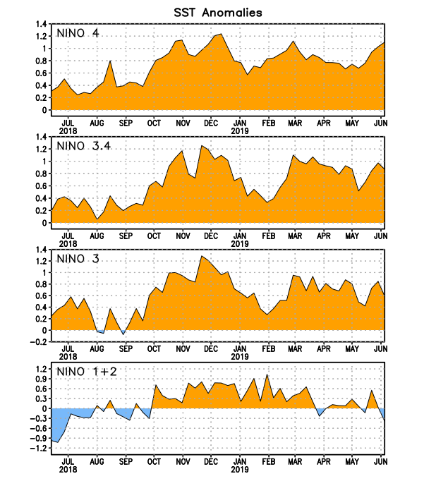
Figure 2. Time series of area-averaged sea surface temperature (SST) anomalies (°C) in the Niño regions [Niño-1+2 (0°-10°S, 90°W-80°W), Niño-3 (5°N-5°S, 150°W-90°W), Niño-3.4 (5°N-5°S, 170°W-120°W), Niño-4 (5ºN-5ºS , 150ºW-160ºE)]. SST anomalies are departures from the 1981-2010 base period weekly means.
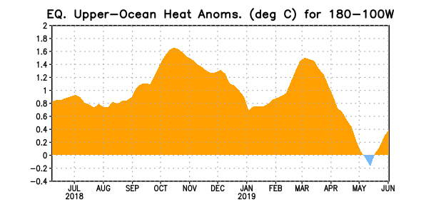
Figure 3. Area-averaged upper-ocean heat content anomaly (°C) in the equatorial Pacific (5°N-5°S, 180º-100ºW). The heat content anomaly is computed as the departure from the 1981-2010 base period pentad means.

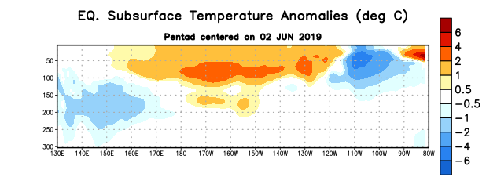
Figure 4. Depth-longitude section of equatorial Pacific upper-ocean (0-300m) temperature anomalies (°C) centered on the pentad of 2 June 2019. Anomalies are departures from the 1981-2010 base period pentad means.

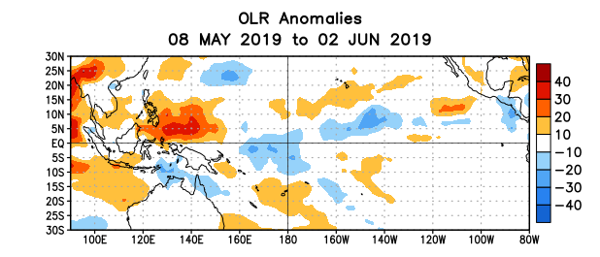
Figure 5. Average outgoing longwave radiation (OLR) anomalies (W/m²) for the period 8 May – 2 June 2019. OLR anomalies are computed as departures from the 1981-2010 base period pentad means.
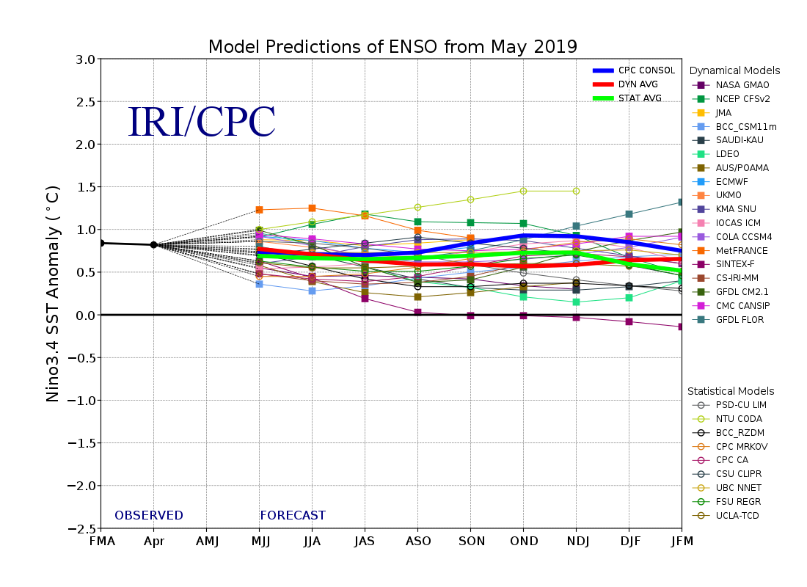
Figure 6. Forecasts of sea surface temperature (SST) anomalies for the Niño 3.4 region (5°N-5°S, 120°W-170°W). Figure updated 20 May 2019.

