EL NIÑO/SOUTHERN OSCILLATION (ENSO) DIAGNOSTIC DISCUSSION

issued by

CLIMATE PREDICTION CENTER/NCEP/NWS

and the International Research Institute for Climate and Society

11 June 2020

ENSO Alert System Status: Not Active

Synopsis: There is a ~60% chance of ENSO-neutral during Northern Hemisphere summer 2020, with roughly equal chances (~40-50%) of La Niña or ENSO-neutral during the autumn and winter 2020-21.

During May 2020, sea surface temperature (SST) anomalies were near-to-below average across the east-central and eastern equatorial Pacific (Fig. 1). All of the Niño indices decreased during the month, and the latest weekly Niño-3.4 index value was -0.4°C (Fig. 2). Equatorial subsurface temperature anomalies (averaged across 180°-100°W) decreased further during the first half of the month, but rebounded slightly toward the end of the month (Fig. 3). However, below-average subsurface temperatures prevailed east of the Date Line (Fig. 4). Also during the month, low-level wind anomalies were easterly across the east-central Pacific, while upper-level wind anomalies were westerly over the central Pacific. Tropical convection departures were weak, but were enhanced near Indonesia and suppressed over the Date Line and west-central Pacific (Fig. 5). Overall, the combined oceanic and atmospheric system remained consistent with ENSO-neutral.
The majority of models in the IRI/CPC plume (Fig. 6) favor ENSO-neutral (Niño-3.4 index between -0.5°C and +0.5°C) through the Northern Hemisphere winter. The forecaster consensus also favors ENSO-neutral during the summer, but then chances become roughly split between La Niña and ENSO-neutral beginning with the August-October season. That consensus mostly reflects the dynamical model guidance, which leans toward La Niña, along with ocean conditions that are somewhat favorable for the development of La Niña. However, enough uncertainty remains that the chance of La Niña remains lower than 50%, and it is unclear whether oceanic and atmospheric anomalies will lock in and persist. In summary, there is a ~60% chance of ENSO-neutral during Northern Hemisphere summer 2020, with roughly equal chances of La Niña or ENSO-neutral (~40-50%) during the autumn and winter 2020-21 (click CPC/IRI consensus forecast for the chance of each outcome for each 3-month period).
This discussion is a consolidated effort of the National Oceanic and Atmospheric Administration (NOAA), NOAA’s National Weather Service, and their funded institutions. Oceanic and atmospheric conditions are updated weekly on the Climate Prediction Center web site (El Niño/La Niña Current Conditions and Expert Discussions). Forecasts are also updated monthly in the Forecast Forum of CPC's Climate Diagnostics Bulletin. Additional perspectives and analysis are also available in an ENSO blog. The next ENSO Diagnostics Discussion is scheduled for 9 July 2020. To receive an e-mail notification when the monthly ENSO Diagnostic Discussions are released, please send an e-mail message to: ncep.list.enso-update@noaa.gov.

Climate Prediction Center
National Centers for Environmental Prediction
NOAA/National Weather Service
College Park, MD 20740

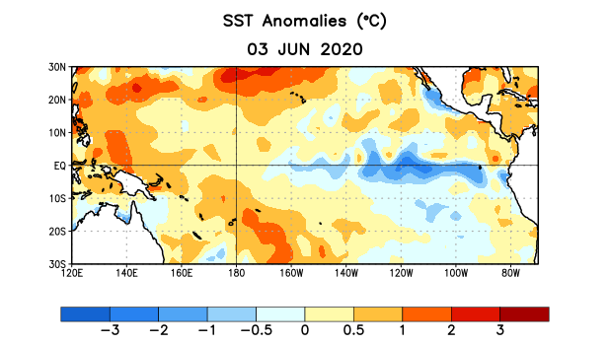
Figure 1. Average sea surface temperature (SST) anomalies (°C) for the week centered on 3 June 2020. Anomalies are computed with respect to the 1981-2010 base period weekly means.

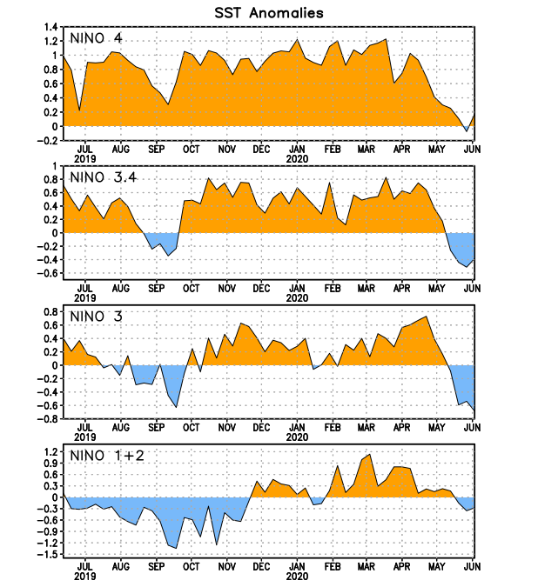
Figure 2. Time series of area-averaged sea surface temperature (SST) anomalies (°C) in the Niño regions [Niño-1+2 (0°-10°S, 90°W-80°W), Niño-3 (5°N-5°S, 150°W-90°W), Niño-3.4 (5°N-5°S, 170°W-120°W), Niño-4 (5ºN-5ºS , 150ºW-160ºE)]. SST anomalies are departures from the 1981-2010 base period weekly means.
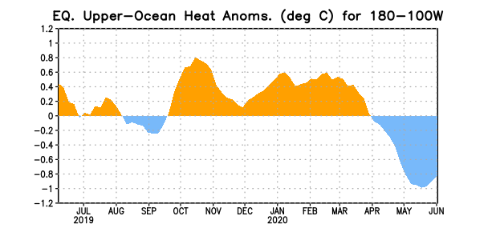
Figure 3. Area-averaged upper-ocean heat content anomaly (°C) in the equatorial Pacific (5°N-5°S, 180º-100ºW). The heat content anomaly is computed as the departure from the 1981-2010 base period pentad means.

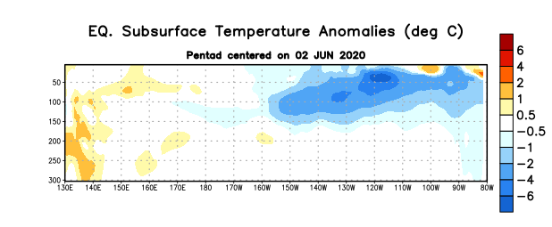
Figure 4. Depth-longitude section of equatorial Pacific upper-ocean (0-300m) temperature anomalies (°C) centered on the pentad of 2 June 2020. Anomalies are departures from the 1981-2010 base period pentad means.

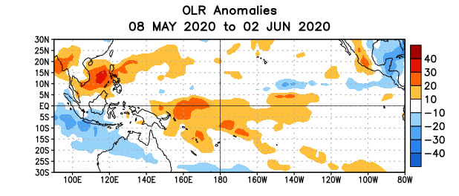
Figure 5. Average outgoing longwave radiation (OLR) anomalies (W/m²) for the period 8 May – 2 June 2020. OLR anomalies are computed as departures from the 1981-2010 base period pentad means.

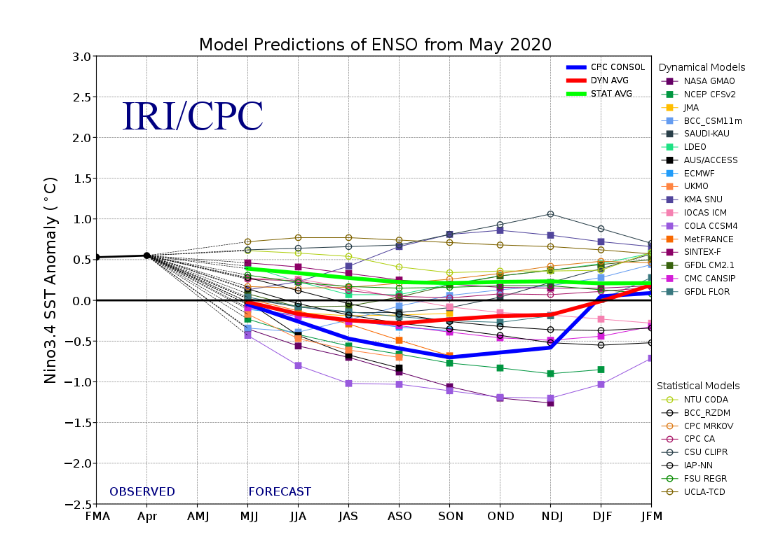
Figure 6. Forecasts of sea surface temperature (SST) anomalies for the Niño 3.4 region (5°N-5°S, 120°W-170°W). Figure updated 19 May 2020.

