EL NIÑO/SOUTHERN OSCILLATION (ENSO) DIAGNOSTIC DISCUSSION

issued by

CLIMATE PREDICTION CENTER/NCEP/NWS

and the International Research Institute for Climate and Society

10 June 2021

ENSO Alert System Status: Not Active

Synopsis: ENSO-neutral is favored through the Northern Hemisphere summer (78% chance for the June-August season) and fall (50% chance for the September-November season).

ENSO-neutral conditions continued during May, with near-average sea surface temperatures observed across most of the equatorial Pacific Ocean (Fig. 1). In the last week, the Niño indices were all at -0.2ºC, except for the Niño-1+2 index, which was -0.4ºC (Fig. 2). Subsurface temperature anomalies remained positive but decreased slightly (Fig. 3) due to the weakening of above-average subsurface temperatures around the thermocline in the central Pacific Ocean (Fig. 4). Low-level easterly and upper-level westerly wind anomalies extended across most of the equatorial Pacific Ocean. At the Date Line, tropical convection was mostly near average, and enhanced rainfall was evident over the western Pacific Ocean (Fig. 5). Overall, the ocean and atmosphere system reflected ENSO-neutral conditions.
A majority of the models in the IRI/CPC plume predict ENSO-neutral to continue through the fall 2021 (Fig. 6). The forecaster consensus generally agrees with this model outlook, although lower probabilities are assigned to El Niño during this period (remaining less than 10%). By the late fall and winter, La Niña chances increase to near 50%, reflecting the historical tendency for a second winter of La Niña following the first, and also the predictions from the North American Multi-Model Ensemble. However, these cooler conditions are predicted to exist for a short duration (3 overlapping seasons) and these predictions are still over 6 months into the future. In summary, ENSO-neutral is favored through the Northern Hemisphere summer (78% chance for the June-August season) and fall (50% chance for the September-November season; click CPC/IRI consensus forecast for the chances in each 3-month period).
This discussion is a consolidated effort of the National Oceanic and Atmospheric Administration (NOAA), NOAA’s National Weather Service, and their funded institutions. Oceanic and atmospheric conditions are updated weekly on the Climate Prediction Center web site (El Niño/La Niña Current Conditions and Expert Discussions). Additional perspectives and analysis are also available in an ENSO blog. A probabilistic strength forecast is available here. The next ENSO Diagnostics Discussion is scheduled for 8 July 2021. To receive an e-mail notification when the monthly ENSO Diagnostic Discussions are released, please send an e-mail message to: ncep.list.enso-update@noaa.gov.

Climate Prediction Center
National Centers for Environmental Prediction
NOAA/National Weather Service
College Park, MD 20740

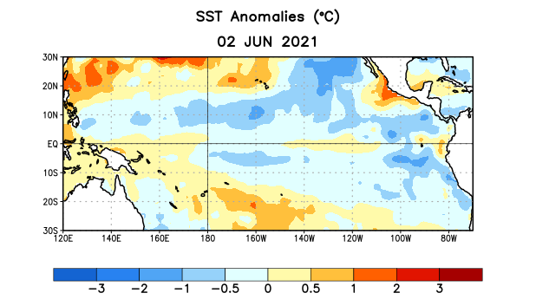
Figure 1. Average sea surface temperature (SST) anomalies (°C) for the week centered on 2 June 2021. Anomalies are computed with respect to the 1991-2020 base period weekly means.

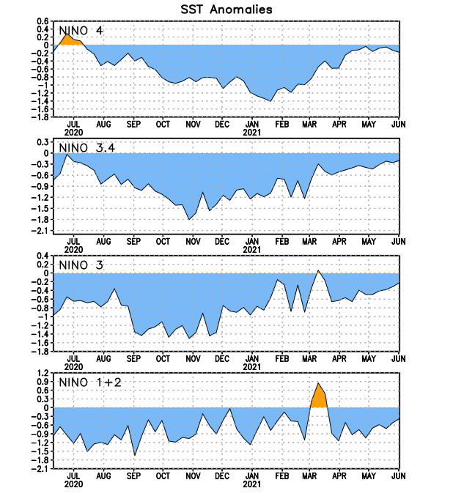
Figure 2. Time series of area-averaged sea surface temperature (SST) anomalies (°C) in the Niño regions [Niño-1+2 (0°-10°S, 90°W-80°W), Niño-3 (5°N-5°S, 150°W-90°W), Niño-3.4 (5°N-5°S, 170°W-120°W), Niño-4 (5ºN-5ºS, 150ºW-160ºE)]. SST anomalies are departures from the 1991-2020 base period weekly means.
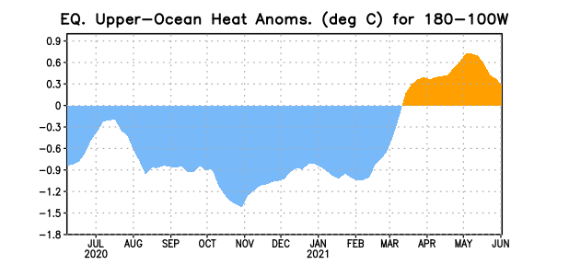
Figure 3. Area-averaged upper-ocean heat content anomaly (°C) in the equatorial Pacific (5°N-5°S, 180º-100ºW). The heat content anomaly is computed as the departure from the 1991-2020 base period pentad means.

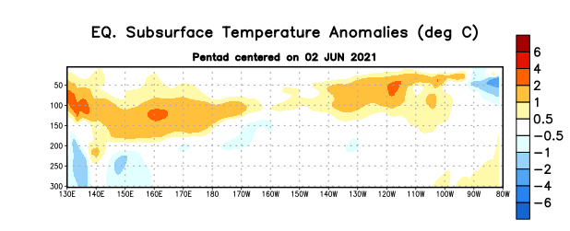

Figure 4. Depth-longitude section of equatorial Pacific upper-ocean (0-300m) temperature anomalies (°C) centered on the pentad of 2 June 2021. Anomalies are departures from the 1991-2020 base period pentad means.

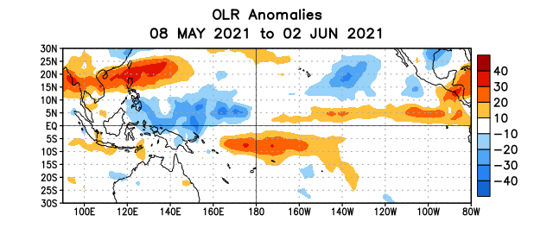
Figure 5. Average outgoing longwave radiation (OLR) anomalies (W/m²) for the period 8 May – 2 June 2021. OLR anomalies are computed as departures from the 1991-2020 base period pentad means.

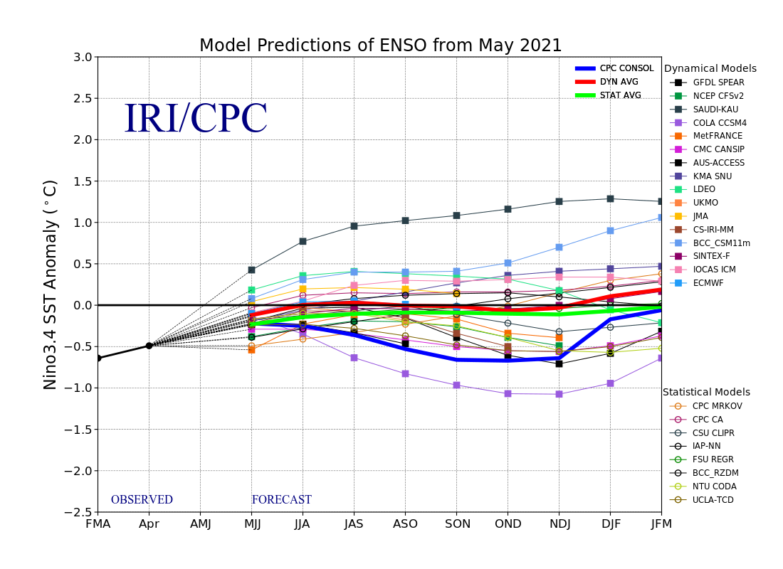
Figure 6. Forecasts of sea surface temperature (SST) anomalies for the Niño 3.4 region (5°N-5°S, 120°W-170°W). Figure updated 19 May 2021.

