EL NIÑO/SOUTHERN OSCILLATION (ENSO) DIAGNOSTIC DISCUSSION

issued by

CLIMATE PREDICTION CENTER/NCEP/NWS

and the International Research Institute for Climate and Society

9 June 2022

ENSO Alert System Status: La Niña Advisory

Synopsis: Though La Niña is favored to continue through the end of the year, the odds for La Niña decrease into the Northern Hemisphere late summer (52% chance in July-September 2022) before slightly increasing through the Northern Hemisphere fall and early winter 2022 (58-59% chance).

During May, below-average sea surface temperatures (SSTs) continued across most of the central and eastern equatorial Pacific Ocean (Fig. 1). However, negative SST anomalies weakened during the past month, as reflected by the Niño indices, which ranged from -0.6ºC to -0.9ºC during the past week (Fig. 2). Subsurface temperatures anomalies (averaged between 180°-100°W and 0-300m depth) also weakened with values returning to near zero (Fig. 3). Below-average subsurface temperatures persisted near the surface to at least ~75m depth from the central to the eastern equatorial Pacific Ocean, with above-average temperatures continuing at depth (~100 to 200m) in the western and central Pacific Ocean (Fig. 4). Low-level easterly wind anomalies prevailed in the east-central equatorial Pacific, while upper-level westerly wind anomalies continued over most of the equatorial Pacific. Convection was suppressed over the western and central Pacific and was weakly enhanced over parts of Indonesia (Fig. 5). Overall, the coupled ocean-atmosphere system continues to reflect La Niña.
The most recent IRI/CPC plume average for the Niño-3.4 SST index forecasts La Niña to persist into the Northern Hemisphere winter 2022-23 (Fig. 6). This is now in greater agreement with the forecast consensus this month, which also predicts La Niña to continue into the winter. However, it is clear that recent observed oceanic and atmospheric anomalies have weakened and this is anticipated to continue through the summer. Uncertainty remains over whether La Niña may transition to ENSO-neutral during the summer, with forecasters predicting a 52% chance of La Niña and a 46% chance of ENSO-neutral during July-September 2022. After this season, the forecast is for renewed cooling, with La Niña favored during the fall and early winter. In summary, though La Niña is favored to continue through the end of the year, the odds for La Niña decrease into the Northern Hemisphere late summer (52% chance in July-September 2022) before slightly increasing through the Northern Hemisphere fall and early winter 2022 (58-59% chance; click CPC/IRI consensus forecast for the chances in each 3-month period).
This discussion is a consolidated effort of the National Oceanic and Atmospheric Administration (NOAA), NOAA’s National Weather Service, and their funded institutions. Oceanic and atmospheric conditions are updated weekly on the Climate Prediction Center web site (El Niño/La Niña Current Conditions and Expert Discussions). Additional perspectives and analysis are also available in an ENSO blog. A probabilistic strength forecast is available here. The next ENSO Diagnostics Discussion is scheduled for 14 July 2022. To receive an e-mail notification when the monthly ENSO Diagnostic Discussions are released, please send an e-mail message to: ncep.list.enso-update@noaa.gov.

Climate Prediction Center
National Centers for Environmental Prediction
NOAA/National Weather Service
College Park, MD 20740

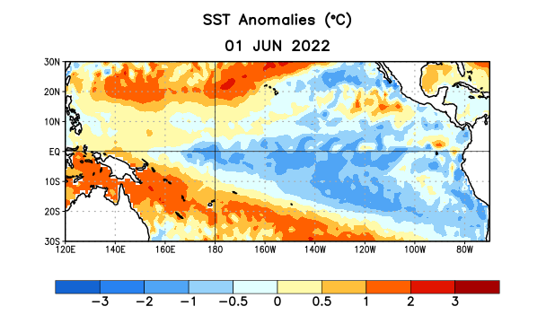
Figure 1. Average sea surface temperature (SST) anomalies (°C) for the week centered on 1 June 2022. Anomalies are computed with respect to the 1991-2020 base period weekly means.

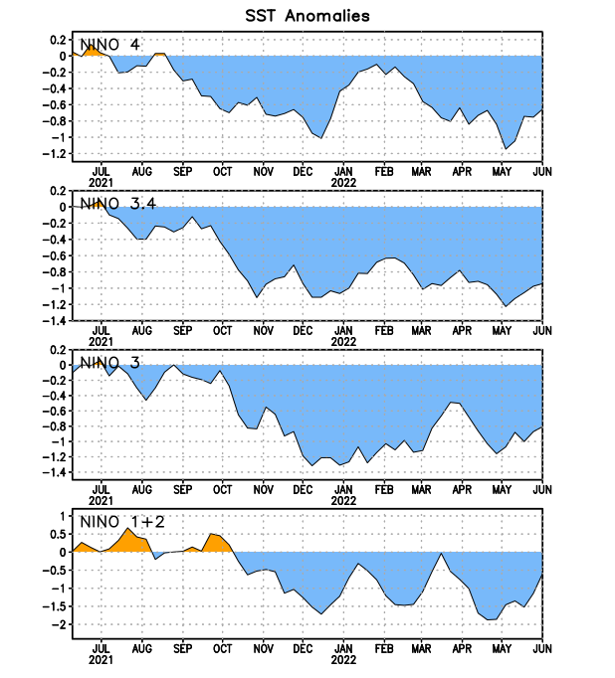
Figure 2. Time series of area-averaged sea surface temperature (SST) anomalies (°C) in the Niño regions [Niño-1+2 (0°-10°S, 90°W-80°W), Niño-3 (5°N-5°S, 150°W-90°W), Niño-3.4 (5°N-5°S, 170°W-120°W), Niño-4 (5ºN-5ºS, 150ºW-160ºE)]. SST anomalies are departures from the 1991-2020 base period weekly means.
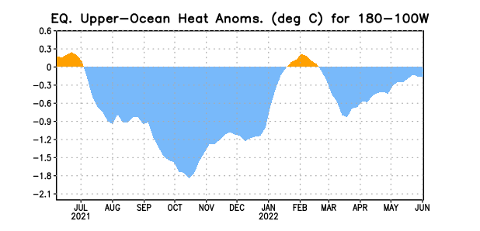
Figure 3. Area-averaged upper-ocean heat content anomaly (°C) in the equatorial Pacific (5°N-5°S, 180º-100ºW). The heat content anomaly is computed as the departure from the 1991-2020 base period pentad means.

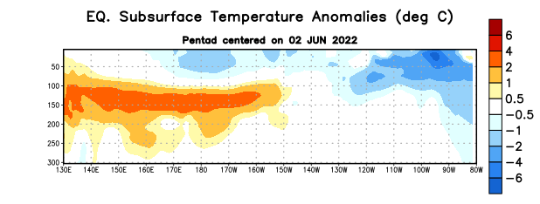

Figure 4. Depth-longitude section of equatorial Pacific upper-ocean (0-300m) temperature anomalies (°C) centered on the pentad of 2 June 2022. Anomalies are departures from the 1991-2020 base period pentad means.

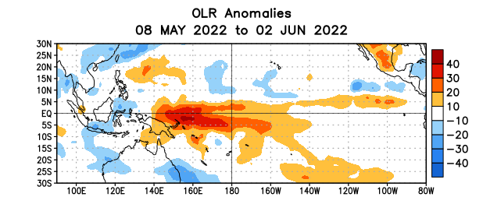
Figure 5. Average outgoing longwave radiation (OLR) anomalies (W/m²) for the period 8 May – 2 June 2022. OLR anomalies are computed as departures from the 1991-2020 base period pentad means.

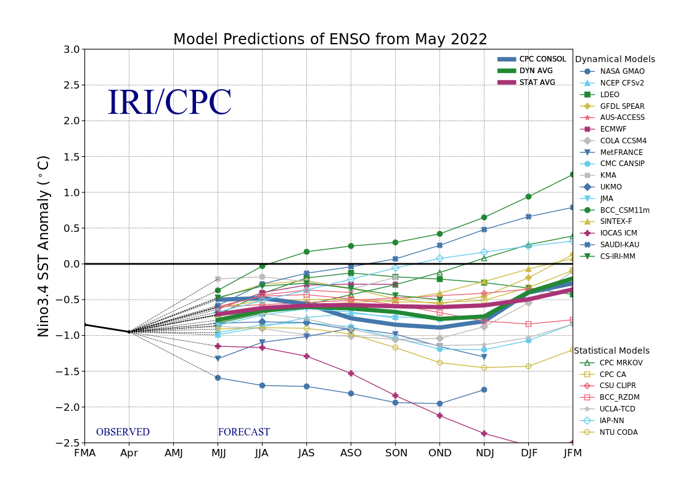
Figure 6. Forecasts of sea surface temperature (SST) anomalies for the Niño 3.4 region (5°N-5°S, 120°W-170°W). Figure updated 19 May 2022.

