EL NIÑO/SOUTHERN OSCILLATION (ENSO) DIAGNOSTIC DISCUSSION

issued by

CLIMATE PREDICTION CENTER/NCEP/NWS

8 June 2023

ENSO Alert System Status: El Niño Advisory

Synopsis: El Niño conditions are present and are expected to gradually strengthen into the Northern Hemisphere winter 2023-24.

In May, weak El Niño conditions emerged as above-average sea surface temperatures (SSTs) strengthened across the equatorial Pacific Ocean (Fig. 1). All of the latest weekly Niño indices were more than +0.5ºC: Niño-3.4 was +0.8ºC, Niño-3 was +1.1ºC, and Niño1+2 was +2.3ºC (Fig. 2). Area-averaged subsurface temperatures anomalies remained positive (Fig. 3), reflecting the continuation of widespread anomalous warmth below the surface of the equatorial Pacific Ocean (Fig. 4). For the May average, low-level wind anomalies were westerly over the western equatorial Pacific Ocean, while upper-level wind anomalies were westerly over the eastern Pacific Ocean. Convection was enhanced along the equator and was suppressed over Indonesia (Fig. 5). Both the equatorial SOI and traditional SOI were significantly negative. Collectively, the coupled ocean-atmosphere system reflected the emergence of El Niño conditions.
The most recent IRI plume indicates the continuation of El Niño through the Northern Hemisphere winter 2023-24 (Fig. 6). Confidence in the occurrence of El Niño increases into the fall, reflecting the expectation that seasonally averaged Niño-3.4 index values will continue to increase. Another downwelling Kelvin wave is emerging in the western Pacific Ocean, and westerly wind anomalies are forecasted to recur over the western Pacific. At its peak, the chance of a strong El Niño is nearly the same as it was last month (56% chance of November-January Niño-3.4 ≥ 1.5°C), with an 84% chance of exceeding moderate strength (Niño-3.4 ≥ 1.0°C). In summary, El Niño conditions are present and are expected to gradually strengthen into the Northern Hemisphere winter 2023-24 (Fig. 7).
This discussion is a consolidated effort of the National Oceanic and Atmospheric Administration (NOAA), NOAA’s National Weather Service, and their funded institutions. Oceanic and atmospheric conditions are updated weekly on the Climate Prediction Center website (El Niño/La Niña Current Conditions and Expert Discussions). Additional perspectives and analyses are also available in an ENSO blog. A probabilistic strength forecast is available here. The next ENSO Diagnostics Discussion is scheduled for 13 July 2023. To receive an e-mail notification when the monthly ENSO Diagnostic Discussions are released, please send an e-mail message to: ncep.list.enso-update@noaa.gov.

Climate Prediction Center
National Centers for Environmental Prediction
NOAA/National Weather Service
College Park, MD 20740
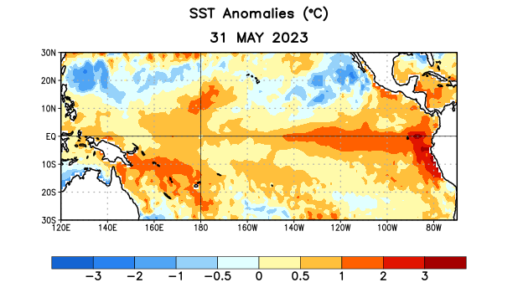
Figure 1. Average sea surface temperature (SST) anomalies (°C) for the week centered on 31 May 2023. Anomalies are computed with respect to the 1991-2020 base period weekly means.

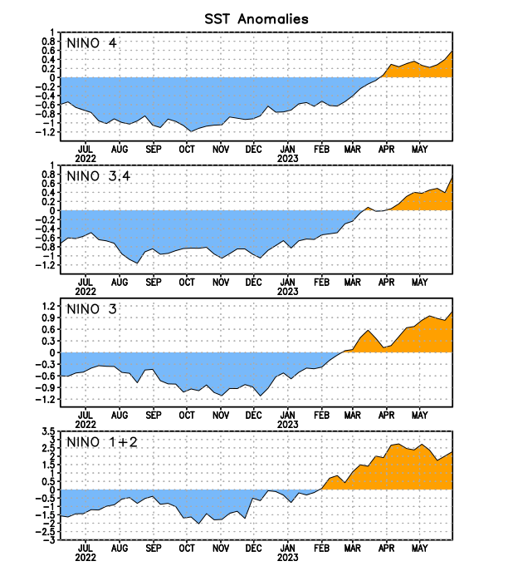
Figure 2. Time series of area-averaged sea surface temperature (SST) anomalies (°C) in the Niño regions [Niño-1+2 (0°-10°S, 90°W-80°W), Niño-3 (5°N-5°S, 150°W-90°W), Niño-3.4 (5°N-5°S, 170°W-120°W), Niño-4 (5ºN-5ºS, 150ºW-160ºE)]. SST anomalies are departures from the 1991-2020 base period weekly means.

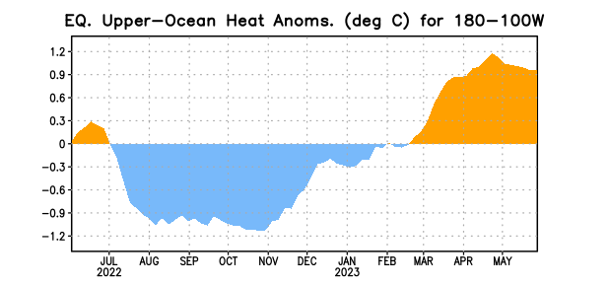

Figure 3. Area-averaged upper-ocean heat content anomaly (°C) in the equatorial Pacific (5°N-5°S, 180º-100ºW). The heat content anomaly is computed as the departure from the 1991-2020 base period pentad means.

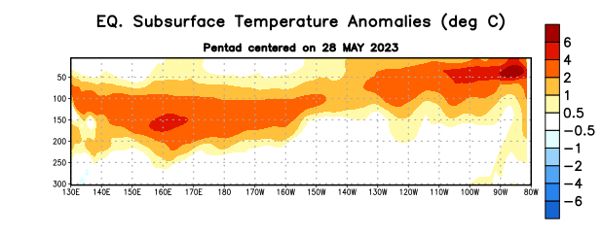
Figure 4. Depth-longitude section of equatorial Pacific upper-ocean (0-300m) temperature anomalies (°C) centered on the pentad of 28 May 2023. Anomalies are departures from the 1991-2020 base period pentad means.

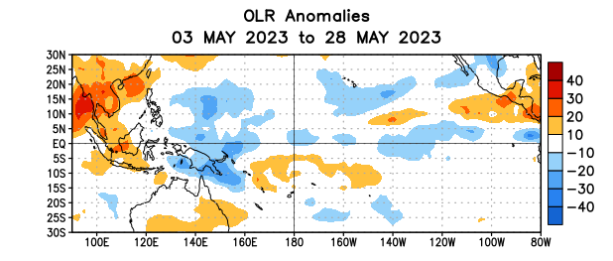

Figure 5. Average outgoing longwave radiation (OLR) anomalies (W/m²) for the period 3 – 28 May 2023. OLR anomalies are computed as departures from the 1991-2020 base period pentad means.

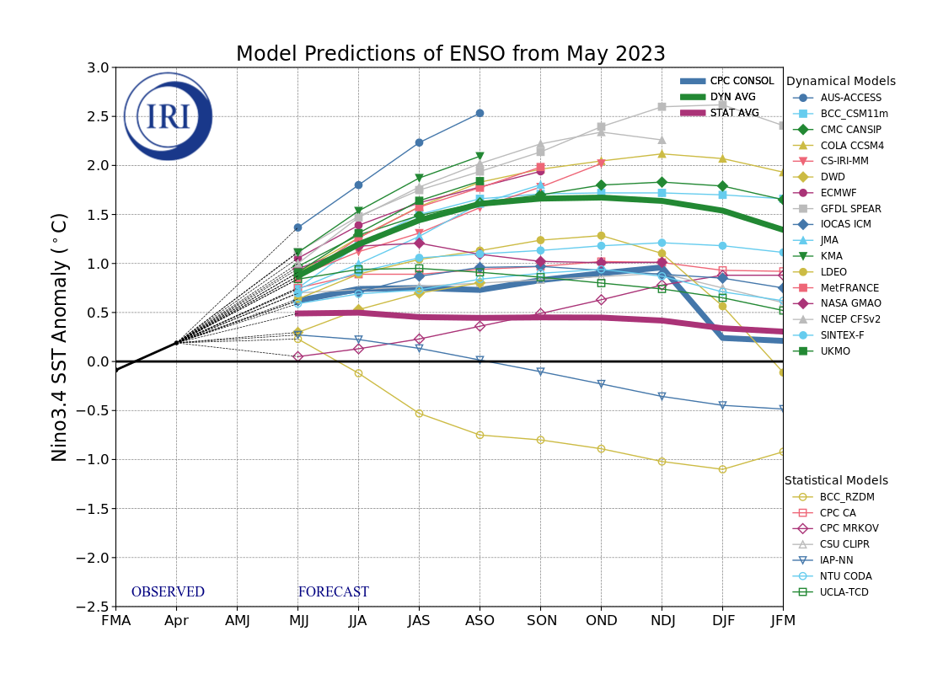
Figure 6. Forecasts of sea surface temperature (SST) anomalies for the Niño 3.4 region (5°N-5°S, 120°W-170°W). Figure updated 19 May 2023 by the International Research Institute (IRI) for Climate and Society.
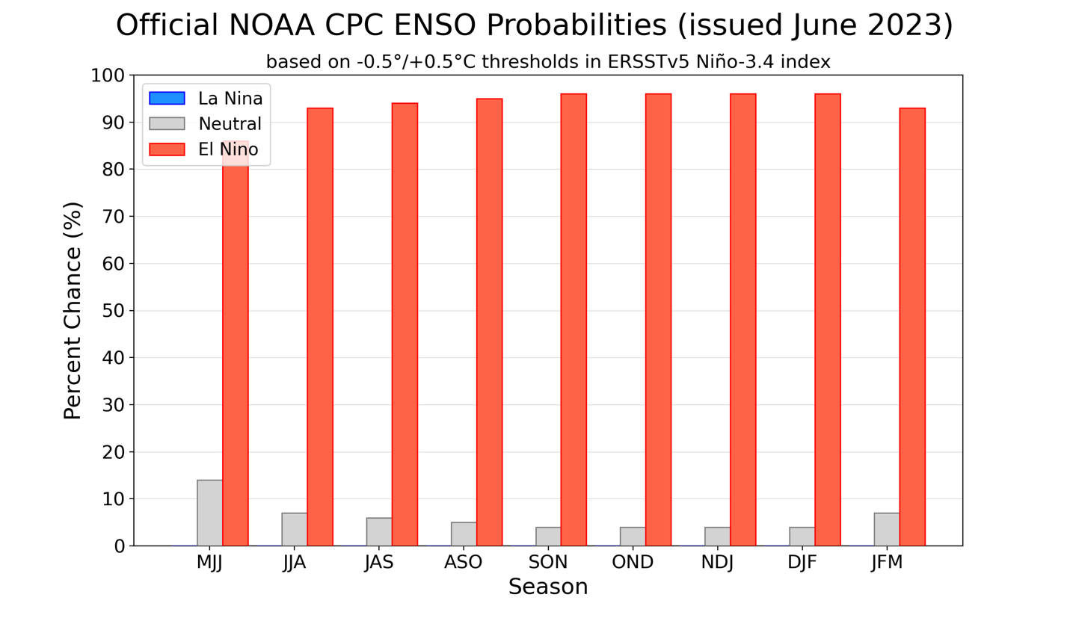Figure 7. Official ENSO probabilities for the Niño 3.4 sea surface temperature index (5°N-5°S, 120°W-170°W). Figure updated 8 June 2023.

