EL NIÑO/SOUTHERN OSCILLATION (ENSO) DIAGNOSTIC DISCUSSION

issued by

CLIMATE PREDICTION CENTER/NCEP/NWS

12 June 2025

ENSO Alert System Status: Not Active

Synopsis: ENSO-Neutral is likely in the Northern Hemisphere summer 2025 (82% chance in June-August) and may continue into winter 2025-26, though confidence is lower (48% chance of Neutral and 41% chance of La Niña in November-January).

In the past month, ENSO-neutral conditions persisted, with sea surface temperatures (SSTs) near average over most of the equatorial Pacific Ocean (Fig. 1). The latest weekly Niño index values ranged from -0.1°C to +0.4°C (Fig. 2). Subsurface ocean temperatures were near-to-above average (averaged across 180°-100°W, Fig. 3), with above-average subsurface ocean temperatures at depth in the central and western Pacific (Fig. 4). For the month, low-level winds were easterly over the east-central Pacific, while upper-level winds were mostly near average across the equatorial Pacific Ocean. Convection was enhanced over Indonesia (Fig. 5). Collectively, the coupled ocean-atmosphere system in the tropical Pacific reflected ENSO-neutral.
The IRI and North American Multi-Model Ensemble predictions indicate ENSO-neutral is most likely through the Northern Hemisphere winter 2025-26 (Fig. 6). The forecast team also continuously favors ENSO-neutral through early 2026, with smaller chances that La Niña could form during winter 2025-26. In summary, ENSO-Neutral is likely in the Northern Hemisphere summer 2025 (82% chance in June-August) and may continue into winter 2025-26, though confidence is lower (48% chance of Neutral and 41% chance of La Niña in November-January; Fig. 7).
This discussion is a consolidated effort of the National Oceanic and Atmospheric Administration (NOAA), NOAA’s National Weather Service, and their funded institutions. Oceanic and atmospheric conditions are updated weekly on the Climate Prediction Center website (El Niño/La Niña Current Conditions and Expert Discussions). Additional perspectives and analyses are also available in an ENSO blog. A probabilistic strength forecast is available here. The next ENSO Diagnostics Discussion is scheduled for 10 July 2025. To receive an e-mail notification when the monthly ENSO Diagnostic Discussions are released, please send an e-mail message to: ncep.list.enso-update@noaa.gov.

Climate Prediction Center
National Centers for Environmental Prediction
NOAA/National Weather Service
College Park, MD 20740

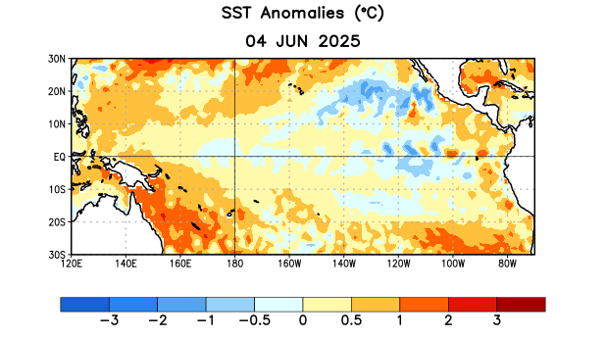
Figure 1. Average sea surface temperature (SST) anomalies (°C) for the week centered on 4 June 2025. Anomalies are computed with respect to the 1991-2020 base period weekly means.

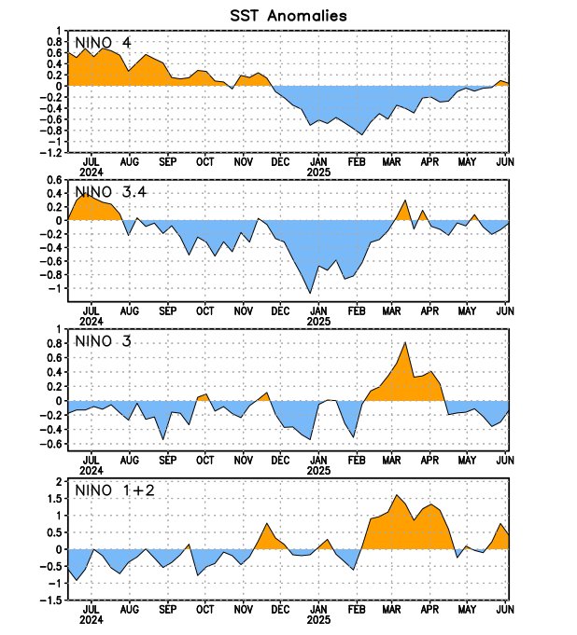
Figure 2. Time series of area-averaged sea surface temperature (SST) anomalies (°C) in the Niño regions [Niño-4 (5ºN-5ºS, 150ºW-160ºE), Niño-3.4 (5°N-5°S, 170°W-120°W), Niño-3 (5°N-5°S, 150°W-90°W), Niño-1+2 (0°-10°S, 90°W-80°W)]. SST anomalies are departures from the 1991-2020 base period weekly means.

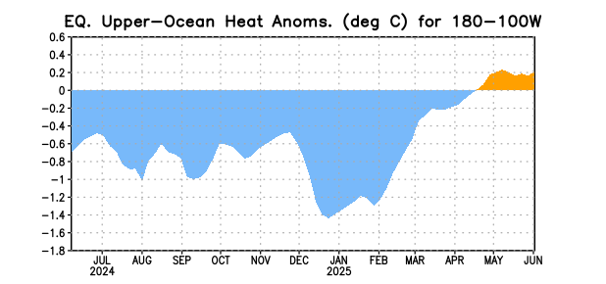
Figure 3. Area-averaged upper-ocean heat content anomaly (°C) in the equatorial Pacific (5°N-5°S, 180º-100ºW). The heat content anomaly is computed as the departure from the 1991-2020 base period pentad means.

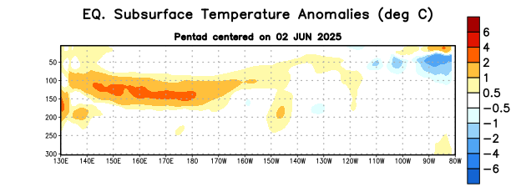
Figure 4. Depth-longitude section of equatorial Pacific upper-ocean (0-300m) temperature anomalies (°C) centered on the pentad of 2 June 2025. Anomalies are departures from the 1991-2020 base period pentad means.

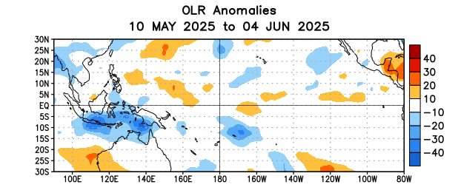
Figure 5. Average outgoing longwave radiation (OLR) anomalies (W/m²) for the period 10 May – 4 June 2025. OLR anomalies are computed as departures from the 1991-2020 base period pentad means.
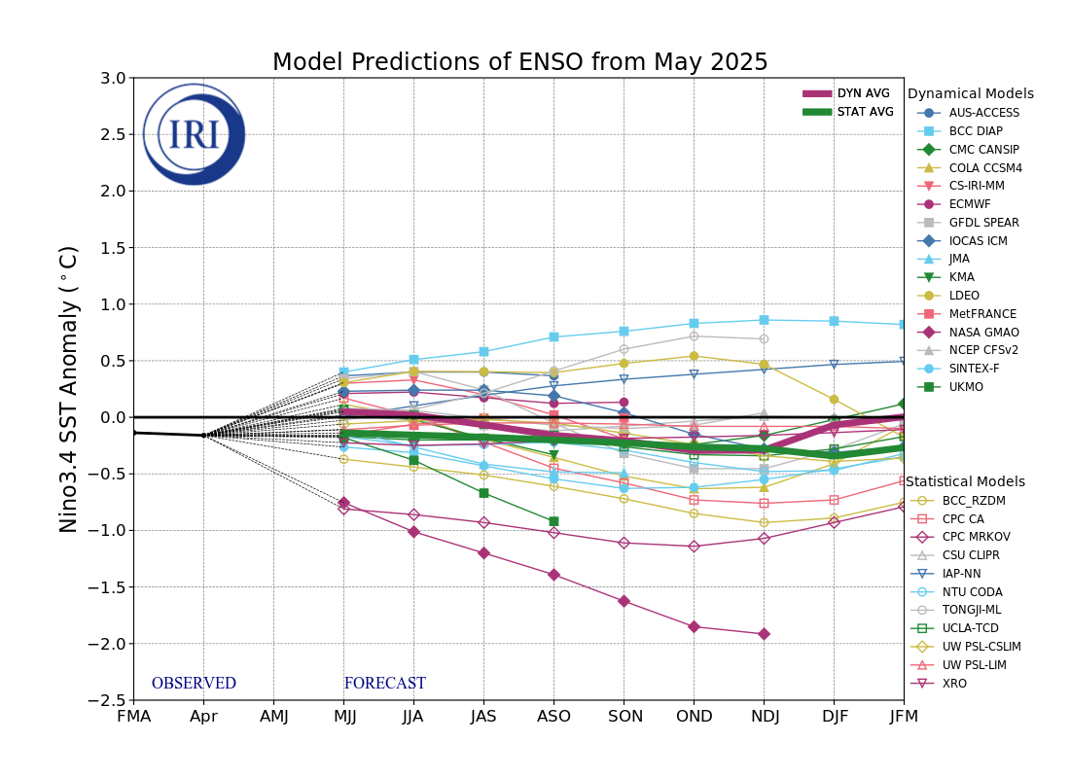
Figure 6. Forecasts of sea surface temperature (SST) anomalies for the Niño 3.4 region (5°N-5°S, 120°W-170°W). Figure updated 19 May 2025 by the International Research Institute (IRI) for Climate and Society.

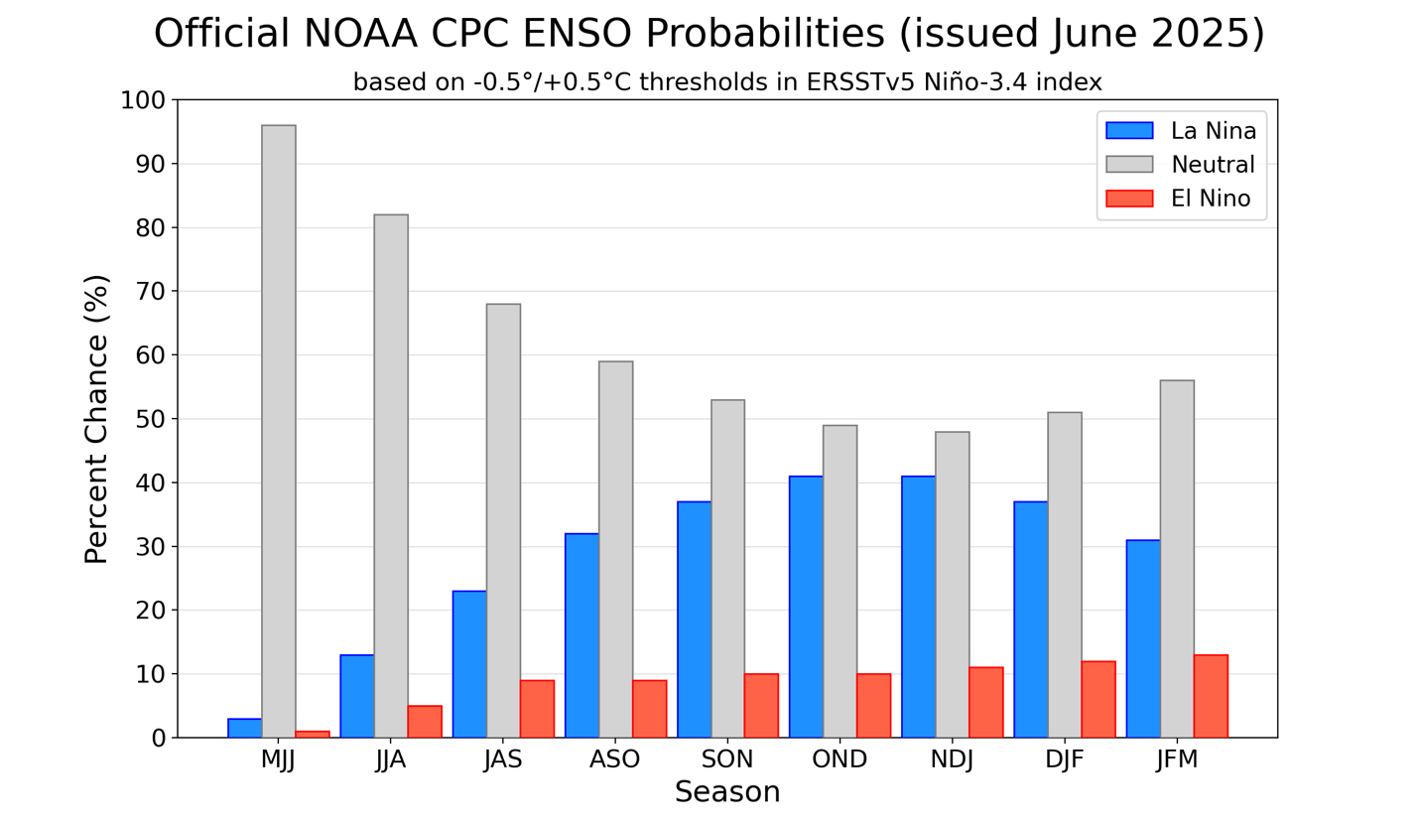Figure 7. Official ENSO probabilities for the Niño 3.4 sea surface temperature index (5°N-5°S, 120°W-170°W). Figure updated 12 June 2025.

