EL NIÑO/SOUTHERN OSCILLATION (ENSO) DIAGNOSTIC DISCUSSION
issued by
CLIMATE PREDICTION CENTER/NCEP/NWS
6 March 2008

Synopsis: La Niña is expected to continue through the Northern Hemisphere spring 2008.
Atmospheric and oceanic conditions during February 2008 continued to reflect a strong La Niña. Equatorial SSTs were more than 2.0°C below average across large portions of the central and east-central equatorial Pacific (Fig. 1), and the corresponding weekly values of the Niño-4 and Niño-3.4 indices remained between −1.6°C and −2.1°C during the month (Fig. 2). In contrast, SSTs in the far eastern equatorial Pacific were above average during February 2008, in association with a warming trend that began in mid-December. The upper-ocean heat content (average temperatures in the upper 300m of the oceans between 180° - 100°W) remained below average across the equatorial Pacific during February (Fig. 3), with the largest temperature anomalies averaging −2°C to −6°C at thermocline depth (Fig. 4). Consistent with these oceanic conditions, stronger-than-average low-level easterly winds and upper-level westerly winds persisted across the central equatorial Pacific, convection remained suppressed throughout the central equatorial Pacific, and enhanced convection covered the far western Pacific. Collectively, these oceanic and atmospheric conditions are similar to those accompanying the last strong La Niña episode in 1998-2000.
The most recent dynamical and statistical SST forecasts for the Niño 3.4 region continue to indicate a moderate-to-strong La Niña through March 2008, and a weaker La Niña through April-May-June 2008 (Fig. 5). Thereafter, there is considerable spread in the forecasts, with approximately one-half indicating that La Niña could continue into the Northern Hemisphere fall. Current atmospheric and oceanic conditions and recent observed trends support the likely continuation of La Niña through the Northern Hemisphere spring 2008.
Expected La Niña impacts during March-May 2008 include a continuation of above-average precipitation over Indonesia and below-average precipitation over the central equatorial Pacific. The above average SSTs in the eastern equatorial Pacific may result in increased rainfall over Ecuador and northern Peru, similar to the evolution during the 1998-2000 La Niña episode. Compared to the Northern Hemisphere winter, La Niña impacts over the United States in spring are typically less pronounced. The primary springtime signal for the contiguous United States is an increased probability of below-average precipitation across the South, particularly in the Southeast.
This discussion is a consolidated effort of the National Atmospheric and Oceanic Administration (NOAA), NOAA’s National Weather Service, and their funded institutions. Oceanic and atmospheric conditions are updated weekly on the Climate Prediction Center web site (El Niño/La Niña Current Conditions and Expert Discussions). Forecasts for the evolution of El Niño/La Niña are updated monthly in the Forecast Forum section of CPC's Climate Diagnostics Bulletin. The next ENSO Diagnostics Discussion is scheduled for 10 April 2008. To receive an e-mail notification when the monthly ENSO Diagnostic Discussions are released, please send an e-mail message to: ncep.list.enso-update@noaa.gov.
Climate Prediction Center
National Centers for Environmental Prediction
NOAA/National Weather Service
Camp Springs, MD 20746-4304

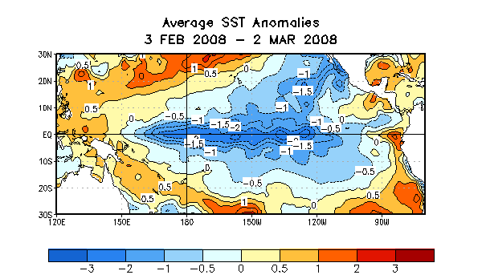

Figure 1. Sea surface temperature (SST) anomalies (°C) during 3 February - 2 March 2008. Anomalies are computed with respect to the 1971-2000 base period weekly means (Xue et al. 2003, J. Climate, 16, 1601-1612).

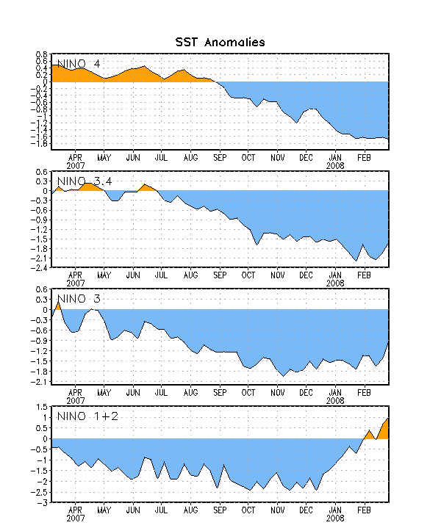

Figure 2. Time series of area-averaged sea surface temperature (SST) anomalies (°C) in the Niño regions [Niño-1+2 (0°-10°S, 90°-80°W), Niño-3 (5°N-5°S, 150°W-90°W), Niño-3.4 (5°N-5°S, 170°W-120°W), Niño-4 (150ºW-160ºE and 5ºN-5ºS)]. SST anomalies are departures from the 1971-2000 base period weekly means (Xue et al. 2003, J. Climate, 16, 1601-1612).

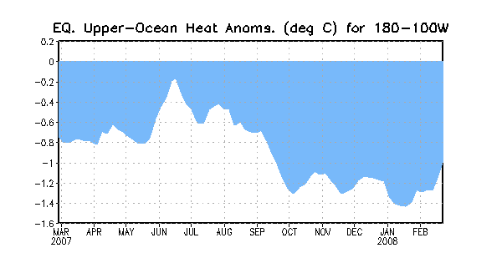
Figure 3. Area-averaged upper-ocean heat content anomalies (°C) in the equatorial Pacific (5°N-5°S, 180º-100ºW). Heat content anomalies are computed as departures from the 1982-2004 base period weekly means.

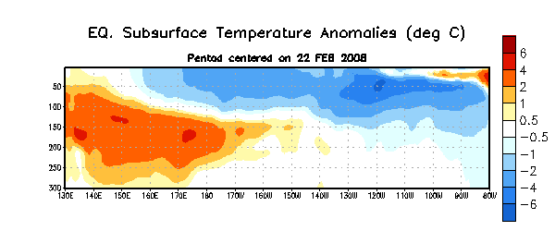

Figure 4. Depth-longitude section of equatorial Pacific upper-ocean (0-300m) temperature anomalies (°C) centered on the week of 22 February 2008. The anomalies are averaged between 5°N-5°S. Anomalies are departures from the 1982-2004 base period weekly means.

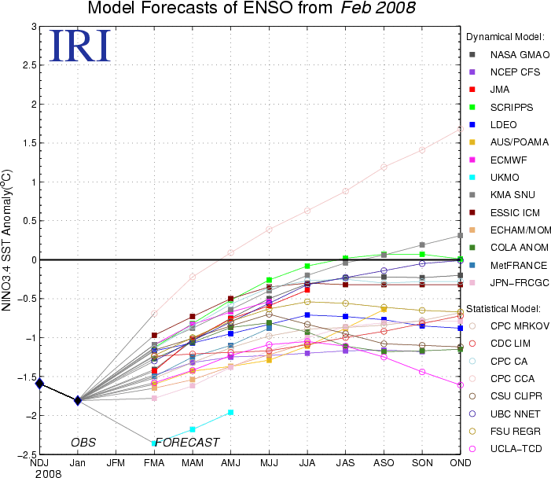

Figure 5. Forecasts of sea surface temperature (SST) anomalies for the Niño 3.4 region (5°N-5°S, 120°W-170°W). Figure courtesy of the International Research Institute (IRI) for Climate and Society. Figure updated 20 February 2008.

