EL NIÑO/SOUTHERN OSCILLATION (ENSO) DIAGNOSTIC DISCUSSION

issued by

CLIMATE PREDICTION CENTER/NCEP/NWS
4 March 2010

ENSO Alert System Status: El Niño Advisory

Synopsis: El Niño is expected to continue at least through the Northern Hemisphere spring 2010.
A moderate-to-strong El Niño continued during February 2010, with sea surface temperature (SST) anomalies exceeding 1.5°C in parts of the equatorial Pacific Ocean at the end of the month (Fig. 1). Weekly values of the Niño-3.4 index remained steady at +1.2°C during February (Fig. 2). An oceanic Kelvin wave was initiated in early February, which acted to increase the subsurface heat content anomalies (average temperatures in the upper 300m of the ocean, Fig. 3), and to strengthen subsurface temperature departures (exceeding +2°C down to 100-175m) across much of the equatorial Pacific (Fig. 4). SSTs were sufficiently warm to support deep tropical convection, which strongly increased across the central and eastern tropical Pacific, while remaining suppressed over Indonesia (Fig. 5). Equatorial low-level westerly wind anomalies also strengthened during February, while upper-level easterly wind anomalies weakened slightly. Collectively, these oceanic and atmospheric anomalies reflect a moderate-to-strong El Niño episode.
Nearly all models predict decreasing SST anomalies in the Niño-3.4 region through 2010, with the model spread increasing at longer lead times (Fig. 6). The majority of models predict the 3-month Niño-3.4 SST anomaly will drop below +0.5°C by May-June-July 2010, indicating a transition to ENSO-neutral conditions near the onset of Northern Hemisphere summer. However, several models suggest the potential of continued weak El Niño conditions through 2010, while others predict the development of La Niña conditions later in the year. Predicting when El Niño will dissipate and what may follow remains highly uncertain.
El Niño impacts are expected to last through the Northern Hemisphere spring, even as equatorial SST departures decrease, partly in response to the typical warming that occurs between now and April/May. Expected impacts during March-May 2010 include drier-than-average conditions over Indonesia and enhanced convection over the central and eastern equatorial Pacific Ocean, as well as coastal sections of Peru and Ecuador. For the contiguous United States, potential El Niño impacts include above-average precipitation for the Southwest, the south-central states, and Florida, and below-average precipitation in the Pacific Northwest and Great Lakes region. Above-average temperatures are most likely across the northern tier of states (excluding New England and the Northern Plains), while below-average temperatures are favored for the south-central and southeastern states.
This discussion is a consolidated effort of the National Oceanic and Atmospheric Administration (NOAA), NOAA’s National Weather Service, and their funded institutions. Oceanic and atmospheric conditions are updated weekly on the Climate Prediction Center web site (El Niño/La Niña Current Conditions and Expert Discussions). Forecasts for the evolution of El Niño/La Niña are updated monthly in the Forecast Forum section of CPC's Climate Diagnostics Bulletin. The next ENSO Diagnostics Discussion is scheduled for 8 April 2010. To receive an e-mail notification when the monthly ENSO Diagnostic Discussions are released, please send an e-mail message to: ncep.list.enso-update@noaa.gov.
Climate Prediction Center
National Centers for Environmental Prediction
NOAA/National Weather Service
Camp Springs, MD 20746-4304
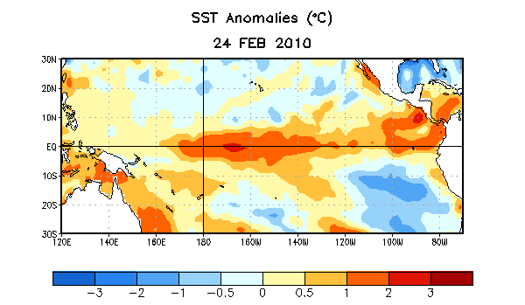
Figure 1. Average sea surface temperature (SST) anomalies (°C) for the week centered on 24 February 2010. Anomalies are computed with respect to the 1971-2000 base period weekly means (Xue et al. 2003, J. Climate, 16, 1601-1612).

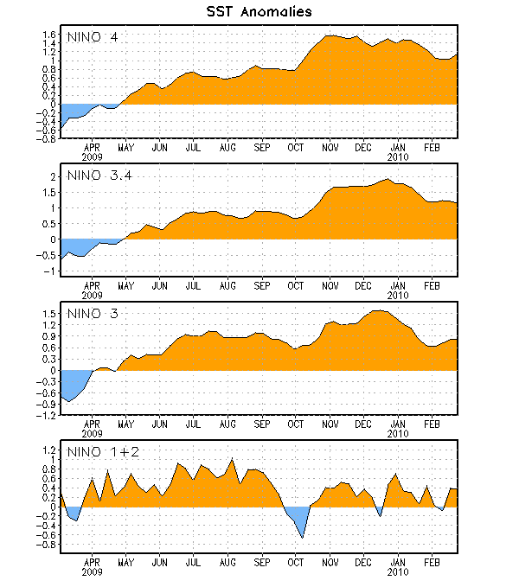
Figure 2. Time series of area-averaged sea surface temperature (SST) anomalies (°C) in the Niño regions [Niño-1+2 (0°-10°S, 90°W-80°W), Niño 3 (5°N-5°S, 150°W-90°W), Niño-3.4 (5°N-5°S, 170°W-120°W), Niño-4 (150ºW-160ºE and 5ºN-5ºS)]. SST anomalies are departures from the 1971-2000 base period weekly means (Xue et al. 2003, J. Climate, 16, 1601-1612).

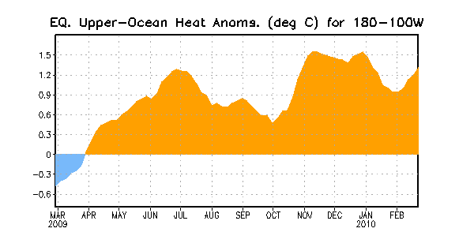
Figure 3. Area-averaged upper-ocean heat content anomalies (°C) in the equatorial Pacific (5°N-5°S, 180º-100ºW). Heat content anomalies are computed as departures from the 1982-2004 base period pentad means.

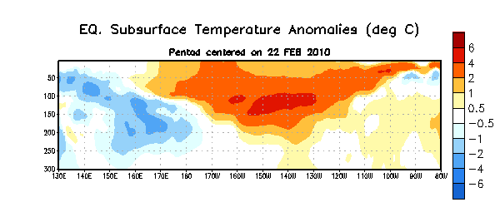
Figure 4. Depth-longitude section of equatorial Pacific upper-ocean (0-300m) temperature anomalies (°C) centered on the week of 22 February 2010. The anomalies are averaged between 5°N-5°S. Anomalies are departures from the 1982-2004 base period pentad means.

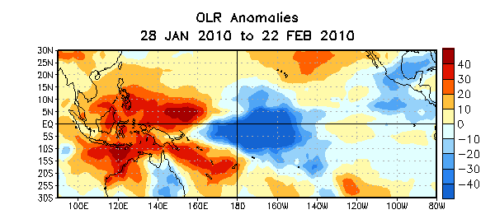
Figure 5. Average outgoing longwave radiation (OLR) anomalies (W/m²) for the four-week period 28 January – 22 February 2010. OLR anomalies are computed as departures from the 1979-1995 base period pentad means.

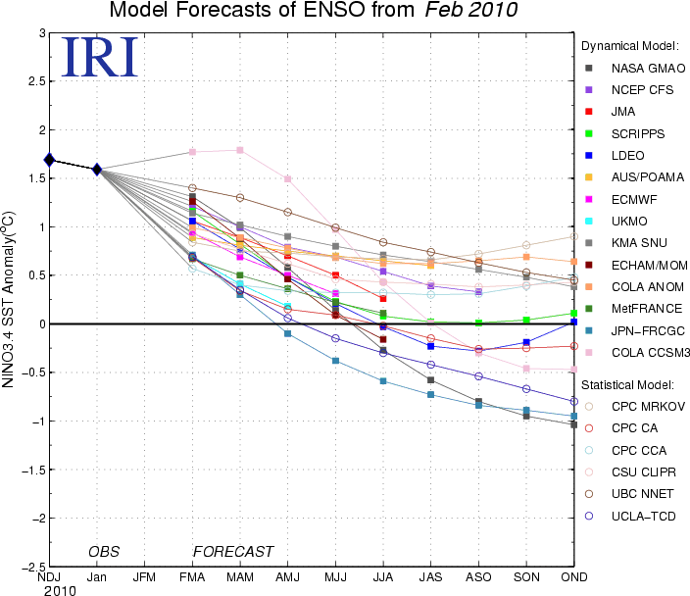

Figure 6. Forecasts of sea surface temperature (SST) anomalies for the Niño 3.4 region (5°N-5°S, 120°W-170°W). Figure courtesy of the International Research Institute (IRI) for Climate and Society. Figure updated 16 February 2010.

