EL NIÑO/SOUTHERN OSCILLATION (ENSO) DIAGNOSTIC DISCUSSION

issued by

CLIMATE PREDICTION CENTER/NCEP/NWS
and the International Research Institute for Climate and Society
8 March 2012

ENSO Alert System Status: La Niña Advisory

Synopsis: La Niña is expected to transition to ENSO-neutral conditions by the end of April 2012.
La Niña weakened during February 2012, as near- to- above average sea surface temperatures (SST) emerged in the eastern equatorial Pacific Ocean (Fig. 1). However, below-average SSTs persisted in the central Pacific, as indicated by the latest weekly Niño-3.4 and Niño-4 indices which were near –0.5°C (Fig. 2). The oceanic heat content (average temperature in the upper 300m of the ocean) anomalies also weakened notably (Fig. 3), as reflected by a shallow lens (0m to ~25m depth) of positive temperature anomalies east of 125°W and by diminished below-average temperatures east of the Date Line (Fig. 4). These changes are partly associated with strong low-level westerly wind anomalies across the eastern Pacific, which at times reflected the absence of equatorial easterlies in that region. Nonetheless, the larger scale atmospheric circulation anomalies continued to reflect the ongoing La Niña. Enhanced low-level equatorial easterlies persisted over the central and west-central Pacific, while convection remained suppressed in the western and central Pacific, and enhanced over Malyasia and the Phillipines (Fig. 5). Collectively, these oceanic and atmospheric patterns reflect a weakening La Niña.
A majority of models predict ENSO-neutral conditions to return during March-May 2012 and to continue through the Northern Hemisphere summer 2012 (Fig. 6). The rapid weakening of the negative surface and subsurface temperature anomalies during February 2012, combined with the historical tendency for La Niña to dissipate during the Northern Hemisphere spring, lends support to the return of ENSO-neutral conditions in the coming months. Therefore, La Niña is expected to transition to ENSO-neutral conditions by the end of April 2012 (see CPC/IRI consensus forecast).
Because impacts often lag the demise of an ENSO episode, La Niña-like impacts are expected to persist into the upcoming season. Over the U.S. during March - May 2012, La Niña is associated with an increased chance of above-average temperatures across the south-central U.S., and below-average temperatures in the northwestern U.S. Also, above-average precipitation is favored across western Washington, the Ohio Valley, and lower Great Lakes, while drier-than-average conditions are more likely across Florida, the Gulf Coast, and the southwestern U.S. (see 3-month seasonal outlook released on 16 February 2012).
This discussion is a consolidated effort of the National Oceanic and Atmospheric Administration (NOAA), NOAA’s National Weather Service, and their funded institutions. Oceanic and atmospheric conditions are updated weekly on the Climate Prediction Center web site (El Niño/La Niña Current Conditions and Expert Discussions). Forecasts for the evolution of El Niño/La Niña are updated monthly in the Forecast Forum section of CPC's Climate Diagnostics Bulletin. The next ENSO Diagnostics Discussion is scheduled for 5 April 2012. To receive an e-mail notification when the monthly ENSO Diagnostic Discussions are released, please send an e-mail message to: ncep.list.enso-update@noaa.gov.

Climate Prediction Center
National Centers for Environmental Prediction
NOAA/National Weather Service
Camp Springs, MD 20746-4304
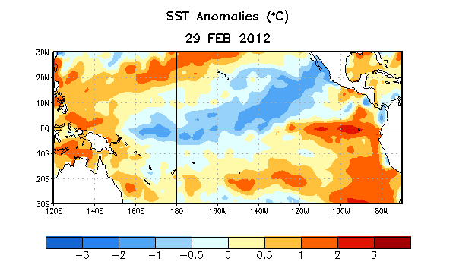
Figure 1. Average sea surface temperature (SST) anomalies (°C) for the week centered on 29 February 2012. Anomalies are computed with respect to the 1971-2000 base period weekly means (Xue et al. 2003, J. Climate, 16, 1601-1612).

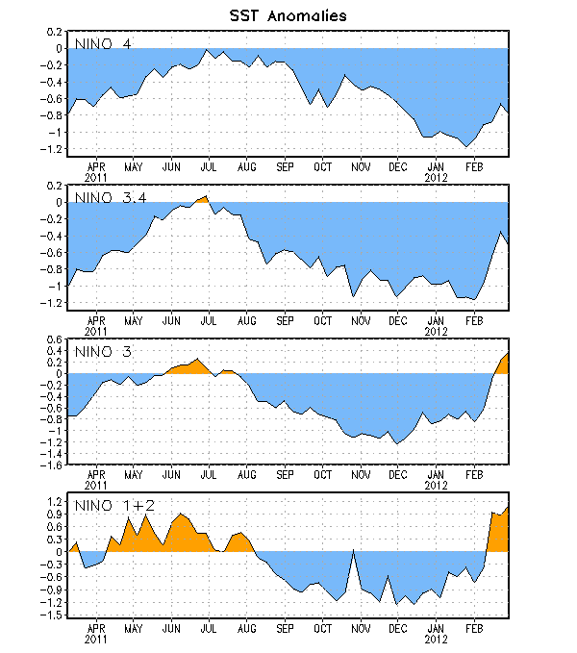
Figure 2. Time series of area-averaged sea surface temperature (SST) anomalies (°C) in the Niño regions [Niño-1+2 (0°-10°S, 90°W-80°W), Niño 3 (5°N-5°S, 150°W-90°W), Niño-3.4 (5°N-5°S, 170°W-120°W), Niño-4 (150ºW-160ºE and 5ºN-5ºS)]. SST anomalies are departures from the 1971-2000 base period weekly means (Xue et al. 2003, J. Climate, 16, 1601-1612).

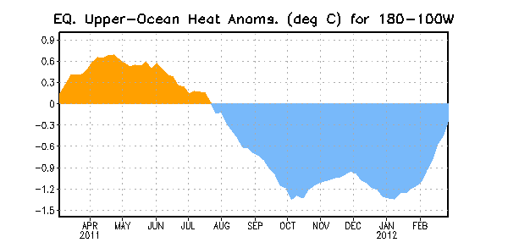
Figure 3. Area-averaged upper-ocean heat content anomaly (°C) in the equatorial Pacific (5°N-5°S, 180º-100ºW). The heat content anomaly is computed as the departure from the 1982-2004 base period pentad means.

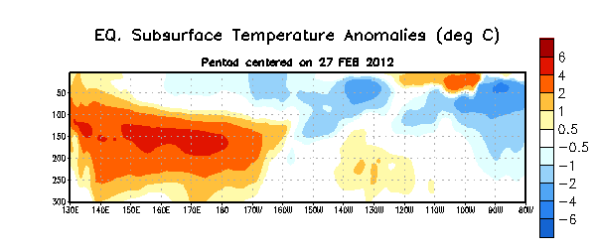
Figure 4. Depth-longitude section of equatorial Pacific upper-ocean (0-300m) temperature anomalies (°C) centered on the week of 27 February 2012. The anomalies are averaged between 5°N-5°S. Anomalies are departures from the 1982-2004 base period pentad means.

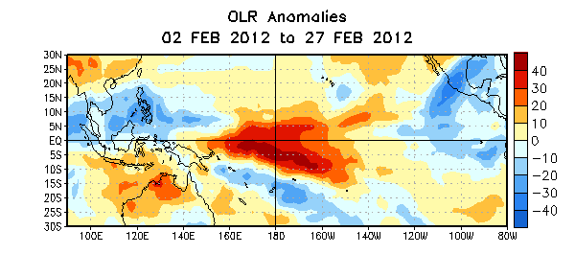

Figure 5. Average outgoing longwave radiation (OLR) anomalies (W/m²) for the four-week period 2– 27 February 2012. OLR anomalies are computed as departures from the 1979-1995 base period pentad means.

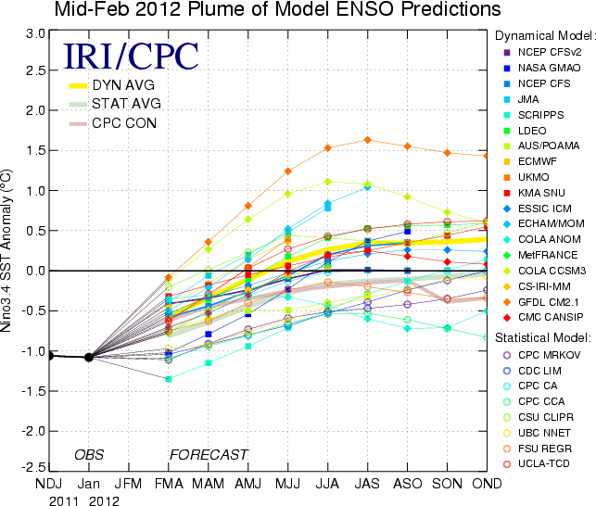
Figure 6. Forecasts of sea surface temperature (SST) anomalies for the Niño 3.4 region (5°N-5°S, 120°W-170°W). Figure courtesy of the International Research Institute (IRI) for Climate and Society. Figure updated 14 February 2012.

