EL NIÑO/SOUTHERN OSCILLATION (ENSO) DIAGNOSTIC DISCUSSION

issued by

CLIMATE PREDICTION CENTER/NCEP/NWS
and the International Research Institute for Climate and Society
5 March 2015

ENSO Alert System Status: El Niño Advisory

Synopsis: There is an approximately 50-60% chance that El Niño conditions will continue through Northern Hemisphere summer 2015.
During February 2015, El Niño conditions were observed as the above-average sea surface temperatures (SST) across the western and central equatorial Pacific (Fig. 1) became weakly coupled to the tropical atmosphere. The latest weekly Niño indices were +0.6°C in the Niño-3.4 region and +1.2°C in the Niño-4 region, and near zero in the Niño-3 and Niño-1+2 regions (Fig. 2). Subsurface temperature anomalies increased (Fig. 3) associated with a downwelling oceanic Kelvin wave, which was reflected in positive subsurface anomalies across most of the Pacific (Fig. 4). Consistent with weak coupling, the frequency and strength of low-level westerly wind anomalies increased over the equatorial Pacific during the last month and a half (Fig. 5). At upper-levels, anomalous easterly winds persisted across the east-central Pacific. Also, the equatorial Southern Oscillation Index (EQSOI) remained negative for two consecutive months. Convection was enhanced over the western equatorial Pacific and near average around the Date Line (Fig. 6). Overall, these features are consistent with borderline, weak El Niño conditions.
Compared to last month, several more models indicate El Niño (3-month values of the Niño-3.4 index equal to or greater than 0.5°C) will continue throughout 2015 (Fig. 7). This is supported by the recent increase in subsurface temperatures and near-term model predictions of the continuation of low-level westerly wind anomalies across parts of the equatorial Pacific. However, model forecast skill tends to be lower during the Northern Hemisphere spring, which contributes to progressively lower probabilities of El Niño through the year. In summary, there is an approximately 50-60% chance that El Niño conditions will continue through Northern Hemisphere summer 2015 (click CPC/IRI consensus forecast for the chance of each outcome).
Due to the expected weak strength, widespread or significant global impacts are not anticipated. However, certain impacts often associated with El Niño may appear in some locations during the Northern Hemisphere spring 2015.
This discussion is a consolidated effort of the National Oceanic and Atmospheric Administration (NOAA), NOAA’s National Weather Service, and their funded institutions. Oceanic and atmospheric conditions are updated weekly on the Climate Prediction Center web site (El Niño/La Niña Current Conditions and Expert Discussions). Forecasts are also updated monthly in the Forecast Forum of CPC's Climate Diagnostics Bulletin. Additional perspectives and analysis are also available in an ENSO blog. The next ENSO Diagnostics Discussion is scheduled for 9 April 2015. To receive an e-mail notification when the monthly ENSO Diagnostic Discussions are released, please send an e-mail message to: ncep.list.enso-update@noaa.gov.

Climate Prediction Center
National Centers for Environmental Prediction
NOAA/National Weather Service
College Park, MD 20740

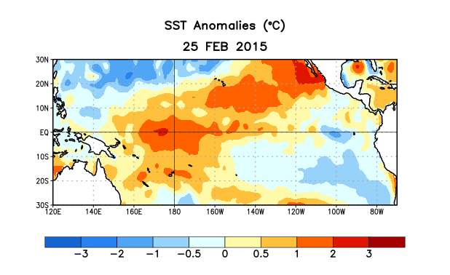
Figure 1. Average sea surface temperature (SST) anomalies (°C) for the week centered on 25 February 2015. Anomalies are computed with respect to the 1981-2010 base period weekly means.

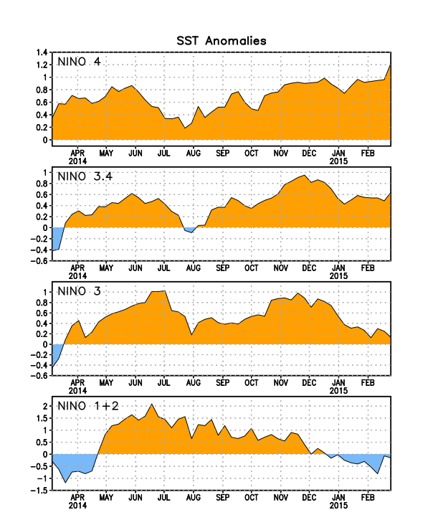
Figure 2. Time series of area-averaged sea surface temperature (SST) anomalies (°C) in the Niño regions [Niño-1+2 (0°-10°S, 90°W-80°W), Niño 3 (5°N-5°S, 150°W-90°W), Niño-3.4 (5°N-5°S, 170°W-120°W), Niño-4 (5ºN-5ºS , 150ºW-160ºE]. SST anomalies are departures from the 1981-2010 base period weekly means.
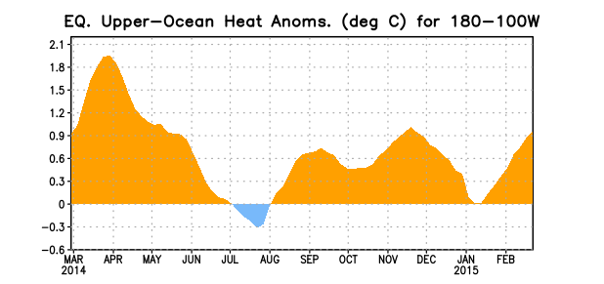
Figure 3. Area-averaged upper-ocean heat content anomaly (°C) in the equatorial Pacific (5°N-5°S, 180º-100ºW). The heat content anomaly is computed as the departure from the 1981-2010 base period pentad means.

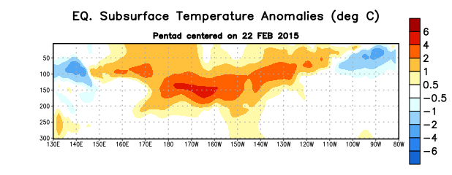
Figure 4. Depth-longitude section of equatorial Pacific upper-ocean (0-300m) temperature anomalies (°C)
centered on the pentad of 22 February 2015. The anomalies are averaged between 5°N-5°S. Anomalies are departures from the 1981-2010 base period pentad means.

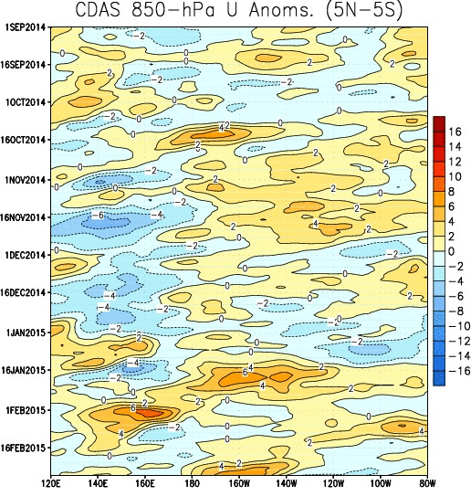
Figure 5. Time-longitude low-level (850-hPa) zonal wind anomalies averaged between 5°S-5°N. Anomalies are computed with respect to the 1981-2010 base period weekly means.

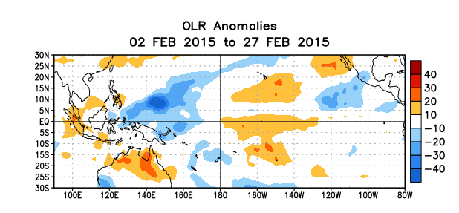
Figure 6. Average outgoing longwave radiation (OLR) anomalies (W/m²) for the period 2 – 27 February 2015. OLR anomalies are computed as departures from the 1979-1995 base period pentad means.

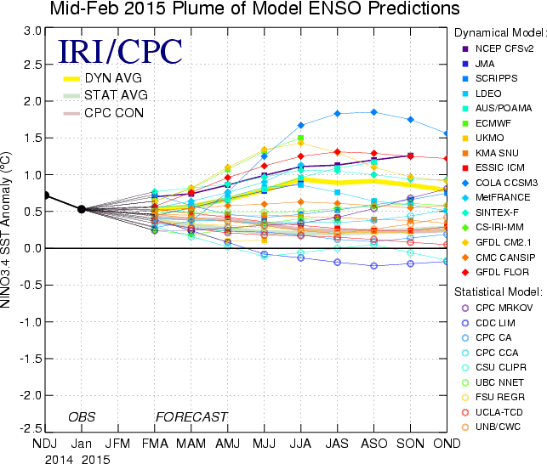

Figure 7. Forecasts of sea surface temperature (SST) anomalies for the Niño 3.4 region (5°N-5°S, 120°W-170°W). Figure updated 17 February 2015.

